**PYTHAGORAS SERIES**

**SOLID FOUNDATION INTEGRATED SCIENCE FOR JUNIOR HIGH SCHOOL**

**Question and Answers**

**TABLE OF CONTENTS**

**Chapter Page**

1. MATTER AND ATOM…………………………………………………………………….………………………………….
2. PHYSICALl AND CHEMICAL CHANGES, MIXTURES AND COMPOUNDS………………………
3. FQRCE, WEIGHT AND MASS …………………………………………………………………………………………..
4. WATER, SOLUTIONS AND SOLUBILITY…………………………………………………………………………….
5. THE SOLAR SYSTEM, SATELLITES AND MEASUREMENT…………………………………………..……
6. PEASSURE ………………………………………………………………..……………………………………………………
7. DENSITY………………………………………………………………………………………………………………….………..
8. METALS, ALLOYS AND RUSTING……………………………………………………………………………..………..
9. WORK, ENERGY AND MACHINES……………………………………………………………….………..………..
10. HEAT AND TEMPERATURE………………………………………………………………………..………..………..
11. GASES………………………………….………………………………….………………………………….………..………..
12. LIGHT………………………………….………………………………….………………………………….………..………..
13. LIQUID SURFACE IN CONTACT WITH SOLIDS, CAPILLARITY, ACIDS AND BASES……..
14. MAGNETISM AND ELECTRICITY ………………………………….………………………………….……………
15. ELECTRONICS………………………………….………………………………….………………………………….………..
16. DIGESTION AND DENTITION………………………………….……….………………………………….………..
17. EXCRETION………………………………….………………………………….………………………………….………..
18. RESPIRATION………………………………….………………………………….………………………………….………..
19. OSMOSIS, DIFFUSION AND TRANSPIRATION………………………………….……………………………
20. FLOWERING PLANTS, PHOTOSYNTHESIS AND DISPERSAL OF SEEDS………………………

21. SENSE ORGANS……………………………………………………..

22 CELLS AND BLOOD……………………………………………………………………………

23. REPRODUCTION……………………………………………………………………………….

24 MICROES, DISEASES AND FOOD……………………………………………………………

25. ENVIRONMENT. POLLUTION, WEATHERING AND DISEASES…………………………….

26. ECOLOGY………………………………………………………………………………

27. GENERAL INTRODUCTION TO AGRICULTURE…………………………….

28. AGRICULTURE TOOLS………………………………………………………………………………………………………..

29. PLANT NUTRTENTS AND SOIL…………………………………………………………………………………………..

30. VEGETABLES………………………………………………………………………………………………………………………..

31. CROP PROTECTION………………………………………………………………………………………………………….

32. FARMING SYSTEMS AND FISH FARMING…………………………………………..

33. POULTRY HUSBANDRY………………………………………………..

34. FARM ANIMALS………………………………………………..

**CHAPTER ONE**

**(Q1) Within an atom, there are 5 electrons and 2 neutrons. Find its mass number.**

Soln:

Number of electons = 5.

Number of neutrons = 2.

Mass number = 5 + 2 = 7.

**(Q2) There are 2 neutrons and 6 protons within an atom. Determine its mass number.**

Soln:

Number of neutrons = 2.

Number of proton = 6.

Mass number = 2 + 6 = 8.

**(Q3) An atom has a mass number of 10. If it contains 2 electrons, how many neutrons does it contain?**

Soln:

Mass number = 10.

Number of electrons = 2.

Number of neutrons =?

Since mass number = number of neutrons + number of electrons,

=>10 = number of neutrons + 2,

=> 10 – 2 = number of neutrons,

=>number of neutrons = 8.

**(Q4) An atom which contains 3 electrons has a mass number of 8. Determine the number of neutrons that it contains.**

Soln:

Number of electrons = 3.

Mass number = 8.

Number of neutrons =?

Since mass number = number of electrons + number of neutrons,

=>8 = 3 + number of neutrons,

=>number of neutrons = 8 – 3 = 5.

**(Q5) An atom has 4 protons and a mass number of 12. How many neutrons does it contain?**

Soln:

Mass number = number of protons + the number of neutrons.

=>Mass number = 4 + number of neutrons,

=>12 = 4 + number of neutrons,

=>number of neutrons = 12 – 4 = 8.

**(Q6) An atom whose mass number is 10 contains 8 neutrons. Determine the number of protons that it contains.**

Soln:

Number of neutrons = 8.

Mass number = 10.

Since mass number = number of neutrons + number ofprotons,

=>10 = 8 + number of protons,

=>Number of protons = 10 – 8 = 2.

**Atomic symbol:**

* If X = the element, A = its mass number and Z = its atomic number, then the atomic symbol of the element X is written as .
* For example, the atomic symbol represents theelement sodium, whose mass number is 23 and whose atomic number is 11.
* Also the symbol represents the element magnesium, whose mass number is 24 and whose atomic number is 12.

**(Q1) The atomic symbol of an element is .**

1. **What is the mass number?**
2. **Write down its atomic number.**
3. **Find the number of neutrons.**

Soln:

1. The mass number = 10.
2. The atomic number = 7,

=>it contains 7 electrons.

(c) From Mass number = number of neutrons + number of electrons,

=>10 = number of neutrons + 7,

=>10 – 7 = Number of neutrons,

=> it contains 3 neutrons.

**(Q2) An element has an atomic symbol. Determine**

**(a) its atomic number.**

**(b) the number of protons it contains.**

**(c) its mass number**

**(d) the number of neutrons it contains.**

Soln:

1. The atomic number = 8.
2. The number of protons = the atomic number = 8.
3. The mass number = 12.
4. Number of neutrons = mass number – number of electrons = 12 – 8 = 4.

**(Q3) Write the atomic symbol of an element Y, which contains 8 electrons and 5 neutrons.**

Soln:

Since there are 8 electrons=>the atomic number = 9.

The mass number = number of electrons + number of neutrons,

=> the mass number = 8 + 5 = 13.

The atomic symbol.

**(Q4)An element B has 10 protons and 8 neutrons. Write down its atomic symbol.**

Soln:

Since the number of protons = 10, then the atomic number = 10.

Number of neutrons = 8.

Mass number = number of neutrons + the number of protons.

Mass number = 10 + 8 = 18

The atomic symbol is .

**Isotopes:**

* These are two or more atoms which have the same atomic number, but different mass numbers.
* Within an atom, the number of protons is always fixed or constant but the number of neutrons may vary.
* If the number of neutrons vary, then the mass number of the atom will also vary.
* For this reason it is therefore possible to have two atoms of the same element, which have the same atomic number but different mass numbers, and such two atoms are called isotopes.
* Examples of isotopes are

1. and
2. and

**Electronic configuration:**

* This shows the number of electrons within each orbital of an atom.

**(Q1) Write the electronic configuration of an element X whose atomic number is 7.**

Soln:

**N/B:** The first orbital can take a maximum of 2 out of the 7 electrons found in the element X, the rest must be found in the second orbital.

Soln:

The required electronic configuration is 2 : 5.

**(Q2)Write down the electronic configuration of an atom, whose atomic number is 12.**

Soln:

Since the first orbital can contain a maximum of 2 electrons, and the second one a maximum of 8, the required electronicconfiguration is 2 : 8 : 2, since the given atom contains 12 electrons.

**(Q3)The atomic symbol of sodium is given as. Write down its electronic configuration.**

Soln:

Since the atomic number of sodium = 11, then its electronic configuration is 2 : 8 : 1.

.

**The atomic structure:**

* This refers to a diagram of an atom, which shows the number of electrons within each orbital.

**(Q1) The atomic number of an element is 13. Write down its atomic structure.**

Soln

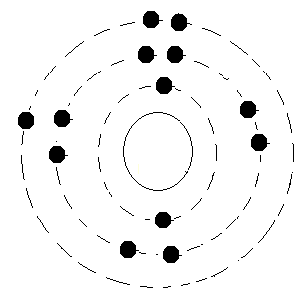

**(Q2)The atomic number of an element is 3. Write down its atomic structure.**

Soln:

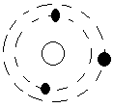

**(Q3)Write down the atomic structure of an element, which contains only two protons.**

Hint:

Since the number of protons and electrons are the same, then the number of electrons = 2.

**(Q4) An element has as its atomic symbol. Write down its atomic structure.**

Soln:

Since the atomic number of the element is 10, then it contains 10 electrons.

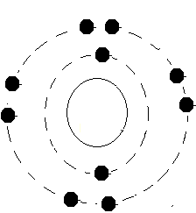

**QUESTIONS**

**(Q1) (a) What is matter and why is a stone said to be matter.**

Ans:

* Matter is any thing which has weight and occupies space.
* A stone is said to be matter since it has weight and occupies space.

**(b) List the three states of matter.**

Ans:

* These are the liquid, the solid, and the vapour states.

1. **Explain why the molecules within a solid are not free to move about.**

Ans

* Because the attractive forces acting between them are very strong.

**(d) Why does a liquid take the shape of its container.**

Ans:

* Because a liquid does not have a definite shape.

**(e) Why does gas always spreads out to fill its container.**

Ans:

* Because the attractive forces acting between it molecules are the weakest.

**(Q2) (a) Differentiate between melting and evaporation.**

Ans:

* In melting a solid changes into the liquid state, but in evaporation a liquid change into the vapour state .

**(b) When is a gas said to have undergone condensation.**

Ans:

* When it changes into the liquid state.

**c) Explain what happens if solid iodine or camphor is heated.**

.

Ans:

* Each of them will change directly from the solid into the vapour state.

**(d) Why is water not considered as an element?**

- Because it contains two different kinds of atoms.

**(e) What are chemical symbols?**

Ans

* They are letters used to represent elements.

**(Q3) (a) Write down the chemical symbols for the following elements:**

1. **Iron (ii) zinc (iii) silver (iv) chlorine (v) potassium.**

Ans:

* (i) iron…………………Fe

(ii)Zinc………………..Zn

(iii) Silver…………….Ag

(iv)Chlorine …………Cl

(V) Potassium……….K

**(b) What is the difference between an atom and a molecule?**

Ans:

* An atom is the smallest particle which can exist, but a molecule is the combination of two or more atoms.

**(c) Make a labeled diagram of the atom.**

**(d) Name the items found within the nucleus.**

Ans:

* These are the protons and the neutrons.

**(e) What do we mean if we say that an atom is neutral?**

Ans:

* It means that it contains the same number of positive and negative charges.

**(Q4) (a) What is the difference between atomic number and mass number?**

* While the atomic number refers to the either the number of electrons or protons, the mass number refers to the total number of protons and neutrons.

**(b) What will be the atomic number of an atom, which contain 8 electrons?**

Ans:

* 8

**(c) Write down the mass number of an atom, which contains 4 electrons and 2 neutrons.**

Ans:

* 6

**(d) What is an ion?**

- An ion is either a positively or a negatively charged atom.

**(e) Briefly explain how negative ions are formed.**

Ans:

* When an atom gains an electron or electrons, its number of negative charges become more than that of the positive charges, making it a negative ion.

**CHAPTER TWO**

**PHYSICAL AND CHEMICAL CHANGES,**

**MIXTURES AND COMPOUNDS.**

**(Q1) State whether the following are physical or chemical changes:**

1. The boiling of egg for five minutes.
2. Chewing a piece of bread.
3. Chewing of piece of meat for two minutes in the mouth.
4. Dissolving common salt in water.
5. The burning of charcoal.

Soln:

1. This is a physical change since the egg only changes from the liquid into the solid state, without any change in its food nutrients.
2. It is a chemical change because a substance called ptyalin found in saliva, will break the starch within the bread into simple sugar.
3. This is a physical change since the meat only breaks down into pieces, but the protein it contains does not change since ptyalin has no effect on protein.
4. This is a physical change, since the salt does not change but only breaks down into smaller particles.
5. It is a chemical change because the charcoal changes into a new material.

**(Q2) Determine whether the following are physical or chemical changes:**

1. The melting of ice.
2. Putting HCl into NaoH.

Soln:

1. This is physical change since the ice only changes from the solid into the liquid state, and still remains as water.
2. In other words, no new substance is formed.
3. This is a chemical change because the HCl will combine with the NaoH to form NaCl and H2O, which are new substances.

**(Q3) Explain how you will demonstrate that**

(a) a liquid has no fixed shape.

(b) a gas has no fixed volume.

Soln:

a). Containers of different shapes are taken, and liquid such as water is poured into each of them one after the other.

- It will be noticed that in each case, the liquid will take the particular shape of the container into which it is placed.

- When smoke is created at one corner of a room, it spreads to fill the whole room, which shows that a gas has no fixed volume..

**Industrial application:**

1. It is used to separate crude oil into its various components or parts.
2. It is used to separate liquefied air into oxygen and nitrogen.

**The separation funnel:**

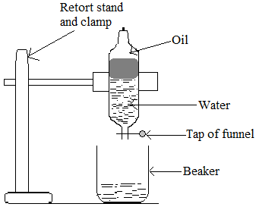

* This is used to separate two or more immiscible liquids found within a mixture, according to their densities.
* The mixture is poured into the separating funnel.
* The set-up is allowed to stand for some time for the liquid to settle.
* The tap is opened to allow the bottom layer of liquid which has the greatest density to flow out.
* Among the liquids left within the mixture, the one with the greatest density then forms the bottom layer, which can also be made to follow out.
* By so doing, the mixture can be separated into its constituents.
* Within the round bottle flask will be left the water constituent of the mixture.

**(Q1) Explain how you will separate a mixture of grinded salt and sand,**

Soln:

* Add water to the mixture in order to dissolve the salt in the water.
* Filter the mixture of the salt water and the sand, for the sand to be deposited on the filter paper or the cotton wool.
* Evaporate the filtrate to get the salt.

**(Q2) Given a mixture of sand, iron fillings and camphor, briefly explain how you will separate such a mixture.**

Soln:

* Heat the mixture for the camphor to sublime, and condense the camphor in its gaseous state into solid camphor by means of a cold surface.
* The mixture remaining which consists of iron fillings ad sand is then separated by using a magnet to remove the iron fillings.

**(Q3) Briefly explain you will obtain kerosene from a mixture of petrol and kerosene.**

Soln:

* This is by means of distillation.
* Heat the mixture in a round bottom flask, for the petrol to be changed into the vapour state, since it has the lower boiling point.
* Condense the petrol vapour into liquid by allowing it to move into the condenser.
* Collect this liquid petrol in a beaker.
* The kerosene will be left in the round bottom flask.

**(Q4) Classify the following as mixture or compound:**

i.e. toothpaste, smoke, petrol, kerosene, common salt, salt solution, dye, water, sugar or sucrose, soup.

Soln:

* The mixtures are toothpaste, paint, smoke, salt water or salt solution, dye and soup.
* The compounds are water, sugar or sucrose, common salt, petrol and kerosene.

**CHAPTER THREE**

**FORCE, WEIGTH AND MASS**

**Questions:**

**(Q1)(a) Define force.**

(b) List three effectsof force.

(c) Explain why when a stone is thrown into the air, it returns to the ground.

Ans: Because the force of gravity pulls it back to the surface of the earth.

**(Q2) A boy is running round a circular path. Determine the forces which are acting on him.**

Ans: The forces acting on him are the force of gravity which is pulling him towards the surface of the earth, and the centripetal force which enables him to ran in the circular path.

**(Q3)(a) Differentiate between cohesive and adhesive forces.**

(b)Explain why a body has weight

Ans: Because the force of gravity which is pulling it towards the centre of the earth, enables it to exert a force (weight) on its support.

**(c)Explain what the following mean:**

(i) Friction.

(ii) The weight of an object.

(iii) The mass of an object.Ans: (i) Friction refers to the force, which tries to prevent objects from moving when they are being pulled across a surface. (ii) The weight of a body refers to the force which it exerts on its support, or on any thing that freely supports it. (iii) The mass of a body refers to the amount of matter or material that it contains.

**(Q4)(a) List three differences between weight and mass.**

(b) Explain why or what causes a body or have weight.

Ans: A body has weight because the force of gravity is pulling it towards the centre of the earth, which enables it to exert a force (weight) on its support.

**(Q5)Briefly explain the main difference between a scalar and a vector quantity.**

Ans: While a scalar quantity has only magnitudebut no direction, a vector quantity has both magnitude and direction.

**(Q6)Briefly explain with the aid of diagrams, how each of the following can be used to determine the mass or the weight of a body:**

1. The spring balance.
2. The beam (lever) balance.

**(Q7)(a) State two advantages or importance of friction.** Ans: i) It enables us to walk. ii) It enables a car to come to a stop, when the brakes are applied.

**(Q8) You are given two different liquids.Briefly explain how you will determine which one is more viscous, or has the greater viscosity**. . Ans: Place the the two liquids into two different identical cylinders, and drop two small identical metal balls, one into each liquid at the same time. The liquid in which the ball falls slowly has the greater viscosity.

**(Q9)List two differences between weight and mass.**

Ans: i) While weight is a vector quantity, mass is a scalar quantity. ii) While the weight of a body changes from one place to another, the mass of the same body always remains constant from one place to another.

**(Q10)Explain why an object thrown into the air, always returns or falls to the surface of the earth.**

Ans: It is the force of gravity which always pulls it to the surface of the earth.

**CHAPTER FOUR**

Water, Solutions and Solubility

**Q.1. Explain how you will prepare a solution of sodium chloride using the method of neutralization.**

Solution

1. Put sodium chloride into water and stir for it to dissolve.
2. The salty water had is a solution of sodium chloride

**Q.2. List three solvents and give one use of each.**

Solution

1. Water: which is used to dissolve sugar.
2. Alcohol: which is used to extract pigment from plant.
3. Thinner: which is used to dissolve paints.

**Q.3. Explain why certain mixtures are shaken before their use.**

.

Solution

* Because some of the solute tends to settle at the bottom of the container.
* Shaking or stirring will give rise to a homogenous mixture, which is a mixture in which the solid particles of the solute are evenly spread.

**Q.4. Give three methods used in water purification and explain each one of them.**

Solution

Three of the methods used in water purification are:

1. Boiling: In this method, the water is boiled for about 20 minutes to kill almost all the germs it contains.
2. Filtration: In this the water is made to pass through a filter paper, or a filter bed made of sand and stones or a white cloth.
3. Chemical treatment: In this method, chemicals such as chlorine and alum are added to the water. While the chlorine kills the germs in the water, the alum causes all the suspended particles within the water to settle to the bottom.

**Q.5. By arranging them in their order of purity, name four sources of natural water.**

Solution

1. Rain water:

* This is the purest form of natural water, and it contains the least amount of dissolved material.

1. Well water:

* This comes next in term of purity after rain water.

—Water from deep wells are clean because it has been filtered by different layers of soil.

1. River/stream water:

* In terms of purify, this comes third.

1. Sea/lake water:

* This contains the highest level of dissolved material which makes it the least pure.

**Q.6. You have travelled to a village where the only source of drinking water available is a stream. Briefly explain how you will make a gallon of the stream water good for drinking.**

Solution

1. I will first boil the water for about 20minutes, to kill the germs in it.
2. I will then filter the boiled water, before drinking it.

**Q.7. For each of the following, give a suitable solvent which can be used to dissolve each: Common salt, paint, sucrose, coal tar and chlorophyll.**

Solution

Substance Solvent

Common salt…………………………………………… water.

Paint………………………………………………………..kerosene/tinner/petrol.

Coal tar ……………………………………………… …..turpentine/kerosene/petrol.

Sucrose ……………………………………………………water.

Chlorophyll……………………………………………….alcohol.

**(Q1) Explain why it necessary for water from certain natural sources, must to be purified before being used.**

**Ans:**

* To kill the germs in the water and remove harmful chemicals from it.
* To remove the solid particles from it.

**(Q2) You are given a small amount of a liquid suspected to be water. List three tests you will carry out to determine whether it is pure or good water or not.**

**Ans:**

* I will first determine the boiling point and the freezing point of the liquid. If they are respectively 100C and 0C, then it is likely the liquid is good water.
* Finally I will add a few drop of the liquid to anhydrous copper II sulphate, and if the colour changes from white to blue, then the liquid is water.

**(Q3)(a) What do you understand by water conservation?**

(b) Explain why it is important for water to be conserved.

(c) List three methods of water conservation.

**(Q4)(a) What is the cause of hardness in water?**

**Ans:**

* Due to the presence of calcium and magnesium ions in the water.

**(b) Differentiate between temporary and permanent hardness of water.**

**Ans:**

* Temporary hardness is due to the presence of calcium hydrogen carbonate in the water, while permanent hardness is due to presence of magnesium or calcium sulphate.

**(c) Explain why hard water does not easily form lather with soap, or why hard water wastes soap.**

**Ans:**

* When soap is used for washing using hard water, the soap starts combining with the calcium and the magnesium ions within the water to form a solid called scum.
* It is only after all these ions have combined with the soap to form scum, that the water will begin to form lather with the soap, for washing to take place.
* In this way part of the soap is wasted.

**(5)(a) Write a short note to explain what the water cycle is.**

**(b) Differentiate between a dilute solution and an aqueous solution.**

**(c) When is a solution said to be concentrated**.

**Ans:**

* When the amount of solute dissolved in the solvent to form the solution is great.

**(d) What is it that it is impossible to dissolve more solute, in a saturated solution?**

**Ans:**

* Because the solution contains the maximum amount of solute, that it can contain or be dissolved in it.

**(Q6)(a) What is solubility?**

**(b) List three factors which affect solubility, and explain the effect of each.**

**.**

**Ans:**

(a)Temperature;

* Solubility increase as the temperature increases.
* Stirring; Solubility increases as stirring increases.
* Nature of the solute:
* The smaller the particles of the solute, the greater its solubility within a given solvent.

**(Q7)(a) What is the main difference between a suspension and a colloid?**

**Ans:** The particles of a suspension settle on standing, but those of colloid do no settle on standing.

**(Q8)** **List three differences between a true solution and a suspension.**

**(Q9)(a) Explain the role played by the alum and the chlorine, during water purification.**

**(b) Why is water from wells regarded to be good and clean?**

**Ans:**

* Because the water has been well filtered by the different layers of soil or rocks, found deep down the earth.

**(Q10)**(**a) List three differences between hard water and soft water.**

**(b) Give two ways of making hard water soft.**

**Ans:**

* By boiling.
* By distillation.

**(c) Describe an experiment to show that water from different sources, have different lathering abilities.**

**(Q11) the treatment of water for town supply, the water is first passed through gravel and sand bed. Potash (alum) is then added followed by the addition of chlorine. State the reason for each of these steps.**

Soln:

* The sand and gravel bed serves as filter, and as such removes the undissolved particles or debris from the water.
* The potash or the alum added, causes the small particles in the water to stick together and drop to the bottom.
* The chlorine kills the germs within the water.

(**Q12) Name three sources of natural water, and two cations which cause hardness in water.**

Soln:

* These sources are rivers and rainwater.
* Two cations which causes hardness in water are calcium ions(ca2+) and magnesium ions(mg2+).

**(Q13)(a)Give two examples of detergents.**

**(b)Explain why it is better to use detergent for washing, when using hard water rather than using soap.**

Soln:

* Soap when used for washing in hard water is affected by the ca2+ ions and the mg2+ ions found in the water.
* For this reason, part of the soap becomes wasted.
* By since these ions have no effect on detergents, no portion of the detergent becomes wasted.

**Chapter Five**

**The Solar System, Satellites And Measurement**

* The sun, the planets and all the heavenly bodies which move around it from the solar system.
* Heavenly bodies are structures that are high up in the atmosphere, but have no specific names.
* The solar system is circular in shape and forms part of the Milky Way galaxy.
* A galaxy is the name given to a large number of stars.
* The centre of the solar system is occupied by the sun, whose great mass creates the gravitational force which enables other objects to travel round it in an orderly manner.
* The universe is made up of space and everything that exists in it, and is indeed very large.
* It is composed of a number of galaxies.
* Each star is a source of heat and light, which means that each produces heat and light.
* The stars which include our sun are giant shining balls of hot gases.
* The main difference between a star and a planet is that, while a star produces its own light, a planet does not do so but reflects the sun`s light.
* For this reason, a planet can be seen since it reflects light from the sun.
* At night, planets and stars look like, but while the planet produces steady light, that produced by the sun is twinkling.

**The planets:**

* These are heavenly bodies that move around the sun.
* Each planet moves in a circular path called its orbit.
* The planet in the course of movement do not clash or meet, due to the sun`s gravitational force and each is at a particular distance away from the sun.
* The shape of the orbital path used by the planet around the sun is called ellipse.
* There are nine planets and naming them with respect to their closeness or nearest to the sun, we have: Mercury, Venus, Earth, Mars, Saturn, Uranus, Neptune and Pluto.
* All the planets with the exception of Pluto are surrounded by different kinds and amount of gases called atmosphere.
* For this reason, an atmosphere is the name given to the layer of gases which surrounds a planet.
* Among all the planets, the earth is the only one with enough oxygen and water on its surface to support life.
* While some of these planets have one or more moons moving around them, others have none.
* Each planet moves round the sun, and one complete movement of a planet round the sun is called a revolution.
* The earth takes a year or 365 days to revolve once round the sun.
* Apart from that, each planet spins on its axis which is an imaginary line through its centre, and this movement is called rotation.
* The earth takes 24hours to perform this rotation and it is this earth`s rotation which cause day and night.

The temperature, atmosphere, length of days and nights as well as other conditions vary from planet to planet and depend on the following factors:

1. The distance of the planet from the sun.
2. The planet`s atmosphere.
3. The planet`s rotation.

**Facts about some planets:**

**Mercury:**

* Since this is the planet nearest to the sun, it is the hottest planet.

**Venus:**

* When viewed from the earth, this is the brightest of all the planets.

**Earth:**

* This is the only planet known to have life on it, since it has conditions which favour life.
* These conditions include the presence of oxygen and water, as well as a good or moderate temperature.

**Mars:**

* This is referred to as the red planet.

**Jupiter:**

* This is the largest of all the planets and it has a very big red spot on its surface.

**Saturn:**

* This I the second largest planet and it has three colourful rings around it.

**Pluto:**

* This is the farthest planet from the sun.
* It is also the darkest and coldest planetsince the rays of the sun does not get to it.

**Space Travel:**

* The spaceship or the rocket is the only vehicle that can be used to travel to space.
* People who travel to space are called astronauts.

**The MOON:**

* A moon is a natural satellite which orbits or moves round a planet.
* Our earth has one moon which is a solid heavenly body which moves round the earth.
* The moon has no air or water and its surface is covered with plains, mountains and large holes called craters.
* It is also the nearest heavenly body to the earth.

**The Sun:**

* This is the star around which all the planets move.
* The importance or the uses of the sun`s energy are for the evaporation of liquid, in the drying of clothes and food, and in the salt making industries.
* It also used in keeping the atmosphere warm and provides light for sight or seeing.
* It also provides the light energy needed for photosynthesis.

**Asteroids:**

* They are also referred to as planetoids, and are irregularly shaped objects found within space.

**Meteoroids:**

* They are small heavenly bodies made up of iron and rock which sometimes fall from space to earth.
* Even though many meteoroids fall from space into the earth`s atmosphere, most of them burn up as a result of friction between them and the gases within the atmosphere.
* While they are falling through the atmosphere they are called meteors, but if they reach the earth`s surface they are referred to as meteoroids.

**Rotation of the earth:**

* The rotation or the spinning of the earth refers to its turning on its axis.
* A complete rotation of the earth which takes 24hours to occur, causes it to turn through an angle of 3600.
* The rotation of the earth causes day and night.
* Since the earth moves round the sun, the part of the earth which faces the sun will have light i.e. day, while the part which does not face the sun will have darkness.

**The revolution of the earth:**

* This refers to the movement of the earthround the sun.
* When the earth moves round the sun once, it is said to have made one revolution.
* The earth takes 365 days to make a complete revolution round the sun.
* It must be noted that the rotation and the revolution of the earth occurs at the same time.
* Therefore at any instant as the earth is rotating on its axis, it is also revolving round the sun.

**Earthquake:**

* This refers to the violent shaking movement of a portion of the earth as a result of the sudden movement of rocks, which are found deep down the earth.

**Effects of earthquake:**

* It leads to the destruction of infrastructures such as roads, buildingsand bridges.
* It can lead to the loss of lives and property.
* The lowering and rising of parts of the seamay occur, leading to the creation of tidal wave.

**Volcano:**

* This is an opening in the earth`s surface through which hot melted rock is ejected up into the sky, and onto the earth`s surface.
* This melted rock is called magna and before this magna appears, there will be the ejection of steam, gases, ashes and rocks.

**Effects of Volcano:**

* It can lead to the loss of life and property.
* It can lead to the formation of precious stones and minerals.
* The ashes and the gas released pollute the atmosphere.
* The rocks had as a result of volcanic action, break down to form fertile soil.

**Satellites:**

* A satellite is an heavenly body, which moves round a planet.
* There are two types and these are the natural and the artificial satellites.
* While natural satellite is naturally made, artificial satellite is man made.

**The uses of satellites:**

* The uses or importance of satellites are for the following purposes:

1. For communication purposes.
2. To study and forecast the weather.
3. To carry instruments into space and for scientific research purposes.
4. For military purposes.

**Measurement:**

* There are different types of measuring instruments and each is used for a specific measurement.
* One of the main importance of accurate measurement or measurement being accurate is to avoid cheating.
* Apart from that, inaccurate measurement can lead to dangerous situations or disasters.
* For example, in the manufacturing of drugs, the chemicals used must be measured accurately.

**Some measuring instruments:**

* There are different types of measuring instruments and some of them are:

1. **What is the metre rule?**

* This is used to measure the lengths of objects which are greater than 50cm.

1. **What is Calipers/ vernier calipers?**

* This is used to measure the lengths of small objects where ordinary ruler cannot be used.

1. **What is the tape measure?**

* This is used to measure long lengths, such as that of a football field.

1. **What is the micrometer screw gauge?**

* This is used to measure small lengths or distances such as the diameter of a piece of wire.

1. **What is the lever or beam balance?**

* This is used to determine the weight or the mass of an object.

1. **What is the measuring cylinder?**

* This is used to pour out various volumes of a liquid.
* For example, it can be used to pour out 25cm3 of water into a container.

1. **What is measuring flask and the pipette?**

* This is used to determine a fixed pre-determined volume of a liquid, into a container.
* For example, if we want to get 50cm3 of water into a container, then we have to use the 50cm3 capacity measuring flasks or the 50cm3 capacity pipette.

1. **What is the burette?**

* This can be used to run off any volume of liquid, to any required volume.
* It consists of a tap which when opened causes the liquid in the burette to run out, until the required volume of liquid within the burette is had.

**Some quantities and their units of measurement:**

* The units used for certain quantities are as follows:

1. Length ……………………………………. Metres (m).
2. Mass ………………………….. Kilogram (kg).
3. Temperature …………………… degree celcius (0C) or degrees kelvin (0k).
4. Current …………………………..Amperes (A).
5. Area ……………………………… Metre squared (m2).
6. Volume …………………………. Metre cubed (m3).
7. Speed ……………………………… Kilometre per hour (km/h), or metre per second (m/s).
8. Density ……………………….. Kilogram per metre cubed (kg/m3) or gram per centimetre cubed (g/cm3).
9. Velocity/ speed ……………………… metres per second (m/s) or kilometer per hour (km/h).
10. Acceleration ……………………….Metres per second squared (m/s2).
11. Force ……………………………. Newtons (N).
12. Mass …………………… kilogram (kg).
13. Weight ………………….. Newtons (N).

**Chapter six**

**Pressure:**

**Calculating Pressure:**

**(Q1) Calculate the pressure exerted by a block of area 100m2, if it has a weight of 40kg. Take ‘g’ or acceleration due to gravity = 10m/s2.**

Soln:

Pressure =

**N/B:** To get the force, we must multiply the weight or mass in kg by ‘g’ or the acceleration due to gravity, i.e 10m/s2.

Since weight = 40kg,

=>force = 40 x 10 = 400N.

Area = 100m2

But Pressure =

Pressure =

=>P = 4NM-2.

**(Q2)The area of a bottle is 50m2. If it has a mass of 20kg, calculate the pressure that it will exert on top of a table.**

Soln:

Since mass = 20kg,

=>force = 20 x 10 = 200N.

Area = 50m2.

But Pressure = =

=> pressure = 4pascal.

**N/B:** If the mass or weight is given in grams, it must be converted into kg (kilogram).

**(Q3)A rectangular block of length 18m and breadth 10m, lies on the surface of the floor. Calculate the pressure that will exert on the surface of the floor, if it has a mass of 4000g.**

Soln:

Mass = 4000g =,

i.e divide the mass in grams by 1000 to convert it into kg.

Since mass = 4kg, then force = 4 x 10 = 40N.

Area of rectangle = Length x Breadth.

Area of the rectangle = 180 x 10 = 180m2.

Pressure = =

=>pressure = 0.2p

**(Q4)A rectangular box of length 20m and breadth 10m, lies on a table. If it has a weight of 8000g, calculate the pressure which it will exert on the table.**

**(Take ‘g’ = 10ms-2).**

Soln:

Since area of rectangular block = length x breadth,

=>area = 20 x 10 = 200m.2

Weight = 8000g = .

Force = 8 x 10 = 80N.

Pressure = = 0.4.

Pressure = 0.4NM-2.

**(Q4)A square box of side or length 5m, lies on a table. If it has a mass of 25kg, find the pressure it will exert on the table.**

Soln:

Length or side of box = 5m.

Area of square box = length squared = 52 = 25m2.

Mass = 25kg.

Force = 25 x 10 = 250N.

Pressure =

= NM-2.

**N/B:** Area of a square is also given by breadth squared i.e. B2.

**(Q5)A block which is in the shape of a square of breadth or length 2m has a mass of 8000g. Find the force it exerts on the ground as it lies there.**

Soln:

Breadth of the block = 2m.

Area of square block = Breadth squared or length square = 22 = 4m2.

Mass = 800g =

Force = 8 x 10 = 80N.

Pressure =

**N/B:** If the mass or weight is given in Newtons (N), then it is force and as such we must not convert it.

**(Q6) The weight of a box is 40N. If it has an area of 20m2, calculate the pressure it will exert if it lies on a table.**

Soln:

Weight = 40N. (i.e Force).

Area = 20m2.

Pressure = 2.

**(Q7) A rectangular box has a length of 5m and a breadth of 4m. If it has a mass of 80N, calculate the pressure it will exert on a table that it is placed.**

Soln:

Area of rectangular block

= L x B = 5 x 4 = 20m2

Weight = force = 80N. (Since it is in newtons).

Pressure =

**(Q8) The mass of a pen is 20N. If it has an area of 4m2, calculate the pressure it will exert on its support.**

Soln:

Mass = 20N => force = 20N.

Area = 4m2.

Pressure =

**(Q9) A chalk box of dimension 5m by 4m exerts a force of 200N. Calculate the pressure it will exert.**

Soln:

L = 5m, B = 4m.

Area = L x B = 5 x 4 = 20m2

Force = 200N.

Pressure = -2.

**(Q10)The pressure exerted by an object is 4N/m2. If the force exerted is 80N, calculate the area of this object.**

Soln:

P = 4N/m2

F = 80N

A = ?

But since A = =

=>4A = 80 => A =

Area = 20m2.

**(Q11) The pressure exerted by an object is 5Nm—2. If its surface area is 20m2, calculate the force exerted by this object.**

Soln:

P = 5N, A = 20m2, F = ?

But F = P x A = 5(20) = 100N.

**(Q12) The pressure exerted by a block of length 10m and breadth 8m is 10p. Calculate the force.**

Soln:

P = 10p.

A = L x B = 10 x 8 = 80m2

F = ?

But since P = ,

=>F = 8 x 10 = 80,

force = 80N.

(in kg) = , where ‘g’ = acceleration due to gravity.

**(Q13) An object exerts a pressure of 40N/m2. If it has an area of 10m2, calculate**

**(i) the force.**

**(ii) the weight.**

Soln:

P = 40N/m2, A = 10m2, F = ?

But since P = 40 = ,

=>F = 40 x 10 = 400,

=>F = 400N.

(ii)Weight = => weight = 40kg.

**(Q1)(a) Define pressure.**

(b)Two cements blocks each of weight 5kg, and of surface areas 8m2 and 2m2 respectively lie on the ground. Which of them will exert a greater pressure on the ground.

Ans: The one with the smaller surface, because the smaller the surface area, the greater becomes the pressure.

**(Q2)A block of weight 30kg and whose surface area is 80m2 lies on the ground. Determine the pressure it exerts on the ground. [Take ‘g’ = 10m/s2].**

Ans: 3.8Nm-2.

**(Q3)A wooden box of mass 3000g and whose surface area is 50m2, is placed on a table. By taking g = 10m/s2, calculate the pressure that it will exert on the table.**

Ans: 0.6Nm-2.

**(Q4) A rectangular wooden block of length 12m and breadth 10m lies on a box. Calculate the pressure it exerts on the box if**

**a) it has a mass of 0.7kg.**

Ans: 0.06p

(b) it has a mass of 2000g.

Ans: 0.17p.

**(Q4) A rectangular shaped object has a length of 20m and a breadth of 10m. If it exerts a pressure of 0.4Nm-2 on a table on which it rests, determine**

**(a) the force.**

Ans: 80N.

(b) the weight of the object.

Ans: 8kg.

[Take ‘g’ = 10ms-2].

**(Q5) A square box of length 6m rests on the ground. If it has a mass of 72kg, how much pressure will it exert on the ground?**

**[Take g = 10ms-2].**

Ans: 20Nm-2.

**(Q6) A square metallic money save has a mass of 9kg, and exerts a pressure of 10Nm-2. By taking ‘g’ =10m/s2,**

1. **Calculate the force.**

Ans: 90N.

**(B) the length of the save.**

Ans: 3m.

**(Q7) A box has a weight of 80N and a surface area of 20m2. Calculate the pressurethat will exert on the ground. [Take g = 10m/s2].**

Ans: 4Nm-2.

**(Q8) A rectangular wooden constructed box, has a length of 10m and a width of 80m. If it has a mass of 100N, calculate the pressure that it exerts on the ground. [Tae g = 10m/s2].**

Ans: 1.3Nm-2.

**(Q9) A metallic box of dimension 20m by 16m exerts a force of 400N. (a) calculate the pressure that it exerts.**

Ans: 1.3Nm-2.

1. Determine the weight of the box. Ans: 40kg.[Take g = 10ms-2].

**(Q10)The pressure exerted by an object is 40N/m2. If it exerts a force of 1200N, calculate the area of this object.**

Ans: 30m2.

**(Q11) The pressure exerted by a square block of length 10m is 8p. By taking ‘g’ = 10ms-2, calculate**

(a)the force. Ans: 800N.

(b)the weight. Ans: 80kg.

**(Q12)With the aid of a diagram, briefly explain how you will show that the pressure within a liquid increases with depth.**

**(Q13) Describe an experiment to show that within a liquid, the pressure acts in all direction.**

**Chapter Seven**

**Density:**

**(Q1) A lump of metal has a weight of 72g and a volume of 20cm3. Find its density.**

Soln:

Density =

= = 3.6gcm-3.

**(Q2) A piece of gold has a density of 5g/cm3 and a volume of 15cm3. Calculate its mass.**

Soln:

Since density = =>

mass = density x volume,

=>mass = 5 x 15 = 75g.

**(Q3) A piece of stone weighs 60g. When it was put into a measuring cylinder containing water, the water level rose from the 55cm3 mark to the 75cm3 mark. Find the density of the stone.**

Soln:

Initial volume of water = 55cm3.

Volume of water after the immersion of the stone = 75cm3.

Volume of stone = 75 – 55 = 20cm3.

Mass of stone = 60g.

Density o stone = , = = 3gcm-3.

**(Q4) A cuboid made of silver has a weight of 200g. It has a length of 8cm, breadth of 4cm and a height of 2cm. determine its density.**

Soln:

Volume of cuboid = L x B x H

= 8 x 4 x 2 = 64cm2.

Mass of cuboid = 200g.

Density =

= 3.1g/cm3.

**(Q5) An aluminum cube of side 5cm has a mass of 0.05kg. Find its density.**

**N/B: Since the length or the side of the cube is given in centimetres, then the mass in kilogram must be converted into grams.**

Soln:

Mass = 0.05kg

= 0.05 x 1000 = 50g.

Volume of cube = side cubed

= 53 = 125cm3.

Density =

= 0.4gcm-3.

**(Q1)(a) Define density.**

Ans: The density of a body is its mass divided by its volume.

1. **Explain why a piece of wood, when pushed to the bottom of a bucket containing water and then released, rose to rest on the surface of the water.**

Ans: Because the density of the wood is less than that of water.

1. **A piece of metal when dropped in a liquid sank to the bottom of the liquid. Explain why this is so.**

Ans: Because the density of the metal is greater than that of the liquid.

**(Q2)Briefly explain how you will determine the density of cylindrically shaped metal.**

Ans;

* Determine its mass using the weighing machine.
* Measure its dimensions so as to be able to determine its volume.
* Divide the mass by the volume to get the density.

**(Q3) How will you determine the density of a piece of rock?**

Ans:

* Find the mass of the rock using a weighing machine.
* Put water into a measuring cylinder and note the volume of the water within the cylinder.
* By means of a thread, immerse the rock into the water and note the new volume.
* Determine the difference between these two volumes, which is the volume of the rock.
* Divide the mass by this volume to get the density.

**(Q4) A piece of metal of density 3g/cm3 was placed into a measuring cylinder. If the level of the water rose from the 80cm3 mark to the 100cm3 mark, find the mass of the metal.**

Ans: 60g.

**(Q5) cuboid of mass 200g has a length of 8cm and a height of 2cm. If it has a density of 3.1g/cm3, calculate its breadth.**

Ans: 4cm.

**(Q6) A man who weighs 60kg entered into a swimming pool, and noticed that his weight has decreased by 10kg. Why is this so?**

Ans: Because the water exerted, an upward force called up-thrust on his body.

**(Q7)Explain how a submarine can be made to sink deep down into the sea.**

Ans:

* This can be done by drawing water into its ballast tanks, which causes an increase in its mass as well as an increase in its density.
* The density of the submarine therefore becomes greater than that of the sea water, causing it to sink into the sea.

**CHAPTER EIGHT**

**QUESTIONS:**

**(1)(a) List two properties of metals**

Ans:

* They have high melting points.
* They are lustrous.

**(b) List three properties of non metals.**

Ans:

* They are not malleable.
* They are poor conductors of heat and electricity.
* They have low densities.

**(c) When is a metal said to be reactive?**

Ans:

When it can easily react with oxygen, water or acid.

**(d) Give one use of copper.**

Ans:

Used in making electrical wire.

**(2)(a) What are semi conductors?**

Ans:

* They are a group or materials which are neither good conductors nor good insulators.
* Give one use of semi conductors.

Ans: They are used in making transistors.

**( b) Explain what an alloy is .**

Ans: It is what we get when two metals are combined together.

**(c) Explain why pure metals are sometimes converted into alloys, before they are used.**

Ans:

- Because these pure metals have certain bad properties or disadvantages.-These disadvantages are removed when these pure metals are converted into alloys.- (d) Give the main disadvantages associated with pure iron, and explain how this can be removed.Ans:The main disadvantage is that it rusts easily, and this can be removed by converting the iron into steel.

**(Q3)(a) Explain why aluminum is not used for the making or construction of aircraft .**

Ans: Because it is not strong enough for safety reasons.

(**b) Why is it that duralumin is used for the construction of aircraft.**

Ans: Because it is strong enough for safety reasons, but very light to make the aircraft move very fast.

**(c) Give the composition of the following alloys:**

(i) Solder. (ii) Brass. (iii) Bronze.

Ans :

* (i) Solder…………….tin and lead.
* (ii) Brass……………copper and zinc.
* (iii) Bronze ………...copper and tin.

**(d) Give two conditions which are needed to enable iron to rust.**

- Ans: These conditions are the presence of water and oxygen.

**(e) List three methods used to prevent rusting.**

Ans:

* These methods are:

1. Painting.
2. Greasing.
3. Plating.

**(f) Explain why painting or greasing prevents the rusting of metals.**

Ans: Before rusting occurs, the surface of the metal must come into contact with water and air. - But by painting or greasing the metal’s surface, water or air cannot come into contact with it.- For example when a metal such as iron is painted or covered with grease, corrosion or rusting does not occur, since the paint or the grease will prevent air, moisture or water from coming into contact with the iron (metal).

**PLATING:**

- This is the process in which a light coat of one metal is used to cover another metal.- Plating a metal which corrodes with another metal can also prevent corrosion or rusting.

**CHAPTER NINE**

**WORK, ENERGY AND MACHINES:**

* Work is done when an applied force moves through a distance, in the direction of the force.
* In science work is only done if there is movement of the applied force.
* For this reason, a man pulling a track does work, but a man who carries a load and stands at a place does no work.
* Work **=** Force **x** distance **or**work **=** mgh,

Where m **=** mass of the object.

g **=**acceleration due to gravity.

h **=**height of the object above the ground.

**(Q1) Find the work done when a force of 20N, pulls a block through a distance of 5m.**

**Soln**

Force **=**20N.

Distance **=**5m.

Work done**=**Force **x**distance.

Work done**=** 20 **x** 5 = 100J.

**(Q2) Calculate the work done when a force of 2.5N moves through a distance of 4m**.

**Soln**

Force **=** 2.5N.

Distance **=** 4m.

Work done **=** Force **x** distance **=** 2.5 **x** 4 = 10J.

**NB:** If the weight or mass is given in kg, it must be changed into force by multiplying by **‘g’** or the acceleration due to gravity **i.e** 10m/s².

**(Q3) Calculate the work done when a body of mass 5kg moves through a distance of 10m.**

**Soln**

Mass **=** 5kg.

Force **=** 5 **x** 10 **=** 50N.

Distance **=** 10m.

Work **=** Force **x** distance

**=** 50 **x** 10 **=** 500J.

**(Q4) Calculate the work done when a body of weight 0.5kg, moves through a distance of 20m.**

**Soln**

Weight **=** 0.5kg.

Force **=** 0.5 **x** 10 **=** 5N.

Distance **=** 20m.

Work done **=** Force **x** distance **=** 5 **x** 20 **=** 100J.

**NB:** If weight is given in grams, it must first be converted to kg by dividing by **1000.**

**(Q5)**  **A body of mass 400g moves through a distance of 20m. Find the work done.**

Mass **=**400g **=** 400/1000 **=** 0.4kg.

Force **=** 0.4 **x** 10 **=** 4N.

Work done **=** Force **x** distance

**=** 4 **x** 20 **=** 80J.

**(Q6) A table of mass 6000g is moved through a distance of 4m. Calculate the work done.**

**Soln:**

Mass **=** 6000g **=** 6000/1000 **=** 6kg.

Since force **=** mass **x** ‘g,’

then force **=** 6 **x** 10 **=** 60N.

Distance **=** 4m.

Work done **=** Force **x** distance

**=** 60 **x** 4 **=** 240J.

**NB:** If the distance is given in **cm**, we must change it into metres by dividing by **100.**

**(Q7)**  **A block of mass 5kg moves through a distance of 300cm. Calculate the work done.**

**Soln:**

Mass **=** 5kg.

Force **=** 5 **x** 10 **=** 50N.

Distance **=** 300cm **=** 300/100 **=** 3m.

Work done **=** force **x** distance

**=** 50 **x** 3 **=** 150J.

**(Q8) The distance moved by a force of 50N is 800cm. Find the work done.**

**Soln:**

Distance **=** 800cm **=** 800/100 **=** 8m.

Force **=** 50N.

Work done **=** Force **x** distance

**=** 50 **x** 8 **=** 400J.

**(Q9) A body of mass 600g moved through a distance of 200cm. Find the work done.**

**Soln:**

Mass **=** 600g **=** 600/1000**=** 0.6kg.

Force **=** 0.6 **x** 10 **=** 6N.

Distance **=** 200cm **=** 200/100 **=** 2m.

Work done **=** Force **x** distance **=** 6 **x** 2 **=** 12J.

**(Q10) Find the distance travelled by a force of 50N, if it does a work of 200J.**

**Soln:**

Force **=** 50N.

Work done **=** 200J.

Distance **=** ?

Since work done **=** force **x** distance,

**Then** 200 **=** 50 **x** distance, and dividing through using 50 =>

200/50 **=** 50 **x** distance/50, =>

Distance **=** 4m.

**(Q11) Find the distance moved by a force of 10N, if it did work of 50J.**

Force **=** 10N.

Work done **=** 50J.

Distance **=**?

Since work done **=** force **x** distance, then

50 **=** 10 **x** distance, and dividing through using 10 =>

50/10 **=** 10 **x** distance/10,

=>5 **=** distance, =>

Distance **=** 5m.

**(Q12) Find the distance travelled by a body of weight 5kg, if the work done = 200J.**

**Soln:**

Weight **=** 5kg.

Force **=** 5 **x** 10 **=** 50N.

Work done **=** 200J.

Distance **=**?

Since work **=** force **x** distance,

then 200 **=** 50**x** distance.

200/50 **=** 50 **x** distance/50.

Distance **=** 4m.

**(Q13) Calculate the distance moved by a body of mass 7000g, if the work done is 3500J.**

**Soln:**

Mass **=** 7000g **=** 7000/1000 **=** 7kg.

Force **=** 7 **x** 10 **=** 70N.

Since work done **=** force **x** distance,

then 3500 **=** 70 **x** distance,

=>3500/70 **=** 70 **x** distance/70,

=> distance **=** 50m.

**NB:** When force is divided by acceleration due to gravity **i.e.** ‘g’ or 10m/s², we get weight.

**(Q14) A body moved a distance of 10m and did a work of value 4000J. Calculate**

1. the force.
2. the weight.

**Soln:**

(a) Distance **=** 10m.

Work done **=** 4000J.

Since work done **=** force **x** distance, then

4000 **=** force **x** 10, =>

4000/10 **=** force **x** 10/10,

=> force **=** 400N.

**(b)**Weight **=** force/’g’ **=** 400/10 **=** 40,

=> weight **=** 40kg.

**(Q15) Calculate the work done by man of mass 70kg, if he climbs a tree 5m high.**

**[Take g = 10m/s²]**

.

**Soln:**

Mass **=** 70kg.

Force **=** 70 **x** 10 **=** 700N.

Distance **=** 5m.

Since work done **=** force **x** distance,

then work done = 700 **x** 5 **=** 3500J.

**(Q16) A man of weight 500g climbs a mountain, which is 20m high. Calculate the work done.**

**Soln:**

Weight**=** 500g **=** 500/1000 **=** 0.5kg.

Force **=** 0.5 **x** 10 **=** 5N.

Distance **=** 20m.

Work done **=** force **x** distance

= 5 **x** 20 **=** 100J.

**(Q17)**  **A man of 500g is moved up a pole which is 700cm long. Find the work done**

**Soln:**

Weight **=** 500g **=** 500/1000 **=** 0.5kg.

Force **=** 0.5 **x**10**=** 5N.

Distance **=** 700cm **=** 700/100 **=** 7m.

Work done **=** force **x** distance **=** 5 **x** 7 **=** 35J.

**(Q18) A simple machine is used to lift a load through a height of 5.0m. If the force exerted by the machine is 200N, calculate the work done by the machine**.

**Soln:**

Distance **=** 5.0m **=** 5m.

Force**=** 200N.

Work done **=** Force **x** Distance

**=** 200 **x** 5 **=** 1000J.

**(Q19) Calculate the work done by a man of mass 65kg, if he climbs a ladder which is 4m high**

**Soln:**

Force **=** 65 **x** 10 **=** 650N.

Distance moved **=** 4m.

Work done**=** 650 **x** 4 **=**2600J.

**NB:** If the weight or the mass is given in Newtons, then it is force.

We must therefore not multiply it by ‘g’ or acceleration due to gravity.

**(Q20**) The weight of a bag of cement is 40g. If it moved through a distance of 2m, calculate the work done.

**Soln:**

Weight **=** 40g.

Distance moved**=** 2m.

Work done **=** 40 **x** 2 **=** 80J.

**(Q21**) If the work done in moving a bag of rice of weight 500N is 1000J, calculate the horizontal distance moved.

**Soln:**

Since weight **=** 500N, =>

force **=** 500N. Since work done **=** force **x** distance,

then 1000 **=** 500 **x** distance,

=>1000/500 **=** 500 **x** distance/500,

=> distance **=** 2m.

**(Q22) An object of mass 2kg was lifted vertically upwards through a distance of 5m. Calculate the work done. [Take ‘g’ = 10m/s²].**

**Soln:**

Mass **=** 2kg.

Height above the ground, h **=** 5m.

g**=** 10m/s².

Work done **=** mgh **=** 2 **x** 10 **x** 5 **=** 100J.

**(Q23) A man of mass 1kg was lifted 4m above the ground. Calculate the work done. [Take ‘g’ = 9.8m/s²]**

**Soln:**

m **=** 1kg.

h**=** 4m.

g**=** 9.8m/s².

Work done **=** mgh

**=** 1 **x** 4 **x** 9.8 **=** 39.2J.

**(Q24) Calculate the work done when a body of mass 500g, is lifted through a distance of 2m above the ground. [Take ‘g’ = 10m/s²]**

**Soln:**

Mass **=** 500g **=** 500/1000 **=** 0.5kg.

h **= 2m and** g **=** 10m/s².

Work done **=** mgh **=** 0.5 **x** 10 **x** 2 **=** 10J.

**(Q25) The work done by lifting a stone to a height of 1m above the ground is 50J. Taking ‘g’ = 10m/s², find the mass of the stone.**

**Soln:**

Since work done **=** mgh,

then 50 **=** m **x** 10 **x** 1, =>

50 **=** 10m, **=>**m **=** 50/10 **=** 5.

Mass **=** 5kg.

**(Q26) Calculate the work done when a stone of weight 2kg is lifted 300cm above the surface of the earth, and allowed to fall to the ground. [Take g = 10m/s²]**

**Soln:**

m **=** 2kg, h**=**300cm **=** 300/100 **=** 3m.

g**=** 10m/s².

Work done **=**mgh **=** 2 **x** 10 **x** 3 **=** 60J.

**POWER:**

- This is define as the rate of doing work.

- Power **=** work done.

Time taken.

-The unit of power is J/s {**i.e** joules per second} or watt {w}.

**(Q1) The work done by a body by moving up a staircase is 2,400J. If the time taken to move up the staircase is 10 seconds, calculate the power.**

**Soln:**

Work done **=** 2,400J.

Time **=** 10 seconds.

Power **=** work done**=** 2,400

Time taken 10

**=** 240J/s or 240w

**(Q2) It takes a man 9 seconds to move an object of weight 30N through a distance of 3m. Calculate the power.**

**Soln:**

Weight **=** 30N, andsince weight is given in Newtons, then it is force.

Force**=** 30N.

Distance **=** 3m. Time **=** 9 seconds.

Work done **=** force **x** distance

**=** 30 **x** 3 **=** 90J.

Power **=** Work done **=** 90

Time 9

**=** 10, **=>** Power **=** 10w.

(Q3) **A body of weight 40kg is pushed through a distance of 5m, within a time interval of 2 minutes. Calculate the power.**

Soln:

Weight = 40kg.

Force = 40 x 10 = 400N.

Distance = 5m.

Work done = force x distance = 400 x 5 = 2000J.

Time = 2 minutes = 2 x 60 = 120 seconds.

Power =

= .

**N/B:** If the time is in minutes, convert it first into seconds by multiplying by 60.

**(Q1) A mango on top of a tree falls to the ground. Give the energy transformation which occurs.**

**Soln:**

* The mango on the tree possesses potential energy, which is converted into kinetic energy as it falls to the ground.
* When the mango hits the ground, this kinetic energy is changed into sound energy.
* The energy transformation is P.e -> K.e -> Sound energy.

**(Q2) A car battery is used to light the bulb of a car. Give the energy transformation which occurs.**

Soln:

* The chemical energy within the battery will first be converted into electrical energy, which will be later on converted into the heat energy needed to heat the bulb in order to produce light.
* The energy transformation is chemical energy -> electrical energy -> heat energy -> light energy.

**(Q3) A man kicks a football. Give the energy transformation which occurs.**

Soln:

* Initially the energy within the man which is chemical energy had from the food eaten, will be changed into kinetic energy as the man kicks the ball.
* This kinetic energy will be converted into the sound heard as the ball is kicked.
* The energy transformation therefore is chemical energy -> kinetic energy -> sound energy.

**(Q4) Give the energy transformation which occurs when water behind a dam is used to produce electricity.**

Soln:

* Water behind the top part of the dam, which has been raised above the ground and as such possesses potential energy, is made to rotate the turbines of the generator which is associated with kinetic energy.
* As the turbine rotates, electricity is produced since the kinetic energy will be converted into electrical energy.
* This electrical energy will be converted into the heat energy, needed to heat the filament of the bulb in order to produce to the light.
* The energy transformation therefore is P.e -> K.e -> electrical energy -> heat energy -> light energy.

**(Q5) A boy throws a ball to hit a wall. Give the energy transformation which occurs.**

Soln:

* As the boy throws the ball, the chemical energy within his body had from the food eaten, will be converted into kinetic energy.
* As the ball hits the wall, sound is produced and as such the kinetic energy has been converted into sound energy.
* The energy transformation is chemical energy -> kinetic energy -> sound energy.

**(Q6) A torch light is switched on. Give the energy transformation which occurs.**

Soln:

* First the chemical energy within the cells or battery within the torch light, will be converted into the electrical energy used to heat the filament of the bulb of the torch light to produce light.
* The energy transformation is chemical energy -> electrical energy -> heat energy -> light energy.

**(Q7) List five uses of solar energy.**

Ans: - Needed for photosynthesis.

* Production of light.
* Production of electricity.
* For drying purposes, e.g. to dry food.
* Used by animals for seeing during the body.

**ENERGY SOURCE AND INTER-CONVERSION:**

- Even though there are different forms of energy, they can be classified into two main forms and these are kinetic energy and potential energy.

**Kinetic Energy (K.E):**

Is the energy possessed by a moving body?

K.E **=** ½ mv², where K.E**=** kinetic energy of a moving body,

m **=**the mass of the object or body in kg and v**=**the velocity or speed of the body.

**(Q1) A body of mass 2kg moves with a velocity of 10m/s.Find its kinetic energy.**

**Soln:**

m **=** 2kg.

v**=** 10m/s.

K.E **=** ½ mv²**=** ½ **x** 2 **x** 10²**=** 100J.

**(Q2) The kinetic energy possessed by a moving ball is 20J. If the mass of the ball is 10kg, calculate its speed.**

**Soln:**

K.E **=** 20J.

m **=** 10kg and v**=**?

Since k.e**=** ½ mv²,

then 20 **=** ½ **x**10 **x** v²,

=>20 **=** 5v², **=>**v²**=**20/5 **=** 4,

**=>**v²**=**4, **=>**v **=** 2 (i.e find the square

**root of 4).**

**(Q3) A block of mass 2000g moves with a speed of 5m/s. Find its kinetic energy.**

**Soln:**

m **=** 2000g **=** 2000/1000 **=** 2kg.

v**=** 5m/s.

K.E **=** ½ mv²**=** ½ **x** 2 **x** 5²**=** ½ **x** 2 **x** 25J = 25J.

**POTENTIAL ENERGY (P.E):**

Is the energy possessed by a body by virtue of its position above the earth’s surface?

- Therefore every body or object which is raised above the surface of the earth, possesses potential energy.- P.E **=** mgh, where m**=** mass of object in kg, h**=** height of object above the ground and ‘**g**’**=**10m/s².

**(Q1) Find the potential energy possessed by a block of mass 2kg, when it is raised 30m above the surface of the earth. [Take g= 10m/s²].**

**Soln:**

m **=** 2kg, g**=** 10m/s² and h**=** 30m.

P.E **=** mgh **=** 2 **x** 10 **x** 30 **=** 600J.

**(Q2) A mango of mass 500g hangs on the top of a tree, and it is 20m above the surface of the ground. Find the energy it has.**

**NB:** Because the mango is above the surface of the earth, it possesses potential energy.

**Soln:**

m **=** 500g **=** 500/1000 **=** 0.5kg.

h**=** 20m and g **=** 10m/s².

P.e**=** mgh **=** 0.5 **x** 10 **x** 20 **=** 100J.

**MACHINES:**

A machine is a device which enables work to be done easily. By means of a machine, a small force (effort), which is applied at one end can be used to overcome a large force (load) at another end. A machine does work by taking in energy at one end, and feeding it out at another end, possibly in another form. The work done by the machine is the amount of energy transferred or converted.

**SIMPLE MACHINE (THE LEVER):**

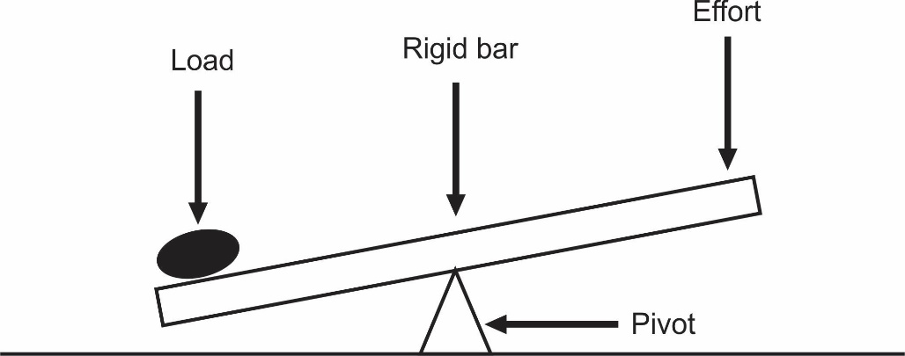

* The lever is a rigid straight bar, which an immovable point has called the pivot or the fulcrum.
* The force which is applied to the lever (machine) is called the effort, and the work or the force it overcomes is known as the load.
* In the lever, a small force applied at one point (effort) is used to overcome a great force or load at another point.

**LOAD AND EFFORT DISTANCE:**

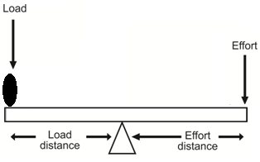

* The effort distance is the distance between the effort and the pivot.
* The load distance is the distance between the load and the pivot.
* Examples of levers are crowbar, wheelbarrow, nut cracker, pincers and hammer.

.

**TYPES OF LEVERS:**

* Levers are classified into three types and these are:

1. First class levers.
2. Second class levers.
3. Third class levers.

**FIRST CLASS LEVERS:**

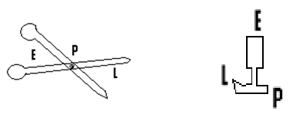

* In this type the pivot is between the load and the effort.
* Examples are the see-saw, scissors and the screw driver.
* The velocity ratio of the first class lever is greater than 1.

**THE SECOND CLASS LEVER:**

- In this type, the load is between the effort and the pivot.

- The velocity ratio of this type of lever is also greater than 1, and examples are the wheelbarrow, the nut cracker and the bottle opener.

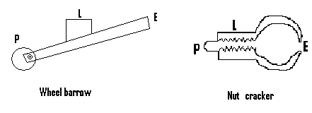

**THE THIRD CLASS LEVER:**

- In this type, the effort is between the load and the pivot. . - Examples are the knife, a pair of tong and a pair of compass.

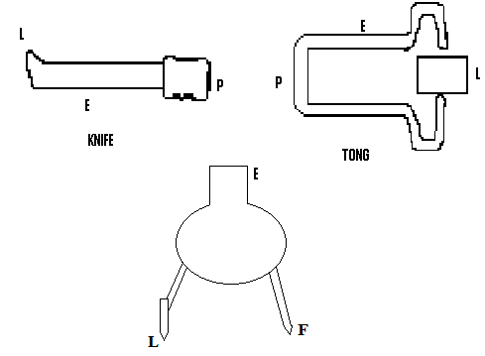

**THE VELOCITY RATIO (V.R):**

* This is the distance moved by the effort to the distance moved by the load.
* V.R **=** Distance moved by effort

Distance moved by load

**OR** V.R**=** Effort distance

Load distance

**(Q1) In using a simple machine, the effort moved through a distance of 150cm, and the load moved through a distance of 30cm.Find the velocity ratio.**

**Soln:**

Effort distance **=** 150cm.

Load distance **=** 30cm.

V.R **=** Effort distance**=**150**=** 5

Load distance 30

**NB:** V.R has no units

**(Q2) An effort applied at the end of a stick travelled through a distance of 6m, while the load moved through a distance of 2m. Calculate the V.R.**

**Soln:**

Distance travelled by effort **=** 6m.

Distance travelled by load **=** 2m.

V.R **=** Dist. travelled by effort

Dist. travelled by load

V.R **=** 6/3 **=** 2.

**(Q3) An effort which was applied at a distance of 10m away from the pivot of a machine, moved through a distance of 20m while the load moved a distance of 5m. Find the V.R.**

**Soln:**

V.R **=** Dist. moved by effort **=** 20 **=** 4.

Dist. moved by load 5

**(Q4) The velocity ratio of a simple machine is 10. If the effort travels through a distance of 20m, calculate the distance travelled by the load.**

**Soln:**

V.R **=** 10.

Dist. travelled by effort **=** 20m.

Dist. travelled by load **=?**

Since V.R **=** Dist. travelled by effort

Dist. travelled by load

**=>**10 **=** 20

Dist. travelled by load

**=>**10 **x** Dist. travelled by load **=** 20,

**=>**Dist. travelled by load **=** 20 **=** 2m.

10

**(Q5) The velocity ratio of a machine is 20. What distance does the effort travels, if the load moves through a distance of 5m.**

**Soln:**

V.R **=**

Dist. travelled by load **=** 5m.

Dist. travelled by effort **=** ?

Since V.R **=** Dist. travelled by effort

Dist. travelled by load

**then** 20 **=** Dist. travelled by effort

5

**=>**20 **x** 5 **=** Dist. travelled by effort.

Dist. travelled by effort **=** 100m.

**MECHANICAL ADVANTAGE (M.A):**

This is given by the ratio of the load to the effort.

**i.e** M.A **=** Load

Effort

**(Q1) An effort of 10N was applied to raise a stone of mass 20N. Calculate the mechanical advantage.**

**Soln:**

Effort **=** 10N.

Load **=** 20N.

M.A **=** load**=** 20 **=** 2.

Effort 10

**(Q2) A force of 20N was applied at one end of a crowbar to over come a force of 80N. Find the mechanical advantage.**

**Soln:**

Effort **=** 20 and Load **=** 80N.

M.A **=** Load **=** 80 **=** 4.

Effort 20

**(Q3) A simple machine has a mechanical advantage of 10. What effort will be needed in order to raise a load of 20N?**

**Soln:**

M.A **=** 10.

Load **=** 20N.

Effort **=**?

Since M.A **=** Load , then 10 **=** 20

Effort Effort

**=>**10 **x** effort **=** 20,

**=>**Effort **=** 20 **=** 2N.

10

**(Q4) The M.A of a lever is 5. If the effort applied is 20N, calculate the load.**

**Soln:**

M.A **=** 5.

Effort **=** 20.

Load **=**?

Since M.A **=** Load,

Effort

**then** 5 **=** Load,

20

=> Load **=** 5 **x** 20 **=** 100N.

**NB:** If the load is given in **kg,** then it must be changed into Newton.

**(Q5) Find the mechanical advantage of a machine, if a force of 20N applied at one end was used to overcome a load of 9kg.**

**Soln:**

M.A **=**?

Effort **=** 20N.

Load **=** 9kg **=** 9 **x** 10 **=** 90N.

M.A **=** Load **=** 90 **=** 4.5.

Effort 20

**EFFICIENCY OF A MACHINE:**

* The efficiency of a machine is the ratio of its work output to its work input.
* Efficiency **=** work output**x** 100

Work input

**or** Efficiency **=** useful energy output **x** 100%

Energy input

- Efficiency is usually expressed as a percentage.The efficiency of a machine can never be 100%, because part of the work input is used to overcome friction between the moving parts of the machine, and becomes wasted as heat. Part of the energy input is also wasted in the raising of the moving parts of the machine. By reducing friction in a machine, its efficiency improves and this saves energy.

**(Q1)** A **machine needs 100J of energy to produce an output of 80J. Calculate the efficiency.**

**Soln:**

Work output **=** 80J.

Work input **=** 100J.

Efficiency **=** work output **x** 100

Work input

**=** 80 **x** 100 **=** 80%.

100

**(Q2) A man operating a machine puts in 60J of energy and gets an output of 50J of energy. Calculate the efficiency.**

**Soln:**

Work output **=** 50J.

Work input **=** 60J.

Efficiency **=** work output **x** 100

work input

**=** 50 **x** 100 **=** 83.3%.

60

**(Q3) The efficiency of a machine is 40%. If the output is 12J, find the work input.**

**Soln:**

Efficiency **=** 40% **=** 0.4.

Output **=** 12J, input**=**?

Efficiency **=** Output

Input

=> 0.4 **=** 12

Input

**=>** 0.4 **x** input **=** 12,

=> Input **=**12 **=** 30J.

0.4

**NB:** If we convert the efficiency from percentages into decimals, then we can use the formula:

Efficiency **=** Output

Input

**(Q4) The efficiency of a machine is 60%. Calculate**

1. **the work done by the machine, if the energy input is 540J.**
2. **the amount of energy needed by the machine to do 90J of work.**

**Soln:**

a).Efficiency **=** 60% **=** 0.6.

Input **=** 540J.

Output **=**?

Since efficiency **=** output, **then** 0.6 **=** output **=>** output **=** 0.6 **x** 540 **=** 324J.

Input 540

b. **NB:** The amount of energy needed by the machine is equal to the work input.

The work done or to be done is the work output.

Efficiency **=** 0.6.

Output **=** 90J, input **=**?

Since efficiency **=** output

input

**then** 0.6 **=** 90 **=>** 0.6 **x** input **=** 90,

input

=> input **=** 90 **=**150J.

0.6

**(Q5) In a machine, 200J of energy was obtained or wasted as heat. If the input energy is 600J, calculate the efficiency of the machine.**

**Soln:**

Input **=** 600J.

Output **=** 600 ­— 200 **=** 400J.

Efficiency **=** work output **x** 100

Work input

**=** 400 **x** 100 **=** 66.7%.

600

**NB:** In a machine the energy lost or wasted **=** input — output,

=> energy lost **+** output **=** input.

**(Q6) In a machine 20J of energy appears as heat. If the machine was used to overcome or do a work of 60J, calculate the efficiency.**

**Soln:**

Energy wasted **=** 20J.

Output energy **=** 60.

Input energy **=** energy lost **+** output energy **=** 20 **+** 60 **=** 80J.

Efficiency **=** Output **x** 100

Input

**=** 60 **x** 100 **=** 75%.

80

**(Q7)**

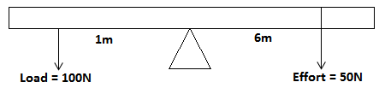

**Calculate the efficiency of the given lever.**

Soln:

Work output = Load x Load distance

= 100 x 1 = 100J.

Work input = effort x effort distance

50 x 6 = 300J.

Efficiency =

= .

**THE INCLINED PLANE:**

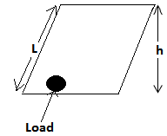

* A heavy object can be raised more easily by pulling it along a sloping surface, than by lifting it vertically.
* Such a sloping surface is called an inclined plane.
* In order to raise the object to a height **h**above the ground, we must move it through a distance **L**along the inclined plane.
* It must be noted that the distance covered by the load is **h** and not **L**in this case
* Work done on the load **=** work done by the effort **i.e** load **x** distance moved by the effort.
* The inclined plane can be used to raise a load from the ground into a truck.
* For an incline plane, V.R **=** distance moved by the effort **=** L

Distance moved by the load h

.

* Also for incline plane, M.A **=** distance moved by effort**=** L

Distance moved by load h

**(Q1) A load was moved 50cm along an inclined plane. If it was raised from the ground by a distance of 10cm, calculate**

1. the velocity ratio.
2. the mechanical advantage.

**Soln:**

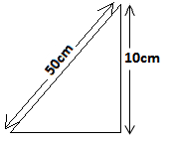

**L = 50cm and h = 10cm.**

**(a)V.R = .**

**(b)M.A = .**

**(Q2) An inclined plane has a mechanical advantage of 20. If the effort moves through a distance of 80m, calculate the distance moved by the load.**

**Soln:**

M.A **=** 20, L**=** 80m and h**=** ?

From M.A **=** L/h **=>**20 **=** 80/h,

=>20h **=** 80,**=>**h **=** 80/20 **=** 4.

Distance moved through by the load **=** 4m.

**(b) An inclined plane is classified as a machine because,**

**(I) it enables work to be done easier or faster.**

**(II) a heavy load can be overcome with a smaller effort by pushing it up the plane, than by lifting it directly upward.**

**(Q3) Calculate the velocity ratio of an inclined plane of length 16m, if it is 4m above the ground.**

Soln:

L = 16m and h = 4m.

V.R =

**(Q4) Find the velocity ratio of an inclined plane of length 16m, if the height of the ground is 4m and the efficiency of the machine is 80%. Find also its mechanical advantage.**

N/B: For an inclined plane,

V.R = .

Soln:

V.R = =

Efficiency = %(N/B: when this formula is used, the efficiency must be in percentage but not in decimal).

Since efficiency = 80%, then 80% = ,

=> 80 = =>80 = => 80 = 25M.A,

=>M.A = .

**.**

**QUESTIONS**

1. **(a) Define work.**

**(b)A man applied a force against a table which did not move. Explain why no work was done.**

**Ans:**  Because the point of application of the force did not move.

**(Q2) A man pulled a bag with a force of 30N, through a distance of 20m. Calculate the work done.**

**Ans:** 600J.

**(Q3) A block of mass 15kg was moved through a distance of 2m. Calculate the work done.**

**Ans:** 300J.

**(Q4) A 5kg was moved through acertain distance. If the work done was 500J, determine this distance.**

**Ans:**  10m.

**(Q5) A body of mass 600g moved through a distance of 15m. Determine the work done.**

**Ans:** 900J.

**(Q6) A boy pulled a 12kg table through a distance of 400cm.Find the work done.**

**Ans:** 480J.

**(Q7) A bag of rice has a weight of 800g. A boy pulled a half bag rice through a distance of 700cm. Calculate the work done.**

**Ans:** 56J.

**(Q8) Find the work done by a force of 40N, which moved through a distance of 50m.**

**Ans:** 2000J.

**(Q9) Calculate the distance moved by a 20N force, if the work done was 800J.**

**Ans:**  40cm.

**(Q10) By moving through a distance of 5000cm, the work done by a force was 2000J. Calculate this force.**

**Ans:** 40N.

**(Q11) By pushing a box of nails through a distance of 20m, the amount of work done was 8000J. Determine**

1. the force.

**Ans:** 400N.

1. the weight.

**Ans:** 40kg.

**(Q12) A boy of weight 40kg climbed a 10m high pole to its top. By taking ‘g’ = 10m/s², calculate**

1. the work done.

**Ans:** 4000J.

1. The potential energy possessed by the body.

**Ans:** 4000J.

**(Q13) Determine the work done if a body of mass 200g is lifted through a distance of 3m. [Take ‘g’ = 10m/s²]**

**Ans:** 6J.

**(Q14) The work done by lifting a box to a height of 3m above the ground is 80J. Taking ‘g’ = 10m/s², find the weight of the box**.

**Ans:** 2.7kg

**(Q15) The work done by a boy by climbing a staircase is 8000J. If he took 20 seconds to dose, determine the power.**

**Ans:** 400J/s **or** 400w.

**(Q16) A block of weight 30kg was pulled through a distance of 8m, within a time interval of 4 minutes. Calculate the power.**

**Ans:** 10w **or** 10J/s²

**(Q17)** A block of mass 4kg moves with a speed of 20ms­¹. Find its kinetic energy

**Ans:** 800J.

**(Q18) A piece of metal has a mass of 5000g. If it moves with a speed of 6m/s, calculate its kinetic energy.**

**Ans:** 90J.

**(Q19) The energy possessed by a moving ball of mass 2kg is 64J. Determine its speed.**

**Ans:** 8m/s.

**(Q20) In a machine, an effort applied moved through a distance of 12m. If the load moved through a distance of 10m, determine the velocity ratio.**

**Ans:** 1.2.

**(Q21) The velocity ratio of a machine is 20. If the effort travels through a distance of 30m, find the distance moved by the load.**

**Ans:** 1.5m.

**(Q22) In a machine an effort of 20N was applied to raise an object of mass 50N. Find the mechanical advantage.**

**Ans:** 2.5.

**(Q23) The mechanical advantage of a machine is 5, and the effort needed to raise a load is 3N. Find the load.**

**Ans:** 15N.

**(Q24) In a machine an input of 140J of energy gave rise to an output of 70J of energy. Determine it efficiency.**

**Ans:** 50%.

**(Q25) The efficiency of a machine is 30%. If the work input is 60J, determine the output work.**

**Ans:** 18J

**(Q26) The output energy of a machine is 50J. If 10J of the input energy was wasted as heat, determine the efficiency of the machine.**

**Ans:** 83%

**(Q27) In a machine 60J of energy was wasted or used to overcome friction. If the machine was used to do a work of 80J, determine its efficiency.**

**Ans:** 57% .

**(Q28) Explain how machines save time and labour.**

**Ans:**

* Machines make work easier and done faster.

Fewer people can do work in a shorter time when using a machine, than when doing the same work manually.

**(Q29) State five uses of machines.**

Ans:

* For cutting objects.
* For grinding vegetables.
* For lifting objects.
* For cracking nuts.
* For mixing ingredients.

(Q30)**Give three reasons why the output energy of a machine is always less than the input energy.**

Ans:

* This is because

1. part of the input energy is used to overcome friction.
2. part of the input energy is usedto overcome inertia.
3. part of the input energy is used to overcome gravitational force.

(Q31)**List three reasons why the efficiency of a machine is always less than 100%.**

Ans:

* Because

1. the input energy of a machine is always greater than the output energy.
2. part of the input energy is used in overcoming friction.
3. part of the input energy is used to overcome gravitational force.

**CHAPTER TEN**

**Heat and temperature:**

**What is heat?**

* Is the type of energy which flows from the hot part to the cool part of a body.

**What is temperature?**

* Is a number which tells us how hot or cold a body is.

**What are the sources of heat?**

* The main sources of heat include some natural and sometimes artificial sources. These include:
* Solar energy.
* Fossil fuel.
* Hydroelectric power.
* Nuclear energy.
* Geothermal energy.
* Friction.

**What is a thermometer?**

* This is a device used to measure temperature.

**Name the types of thermometers?**

1. Liquid in glass thermometer.
2. Thermoelectric thermometer.
3. Platinum resistance thermometer.
4. Gas thermometer.
5. Pyrometer.
6. Digital thermometer.

**What is a Liquid in glass thermometer?**

* These thermometers contain a liquid and there are two types. These are:

1. Mercury thermometer.
2. Alcohol thermometer.

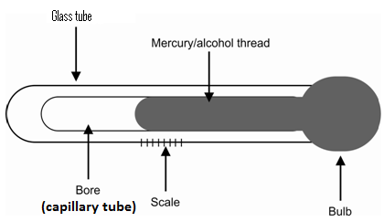

* The liquid in glass thermometer consists of a glass bulb, which contains a liquid, which is capable of rising or falling within a bore due to its expansion and contraction.
* It also has a temperature scale.

**How does a liquid in glass thermometer works?**

* It works on the principle that matter expands when heated and contracts when cooled.
* When the thermometer is brought into contact with a hot body (or when the surrounding is hot), heat moves into the liquid in the thermometer from the hot body or the hot surrounding.
* This causes the liquid to expand and rise in the bore, to indicate a high temperature.
* If the thermometer is brought into contact with a cold body (or brought into a cold environment), heat will move from the liquid within the bulb into the cold body or surrounding.
* The liquid in the bulb becomes cool and contracts, causing the level of mercury or alcohol (alcohol or mercury thread) to fall indicating a low temperature.

**Describe how to determe the lower fixed point (ice point) of a thermometer ?**

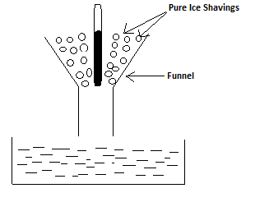

* To determine the lower fixed point of an un-graduated thermometer, the thermometer is pushed into pure ice shavings.
* The alcohol or mercury thread in the bore or stem starts to fall.
* At a particular point, the thread stops falling and remains steady.
* This point is marked as the lower fixed point.

**Describe how to determe the upper fixed point of a thermometer: The hypsometer:**

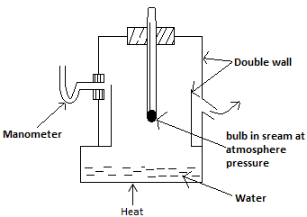

* The thermometer is pushed through a hole in a cork and placed inside the hypsometer.
* Water is boiled at the lower part of the hypsometer, and the steam produced is made to surround the bulb.
* The mercurythread begins to rise and stops rising at a particular level.
* This point is marked as the upper fixed point.
* The double wall reduces the loss of heat and the consequent cooling of the vapour, surrounding the bulb.
* The manometer gives a warning, if the pressure inside the hypsometer becomes different from that of the atmosphere.

**What are thermometric liquids?**

* These are liquids used as threads in thermometers.
* For a liquid to be a good thermometric liquid, it must possess the following features:

1. It must have a wide temperature within which it boils and freezes.
2. It must have a regular volume expansitivity.
3. It must not wet glass.
4. It must be a very good conductor of heat.
5. It must be coloured and opaque.
6. It must not vapourize easily.

**State reasons why water is not used as a thermometric liquid?**

1. The volume expansion of water is not regular.
2. It wets glass.
3. It vapourizes and condenses in tubings.

**Choice of liquid for thermometers:**

**State reasons why mercury is preferred to alcohol (advantages of mercury over alcohol)?**

1. It does not wet glass as alcoholdoes.
2. It does not like alcohol vaporize to occupy the upper part of the bore.
3. Unlike alcohol, it is coloured or opaque and can easily be seen and read when used in thermometers.
4. It is a better conductor of heat than alcohol, and therefore responds more rapidly to temperature changes.

**State advantages of alcohol thermometer over that of mercury?**

1. Alcohol thermometers can be used in extremely cold area, where mercury thermometers cannot be used.
2. Alcohol possesses a coefficient of expansion about six times that of mercury.

**State disadvantages of alcohol thermometer over that of mercury?**

1. It is colourless and as such its reading is difficult.
2. It wets glass.
3. It vapourizes to occupy the upper part of the bore.
4. It is not too good a conductor of heat and responds slowly to temperature changes.

**State disadvantages of mercury thermometer over that of alcohol?**

* Mercury thermometers cannot be used in very cold areas.
* It has a low coefficient of expansion.

**State the temperature Scales?**

There are three types and these are:

1. The Celsius scale.
2. The Fahrenhit scale.
3. The Kelvin scale.

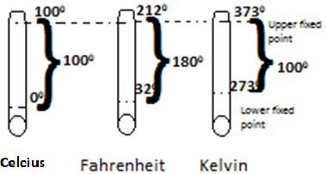

**What is the Celsius scale?**

* A thermometer using the celcius scale has a lower fixed point of 00.
* It has an upper fixed point of 1000 and a fundamental interval of 1000.

**What is the Fahrenheit scale?**

1. A thermometer using the Fahrenheit scale has a lower fixed point of 320 and an upper fixed point of 2120.
2. It has a fundamental interval of 1800.

**What is the Kelvin scale?**

* A thermometer using the Kelvin scale has a lower fixed point of 2730, and an upper fixed point of 373.
* It has a fundamental interval of 1000.

**Expansion of solids and liquids:**

* Matteexpands when heated and contracts when it cools.

.

**What are the effects of expansion?**

* Bridges built of metal expand when heated by the sun.
* Large forces are produced due to this expansion, which can cause damage to the bridge.
* In order to prevent this damage, room is made for its expansion by leaving gaps between the metal parts, and making both or one end of the bridge to rest on rollers.
* Metal roofing sheets expand on hot days.
* To make room for this expansion, roofing sheets have their edges placed on top of each other.
* It must also be noted that the cracking noise heard from the roofs during hot weather, is due to the occurrence of expansion in the roofing sheets.
* Railway lines have expansion gaps or overlapping tapered joints, so as to make room for expansion.

**State some applications or useful applications of expansion?**

1. It can be used to remove tight metal lids of bottles.
2. Used to fit the metal wheel on axles of trains.
3. Expansion is needed in order for thermostats to function.
4. Used to rivet steel plates together in ship building and in the construction of boilers.

**State some uses of bimetallic strip?**

1. It is used in the thermostat.
2. Thermostats are devices used to control the temperature of items such as electric iron, room heaters, refrigerators, electric cookers and water heaters.
3. The thermostats within these items are set to the required temperatures.
4. The bimetallic strip within these thermostats forms part of the electric circuit.
5. As the temperature of the equipment such as the electric iron increases to the required temperature, the strip becomes heated and bends in a direction so as to open the circuit.
6. When the equipment cools, the bimetallic strip also cools and straightens up at a particular temperature for the circuit to be closed.
7. Current then restarts to flow through the circuit and the item continues to work.
8. This process keeps on repeating itself.

**.**

**Describe the experiment to demonstrate that solids expand when heated and contract when cooled?**

1. A hole is created in the middle of a piece of flat metal, in such a way that an egg cannot pass through it.
2. Place an egg in this hole and heat the metal.
3. After a time, the hole expands and the egg falls through the ground.
4. Allows the metal to cool and this time, it will be noted that the egg cannot pass through the hole.
5. Metals therefore expand when heated and contract when cooled.

**Describe the experiment to demonstrate the expansion and the contraction of liquid when heated and cooled:**

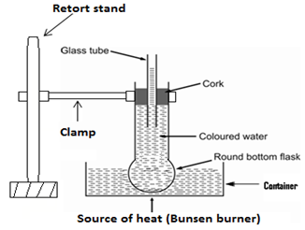

1. A round bottom flask is filled with coloured water.
2. A glass tube is fitted with cork and fitted in the flask. so that one end of the glass tube enters the coloured water.
3. The other end must project out at the top of the flask.
4. Mark the initial level of the liquid within the glass tube.
5. Heat the round bottom flask in a water bath.
6. The level of coloured water in the glass tube first falls, due to the expansion of the glass.
7. The level of water then rises in the tube.
8. The round bottom flask is then removed from the water bath.
9. The coloured water cools, contracts and the level of water in the tube falls.
10. Liquids therefore expand when heated and contract when cooled.

**What is transmission or transfer of heat?**

* This is the process by which heat travels from one part of a medium to another.
* The transmission of heat can occur in three ways and these are by:

1. Conduction.
2. Convection.
3. Radiation.

**What is conduction?**

Is the type of heat transfer, in which the heat is passed from one section of a body or a material to another?

* In conduction, the particles of the medium or the material do not move, but only transfer the heat they gain to their neighbors.
* These neighbors in turn pass the heat unto other neighbors and by so doing, the heat is transmitted across the material.
* For conduction to occur, there must be a material medium such as a metal.
* Conduction can be demonstrated by holding one end of a spoon, whilst the other end is placed in a fire.
* After a time, the portion we are holding becomes hot due to conduction.

**State two characteristics of conduction?**

* It occurs in solids.
* The molecules of the medium do not move.

**What are good conductors?**

* These are those materials through which heat can easily pass, and examples are metals such as aluminum, copper and zinc.
* Items such as cooking utensils are made of good conductors, so that heat can easily pass through them to cook the food when they are being used for cooking.

**conductors of heat (Insulators):**

* Are those materials through which heat cannot easily pass? Examples are rubber, wood and plastics.
* The handles of cooking utensils are made of bad conductors, so as to remain cold while the utensil is hot, to enable us touch them.

**Comparism of thermal conductivity:**

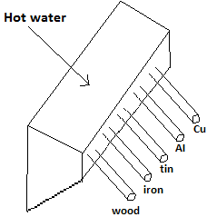

* Rods of different materials but of the same length and diameter are used.
* They are passed through corks inserted in holes in the side of a metal trough.
* The rods are first dipped into molten paraffin wax and then withdrawn, so as to allow a coating of wax to solidify on them.
* Boiling water is then poured into the trough, so that the ends of the rods are all heated to the same temperature.
* After a few minutes interval, it will be noticed that the wax has melted to different extents along the rods.
* This indicates that there are differences in the thermal conduction of different metals.

**To demonstrate that metal a good conductor of heat:**

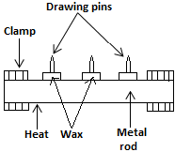

* The items needed are metal rod, wax, drawing pins and stop-clocks.
* The pins are attached at intervals along the rod using molten wax, and one end of the rod is heated.
* After a time interval, the wax will melt and the drawing pins will fall, but they will fall in a specific order.
* The pin which is closest to the source of heat will drop first, followed by the next until the last pin drops.
* This shows that heat has been moved or conducted along the metal.

**CONVECTION:**

- This is the type of heat transfer which occurs in liquids and gases, in which there is movement of particles of the medium and which also requires a material medium.

- An example of convection occurs when a liquid such as water is heated.

- If water is heated in a container, the particles at the bottom become heated first.

-These heated particles or molecules move upwards, and their previous positions are occupied by particles from the top.

-These particles in turn get heated and move upwards, while other particles take their positions.

- By so doing, the heat is carried throughout the liquid.

- Convection does not occur in solids but only in liquids and gases.

* In short, convection is the process by which heat energy is transferred in a fluid by the actual movement of the heated liquid or gas molecules, or particles.

.

**To demonstrate convection or convection current in water:**

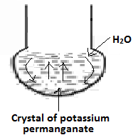

* Convection (convection current) in water can be shown by filling a large flask with water.
* A single crystal of potassium permanganate is dropped to the bottom of the flask, through a length of glass tubing.
* On heating the bottom of the flask with a small flame, an upward current of coloured water will ascend from where the heat is applied.
* This colour reaches the top and spreads out.
* When it moves upwards after a time, the initial position of the coloured water is taken over by the cooler liquid, which also goes through the same process.

**Application of convection current:**

* Convection currents are seen in everyday life in these areas:
* The ventilation of rooms.
* Land and sea breeze.
* The cooling system of an engine (radiator).

**Land and sea breeze:**

* Breeze generally blows from the sea to the land on hot days, while at night, the breeze is rather blown from the land to the sea.
* During the day, the sun heats the land more than the sea.
* The heated air over the land expands and rises, while cooler air blow from the sea to take its place i.e. sea breeze.
* At night, the temperature of the land falls faster than that of the sea.
* The hotter air over the sea expands and rises while cool air from the land blows to occupy its position i.e. land breeze.

**RADIATION:**

- This is the type of heat transfer in which no material medium is required.

- It is the means by which heat energy travels from the sun across empty space to us.

- If we sit near a coal pot or near an electric bulb, the heat from them gets to us through radiation.

- It must be noted that a dark (black body) absorbs more heat (radiation energy) than a white or polished (shining) body.

- A white body (shining body) on the other hand reflects heat energy and for this reason, if a black ball and white ball are both exposed to the same amount of heat, the black body or ball will absorb more heat than the white one.

- The temperature of the black ball will therefore be higher than that of the white ball.

- People who live in hot areas wear white clothes or clothes in light colours, to reflect heat away and feel comfortable.

- If these people are to wear black clothing or clothes in dark colours, more heat will be absorbed, making them feel uncomfortable.

- Buildings are normally white washed or painted white outside, in order to reflect heat away during hot weather.

- This enables those inside to feel comfortable.

- Also the roofs of certain buildings and factories are made of aluminum which is shiny in appearance, in order to reflect heat away during hot weather.

- Vessels containing flammable gases or liquids are silver or aluminum coated in order to reflect heat away.

**Dark body –A better radiator:**

- A dark body or black body radiates more heat or loses heat faster than a white or shining body.

- Therefore if two metal balls, one painted white and the other one painted black are heated to the same temperature, and allowed to cool, the temperature of the dark one will fall faster than that of the white one since it is a better radiator of heat.

- For this reason, vessels in which hot water or food etc are kept, are painted white or in light colours, to reduce the amount of heat lost through radiation.

- Car radiators are painted in dark colours to enhance the lost of heat through radiation.

- Cooling fins of freezers are dark in colour to enhance the lost of heat through radiation.

.

**The vacuum flask (the thermo flask):**

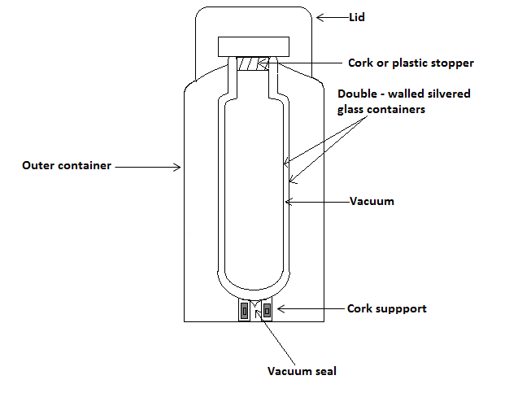

* The thermo flask consists of a double-walled glass vessel having a vacuum between its walls.
* Both walls are silvered on the vacuum side, and no heat can enter or leave the inner flask by convection or conduction across the vacuum.
* A certain amount of heat can be lost through radiation but this will be reduced to the minimum due to the silvering.
* A little heat will be transmitted by conduction through the thin glass wall at the neck, and through the stopper or cork which is a bad conductor of heat.
* The wide opening in the inner most flask is for the substance, eg. hot or cold liquid.
* The flask is normally placed on insulators (cork) and is finally enclosed in a metal container.

|  |  |  |
| --- | --- | --- |
| **Mode of heat lost** | **Part of the flask** | **How to prevent heat lost** |
| Conduction | Cork  vacuum | * The cork support and the cork lid prevent heat lost by conduction. * The vacuum prevents heat lost by convection within the double wall. |
| Convection | Vacuum | The vacuum between the double wall prevents the loss of hear by convection. |
| Radiation | The silver coated surface wall | The smooth shining surface of the flask reflects back the heat that would have been lost through radiation. |

**Evaporation:**

It is the process in which a liquid changes into vapour and this occurs at all temperature.

* Evaporation increases with:

1. Increase in temperature.
2. Decrease in atmospheric pressure.
3. Increase in the exposed surface area.

* The boiling point of a substance changes, as the atmospheric pressure changes, for it decreases as the pressure decreases, and increases as the pressure increases.
* Some liquids evaporate very quickly due to their low boiling points.
* Such substances are called volatile liquids or substances.

**The difference between evaporation and boiling:**

1. Evaporation occurs at all temperatures, but boiling occurs at a definite temperature i.e. the boiling point.
2. In evaporation, the liquid turns into vapour only at the surface, but in boiling, the liquid turns into vapour throughout the whole liquid.

.

**Lagging:**

Is the process in which materials of low thermal conductivity (i.e. poor conductors) are used to cover hot bodies, in order to prevent the loss of heat.

**Cooling by evaporation:**

* Before a liquid evaporates, it absorbs heat from it`s surrounding, since heat is needed for the evaporation process.
* If a liquid such as water is placed on the hand, the hand feels cold after a time period.
* This is due to the fact that the liquid on the hand, evaporates after a time period.
* The energy which it needs to do so is taken from the hand, causing it to feel cold.
* Liquids such as methylated spirit or ether, evaporate rapidly since they are volatile.
* Therefore when they are placed on the other hand, it feels very cold within a short time.
* When the human body becomes hot, sweat is produced.
* As the sweat evaporates, heat is taken from the body causing it to become cold.
* Perspiration or sweating is therefore a method used by the body to cool itself.

**Latent heat of vapourization:**

* When a liquid is heated, its temperature increases until it gets to its boiling point.
* At the boiling point, the temperature remains constant, even though heat is still being supplied to the liquid.
* The heat provided in this case will cause the liquid to change into the vapour state, without causing any increase in temperature.
* This amount of heat needed by a liquid at its boiling point, in order to change into the vapour state without causing any increase in it temperature, is called the latent heat of vapourization
* .

**Latent heat of fusion:**

* This is the amount of heat which is needed to convert a solid into liquid, at its melting point without any increase in temperature.
* For example, consider ice whose temperature is -60C.
* If the ice is heated, its temperature increases until it gets to 00C, which is the melting point of ice.
* At 00C, the temperature remains constant while the ice changes into water, eventhough heat is still being provided to the ice.
* The freezing point of a substance is the same as its melting point.
* For example, the freezing point of liquid water is 0oC, while the melting point of solid water or ice is 00C.
* It must also be noted that a liquid expands when it freezes, and contracts when it cools.
* For this reason, if a glass bottle is completely filled with water, and the water is allowed to freeze by placing it in a freezer, the expansion of the water as a result of the freezing, can lead to the possible damage of the bottle.

**Questions:**

(Q1)(a) Differentiate between heat and temperature.

Ans:

* Heat is a type of energy which flows from a region of high temperature, to that of a low temperature,(i.e from the hot to the cold part of a body).
* But temperature is a number which tells us how cold or hot a body is.

(b) With the aid of a diagram, explain how a liquid in glass thermometer works.

(c) Of what importance is the constriction to the clinical thermometer?

Ans:

It enables the user of the thermometer, to read the temperature at leisure or at will.

(d)Explain what the following mean.

(i) The lower fixed point and the upper fixed point.

Ans:

* These are two points which must first be determined and marked on a newly made thermometer.
* While the lower fixed point is the temperature of pure melting ice, the upper fixed point is the temperature of steam.

(e) Briefly explain how the upper fixed point is determined.

Ans:

* The thermometer is pushed through a hole in a cork, and placed inside a hypsometer.
* Water placed at its lower portion is heated to generate steam, to surround the bulb of the thermometer.
* The mercury or alcohol thread rises and stopsdoing so at a particular point.
* This point is marked as the upper fixed point.

(Q2)(a) List two properties of a thermometric liquid.

Ans:

* It must be a good conductor of heat.
* It must not wet glass.

(b)Give two reasons why water is not used as a thermometric liquid.

Ans:

* It wets glass.
* Its volume of expansion is not regular.

(c) Give one disadvantage each of the mercury as well as the alcohol thermometer.

Ans:

* Alcohol thermometers are difficult to read since alcohol is clolourless.
* Mercury thermometers cannot be used in extremely cold areas.

1. Explain why gaps are left between the metal parts of metallic bridges, and one or both ends of the bridge are made to rest on rollers.

Ans:

* To make room for the expansion of the bridge on hot days, in order to avoid its damage.

1. What is a thermostat and name two items which contains thermostats.

(Q3)(a) With the aid of a diagram, briefly describe an experiment to show that liquid expands when heated and contracts when it cools.

(b) Differentiate between conduction and convection.

Ans:

* Conduction is the type of heat transfer which occurs in solids such as metals.
* In this case the particles of the medium do not move, but only transfer the heat they gain unto their neighbours.
* Convection is the type of heat transfer which occurs in liquids and gases, and which actually involves the movement of the liquid or the gas molecules or particles.

1. Water was put into two similar containers, one painted white and the other painted black. If both containers were placed in the sun for a time period, explain why the water placed inside the black container becomes hotter than that of the other one.

Ans:

* A black body absorbs heat better than a white one.
* For this reason, the black container was able to absorb more heat than the other one, causing the water placed in it to become hotter than the other one.

(Q4)(a) You are given a piece of metal. Explain how you will prove that it can conduct heat.

Ans:

* By means of candle wax, pins are positioned along the metal.
* When the metal is heated from one end, the wax will be melted and the pins will fall in succession beginning with the one closest to the heat source.
* This proves that heat has been conducted along the metal.

(b)

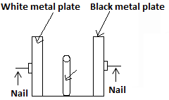

* Above shows an experiment performed by a group of students.
* By means of wax, nails were attached to two similar metal plates, one painted white and the other black.
* A heat provider in the form of a candle was then positioned in the middle of the distance between the two similar metal plates, one painted white and the other black.
* A heat provider in the form of a candle was then positioned in the middle of the distance between the two plants in order for each to receive the same amount of heat.

Sate which of the nails will fall first and explain your answer.

Ans: - The one attached to the black plate will fall first, since this plate will absorb more heat than the other one.

* This will cause the quick melting of the wax used to attached the nail to the plate.

(c) Two identical balls, one brown and the other shiny were heated to the same temperature, and then allowed to cool. Determine which of them cools faster and give reason for that.

Ans: - Since a dark body radiates heat faster than a shiny one, the brown ball cools faster than the shiny one.

(d) Why is it that heat from the sun can only get to us by radiation, and not by conduction or convection?

Ans: -For heat from the sun to get to us, it must travel through empty space or vacuum.

* But conduction and convection do not take place in vacuum, since they require a material medium for the heat to travel through.
* But as for radiation, it requires no material medium for the heat transfer.

(Q5)(a) A woman took her sick child whose body was very hot to a clinic. The nurse first poured cold water on the child`s body and allowed it to dry. Explain why the nurse did so.

Ans: - Just to cool the child`s body, through the evaporation of the water.

* As the water evaporates, it takes heat from the child`s body, causing it to cool.

(b)Explain why when a liquid such as alcohol is placed on the hand, the hand feels cold within a very short time.

- Because alcohol is a volatile liquid with a very low boiling point and evaporates quickly.

(c) Explain the importance of the vacuum found in the thermo flask.

Ans: - To prevent heat loss by convection within the double wall.

* To prevent also the loss of heat by convection.

(d) Explain the difference between the latent heat of vaporization and the latent heat of fusion.

Ans: - The latent heat of vaporization is the amount of heat, needed to change a liquid at it boiling point into the vapour state, without any increase in temperature.

* The latent heat of fusion is the amount of heat needed, to change a solid at its melting point into the liquids state, without any increase in temperature.

(Q6)(a) List three differences between heat and temperature.

Ans:

1. Heat is a form of energy but temperature is not a form of energy..
2. Heat is measured in joules while temperature is measured in degrees celcius or degrees kelvin.
3. Temperature refers to the degree of hotness or coldness of a body, while heat refers to energy which cause a body`s temperature to rise.

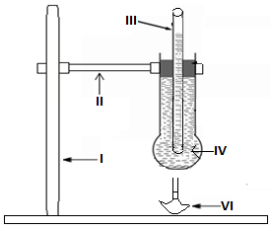

The set-up was used by a student to investigate thermal expansion in liquids.

Use it to answer the following questions;

1. Identify the parts labeled III, IV and VI.

Ans:

* III is a glass tube, IV is coloured water and VI is a source of heat such as burnsen burner.

1. What happens to the level of water in the glass tube, when the bottom of the flask is first heat, and explain why this is so.
2. Also explain what happens to the same level of water in the glass tube, after the water had been heated for a long time and give a reason for your answer.

Ans:

(b) – The water level in the glass tube will fall.

- This is due to the fact that the round bottom flask expands first, before the expansion of the coloured water.

(c) In this case, the level of water in the glass tube rises.

- This is due to the expansion of the coloured water, after the round bottom flask stops expanding.

(Q7)

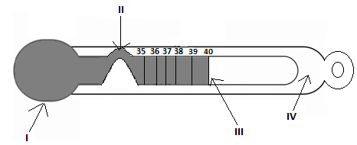

The diagram shows a measuring instrument. Name the instrument.

Ans:

* It is a clinical thermometer.

(b)Name the parts labeled I, II, III and IV.

Ans:

* I is the bulb, II is the constriction, III is the alcohol or the mercury thread which indicates the temperature of the sick person, and IV is the glass tube.

(c)State the use of this instrument.

Ans:

* It is used to measure the temperature of sick people.

(d)State the function of the part labeled II.

Ans:

* The mercury thread breaks at this point, when the thermometer has been used to take the temperature of a person, and is no longer in contact with the person`s body.The temperature can then be read at leisure.

(e)State two properties of the liquid that makes it ideal for use in the instrument.

Ans:

* It expands when it is heated.
* It is coloured and does not wet glass.

(8)State four disadvantages of thermal expansion.

Ans:

These are:

1. The bursting of inflated hot lorry tyres.
2. The appearance of cracks in buildings and bridges made of concrete.
3. The sagging in electric and telephone cables.
4. The bulging of railway lines on hot days, if they are laid without gaps between them.

**Chapter Eleven**

**Gases:**

**Oxygen:**

* This is the part of the air which supports life and burning.
* For without it, burning of items cannot occur and no living thing can live.
* By volume, it forms about 21% of the air.

**Laboratory Preparation:**

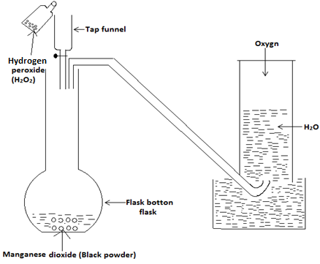

* This is by means of the breaking down or the decomposition of hydrogen peroxide (H2O2).
* In order to ensure the rapid or fast decomposition of the H2O2, manganese dioxide (manganese IV) oxide is used as a catalyst.
* A catalyst is a substance which enables a chemical reaction to occur very fast, but does not take part in the reaction.
* The manganese dioxide is placed into the flat bottom flask, and by means of the thistle funnel, the hydrogen peroxide is added drop by drop to the hydrogen peroxide.
* As the drops of the hydrogen peroxide comes into contact with the manganese (IV) oxide, oxygen gas is evolved or released, which is collected over water

**Method 2:**

**Laboratory preparation of oxygen from potassium trioxochlorate (VI) or potassium chlorate:**

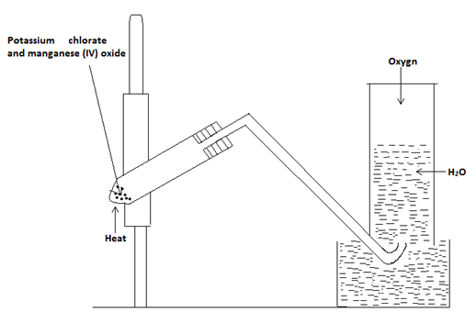

* Take 20g of potassium chlorate and 5g of manganese (IV) oxide.
* Grind them together and heat the mixture.
* The oxygen gas which is evolved is collected over water.

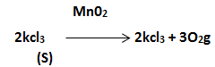

Test for oxygen:

* If a gas has no smell and it rekindles a splint of wood, then it is oxygen.

Properties of oxygen:

* It is a colourless and an odourless gas.
* It is slightly soluble in water.
* Its density is almost the same as that of air.
* It is a neutral gas.

Uses:

1. Liquid oxygen is used to burn fuel in rockets.
2. It is used in the oxyacetylene flame, which is used for welding and cutting of metals.
3. It is used as an aid in breathing, when the natural supply of oxygen is not sufficient e.g. high altitude flying or climbing (mountaineers).

**Carbon Dioxide (CO2):**

* This is also referred to as carbon (IV) oxide.

**Preparation in the laboratory;**

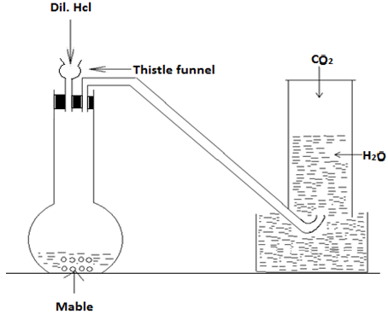

* Pieces of mable (CaC03) are placed into a flat bottom flask, and dilute hydrochloric acid is added to the marble by means of a thistle funnel.
* Effervescence occurs and a colourless gas which is carbon dioxide, is collected over water.
* The equation for the reaction is CaC03 + Hcl ->CaCl2 + H2O + CO2.

Uses:

1. It is used to manufacture effervescing drinks called mineral water, since a solution of carbon dioxide in water has a pleasant taste.
2. It is used in fire extinguishers since it does not support burning.

.

Test for C02:

* In order to determine whether a gas is carbon dioxide, the gas is first passed into lime water.
* If the lime water becomes milky white in colour, then the gas is carbon dioxide.

Hydrogen;

* It is an important gas found within the atmosphere.

Laboratory preparatory:

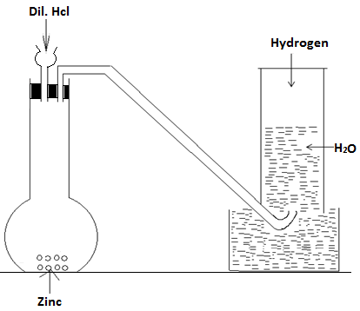

* Pieces of zinc are placed into a flat bottom flask and dilute hydrochloric acid is added to the zinc, by means of the thistle funnel.
* There is effervescence and the hydrogen gas evolved, is collected over water.

Properties:

* It is a colourless gas which has no smell.
* It is a neutral gas and it is less dense than air.
* It burns in air to form water.

Uses:

* It is used in filling balloons.
* It is used in the “hardening” of oils to make margarine.
* It is used in the manufacture of ammonia.
* It is used in the manufacture of hydrochloric acid.
* It is used in the oxyhydrogen flame, which is used for cutting and welding

Test for hydrogen:

* Place a glowing wooden splint into a sample of the gas within a test tube.
* If a pop sound is heard, then the gas is hydrogen.
* If hydrogen is mixed with air and the resulting mixture is heated, it explodes
* Nitrogen: It forms about four fifth of the atmosphere..

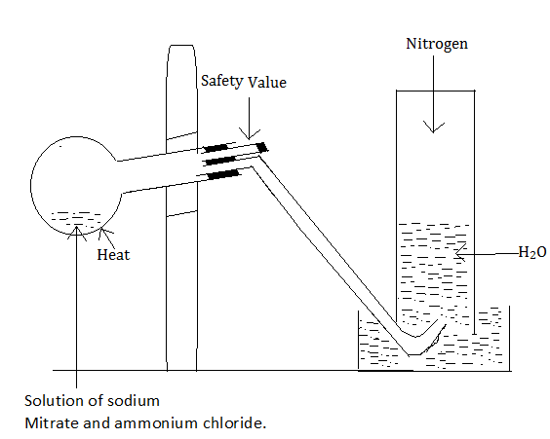

Preparation:

* A solution of ammonium nitrate readily decomposes, when heated slightly to give nitrogen.
* 14g of sodium nitrate and 11g of ammonium chloride are weighed and combined.
* The mixture is placed in a round bottom flask and 350cm3 of water is added.
* Heat is then applied gently and effervescence occurs.
* The nitrogen gas evolved is collected over water

Test for nitrogen:

* If the gas is nitrogen, then it must

1. extinguish or put off a lighted splint placed in it.
2. it must have no smell.
3. it must not turn lime water milky white.

Properties of nitrogen: - It is a colourless and odourless gas. -It is slightly less dense than air and only slightly soluble in water. - Under ordinary conditions, the gas is inert i.e not reactive.

Chlorine:

* This is a very reactive gas and for this reason, it is found in nature in the compound or in the combined state, which implies that it is found combined with other elements.
* It normally occurs in common salt or sodium chloride.

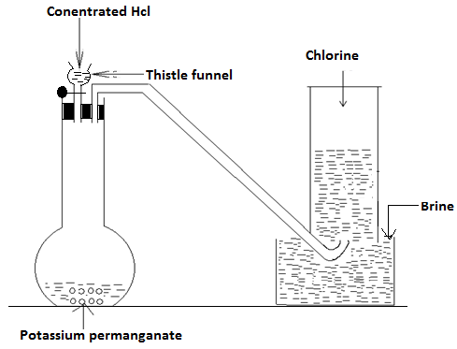

Preparation:

* Solid potassium permanganate is placed in a flat bottom flask, and concentrated hydrochloric acid is dropped on it, from a tap funnel.
* As each drop of acid reaches the permanganate, the corresponding quantity of chlorine is evolved and this is collected over brine or salt water.

Properties:

* It is greenish-yellowish gas.
* It has an unpleasant or irritating smell.
* It bleaches damp litmus paper i.e. it turns damp blue litmus paper or damp red litmus paper colourless.
* **Uses:**
* It is used in making polyvinyl chloride or P.V.C tubes, which are used in making pipes.
* It is used in the manufacture of bleaches, weed killers and pesticides such as D.D.T.
* It is used in water sterilization for domestic and industrial use.
* It is combined with bromine to form chlorofluorocarbons (C.F.C), which is used in refrigerators, air conditions and in many mosquito sprays.

**Test for chlorine:** If the gas is greenish-yellowish in colour and can bleach damp litmus paper, then it is chlorine.

**Ammonia:**

**Preparation in the laboratory:**

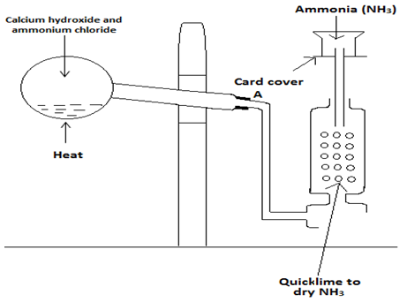

* 25g of slaked lime and 16g of ammonium chloride are grinded together and placed in a round bottom flask.
* The neck of the flask should be made to slope towards the point A, as shown in the diagram.
* The mixture is heated and the ammonia gas evolved is dried by the quickline.
* Since ammonia is soluble in water, it is collected by means of the upward delivery of air as shown in the diagram.

Test for ammonia:

* If the gas has the characteristic choking smell and turn red litmus paper blue, then it is ammonia.

Properties:

* It is a colourless gas.
* It is less dense than air.
* It is highly soluble in water.

Uses:

* It is used in laundry work.
* It is used in the manufacturing of nitric acid.
* It is used in the manufacture of ammonium sulphate which is a fertilizer.

**Chapter Twelve**

**Light Energy:**

**Introduction:**

* This is the form of energy which enables us to see.
* We see objects because light energy from these objects travel into our eyes.
* Light travels in a straight line.
* Objects such as the sun, which can produce and give off their own light are called luminous objects.
* But those which cannot produce and give off their own light, are referred to as non-luminous objects.
* A material is said to be transparent if light can pass through it, and a material through which light cannot pass through is said to be opaque.
* A material through which light can pass through, even though we cannot see through it is said to be translucent.

**Sources of light:**

* The sources of light can be divided into two main groups and these are:

1. Natural sources.
2. Artificial sources.

**Natural sources of light:**

- The sun is the main as well as the most important source of natural light.- Another source of natural light are the stars. - There are also certain living things such as the firefly, which also serve as a source of natural light.

**Artificial sources of light:**

- These are those sources which enable us to see and do things we cannot do, when natural light is not available - Common examples of artificial light include the electric bulb, the candle and fluorescent light tube.

**.**

**Properties of light:**

- It travels in straight line. -It has a speed of 3 x 108m/s. -- It undergoes reflection, refraction and diffraction.

**Rectilinear propagation of light:**

* A ray is the direction of path along which light travels and it is represented by any of the following:

.

* A beam refers to a group of rays, and can be represented by a number of rays such as

or

* Light always travels in a straight line, and the ability of light to travel in a straight line is known as the rectilinear propagation.
* Because light travels in straight line, images of objects have sharp or well defined edges..

**Types of beams:**

* There are three types of beams and these are:

1. **Parallel beam:**

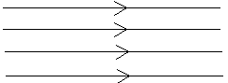

* This is the type of beam in which the rays move parallel to each other and never meet.

**.**

1. **Diverging beam:**

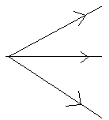

This is the type in which the rays spread out or diverge from a point.

1. **Converging beam:**

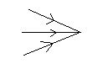

In this type, the rays of the beam seem to meet or converge at a point.

.

**Experiment to show that light travels in straight line:**

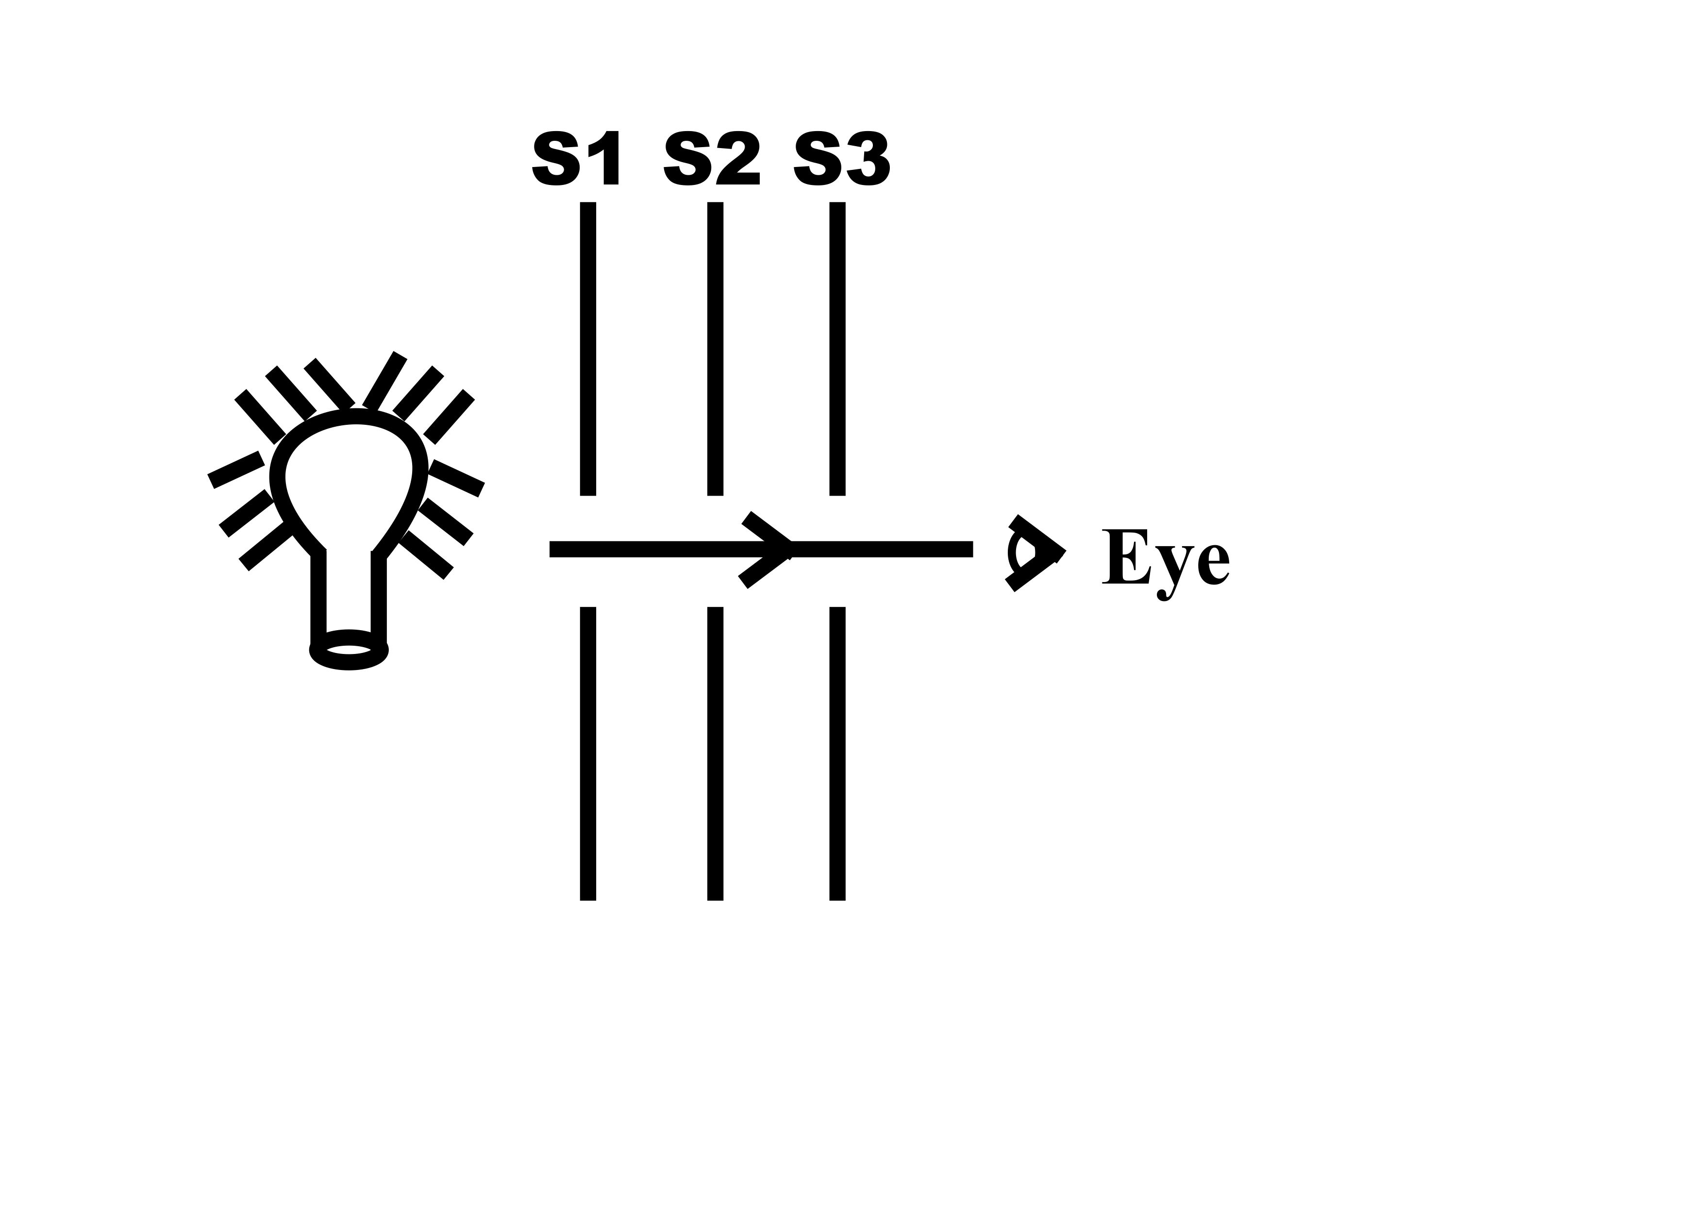

* Three cardboard screens S1, S2 and S3 with small holes in each are arranged in such a way that their holes fall or are in a straight line.
* A source of light is then placed in front of the first cardboard, and it will be noticed that the light can be seen by the eye, at the other side after passing these holes.
* If any one of these screens is moved slightly out of line, the eye can no longer see the light.
* This shows that the light can only be seen when the holes are in a straight line.
* This shows that light travels in straight line.

**The pinhole camera:**

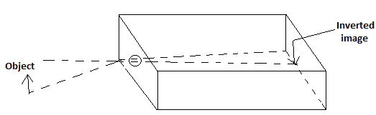

* This type of camera can be constructed by taking a cardboard box, and removing one of its sides.
* The removed side is then replaced with a transparent material.
* A small hole which is about the size of a pin head is made in the middle of the side of the box, which is opposite to the transparent material.
* When an object is placed before he hole, it inverted image will be seen on the screen or the transparent material.
* In order to see the image clearly, all the external light must be removed by covering the box with a black cloth.

**The nature of the image formed:**

* The image is inverted or turned upside down.
* This is due to the fact that light rays from the upper and the lower parts of the object cross each other in the pin hole, before forming the image on the screen.

**The size of the image formed:**

* The size of the image formed, depends on the location of the object from the pin hole.
* The further the pin hole from the object, the smaller becomes the size of the image formed.
* Also the closer the object to the pin hole, the larger becomes the size of the image formed.

**The diameter of the pin (the focus):**

* If the diameter of the pin of the camera is small in size, then only a few rays of light will be able to pass through it, and the image formed will not be bright even though it will be shaper.
* An increase in the size or the diameter of the pin hole, will allow more light rays in.
* This will give rise to a brighter image which is also blurr.

**Shadows:**

* A shadow is formed when an opaque object is placed in the path of light.
* The two types of shadows which can be formed are the umbra and the penumbra.
* The umbra which is made up of a dark region, receives no light at all from the source of light but the penumbra receives a certain amount of light.
* It is formed when the source of light in which the opaque object is placed, is smaller than the object.
* When the source of light is moved further away, the umbra becomes smaller.
* The penumbra is formed when the shadow formed is made up of a dark region, and a semi dark region.
* In this case, when the source of light is moved further away from the object, the penumbra diminishes and the umbra enlarges.
* When the source of light is moved away from the object, the image formed becomes larger and when it is brought near the object, the image becomes smaller.
* Penumbra or partial shadow is brighter and larger while umbra or full shadow is smaller and darker.

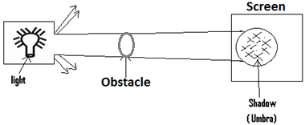

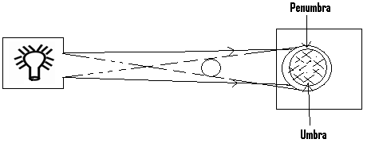

**The eclipse of the moon or lunar eclipse:**

* The earth and the moon are non luminous objects, and as such, they reflect or use the light given by the sun.
* The lunar eclipse occurs when the earth comes between the sun and the moon, putting the moon into total or partial darkness.
* If the moon is put into total darkness, then total lunar eclipse has occurred.
* On the other hand if the moon is not put into total darkness, then partial lunar eclipse has occurred.

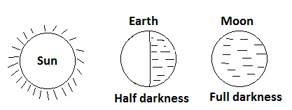

**Eclipse of the sun or solar eclipse:**

* This occurs when the moon comes between the sun and the earth, placing certain portions of the earth into partial darkness.

**Reflection of light:**

* This occurs when light rays directed towards a surface, bounces off the surface.

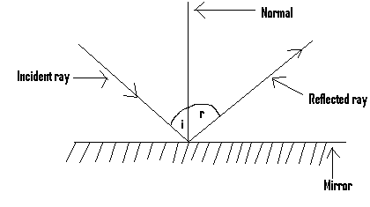

i = the angle of incident.

r = the angle of reflection.

* When a ray of light strikes a reflecting surface such as a mirror, it makes a certain angle with an imaginary line called the normal, which is perpendicular to the surface of the mirror.
* The incident ray is the one, which is directed towards the surface of the reflecting surface.
* The reflected ray is the one thrown off from the reflecting surface.
* The normal is he perpendicular drawn from the surface of the reflecting surface.
* The angle of incidence is the angle between the incidence ray and the normal.
* The angle of reflection is the angle between the reflected ray and the normal.

**The laws of reflection:**

* The first law of reflection states that the incident ray, the reflected ray and the the normal at the point of incidence all lie in the same plane.
* The second law of reflection states that, the angle of incidence is equal to the angle of reflection.
* This second law is what is normally referred to as the law of reflection.

**Types of reflection:**

There are two types and these are:

(1) Regular or specular reflection.

(2) Irregular or diffuse reflection.

**Regular reflection:**

-This occurs when the incident rays all strike the surface of the reflecting surface with the same angle of incidence, and in the same direction and are all reflected in the same direction with an angle of reflection, which is the same as the angle of incident.

-This type of reflection occurs when the reflecting surface is smooth.

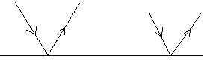

**Diffuse reflection:**This occurs when the incident rays have different angles of incidence, which gives rise to a number of reflected rays with different angles of reflection.

- It occurs on reflecting surfaces which are not smooth.

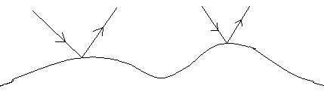

**The nature of the image formed in a plane mirror:**

1. The size of the object is the same as that of the image formed.
2. The image formed is laterally inverted.
3. The object distance is equal to the image distance.
4. The image formed in a plane mirror is not real but virtual, i.e. it cannot be produced on a screen.

**Uses of plane mirror:**

- Used in hairdressing saloons.

- Used I shops to detect thieves.

-Used in bathrooms and the barbering shops.

- Used in the mirror periscope.

**The mirror periscope:**

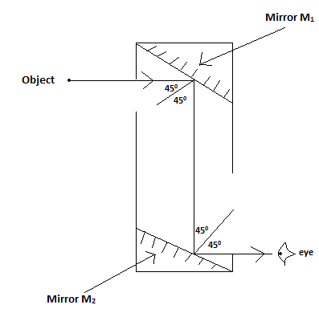

* It consists of two mirrors M`1 and M2 fixed and facing each other at an angle of 450 to the line joining them.
* The upper mirror M1 produces the image of the object, and this image serves as the object of the lower mirror M2 to produce the final image which is seen by the eye.

**Uses/ importance:**

* To look for objects which are behind obstacles.
* Used in submarines for the detection of oncoming warships.
* Used in military tanks to observe objects above the armoured plate.
* Used during football matches by spectators to view matches over the heads of the spectators.

**Formation of images:**

* Images are formed when two or more rays meet or appear to meet.
* There are two types and these are the real image and the virtual image.

**Real image:**

* This is formed by the actual intersection of two or more rays from an object.
* This type of image can be formed on a screen, and an example of such an image is the type produced in a camera.

**.**

**Virtual image:**

* This is formed by the apparent intersection of two or more rays from an object.
* This type of image cannot be formed on a screen.
* Virtual rays and virtual images are represented by dotted lines or rays.
* An example of such an image is the type formed in the plane mirror.

**Refraction of light:**

* This refers to the bending of light rays when they move from one medium into a different medium.
* Water, air and glass are examples of medium and when light is moving in any of these mediums, it travels in straight line.
* But when light which is moving in a particular medium enters a different one, there will be a bend or a change in its direction of movement.
* For this reason, when light moves from air into water, it will be refracted.
* Refraction of light is due to the change in the speed of light, when it moves from one medium into another.
* For example when light moving in air enters into water, its speed will be decreased as it travels in the water.
* As a result of refraction, a pencil placed at an angle in a glass of water appears bend sharply at the surface.
* 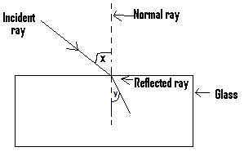

x = the angle of incidence.

y = the angle of refraction.

-The angle of incidence is the angle between the incident ray and the normal at the point of incidence.

-The angle of refraction is the angle between the normal and the refracted ray at the point of incidence.

**Diffraction of light:**

-This refers to the spreading of light rays when it passes through a small opening or hole.

**Rainbow:**

-This is an arch of colours which appears in the sky when the sun shines after a shower of rain.

-Sunlight is a combination of seven colours.

-As the rays of light from the sunlight passes into the drops of rain, each drop acts as a prism.

-The refraction and reflection of these rays leads to the formation of the rainbow.

**Mirage:**

-Sometimes when moving on a paved road we see a pool of water ahead of us, only to get there and notice it does not really exist.

-This is an example of mirage which is caused by hot air near the earth`s surface.

-This warm air refracts or bends light from the sky towards our eyes, causing the image of the sky to appear on the ground as a pool of water.

**Dispersion of light:**

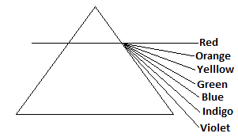

-White light is a mixture of all the visible colours which are seven in number.

-When white light passes through a glass object such as a prism, each of the colours which constitutes or forms part of the white light, will be refracted at a different angle or through a slightly different angle.

-This is so because the refractive index of glass is different for each of the colours.

-The beam of white light is therefore dispersed into a coloured patch of light called the spectrum.

-The seven colours which can be seen in such a spectrum are red, orange, yellow, green, blue, indigo and violet.

-Rainbow is formed when sunlight is refracted through rain drops.

**Experiment to demonstrate dispersion of light:**

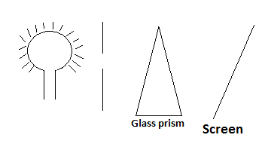

* A slit is cut in a piece of cardboard and placed in front of a light bulb.
* A glass prism is placed in the path of the light ray.
* A screen is placed at the opposite side of the glass prism.
* **Observation:**
* A spectrum of seven colours will be observed on the screen.
* The red colour is the least deviated or refracted, while the violet colour is the most deviated.

**The appearance of coloured objects in white light:**

* When white light falls on a body or an object and all the colours within the light is absorbed by the body or the object, then that object or body will appear black.
* If all the colours within the white light are reflected by the body or the object, then it will appear white.
* On the other hand, some of the colours within the white light may be absorbed while others are reflected.
* And in this case, the object or body appears coloured.
* A body which reflects the green colour and absorbs all the other colours, appears green.
* Also a body which reflects the red colour and absorbs all the other colours, appears red.

**Colour combination (primary and secondary colours):**

* Pure white light can be made by mixing the seven colours of the spectrum.
* The eye will also receive the sensation of white light, when the three primary colours which are red, green and blue are mixed together.
* The primary colours are those which cannot be made by mixing light of other colours.
* Secondary colours are those which can be made by combining two different primary colours.
* For instance, a combination of red and green gives you yellow.
* Almost any colour can be made by mixing the three primary colours in the correct proportions.
* While a combination of red and blue gives us magenta, cyan is obtained by a combination of green and blue.

**Complementary colours:**

* These are any two colours which when added together gives us white light.
* Examples of pairs of these colours area:

1. Red + Cyan = White
2. Green + Magenta = White
3. Blue + yellow = White

* An object will absorb certain colours and reflects others.
* For example a red object appears red when viewed in white light, because it absorbs all colours and reflects only the red colour.
* Also a blue object appears blue in white light, because it reflects the blue colour and absorbs the other ones.

**SOUND:**

* This is the type of wave which can be detected by the ear.
* It can be produced by different instruments and some of these instruments are:

1. **Wind instruments:**

* These are those instruments which produce sound by blowing air into them.
* Examples are the flute, the trumpet, the saxophone and the whistle.

1. **Stringed instruments:**

* These have strings which when pulled and set free lead to the production of sound.
* Examples are the guitar and the violin.

1. **Percussion instruments:**

* These consist of specially made stretched materials or animal skins, which when stricken with the hand or a stick leads to the production of sound.
* Examples are the drums and the congas.
* While music or musical note or tone refers to sound which has a regular frequency,and which is pleasant to the ear, noise refers to sound which has no regular frequency, and which is unpleasant to the ear.
* The pitch or the pitch of a note refers to its position in the musical scale.

**PROPERTIES OR CHARACTERISTICS OF SOUND WAVE:**

These properties or characteristics are:

1. Reflection.
2. Refraction.
3. Diffraction.

**REFLECTION OF SOUND WAVES:**

* This occurs when sound wave moving in a particular direction comes into contact with an obstacle, and its direction of movement is reversed or changed in the opposite direction.
* A reflected sound wave is called an echo, and for this reason an echo is produced when sound wave is reflected from the surface of an obstacle.

**THE IMPORTANCE OR USES OF ECHO:**

* It is used to determine the depth of water bodies such as the sea and rivers.
* It is used to determine the velocity or the speed of sound in air.
* Fishermen use sonar or echo sounder which depends on echoes to determine and locate shoals of fish.
* It is used to determine the distance between two objects.
* **DIFFRACTION OF SOUND:**
* This refers to the spreading of sound waves, as it passes around an obstacle or through a gap.

**REFRACTION OF SOUND:**

* This refers to the change in the direction of movement of sound wave, when it moves from one medium into another.

**Questions:**

(Q1)(a) Why is the sun said to be a luminous body?

Ans: - Because it is able to produce and give off its own light.

(b) Differentiate between a transparent and a translucent material.

Ans:

* For a transparent material, light can pass through it and we can see through it.
* For a translucent material, even though we cannot see through it, light can pass through it.

(c) Give two properties of light.

Ans: It travels in straight line and can undergo reflection.

(d)What is the difference between a ray and a beam.

Ans: - A ray is the path along which light travels but a beam is formed by a group or collection of rays.

(Q2)(a)Briefly describe an experiment which shows that light travels in a straight line.

(b)With the aid of a diagram, describe and explain how the pin hole camera works.

(c)What is a lunar eclipse?

Ans:- It occurs when the earth comes between the sun and moon, putting the moon into total or partial darkness.

(Q3)(a) Explain what the following mean:

1. The incident ray.
2. The angle of incidence.
3. The normal.

(b)State the law of reflection.

Ans: It states that the angle of incident is equal to the angle of reflection.

(c)What do you understand by diffuse reflection.

Ans: - Is a type of reflection in which the angle of incidence of the incident ray, is different from the angle of reflection of the reflected ray.

(d)List two characteristics of the image formed in a plane mirror.

Ans:

* The size of the object and that of the image are the same.
* The image formed is literally inverted.

(e)What is the difference between a diverging beam and a converging beam.

Ans:

* For a diverging beam, the rays spread out from a point.
* For the converging beam, the rays appears or seem to meet or converge at a point.

(Q4)(a) With the aid of a diagram, describe how the mirror periscope functions or works.

(b) Differentiate between real image and virtual image.

Ans: - Real image is formed by the actual intersection of two or more rays coming from an object.

* Virtual image is formed by the apparent intersection of two or more rays coming from an object.

(c)When light was made to pass through a glass material, it was dispersed into the spectrum which is a coloured patch of light. Explain why this is so.

Ans: Because light or white light is made up of seven colours, and each of these colours is refracted at a different angle by the glass.

(d) Differentiate between primary colours and complementary colours.

Ans: - Primary colours are those which cannot be made by mixing other colours.But complementary colours are any two colours, which when mixed give us the white colour.

(Q5)(a) What is the difference between a wind instrument and a stringed instrument .

Ans:

* Sound from a wind instrument is produced by blowing air into it, but that from a stringed instrument is had by pulling the strings and setting them free.

(b)What is an echo and how it is produced.

Ans: An echo is a reflected sound wave, and it is produced when the direction of movement of sound wave is reversed when it hits an obstacle.

(c) Give two uses or importance of echo.

Ans:

* Used to determine the depth of the sea.
* Used to determine the speed of light.

**Chapter Thirteen**

**Liquid surface in contact with solids, capillarity, acids and bases:**

* When a liquid is put into a container, two types of force of attraction act and these are the cohesion and the adhesion forces.

1. **Cohesion (cohesive) force:** This is the type of attractive forces which acts between the molecules of the same type, or a particular type of substance. For example these types of forces act between the molecules of water, so as to bind or bring them together.
2. **Adhesion (adhesive) force:**This is the type of attractive force which acts between the molecules of two different substances. For example if water is put into a drinking glass, adhesive forces will act between the water molecules and the glass molecules

.

**The wetting of glass:**

* When a substance such as water is put on the surface of glass, the water will spread on the surface of the glass.
* Because water is able to spread on the surface of the glass, the water is said to wet glass.
* The water is capable of wetting the glass because the adhesion forces acting between the water and the glass molecules, is greater than the cohesion forces acting between the water molecules.

**Liquids which do not wet glass:**

* When a liquid such as mercury is placed on the surface of a glass, the mercury will not spread on the surface of the glass.
* Because the mercury is unable to spread on the surface of the glass, we say that mercury does not wet glass.
* The mercury was unable to wet the glass because the cohesion forces acting between the mercury molecules, is greater than adhesive forces acting between the mercury molecules and the glass molecules.

**Surface tension:**

* This is the ability of the surface of water to act as an elastic material.
* Items such as a small sewing needle, blade or a mosquito larva can float on the surface of water, since the water’s surface acts as an elastic material, or as a result of surface tension.
* If a few drops of alcohol, soap solution, detergent or camphor is added to the water, the surface tension will be reduced and for this reason, any floating item on the surface of the water such as the needle, blade or insect will sink.

**The effects of surface tension:**

1. It enables items such as needle and blade to float on the surface of water.
2. It enables the mosquito larva to stay on the surface of water.

**Uses of surface tension:**

* Umbrellas, raincoats and tents made of canvas do not leak, because the surface tension of water prevents water from passing through the hole.

**Meniscus:**

* When water is put into a glass tube and its surface is looked at the top, the water appears to be curved upward.
* This curved surface of the water is called meniscus.

**Capillarity:**

* This is the ability of a liquid to rise or fall within a capillary tube.
* A capillary tube is a narrow tube with a narrow bore or hole in its middle.

**Capillary rise or elevation:**

* This refers to the rise of a liquid in a capillary tube, when the tube is placed in the liquid.
* Capillary rise can only occur in a liquid which wets glass, such as water.

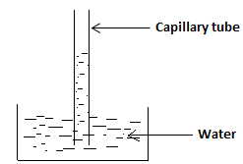

**Factors which affects or determines capillary rise:**

* There are two of such factors and these are:

1. **The width or size of the bore:**

* It is a well-known fact that the thinner or smaller the size of the bore of the capillary tube, the higher will be the rise of the liquid within the capillary tube.

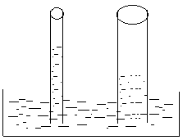

1. **The density of the liquid:**

* The less dense or the lower the density of a liquid, the greater the level to which it will rise within a capillary tube.
* For example, if a liquid is less dense than water, then it will rise to a higher level than water within a capillary tube.

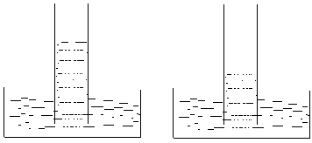

Liquid Water

**Application of capillary rise:**

* Application can be seen in the following cases:

1. The rise of oil such as kerosene in a wick.
2. The absorbing of ink into items such as a blotting paper.

**Capillary depression:**

* If a capillary tube is placed in a liquid which does not wet glass such as mercury within a container, the level of mercury within the tube will fall below the surface of mercury within the container.
* The fall of a liquid such as mercury within a capillary tube, is referred to as capillary depression.
* The greater or the bigger the bore of the capillary tube, the greater will be the fall.

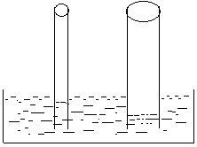

**Acids:**

* An acid is a substance which can dissolve in water to produce H+ ions.

**Types of acids:**

* There are two types and these are:

(i) Mineral acid.

(ii) Organic acid.

**Mineral acids:**

* These acids are prepared from minerals which are dug from the earth.
* Examples are sulpheric acid (H2SO4), and nitric acid (HN03).

**Organic acids:**

* These acids are found inplants and animals.
* Examples are citric acid which is found in lemon and grape fruit, as well as acetic acid which is found in vinegar.

**N/B:** - The sour taste of certain fruits which are unripe or not ripe, is due to the presence of acid.

**Properties of acids:**

1. They have sour taste.
2. Strong acids are corrosive.
3. They turn blue litmus paper red.
4. Their P.H. value is less than 7.

|  |  |
| --- | --- |
| **Acid** | **Source** |
| Lactic acid  Acetic(ethanoic) acid  Citric acid  Tartaric acid  Amino acid  Fatty acid | Milk  Vinegar  Lime/ lemon  Grape  Protein  Fat/ oil |

**Uses of acids:**

* Used in making baking powder e.g. tartaric acid.
* Used in making soap, e.g. fatty acid.
* Used in making artificial fertilizers.
* Used in making drugs, dye and plastic.

**Bases/ alkalis:**

* A base (alkali) is a substance, which when dissolved in water produces OH-- ions.
* Examples are sodium hydroxide and potassium hydroxide i.e. NaoH and KoH.N/B: The properties of bases are almost opposite to those of acids.

**Uses of alkali:**

* Used in making soap e.g. NaoH.
* Used in making glass and paper.

**Neutralization:**

* Is the process in which an acid reacts with a base or alkali, to form a salt and water only.

**Example:**

Hcl + NaoH -> Nacl + H2O.

**N/B: -** Nacl is a salt.

* After neutralization, the solution we get after bringing the acid and the base together is neutral i.e. neither acidic nor basic.

**Saponification:**

-This is the process in which fatty acid is boiled with sodium hydroxide (caustic soda) or potassium hydroxide (caustic sold) solution, to form soap and glycerol.

- i.e. fatty aid + NaoH -> soap + glycerol.

- Saponification is the process used in making soap.

**Salt:**

-A salt is formed when the hydrogen in an acid is replaced by a metal.

N/B: - When blue litmus paper is placed into an acid, its colour changes to red.

But when blue litmus paper is placed into a base, its colour does not change.

In other words, bases have no effect on the colour of blue litmus paper, while acids have an effect on the colour of blue litmus paper.

(Q1) Explain what happens if blue litmus paper, is placed in each of the following:

1. Hcl (b)Orange juice

(c) NaoH.

**Soln:**

1. If blue litmus paper is put into Hcl, its colour will change to red, because Hcl is an acid.
2. Orange juice is acidic, and will therefore change the colour of blue litmus paper to red.
3. Because NaoH is a base, the colour of the blue litmus paper will not change, since a base has no effect on the colour of blue litmus paper.

N/B:

* If red litmus paper is placed into a base or an alkali, its colour changes to blue.
* But if red litmus paper is placed into an acid, its colour does not change.
* In other words acids have no effect on the colour of red litmus paper.

(Q2) Explain what happens if red litmus paper is placed in each of the following:

1. KoH (b)NaoH

(c) H2So4 (d)Hcl

Soln:

1. Since KoH is a base, the colour of the red litmus paper will change to blue.
2. NaoH is also a base, and as such the colour of the red litmus paper will become blue.
3. H2SO4 is an acid and as such it will have no effect on the colour of the red litmus paper, which will remain unchanged or the same.
4. Since Hcl is also an acid, the colour of the red litmus paper will remain the same or unchanged.

**The P.H Scale:**

* This is used to measure the acidity or the alkalinity of a solution.
* In other words, the P.H. scale is used to determine how acidic or alkaline (basic) a solution is.
* If the P.H. value of a solution is less than 7, then that solution is an acid or acidic.
* If the P.H value is greater than 7, then the solution is alkaline or basic.
* If the P.H of a solution is 7, then that solution is neutral i.e. neither acidic nor basic.
* Since the P.H of water is 7, then water is neutral.
* A neutral solution or substance cannot change the colour of a blue litmus paper or a red litmus paper.

(Q3)Explain what happens if (I) Blue litmus paper is put into water.

(II)Red litmus paper is put into water.

Soln:

* In each case, the red or the blue litmus paper will not change in colour, since water is a neutral substance.

**N/B:** Rain water is acidic as well as battery water.Therefore if blue litmus paper is put into either rain water or battery water, its colour becomes red.But if red litmus paper is placed into either rain water or battery water, the red litmus paper remains unchanged in colour.

**(Q4)** You are given the following solutions and their corresponding P.H values:

Solution P.H. Value

A …………………………………. 8

B …………………………………. 2

C …………………………………. 7

D …………………………………. 13

E …………………………………. 7

F …………………………………. 5

G …………………………………. 4

Determine which of these solutions are

(a)basic (b)acidic

(c)neutral

Give reasons for your answer.

Soln:

1. The basic or alkaline solutions are A and D, because their P.H value is greater than 7.
2. The acidic solutions are B, F and G, since their P.H value is less than 7.
3. The neutral solutions are C and E, since their P.H value is 7.

**Indicators:**

-These are organic compounds or dyes, which change colour when the P.H of a solution in which they are placed changes.

- For example when an indicator is placed into let say a colourless solution of P.H 3, the colour of the solution may change to let say blue.

- If the P.H of the solution changes from 3 to let say 6, the colour of the solution may change from blue let say green.

- And when the P.H changes from 6 to let say 10, the indicator may cause the colour of the solution to change from green to let say yellow.

- Some of the acid/ base indicators used, when we are dealing with acids and bases are;

1. Litmus.
2. Methyl orange.
3. Phenolphthalein.

- The colours exhibited by theses indicators in either an acidic or a basic medium, are determined mainly by the P.H of the medium and are indicated in the next table:

|  |  |  |  |
| --- | --- | --- | --- |
| **Indicator** | **Colour in acidic medium or solution** | **Colour in basic medium or solution** | **Colour in neutral medium or solution** |
| Red litmus | Red | Blue | Purple |
| Blue litmus | Red | Blue | Purple |
| Methyl orange | Pink red | Yellow | Orange |
| Phenolphthalein | Colourless | Pink | Colourless |

**Preparation of sodium chloride from the neutralization reaction:**

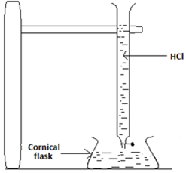

* By means of the burette, a quantity of dilute HCL is added to a quantity of NaoH solution in a conical flask.
* The resultant mixture had is heated in an evaporating dish to get crystals of NaCl.
* The equation of the reaction is NaoH + HCl -> NaCl + H2O.

**Some common acids and their uses:**

1. **Sulpheric acid (H2SO4):**

* Used in making fertilizers.
* Used in making paints, pigments and dyes.
* Used as an electrolyte in car batteries.
* Used in the manufacture of detergents and in the refining of petroleum.
* Used in the manufacture of explosives and pesticides.

1. **Hydrochloric acid:**

* Used in the manufacture of glue and metal chlorides.
* Used as a catalyst in the preparation f glucose from starch.

**A common base and its uses:**

**Sodium hydroxide (NaoH):**

* Used in the manufacture of synthetic fiber such as nylon.
* Used in the manufacture of paper pulp and organic chemicals.
* Used in the neutralization of acids to form salts.
* Used in the manufacture of soaps.

**Questions:**

(Q1)(a) Differentiate between cohesion force and adhesion force.

Ans:

* Cohesion force acts between the molecules of the same type, or one particular substance.
* But adhesion force acts between two different types of molecules, or molecules of two different substances.

(b) Explain what is meant by the wetting of glass by water.

Soln:

* It means that when water is placed on the surface of glass, it spreads on the surface of the glass.

(c)Explain why mercury does not wet glass.

Ans:

* Because the adhesive forces acting between the molecules of mercury and the glass, is weaker than cohesion forces acting between the mercury molecules.

(Q2)(a) Explain why a blade can be made to float on the surface of water.

Ans: Because as a result of surface tension, the surface of the water acts as an elastic material.

(b) What will happen to this floating blade, if soap solution is added to the water?

Ans:

* The blade will sink since the surface tension will be reduced.

\

1. Explain why certain liquids rise within capillary tubes, while the levels of others fall within a capillary tube.

Ans:

* If the liquid can wet glass, then its level will rise within the capillary tube, but if it does not wet glass, then its level will fall within a capillary tube.

(Q3)(a) Differentiate between an acid and a base.

Ans:

* An acid dissolves in water to produce H+ ions (hydrogen ions), but a base dissolves in water to produce OH- ions (hydroxyl ions).

(b) What are organic acids?

Ans:

* They are those acids which are found in plants and animals.

1. List three properties of acids.
2. List two properties of bases.
3. Give two importance or uses of acids.

Ans: - Used in making soap.

* Used in making fertilizer.

(Q4)(a) Differentiate between neutralization and saponification.

Ans:

* In neutralization, an acid reacts with a base to form water and salt only.
* But in saponification, fatty acid is boiled with sodium hydroxide or potassium hydroxide solution to form soap and glycerol.

(b)A boy prepared two different types of drinks, using grape and lemon. Explain why each of these drinks could change the colour of litmus paper from blue to red.

Ans: - Because the grape and the lemon contain acid, which is capable of causing such a colour change.

(c) When red litmus paper was placed in Hcl and orange juice, there was no colour change but when blue litmus paper was used, its colour changed into red. Explain why this is so.

Ans:

* Because Hcl and orange juice are acidic, and acids do not change the colour of red litmus paper, but rather changes that of blue into red.

(Q5)You are given three different types of liquids each of which has been placed in a test tube. One is said to be an acid, another, a base with the last being neutral. By means of blue and red litmus papers only, explain how you will differentiate between them.

Soln:

* Red litmus papers will be placed in each of the given liquids, and the one which will cause its colour to change to blue is the base.
* Blue litmus papers will then be placed in each of them and the one which will cause a colour change to red is the acid.
* The liquid which does not change the colour of the blue and the red litmus paper, is the neutral one.

(Q6)(i) You are given the following: unripe lemon, bicarbonate of soda, wasp sting, vinegar, aspirin, wood ash, bee sting, salt-petre and the liquid found in car battery. Determine which of them are acidic and which are alkaline.

Soln:

The acids are:

1. The unripe lemon, which contains citric acid.
2. Aspirine, which contains salicyclic acid.
3. The liquid found n car battery.
4. Vinegar, which contains acetic acid.
5. Bee sting is also acidic.

The bases or the alkaline are:

1. Salt-petre.
2. Wood ash.
3. Bicarbonate of soda.
4. Wasp sting is alkaline.

(ii) Give two uses of each of the following:

(a)Sulphuric acid.

Ans: As an electrolye in car battery.

(b) In the manufacture of fertilizers.

(iii)Sodium hydroxide

1. In the manufacture of soap.
2. In the manufacture of synthetic fiber.

(iii)(a) A student placed a few drops of red litmus solution or indicator in a test solution. If the colour of the test solution changed into blue, what conclusion can you draw?

Ans:

The test solution is basic or its P.H is greater than 7.

(iii)By placing a few drop of methyl orange indicator into a solution, the colour of the solution became orange. Draw a conclusion for this test.

Ans:

The solution was neutral or its P.H is 7.

(iv)A few drops of phenolphthalein is placed into a solution, and its colour became colourless. Determine the possible P.H values for this solution.

Ans:

Since the colour became colourless, then the solution is either acidic or neutral.

If it is acidic, then its P.H value will be less than 7, and if it is neutral, then its P.H value will be exactly 7.

**Chapter Fourteen**

**Magnetism and electricity**

Magnetism:

* This refers to the forces which operate or act between magnets.

Uses of magnets:

* Used in generators.
* Used in radio, T.V and the compass.
* Telephones, loud speakers, electric fans, electric motors contain magnets.

The poles of a magnet:

* These refer to the two ends of a magnet, where the magnetic forces of attraction are strongest.
* If a bar magnet is placed into a container of nails, it will be seen that the ends or the poles will pick up more nails than any other portion or part.
* This is due to the fact that the magnetism is strongest at these points.

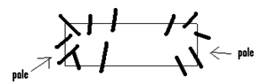

* There are two types of poles and these are:

1. The North pole.
2. The South pole.



**How to determine the north and the south poles of a magnet:**

If we have a bar magnet and we want to determine which of its two ends is the North pole, and which is the south pole, we go through the following steps;

1. Hang the bar magnet from a ceiling using a thread.
2. Allow it to swing freely until it settles.
3. One end will always point in the north direction, while the other end points to the south direction.
4. The end or the pole which points towards the north is the north pole, while the one which points towards the south is the south pole.

Magnetic substances or materials:

* These are materials which can be attracted by a magnet.
* Examples are iron and steel.

Non Magnetic Substances or Materials:

* These are materials which cannot be attracted by a magnet.
* Examples are wood, plastic and paper.

Attraction and repulsion in magnets:

* If two magnets are taken and the end of one is brought towards the end of the other, the magnets may attract or repel each other.

Attraction;

* It is known that attraction will occur if unlike or different poles (i.e. north and south poles) are brought towards each other.
* Example:

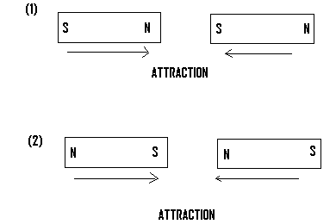

* Repulsion will occur always if two like or similar poles are bought toward each other.

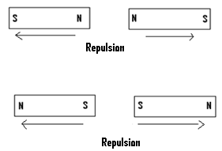

Magnetization (Making a magnet):

* Magnetization refers to the process of changing a magnetic material into a magnet.
* There are three methods of making a magnet and these are:

1. The stroking method.
2. Using electric current.
3. By induction.

The Stroking Method:

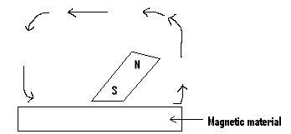

* In this method, the material to be changed into a magnet which must be a magnetic material is placed on a table.
* One end or the pole of a magnet (i.e. either the north or south the pole), is drawn or used to stroke the surface of the material several times, until it becomes a magnet.

..

The Electrical Method:

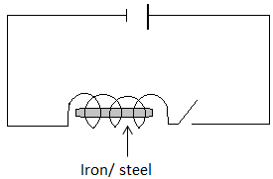

* In this method of making a magnet, a solenoid is used.
* A solenoid is made by winding insulated copper wire round several times, so that current can pass through it.
* The magnetic material to be changed into the magnet, such as iron or steel is placed into the solenoid.
* Electric current is then made to flow through the coil of the copper wire (solenoid) for a short time.
* The steel or iron will be changed into a magnet.

Magnetic induction:

* In this method, the material to be changed into a magnet is attached to a magnet for a long period of time, until it becomes a magnet.

Demagnetization:

* This is the process of making a magnet lose its magnetism.
* A magnet can be demagnetized, or made to lose its magnetism in the following ways:

1. By heating it.
2. By electrical method or by the use of the solenoid.
3. By hammering it.

**Demagnetization through the electrical method:**

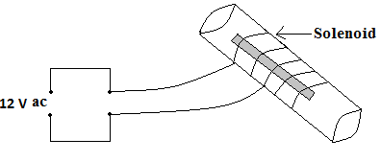

* This is the best method of demagnetizing a magnet.
* The magnet is placed inside a solenoid through which a 12V a.c (i.e. a 12V alternating current) is flowing.
* While the current is still flowing, the magnet is withdrawn in an east-west direction.

Electromagnetism:

* This refers to the temporal magnetism a metal acquires, due to the passage of electric current through it.
* If current is made to flow through a coil of wire, the wire will act as a magnet.
* This type of magnetism is known electromagnetism.
* The coil of wire will no longer act as a magnet, when the current stops flowing through it.
* The wire which acts as a magnet due to the flow or passage of current is called an electromagnet.
* The main difference between a magnet (permanent magnet0, and an electromagnet is that, in a permanent magnet, the magnetism is always available or present but in an electromagnet, the magnetism only becomes present when current is flowing through the metal (coil of wire).

**Magnetic Field:**

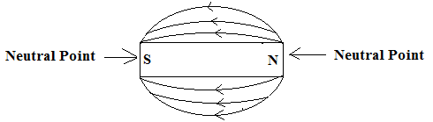

* The area around a magnet, where the magnetic power is felt is called the magnetic field.
* This field is represented by the field lines.
* These field lines always start from the north pole and ends on the south pole.
* An object within the field will experience the effect of the field, but one outside it will not experience its effects.

Ferromagnetic substances:

* These are magnetic substances which are strongly attracted by a magnet.
* Non ferromagnetic substances are those which are weakly attracted by a magnet.

Neutral Point:

* These are areas, where the magnetic field is not experienced.

.

**ELECTRICITY:**

* This is the form of energy which is due to the flow of electrons.
* When electrical energy flows through a substance, it is called electric current.
* For electric current to flow, there must be an electricity generating source such as a generator, a battery or a cell.
* For example if a wire is connected to the ends or terminals of a battery, and connected to a bulb, the bulb will light.
* The battery is the source of the electricity.
* In Ghana most of our electricity supply comes from the Akosombo power station.
* Over there, moving water operates generators to produce electricity.

**Electrical Symbols:**

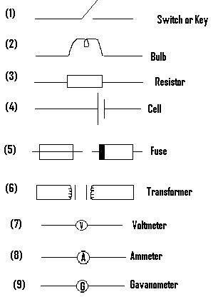

### **Uses of Some Electrical Equipments:**

1. **Switch:**

It is used to turn on or off electrical current.

1. **Voltmeter:**

It is used to measure voltage.

1. **Ammeter:**

It is used to measure current.

1. **Fuse:** It makes the flow of electric current to stop within a circuit, when a fault or a dangerous situation occurs.
2. **Cell (Battery):**

* It supplies the needed current or voltage within a circuit.
* A cell or a battery contains chemical energy, which is changed or converted into electrical energy.

**ELECTRICAL CONDUCTORS:**

-These are materials, through which electric current can flow.

- Examples are copper, zinc, silver and aluminum.

### **ELECTRICAL INSULATORS:**

- These are those materials through which electricity cannot flow or pass.

- Examples are wood, rubber and plastic.

- Electrical wires are covered with insulators such as rubber or plastic, so as to prevent a person from getting a shock, if he or she mistakenly touches them.

### **ELECTRICAL CIRCUIT:**

-This is the path along which electric current flows.

- A simple circuit can be made by connecting a wire to the two ends or terminals of a dry cell.

- A switch or a key may sometimes be included.

- If this key is closed, then current will flow through the circuit, and when the key is opened, current stops flowing through the circuit, and if in this case a bulb forms part of the circuit, it will go off.

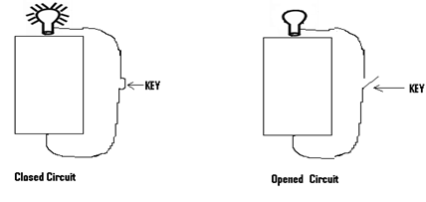

**Battery:**

* A battery is formed when two or more cells are connected together.

Examples:

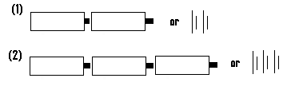

**The terminals of a cell:**The terminals of a dry cell refer to its two ends. A dry cell has two terminals, and these are the positive and the negative terminals.

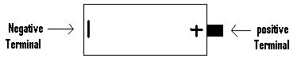

**Arrangement of cells in series or using the series connection:**

* If cells are connected in such a way that, the positive terminal of one cell is connected to the negative terminal of the next cell, then the cells are said to have been connected in series.
* Example 1:
* 
* Two cells connected in series.
* Example 2:
* 
* Three cells connected in series.

**Q1.** Draw an open circuit showing a dry cell, which is arranged in series with a bulb.

***Soln:***

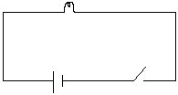

**Q2.** Draw an open circuit to indicate two cells connected in series, and arranged in series with a bulb

***Soln:***

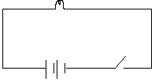

**Q3.**Indicate in the form of a diagram how to connect three cells in series, and arrange them in series with a bulb in an open circuit.

***Soln:***

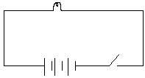

**N/B:**

* Whether mention is made of it or not, an open circuit will always include a switch.
* With reference to a closed circuit diagram, if mention is made of a switch we must include it. But if not, then we leave it out.

(Q4)Indicate in the form of an open circuit diagram, how to connect two cells in series and arrange them in series with

(a)a switch and a bulb.

(b)a switch, a bulb and a voltmeter.

(c)a switch, a bulb and an ammeter.

Soln:

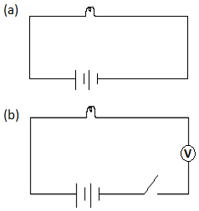

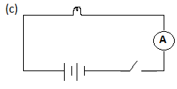

(Q5) Draw a closed circuit diagram to show two cells connected in series, and arranged in series with

(a) a bulb

(b) a bulb and switch

(c) a bulb, a switch and a voltmeter(d)a bulb, a switch and an ammeter.

Soln:

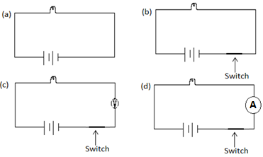

.N/B: If the circuit is said to include a switch and it is not stated whether it is closed or open, then it must be assumed to be an open one.

(Q6) Draw a circuit diagram to indicate three cells connected in series, which have been arranged in series with a lamp and a switch.

Soln:

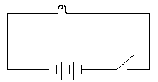

(Q7) Draw a circuit diagram to indicate how three cells can be connected in series, and arranged in series with a switch, a bulb and a galvanometer.

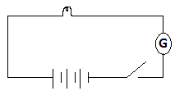 **N/B:** If no mention is made of a switch, then the circuit is assumed to be the closed type.

(Q8) Indicate in the form of a circuit diagram how the three cells can be connected in series and arranged in series with a bulb.

Soln:

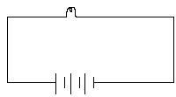

(Q9) Draw a closed circuit diagram to indicate two cells connected in series, and arranged in series with a voltmeter, an ammeter and a bulb.

Soln:

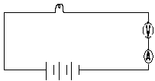

(Q10) Indicate in the form of a circuit diagram how to connect three cells in series, and arrange them in series with a galvanometer, a voltmeter and a key.

Soln:

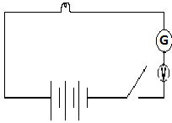

Advantages of arranging cells in series:

* It causes the voltage to be increased, which will in turn cause the light from the bulb to become brighter.

Disadvantages of connecting cells in series:

* It causes the cells to become quickly exhausted or ran down.

Arrangement of bulbs in series:

* Bulbs can also be arranged in series.
* When bulbs are arranged in series and one off them is removed, the rest of the bulbs will go off or not light, because the circuit has been broken.

Example 1:



Two bulbs connected in series

Example 2:



Three bulbs connected in series

Q1. Draw an open circuit diagram which consists of three bulbs connected in series, and arranged in series with two dry cells.

***Soln:***

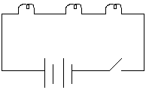

(Q2) Draw a closed electrical circuit diagram to indicate two cells connected in series, and arranged in series with two cells connected in series and a key.

Soln:

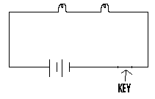

(Q3)(a) Indicate by means of a circuit diagram how three lamps can be connected in series with a switch and three cells connected in series.

(b) Explain what happens if one bulb is removed.

Soln:

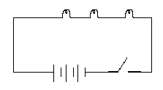

(b)In case the bulbs are on, then they will all go off

(Q4)Indicate by means of an open circuit diagram how to connect three cells in series, and arrange them in series with an ammeter and a galvanometer.

Soln:

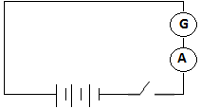

Advantage of arranging bulbs in series:

* It enables defaulted bulbs to be easily detected and changed or replaced.

Disadvantages of connecting bulbs in series:

* The light given is not bright because the same current passes through each of the bulb.

Bulbs in parallel arrangement or connection:

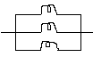

Three bulbs connected in parallel.



Two bulbs connected in parallel.

.

.

Parallel connection of cells:

* In parallel connection of cells, all the positive terminals are connected together and all the negative terminals are also connected together.

Example:

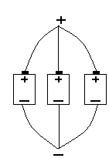 Three cells connected in the parallel manner.

* Consider a circuit in which two cells have been arranged in parallel with a bulb.
* If one of the cells is removed from the circuit, the bulb will still light and not go off.
* In domestic or the house-hold lighting system, the parallel connection or arrangement is used, so that if one item such as a bulb is switched off or removed, the other items such as bulbs will not go off.
* If the series connection was to have been used and one item such as a bulb is removed or switched off, then all the other items will also go off since the circuit will become broken
* When cells are arranged in series, the total voltage is equal to the sum of the individual voltages.
* For example, if two 1.5v cells are arranged in series, then the total voltage will be 1.5 + 1.5 = 3v.
* Also if three 1.5v cells are arranged in series, then the total or resultant voltage will be 1.5 + 1.5 + 1.5 = 4.5v.
* On the other hand, if two or more cells are arranged in parallel, then the total or the resultant voltage is the same as that for one cell.
* For example, if two 1.5v cells are arranged in parallel, then the total or resultant voltage will be 1.5v.
* Also if three 1.5v cells are arranged in parallel, the total voltage will be 1.5v.
* For a cell, the current always flows from positive terminal to the negative terminal.
* Also if two cells are arranged in series and made to supply current to a bulb, then half of the current supplied to the bulb will come from one cell, while the other half will come from the other cell.

Advantage of connecting cells in parallel:

* The cells are not quickly exhausted.

.

Disadvantage of connecting cells in parallel:

* The light given out or produced is not bright.

Q1. Draw an open circuit diagram to show how you will connect two cells in parallel, and arrange them in series with a bulb.

***Soln:***

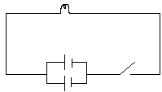

Q2. Draw a closed circuit diagram to indicate two cells connected in parallel, and arranged in series with a key, a voltmeter and a bulb.

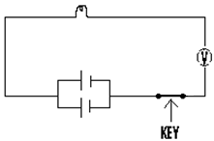

Q3. Draw an open circuit diagram to show how two cells can be connected in parallel, and arranged in series with a switch, an ammeter and a bulb

***Soln:***

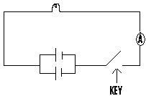

Q4. Draw a circuit diagram to show three cells connected in parallel and arranged in series with three bulbs connected in series.

***Soln:***

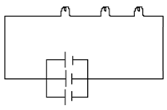

(Q5) A student wanted to find the current an electric bulb uses, so he set up a circuit as shown next:

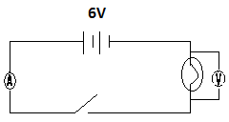

i.e. voltmeter reading was 6v and the resistance of the bulb as found to be 3. Calculate the value of the current the ammeter reads.

Soln:

The value of current the ammeter reads is given by I = = 2A.

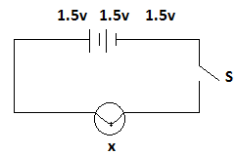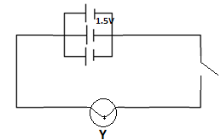

(Q6) Study the above two circuit diagrams and answer the questions which follow.

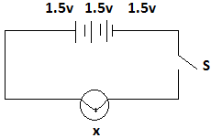



a) Calculate the current that will flow through the lamp X, if it has an internal resistance of 0.5Ω.

b) (i)Determine the voltage of lamp Y.

(ii)Calculate the current that will flow through lamp Y, if it has an internal resistance of 0.5Ω.

Soln:

1. The resistance, R = the internal resistance = 0.5Ω.

Total voltage = 1.5v + 1.5v + 1.5v = 4.5v.

Current I =

Therefore the current that flows through lamp X = 9A.

(b)(i)Since in this case, the cells have been arranged in parallel, then the voltage in lamp Y or across lamp Y = 1.5V.

Also R = the internal resistance = 0.5Ω.

(ii)The current flowing through lamp Y is given by I =

= = 3A.

(Q7)Study the circuit diagram given and answer the questions which follow:

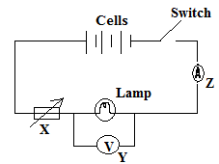

1. Name the components X, Y and Z.
2. What effect will a reduction in the number of cells have on(i) the current in the circuit.

(ii) the voltage.

1. State two changes in the circuit that will increase the brightness of the lamp.

Soln:

1. X is a rheostart or a variable resistor.

Y is a voltmeter and Z is an ammeter.

1. (i)If the number of cells is reduced, the current in the circuit will also be reduced.

(ii)The voltage will also be reduced

(c)The brightness of the lamp can be increased by

(i)increasing the number of cells.

(ii) decreasing the resistance of the variable resistor.

Arrangement of bulbs in parallel:

* Bulbs can also be arranged in parallel.

Example 1



* Two bulbs or lamps connected in parallel.

Example 2



Three bulbs connected in parallel.

* When bulbs are connected in parallel, the current which passes through each bulb is different from that which passes through the other bulbs.
* In other words, the current which passes through each bulb is not the same.
* But in the series connection, the current which passes through each bulb is the same.
* In parallel connection of bulbs, the main current divides or splits into two or more parts, each of which passes through a bulb.

Example 2

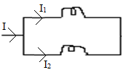

Example 3

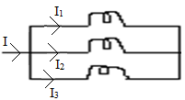

(Q1) Draw an open circuit which consists of two bulbs connected in parallel, and arranged in series with three cells connected in series

Soln:

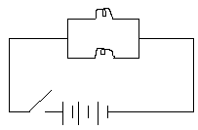

(Q2) Draw an opened diagram indicating three bulbs connected in parallel and arranged in series with three cells connected in parallel and a voltmeter.

Soln:

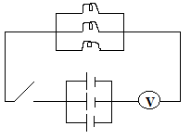

(3) Show by means of a circuit diagram how will you connect two bulbs in parallel and arrange them in series with a dry cell and a key.

Soln:

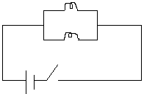

(Q4) Draw a circuit diagram indicating two bulbs connected in parallel, arranged in series with two cells and a key, if these two cells are connected in series.

Soln:

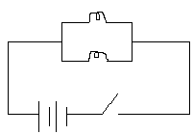

(Q5) Indicate how you will connect two bulbs using the parallel connection , and arranging them in series with two cells and a key, if these two cells are connected in parallel.

Soln:

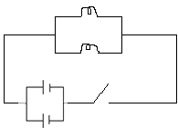

(6) Indicate by means of a circuit diagram how you will connect three bulbs in parallel and arrange them in series with three dry cells connected in series.

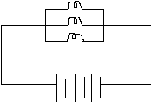

(7) Indicate how you will connect three bulbs in parallel and arrange them in series with a key and three cells which are connected in parallel.

Soln:

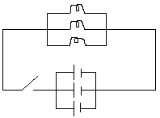

(Q8) Draw an electrical circuit to show the following arrangement:

1. A switch and a light bulb in series with two dry cells in series.
2. A switch and light bulb in series with two dry cells in parallel.

Soln:

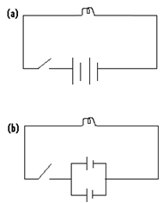

(9) With the aid of a circuit diagram, indicate how you will connect three bulbs in the parallel manner and arrange them in series with a switch, a voltmeter and three cells connected in parallel

Soln:

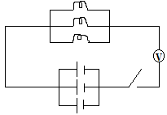

**N/B:**

* When two bulbs are connected in parallel, each will have a direct connection to the battery and as such glow brightly.
* These two bulbs will take twice as much energy as a single bulb will take.
* Energy is therefore taken away from the battery at a faster rate and the battery runs down quickly.
* But if one of these bulbs is removed, the other or others will keep on to glow.
* .

**Advantage of arranging bulbs in parallel:**

* When bulbs are connected in parallel and one of them is removed, the other or others will continue to glow.

**Disadvantage of connecting bulbs in parallel:**

* When one bulb does not light or goes off, it is difficult to detect the location of the fault.

### **ELECTRICAL APPLIANCES:**

1. **Electric bulb:**

* In the bulb, electrical energy is converted or changed into light energy.

1. **Electrical Motor:**

* In this, electrical energy is converted into mechanical energy.

1. **Loudspeaker:**

* In this, electrical energy is converted into sound.

1. **Electrical Iron:**

* In this, electrical energy is converted into heat.

.

1. **Electric Kettle:**

* This converts electrical energy into heat.

**Illegal electrical connections:**

* These are electrical connections which are made without permission from the Electricity Company of Ghana.

**Effects if illegal electrical connection:**

* Drop in voltage can occur which results in power cuts.
* Fire outbreaks.
* Damage to electrical appliances.
* Loss of government revenue.

**Factors leading to high demand of electricity:**

(1) Industrialization (2) Urbanization.

(3)Modernization 4) increase in population.

**Electric devices:**

1. **Television:**

* It uses electricity in electric circuits to receive and display sound and pictures.

1. **Radio:**

* The radio antenna receives radio waves from transmitters and these waves are changed into sound.

1. Computers
2. Telephone
3. **Fax machine:**

* It transmits exact copies of documents and drawings.

**Ways of generating Electricity:**

1. **Hydroelectric Power:**

* In this method, falling water from a dam is used to turn the turbine of a generator, so as to produce electricity.
* Examples are the Akosombo and the Kpong hydroelectric power plants.

1. **Windmill:**

* In this the power of the wind is used to rotate the turbine of a generator to produce electricity.

1. **Solar Energy:**

* In this photovoltaic cells are used to convert solar energy from the sun directly into electricity.

1. **Nuclear energy:**

* At the nuclear power plant, large amount of heat energy is produced as a result of the nuclear reaction which occurs there.
* This heat is used to generate steam, which is used to rotate the turbine of a generator to Sproduce electricity.

1. **Fuels:**

* Fossil fuels such as oil, coal and gases are burnt to produce steam, which is used to turn the turbine of a generator to produce electricity

1. **Chemical:**

* Here, cells or batteries which contain chemicals are used.
* The chemical energy found within these chemicals are changed into electricity.

**Types of cells:**

**These are the dry cell and the wet cell.**

**The wet Cell (Simple Cell):**

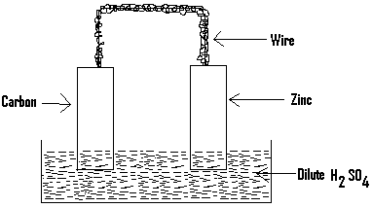

* The wet cell contains a liquid.
* The liquid is referred to as the electrolyte, and examples of electrolytes are Sulphuric acid and ammonium chloride solution.
* Two electrodes one being a carbon rod and the other being a zinc rod, dip into the electrolyte.
* One of these electrodes acts as the positive electrode, while the other acts as the negative electrode.
* These two electrodes are connected to each other by means of a wire.
* Two defects of the simple cell are local action and polarization.
* Local action can be prevented by coating the surface of the zinc with mercury.
* Polarization can be prevented by adding a chemical called depolarizer.
* **The dry cell:**

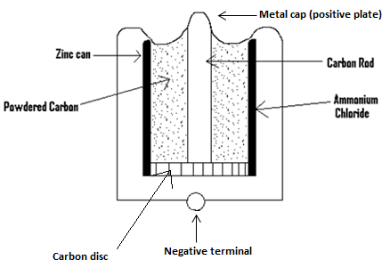

* The dry cell contains no liquid.
* The container is made of zinc which serves as the negative electrode.
* A carbon rod in the centre of the cell serves as the positive pole or electrode.
* An ammonium chloride jelly serves as the electrolyte.

**Direct current (D.C):**

* Is the type of electricity produced from batteries and cells, which flows in only one direction.

Alternating current (A.C):

* Is the type of electricity produced from sources such as hydroelectric power station, whose direction of flow changes with time, i.e. it does not flow in one direction.

**The Electric Generator:**

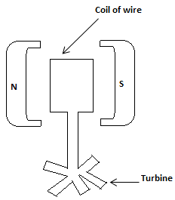

* When a wire is moved between the two poles of a magnet, current will be induced or produced within the wire.
* The generator works on this principle.
* Within a generator can be found a coil of wire, which lies between the two different poles of a magnet.
* Between these two poles can be found the magnetic field.
* When the coil of wire is rotated within this magnetic field, electricity will be produced in the wire.
* The coil is attached to a turbine.
* Therefore rotating the turbine causes the rotation of the coil, which results in the production of electricity to (within the coil).

Safety Precautions on electricity:

1. Wear rubber sandals, when touching electrical appliances.
2. Never touch any electrical appliance when you hands are wet.
3. All electrical faults must be handled by an electrician.
4. Disconnect all appliances from the mains after use, or switch them off.
5. Check wiring, plugs and fuses regularly for faults.

**The fuse:**

* This is a device which stops the flow of current within a circuit, when a dangerous situation arises.
* Some of the electrical devices which contain or make use of fuse are

1. the pressing iron.
2. refrigerators.
3. T.V
4. air conditions.
5. computers.

* In replacing an old fuse with a new one, the current capacity of the fuse wire within the new fuse, must be of the correct rating or value.
* It is dangerous to use any type of fuse.
* The main purposes of a fuse are:

1. to prevent fires which might easily occur, if any large current causes any part of the wiring to become red hot.
2. to prevent harm to those using electrical appliances.
3. to prevent damage to these appliances.

* A fuse contains a piece of wire, which melts when the current flowing through an electrical appliance becomes more than necessary.
* By so doing, the circuit becomes broken or open and current stops flowing through it, and as such through the appliance.

Earth Wires (Earthing):

* Earth wires are protective wires which prevent electric shocks, when an electrical appliance becomes faulty.
* Appliances in the form of metal cases such as electric kettle or electric irons must be earthed.
* This implies that earth wires must be used to connect these metal cases, to the ground.
* If the metal case is touched by a live wire, and as such becomes “live”, then the charges from the electric current will flow away along the earth wire to the ground.
* Any person who therefore touches the metal case will receive no shock.

**Electricity supply and wiring of electric plugs:**

* Electricity from main stations and local substations are supplied to home and work places, through interconnected cables and other necessary appliances such as transformers.
* Supply is done through two cables from a local substation. One cable is called the live or line, and the other cable is known as the neutral cable. In domestic supplies, a third cable is introduced for safety. This is called the earth as it makes a good connection to the earth.
* Domestic electric plugs have cables that have different colour codes. Brown cable is the live wire, blue is the neutral wire, green and yellow is the earth wire.
* The figure below shows a three-pin plug:

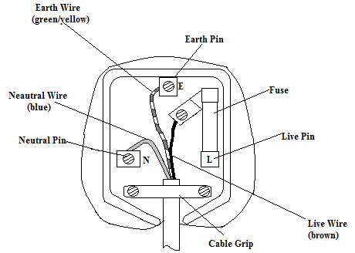

***A correctly wired three-pin plug***

**The heating effect of electric current:**

* When current is passed through a conductor such as a piece of wire, the conductor will offer resistance to the flow of current.
* This results in the conversion of electrical energy into heat energy and the heating of the conductor.
* This conversion and the heating of the conductor is known as the heating effect of electric current.
* The heating effect of electrical current is applied in electrical appliances such as the electric stove, electric iron, electric kettle, the electric heater and the microwave oven.

The potential difference (p.d):

* This is the work done when a charge is moved from one point to another.
* The standard unit of p.d. is the volts (V).

**Resistance:**

* This refers to the opposition to the flow of current within a circuit.
* It makes the flow of current very difficult.
* When current flows through a conductor which offers resistance, heat is always produced and the conductor which may be a wire becomes hot.
* Resistance is measured in ohms (Ω).

Electromotive force (E.M.F)

* This is the force which is required to drive the current through a cell.
* It is measured in volts (v), and the instrument used to measure it is the voltmeter.

**Ohm`s law:**

This states that the electrical current in a given conductor, is directly proportional to the potential difference (p.d) applied at constant temperature.

* From this law, it implies that R =

V = p.d and I = current.

(Q1) A 2v battery is connected to a wire of resistance 10Ω. Calculate the current which flows through the wire.

Soln:

V = 2v, R = 10Ω, I =?

From V = IR.

Divide through using R => = >I =

=> I =

(Q2) The current passing through a piece of wire is 0.3A. If the wire has a resistance of 8Ω when it is connected to a battery, calculate the p.d. across the wire.

Soln:

I = 0.3A, R = 8Ω, v =?

But V = IR => V = 0.3 x 8 = 2.4v.

(Q3)The p.d across a wire through which current is flowing is 4v. If the current flowing through the wire is 0.2 A, find the resistance of the wire.

Soln:

V = 4v, I = 0.2A, R = ?

But V = IR, and dividing through using I => R =

=>R = .

(Q4) Three resistors have resistances 2Ω, 4Ω and 8Ω respectively. Calculate their total resistance when they are connected in

(a)series.

(b)parallel.

Soln:



Total resistance of the three resistors when they are connected in series is given by RT = R1 + R2 + R3

= 2 + 4 + 8 = 14Ω.

(b)

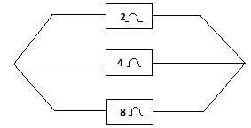

The total resistance RT of the three resistors when they are connected in parallel is given by

=>

=>

7 x RT = 1 x 8, => 7RT = 8 => RT = = 1.14Ω..

Three resistors have resistances 200Ω, 250Ω and 1000Ω respectively. Calculate their total resistance when they are connected in (a) series (b) parallel.

Soln:



The total resistance when connected in series = RT = 200 + 250 + 1000 = 1450Ω

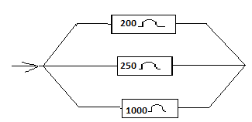

The total resistance of the three resistors when connected in parallel is given by

=

= .

= T x 1 = 1 x 100,

RT = 100Ω.

(Q5)(i) State Ohm`s law.

(ii) Three cells each of e.m.f 2v and negligible internal resistance are connected in series with an ammeter, two resistors of resistance 2Ω and 6Ω and a key.

(a)Draw a circuit diagram of the arrangement.

(b)Calculate the total current that flows in the electrical circuit.

Soln:

(a)

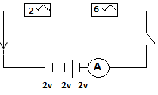

(b) Total voltage, V = 2v + 2v + 2v = 6v.

Total resistance = RT = 2 + 6 = 8V.

Total current, I =

(Q6) Three dry cells, each of e.m.f 1.5v are connected in parallel. This is in turn arranged in series with a switch, two resistors connected in series of resistances 2 Ω and 3Ω respectively and an ammeter.

1. Draw a circuit diagram for this arrangement.
2. Calculate

(a)the total e.m.f.

(b)the total resistance.

(c)the current through the circuit, when the switch is closed.

.

Soln:

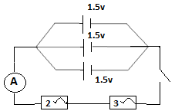

1. the total e.m.f = 1.5v, since the cells are identical and connected in parallel.
2. The total resistance RT = 2Ω + 3Ω = 5Ω, since they are connected in series.
3. Current = I = .

(Q7) Two dry cells, each of e.m.f 2.0v are connected in series with a key and an ammeter. Two resistors of resistances 5Ω and 10Ω are connected in series with the cells.

(a) Draw a circuit diagram for this arrangement.

(b) Calculate

(i) the total e.m.f.

(ii) the overall resistance of the circuit.

(iv) the current which flows through the circuit, when the key is closed.

Soln:

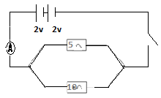

(b)(i)the total e.m.f of the cells = 2.0v + 2.0v = 4.0v ( since they are in series).

(ii)The total overall resistance is given by

= +

=

=> = T = 10,

=> RT = .

(iii)The current I = = 1.2A.

(Q8)Three dry cell each of e.m.f. 2v are connected in parallel. This is in turn connected in series with a switch, a voltmeter and three resistors of resistances 1, 2Ω and 3Ω respectively connected in parallel.

1. Draw a circuit diagram for this arrangement.
2. Calculate the total e.m.f.
3. Find the overall resistance of the circuit.
4. Determine the current which flows through the circuit, when the key is closed.

Soln:

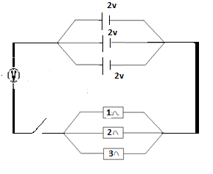

(b) the total e.m.f of the three cells = 2v, since they are connected in parallel.

©If the overall resistance = RT,

then

=

From = 11 x RT = 1 x 6 => 11RT = 6,

=>RT =

(d)current = I =

(Q9)Three dry cells of e.m.f 2v, 3v and 1v respectively are connected in series. This is in turn arranged in series with a voltmeter, an ammeter and three resistors of resistances 1Ω, 2Ω and 4Ω respectively which are connected in series.

1. Represent this on a circuit diagram.
2. Calculate the total e.m.f.
3. Determine the overall reistance.
4. Find the possible current which can flow through the circuit.

Soln:

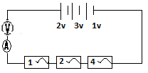

1. Since the cells are connected in series, the total e.m.f = 2 + 3 + 1 = 6v.
2. Since the resistors are connected in series, then the total or the overall resistance = RT = 1 + 2 + 4 = 7Ω.
3. The current which flows through the circuit is given by I = .

(Q10)

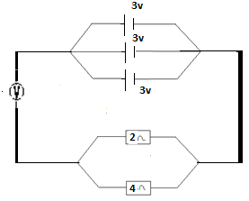

For this given circuit, determine

(a) the total e.m.f.

(b) the total resistance.

(c) the current which flows through the given circuit.

Soln:

(a)The total e.m.f = 3v, since the cells are connected in parallel.

(b)The total resistance RT, is given by

=> = 3 x RT = 1 x 4

=> RT = Ω.

(c)The current is given by I =

(Q11)Calculate the current (I) in the circuit given next:

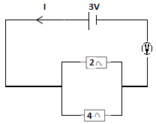

From V = IR => I =

Let R1 = 2Ω and R2 = 4Ω.

Also Let RT = the total resistance. For resistors arranged in parallel,

=>

=>1 x 4 = 3 x RT,

=>4 = 3RT => RT = .

Total e.m.f or the e.m.f = V = 3v.

From I =

(Q12)(i) A cell of e.m.f 1.5v with negligible internal resistance is connected to a 2Ω and 1Ω resistors which are connected in series. If the circuit is closed, calculate:

(a)the current that flows.

(b)the p.d across the 2Ω resistor.

(ii)Define electric power.

(iii)An electric stove is rated 1200W, 240V. How much current does it draw when used on a 240V supply?

Soln:

(i)Since e.m.f = 1.5V => V = 1.5V.

Let RT = the total resistance.

Since the resistors are connected in series, then the total resistance = 2 +1 = 3Ω

=>RT = 3Ω.

From I = => I =

(b)I = 0.5A and R = 2Ω.

From V = IR => V = 0.5 x 2 = 1.0, => the p.d across the 2Ω resistor = 1.0v.

(ii)Electric power is the energy produced at the rate of one joule per second.

(iii)I = and V = 240V.

5A.

Current drawn = 5A.

(Q13)A water heater is rated 1000W, 240V. Calculate the maximum current the heater can take.

Soln:

Power rating = P = 1000W and voltage = V = 240V.

The maximum current = I =

N/B: The power must be in watts in this case.

* If it is given in kilowatts, then it must be converted into watts by multiplying by 1000.
* For example 2kilowatts (2kW) = 2 x 1000 = 2000W.

**Questions:**

(1)(a)Differentiate between the voltmeter and the ammeter.

Ans:

* The voltmeter is used to measure voltage but the ammeter is used to measure current.

(b) Give the importance of fuse within an electrical circuit.

Ans: It stops the flow of current when a fault or a dangerous situation, occurs within the circuit.

(c)Explain what we mean, when we say that cells have been connected is series and parallel.

Ans:

* In the series connection of cells, the positive terminal of one cell is connected to the negative terminal of the next one.
* But in the parallel connection of cells, all the positive terminals of the cells are connected together and all their negative terminals are also connected together.

(Q2)Draw an electrical circuit which shows three lamps connected in series and arranged in series with a key, an ammeter and three cells which are connected in series.

Ans:

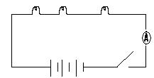

(Q3)With the aid of a diagram, indicate how you will connect two bulbs in parallel, and arrange them in series with a voltmeter and three cells, which are connected in parallel.

Ans:

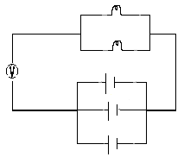

(Q4)(a)Give two effects of illegal electrical connection.

Ans:

* Drop in voltage.
* Fire outbreak.

(b)Give two methods of generating electricity, and briefly explain how this is done in each case.

Ans:

* The methods are the hydroelectric power generation, and the nuclear power generation.
* In the first method, falling water from a dam is used to turn the turbine of the generator, in order for electricity to be produced.
* In the nuclear power method, large amount of heat energy had as a result of nuclear reaction, is used to generate steam to rotate the turbine of the generator, leading to the production of electricity.
* With the aid of a diagram, briefly describe the wet cell.

(5)Briefly describe and explain the mode of operation of the electric generator.

Ans:

* It consists of a coil of wire, which is placed between the two opposite poles of a magnet.
* Between the two poles of the magnet is the magnetic field.
* By rotating the coil in this magnetic field, electricity will be produced within the coil.

(Q6)(a) What do you understand by resistance.

Ans: It refers to the opposition to the flow of current within a conductor.

(b)Briefly explain what the heating effect of electric current means.

Ans:

* When current flows through a conductor, a resistance is offered to the flow of the current leading to the production of heat, which results in the heating of the conductor.
* This heating of a conductor due to the passage of current through it, is what is referred to as the heating effect of electric current.

(c)Write a short note to indicate how appliances such as the electric iron, electric stove and the electric heater function.

Ans:

* These appliances contain conductors of high resistance.
* The passage of electricity through these high resistance conductors, results in the production of great amount of heat within them.

This heat produced is then used for any intended and appropriate purpose.

(Q7)(a) What is the difference between potential difference and the electromotive force.

Ans: The p.d. is the work done, when a charge is moved from one point to another. But the e.m.f is the force which is required to drive the current through a cell.

(b)A 4V cell is connected to a piece of copper wire of resistance 15Ω. Determine the current which flows through this wire.

Ans: 0.27A.

(c) A metal plate has a resistance of 20Ω. If the current flowing through it is 2A, calculate the potential difference across the wire.

Ans: 40V.

(c)The voltage or the p.d across a piece of zinc wire is 8V. Given that 0.8A of current flows through it, determine the resistance offered by the wire.

Ans: 10Ω.

(Q8)Two dry cells, each of e.m.f 3V are connected in parallel. This in turn arranged in series with a switch, three series connected resistors of resistances 3Ω, 4Ω and 2Ω respectively and a voltmeter.

(a)Represent this on a circuit diagram.

Ans:

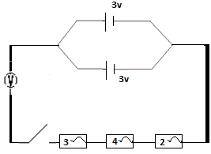

(b)What is the overall e.m.f?

Ans: 3v.

(c)What is the overall resistance?

Ans: 9Ω.

(d)Find the current which will flow through the given circuit. Ans: 0.33A.

(Q9) Three dry cells each of e.m.f 2v are connected in series.

This is then arranged in series with two parallel connected resistors of values 2Ω and 5Ω respectively, a voltmeter and an ammeter.

(a)Draw a circuit diagram for this arrangement.

Ans:

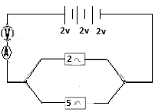

(b) find the total e.m.f.

Ans: 6v.

(c)What it the overall resistance. Ans: 1.4Ω.

(d)Determine the current which flows through the circuit. Ans: 4.3A.

(Q10) Three dry cells of e.m.f 2v, 4v and 6v respectively are connected in series. This is then arranged in series with resistors of resistances 1Ω, 4Ω and 2Ω respectively which are connected in series.

1. Represent this arrangement in a diagram form.

Ans:

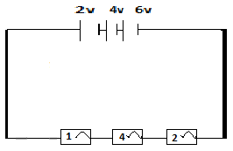

(b) what is the total e.m.f?

Ans: 12V.

(c)What is the total resistance.

Ans: 7Ω.

(d)Determine the current which flows through the given circuit.

Ans: 1.7A.

(Q11)

`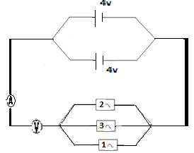

For the given circuit diagram, determine the following

(a) the overall or total voltage.

Ans: 4V.

1. the reading of the voltmeter.

Ans: Since the voltmeter will read the total voltage, then its reading will be 4V.

1. The total resistance.

Ans: 0.55Ω.

(d)What will be the reading of the ammeter.

Ans: - Since the ammeter will read the current, its reading will be equal to that of the current.

* The ammeter`s reading will therefore be 7.3A.

(Q12)(a) Explain what magnets are.

Ans: They are certain types of materials, in which certain types of forces called magnetic forces operate.

(b)Differentiate between magnetism and electromagnetism.

Ans: - Magnetism is the type of forces which act between magnets.

* But electromagnetism is the type of magnetism, which a magnetic material usually in the form of a coil of wire acquires, when current flows through it.

(c)With the aid of a diagram, briefly explain how you will make an electromagnet.

Ans:

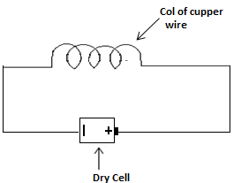

* I will first create a coil using copper wire, and connect the two ends of the coil to the two ends or terminals of a dry cell.
* As current flows through the coil, it will act as a magnet called an electromagnet.

(Q13)(a) What do you understand by the poles of a magnet?

Ans: These are the ends of a magnet where the magnetic forces are strongest.

(b)A bar magnet was placed into nails. Compare to its ends, its middle or mind portion could attract only a few nails. Explain why this is so.

Ans: Because the poles of a magnet where the magnetism are strongest, are located not at the mid portion, but rather at the ends.

(c)A boy brought the south pole of a magnet, towards a pole of a newly made magnet. If the magnets repelled each other, what can you say about the pole of the newly made magnet.

Ans: Since repulsion occurred, then it must be a south pole.

(d)You have been given a newly made magnet. Briefly explain how you will determine its north pole.

Ans: - I will hang it from a ceiling by means of a thread, allowing it to swing until it comes to rest.

The end which points to the north is the north pole.

(Q14)(a) What is magnetization?

Ans: It is the process in which a magnetic material is converted into a magnet.

(b)By the use of electric current or electrical means, briefly explain how you will convert an iron nail into a magnet.

Ans: - The nail is first placed inside a solenoid, which consists of several turns of insulated copper wire.

* Current is then made to flow through the solenoid for a short period of time.
* The nail which has now become a magnet is now removed from the solenoid.

(c)What do you understand by magnetization by induction.

Ans: This is one of the methods of converting a magnetic material into a magnet, by attaching it to a permanent magnet for a long time period.

(Q15)(a) Differentiate between magnetic materials and ferromagnetic materials.

Ans: - A magnetic material is any material which can be attracted by a magnet.

But those magnetic materials which are strongly attracted by a magnet, are said to be ferromagnetic materials.

(b)What is demagnetization?

Ams: It is the process in which a magnet is made to lose its magnetism.

(c)Briefly explain demagnetization through

(i)heating.

(ii)electrical means.

Ans:

* In demagnetization through heating, the magnet is heated to a very high temperature and then allowed to cool while it lies in the east-west direction.
* The magnet loses its magnetism after cooling.

(ii)With reference to demagnetization through electrical means, the magnet is placed inside a solenoid through which a 12V a.c. is flowing.

* While the current is flowing, the magnet is withdrawn in a east-west direction.

(d)Explain why in the just describe method of demagnetization, the magnet had to be withdrawn in an east-west direction, but not in a north-south direction.

Ans: The earth`s magnetism does not act in the east-west direction.

* Since it acts in the north-south direction, withdrawing the magnet which has been demagnetized in this direction will cause the creation or the inducing of magnetism in it again by the earth`s magnet.
* The magnet will therefore remain a magnet.

(Q16)(a) Explain what you understand by the magnetic field to a magnet.

Ans: It is the area around a magnet, in which the magnetic forces of the magnet acts.

* A nail when brought near a magnet was attracted by the magnet. But when it was moved further away, it could no longer be attracted by the magnet. Explain why this is so.

Ans: - Any magnetic material placed within the magnetic field of a magnet, will be attracted by the magnet.

But if placed outside the field, the magnet will not attract it.

In the first case, the nail was attracted by the magnet because it was within the magnet`s magnetic field.

But in the second case, since the nail was not within the magnet`s magnetic field, it was not be attracted by the magnet.

1. During a demagnetization process,, a student placed a bar magnet in the north-south direction and hammered it several times, but the magnetism failed to go away. Explain why this attempt failed.

Ans: Hammering a magnet will cause the disappearance of its magnetism.

* But since the magnet was positioned in the north-south direction, the earth`s magnetism which acts in that direction will induce magnetism into the magnet, any time its magnetism disappears.

1. What is the difference between a permanent magnet and a temporal magnet.

Ans: A permanent magnet is one, whose magnetism is always present.

* But a temporal magnet (electromagnet) is the type, whose magnetism only becomes available when current passes through it.

**Chapter Fifteen**

**Electronics**

* **Introduction:**
* Electronics is the branch of science and engineering, which is closely related to the science of electricity.
* Through electronics, we gt products such as television, radio, computer, DVD player, VCD player and the tape recorder.
* Electronics and electricity both deal with electric current, but each field uses the current in a different way from the other.
* Electricity deals with electric current mainly in the form of energy.
* This energy is used to operate electric equipments such as the electric bulb and the electric motor.
* But in electronics, the current flows through special devices called electron devices which change the current into signals.
* In short, in electronics, the electric current is used in the form of signals.

**Terms used in electronics:**

* **Amplification:**
* This strengthens a weak signal to give rise to a strong one.
* Amplification is done by a device called an amplifier.

**Alternating current:**

* This is an electric current, whose direction of flow keeps on reversing.
* In short, such a current does not flow in one direction.

**Direct current:**

* This is an electric current that always flows in one direction only.

**Electron devices:**

* They are used to change the character of an electric current in some ways.

**Rectification:**

* This refers to the changing of alternating current to direct current.

**.**

**Oscillation:**

* This refers to the changing of direct current to a signal of a desired frequency.

**Transistor:**

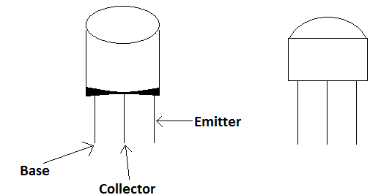

* This is a semi-conductor device, which has three terminals and used for amplification or as an amplifier.
* Transistors are used to operate devices such as radios and televisions.
* The transistor is the fundamental building block that is used in the construction of the circuits, that operate the computer, the mobile phone, the television set and other electronic devices.
* A transistor has three main parts and these are:

1. The emitter (negative lead).
2. The base.
3. The collector (positive lead).

* The diagrams just drawn show some examples of transistors.

**Types of semi-conductors:**

* There are two types and these are:

1. The N – type.
2. The P – type.

**The P-N junction:**

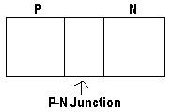

* This is a boundary or junction formed between a P-type and an N-type semi-conductor when they are melted together.
* The P-type semiconductor has more positive charges called holes, than negative charges or electrons.
* On the other hand, the N-type semiconductor contains more negative charges (electrons) than positive charges or holes.
* Even though the P-type and the N-type semiconductors are conductive, the P-N junction is non conductive.
* By the manipulation of this nonconductive layer, the P-N junction can be used as a diode.
* A diode is a device which allows current to flow in only one direction but not in the opposite direction.

**Forward Bias:**

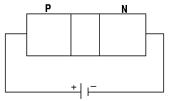

* If the positive terminal of a battery is connected to the P-side and the negative terminal is connected to the N-side, then the P-N junction is said to be forward biased.

**Reverse Bias:**

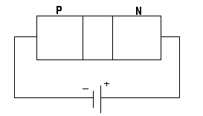

* On the other hand, if the battery is connected with the negative terminal to the P-side, and the positive terminal to the N-side, then the P-N junction is said to be reversed biased.

**Types of transistors:**

* There are two types of standard transistors, and these are:

1. THE NPN transistor.
2. The PNP transistor.

* Every transistor is made up of both the P-type material and the N-type material.
* These two types of transistors already mentioned are generally referred to as biopolar transistors or junction transistors.
* This is due to the fact that they always consist of a thin piece of semiconductor material, which may be the P-type or the N-type semiconductor placed between the thick layers of the opposite type.
* For example a P-type semiconductor, is always placed between two thick layers of the N-type semiconductor.
* In a similar manner, an N-type semiconductor is always placed between two thick layers of the P-type semiconductor.
* In a junction transistor, one of the outside layers is the emitter and the other the collector.
* The middle layer is the base.
* The place where the emitter joins the base is called the emitter junction, and the place where the base joins the collector is called the collector junction.

**The NPN transistor:**

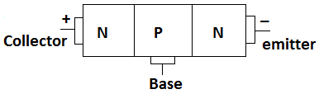

* This type of transistor is formed by placing a thin piece of P type semiconductor material, between two N type semiconductors.
* The voltage of the base must be more positive than that of the emitter.
* The voltage of the collector must in turn, be more positive than that of the base.
* The layers of NPN transistors must also have the proper voltage, connected across them.
* These voltages can be supplied by a battery.
* The emitter contains a lot of electrons and since the base has a greater positive voltage than the emitter, it pulls electrons from the emitter.
* The movement of these pulled electrons creates the flow of current within the transistor.
* This current moves from the emitter to the collector through the base.

The PNP transistor:

* This is a two-junction semiconductor transistor with a P type collector and emitter and an N type base.
* It is formed by placing a thin piece of N type semiconductor material between two P type semiconductor materials.
* Since the NPN type gives a better performance, few transistors used today are the PNP type.

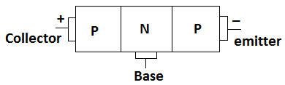

* In the PNP transistor, the voltage of the base must be more negative than that of the emitter.
* The voltage of the collector must in turn be more negative than that of the base.
* These voltages can be supplied by a battery.
* The emitter supplies positive charges which are referred to as holes.
* Because the base has a higher negative voltage than the emitter, it pulls holes from the emitter.
* The movement of these holes forms the flow of current through the transistor.
* The current moves from the emitter to the collector through the base.

**Transistor circuit symbols:**

* There are two types and these are that for the NPN transistors and that for thee PNP transistors.

**Circuit symbol for the NPN transistor:**

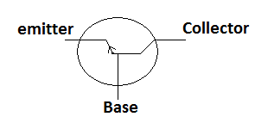

* In circuit symbols, the arrowhead must be drawn to indicate the direction of flow of the current.
* The arrowhead also shows which type of transistor it represents in a circuit diagram. In the NPN circuitsymbol, the arrowhead points away from the base towards the emitter.

**Circuits symbol for the PNP transistor:**

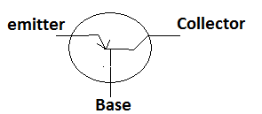

* In this type, the arrowhead is directed towards the base.
* The arrowhead can also be referred to as the emitter arrow.

**The functions of the emitter, base and the collector:**

**The emitter:**

* It emits the majority carriers.
* In the PNP transistor, these majority carriers are the holes.
* And in the NPN transistors, they are the electrons.

**The collector:**

* It collects or receives the majority carriers.

**The base:**

* It separates the emitter and the collector.
* Apart from that, it also serves as a charnel through which the majority carriers move from the emitter to the collector.

**Biasing the base emitter junction and the base collector junction:**

* When we connect a battery to the two junctions of the transistor, then we have biased the base emitter junction and the base collector junction.

**The forward biasing of a NPN transistor (the n-p-n circuit):**

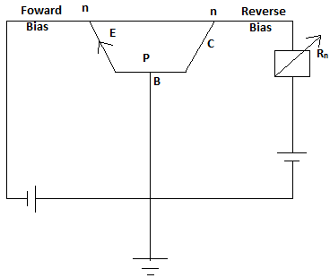

* The diagram shows a N-P-N transistor circuit, in which the base emitter junction is forward biased.
* This means that the N type emitter has been connected to the negative terminal of the battery.
* The base emitter of such a transistor is said to be forward biased, when its N type emitter has been connected to the negative terminal of the battery.
* On the other hand, if the N type collector is connected to the positive terminal of the battery, the base collector junction is reverse biased.
* This is so in the given diagram.

**The forward biasing of a PNP transistor:**The p-n-p circuit:

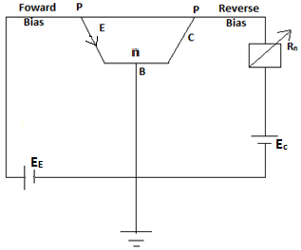

* The given diagram shows a p-n-p transistor circuit which is forward biased.
* Such a transistor becomes forward biased when its P type emitter is connected to the positive terminal of a battery.
* With reference to the same transistor, if its P type collector is connected to the negative terminal of the battery, then the base collector junction is said to be reverse biased.

**Characteristics of transistors:**

1. – Transistors can be used for amplification.

* This means that they can be used to make a weak signal strong.

1. They have a saturation region for switching action.

**Demonstration of the action of a transistor:**

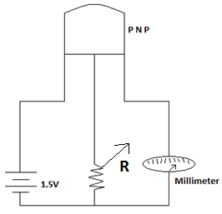

* Connect the base of a PNP or an NPN transistor to a battery and a sensitive ammeter.
* The resistance is varied to different values and for each, the corresponding ammeter reading is noted.

**The use of transistors to produce oscillators as signal sources:**

* Transistors are used to produce oscillators and multivibrators.
* An oscillator is an electronic circuit that produces or generates radio frequency.
* There are two main types and these are harmonic oscillators and relaxation oscillators.
* While harmonic oscillator produces sinusoidal waves, relaxation oscillator produces non sinusoidal waves.

**The multivibrator (he bistable)**

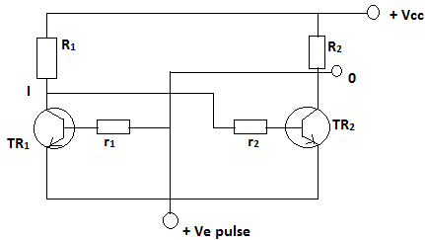

* It consists of two transistors, TR1 and TR2, with load resistance R1 and R2.
* The collector of TR1 is joined to the base of TR2 through a resistance r2.
* The collector of TR2 is similarly connected to the base of TR1 through a resistance r1.
* The circuit keeps one transistor switched on while the other is switched off.

**The phase-shift oscillator:**

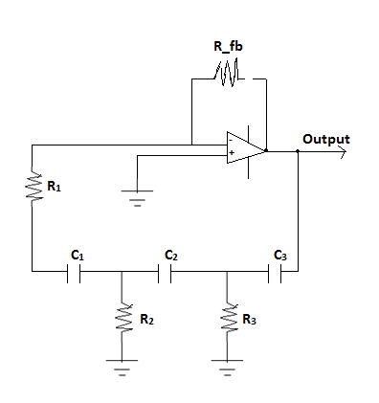

* The diagram is that for the RC shift oscillator.
* As a result of the random motion of electrons within the resistors, noise is produced.
* This noise serves as the starting voltage.
* This low or weak noise voltage gets amplified and appears at the output terminals.
* This amplified noise drives the feedback network, which is the phase shift network.

**CHAPTER SIXTEEN**

Digestion and Dentition

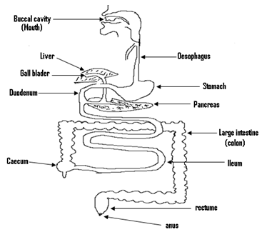

Digestion:

- Is the breaking down of the food we eat, with the help of enzymes into simple substances, so that the body can absorb them.

–In man digestion takes place in the alimentary canal or the digestive system.

–The digestive system is made up of the mouth, pharynx, oesophagus, the stomach, small intestines and the large intestines.

1. Mouth:

- Digestion begins in the mouth.

–The food is first chewed and mixed with saliva.

–Saliva is secreted by the saliva gland.

–Saliva contains an enzyme called ptyalin, which breaks down cooked starch (carbohydrate) into a substance called maltose.

–The food then enters the stomach.

1. Stomach:

–The stomach secretes the gastric juice, which contains enzymes called pepsin.

–The pepsin begins the digestion of protein within the food.

–The protein is changed or digested into peptone.

–The gastric juice also contains hydrochloric acid which kills the bacterias within the food.

- From the stomach, the food then enters the duodenum.

Duodenum:

– All the food substances i.e. protein, carbohydrate, fat and oil are digested within the duodenum.

–The duodenum receives two liquids i.e. one from the pancreas and the other from gall bladder.

–The liquid from the gall bladder is called the bile, and that from the pancreas is called the pancreatic juice.

– The bile emulsifies the fat within the food i.e. it splits it up into smaller particles.

–The pancreatic juice contains three enzymes, and these are:

1. Trypsin.
2. Amylase.
3. Lipase.

–**Trypsin:** It converts any protein still in the food into peptone.

**- Amylase:** It digests cooked or uncooked starch into maltose.

–**Lipase:**It Converts emulsified fat into fatty acid and glycerol.

– Fatty acid and glycerol is the end product of fat digestion, i.e. the digestion of fat ends in the duodenum.

– From the duodenum, the food enters the ileum.

Ileum:

- Is the first part of the small intestine.

– The walls of the small intestines secrete the intestinal juice, which contains an enzyme.

– At this stage the protein had been digested into peptone.

–This enzyme completes the digestion of protein by converting the peptone into amino acid.

–The amino acid is the end product of protein digestion.

–Therefore the digestion of protein ends in the ileum.

- At this stage also, the carbohydrate had been changed into maltose.

– This enzyme also changes the maltose into simple sugar, which is the end product of the digestion of carbohydrate.

– Within the small intestine also, the absorption of amino acid, simple sugar, fatty acid and glycerol into the blood stream occurs.

–They are then carried into the liver where they are stored or kept.

- When any of these substances is needed by the body, the liver releases it into the body.

- Mineral salts and vitamins are not digested, but they are absorbed into the blood stream together with the food substances.

–The part of the food which the body does not need come out as faeces.

Egestion:

- This refers to the process, whereby undigested food comes out of the body through the anus.

- The undigested food is stored in the rectum for a period of time, after the excess water has been absorbed from it in the colon.

- It is this undigested food which comes out of the body as faeces.

Indigestion:

-This refers to the condition in which food is not properly digested.

Causes of indigestion:

* These causes are:

1. Lack of roughage and fluid in the diet we eat.
2. Eating too fast.
3. Overeating.
4. Sleeping immediately after a heavy meal.

Effects of indigestion:

* These are:

(1)Nausea.

(2)Stomach ache.

(3)Severe abdominal pains.

Constipation:

- This refers to the irregular and difficult passage of faeces.It occurs when faeces remain in the rectum for too long, and a lot of water is removed from the faeces.This makes the faeces hard, dry and difficult to be expelled from the bowel.

Causes of constipation:

* These causes are:

1. By not performing physical exercises.
2. By taking in no water or too little water after meals.
3. Eating food that contains less vegetable.
4. Eating foods that contain less roughage.

Effects of constipation:

* These effects are:

1. Headache.
2. Abdominal pains.
3. Loss of appetite for food.
4. General body pains and tiredness.

Ways of preventing constipation:

1. By performing regular physical exercises.
2. Avoiding over eating.
3. Drinking a lot of water after meals.
4. By taking in more roughage or fibre.

Importance of food to man(body):

- For growth.

- In order to live.

–To repair damage caused to the body e.g. sore.

- Provides us with energy.

–Needed it for movement.

Food substances:

–These are names given to the ingredients, which are found within the food we eat. They are:

1. Carbohydrate.
2. Water.
3. Protein.
4. Fat.
5. Minerals.
6. Vitamins.

Primary food substances:

–This is the name given to the carbohydrate, protein, fat and the water, which are found in the food we eat.

Welfare food:

–This is the name given to the vitamins and mineral salts, found within the food we eat.

Balanced diet:

–This is diet which contains all the six food substances, in the correct proportion or amount.

–Eating unbalance diet leads to sickness.

(1)Protein:

–Sources: fish, meat and beans.

Functions:

- For body growth.

–Needed for repairs.

Deficiency:

- Kwashiorkor.

(2)Carbohydrate:

–Sources: Cassava, rice, maize and yam.

Functions:

– Provides heat and energy.

Deficiency:

– Lean growth.

(3)Fat:

–Source: beef, ground nut and pork

Functions:

- Provides the body with heat and energy.

–Maintains the structure of the body.

(4)Mineral salts:

– Sources: vegetables, liver, milk

Functions:

– Regulates life processes such as breathing, reproduction and blood circulation.

(5)Vitamins:

–Sources: milk, egg yolk, vegetables, pawpaw and palm fruit.

Functions:

– For normal growth and reproduction.

- Helps the body to fight against diseases.

– Helps in blood clotting.

Deficiency;

– Lack of vitamin A causes night blindness.

– Lack of vitamin B causes beriberi.

– Lack of vitamin C causes the bleeding of gum.

– Lack of vitamin D causes rickets.

– Lack of vitamin K causes excessive bleeding.

Test for food substances:

–There are various methods used to test for the presence of each of the food substances.

– The tests for protein, glucose or sugar, starch and oil (fat) are what will be considered.

Test for starch:

* A small amount of the food substance is boiled in water, within a test tube.
* A few drops of iodine solution is added to the mixture.
* If the colour of the mixture of the content of the test tube turns blue black, then starch is present.
* In other words, the food substance contains starch.

Test for sugar (glucose):

* A small amount of the substance is dissolved in water, and benedict solution is added to the mixture.
* The mixture is boiled for five minutes and if the colour of the mixture changes from blue to brick red, then the food substance contains sugar.

Test for protein:

* For this, two tests are available and these are:

1. The million test.
2. The burette test.

The million test:

* Put a small amount of the substance in a test tube, and add a few drops of million reagent to it.
* If there is a colour change to white, the mixture is heated.
* If there is a colour change from white into brick red, then the substance given contains protein.

The burette test:

* Few drops of sodium hydroxide solution are added to the food substance.
* Two drops of copper sulphate solution are then added, and the mixture is then shaken.
* If the color of the mixture becomes violet, then sugar is present.
* In short, the food substance contains sugar.

Test for fats and oil:

* Sudan III solution is added to the food substance.
* If there is a color change to red, then the food substance contains fat (oil).

The second test:

* If the given substance is in the liquid form, a few drops of it is placed on a sheet of white paper.
* But if the substance is a solid (i.e fat), crush the substance on a white paper.
* The paper is then placed in the sun for a few minutes.
* If a translucent spot or mark appears on the paper, then the given substance contains fat or oil.

**(Q1)** You are given a substance. Explain how you will test if it contains the following food substances:

1. Starch. (b) Sugar.

(c)Protein. (d) Fat/oil.

Solution:

1. **Starch:**

– Boil a small amount of the food substance in water within a test tube.

– Add a few drops of iodine solution to it.

– If the colour of the mixture or the content of the test tube turns blue black, then starch is present i.e. the substance contain starch.

1. **Sugar:**

-- Dissolve a small amount of the substance in water, and add benedict solution to it.

– Boil the mixture for five minutes, and if the colour of the mixture changes from blue to brick red, then the substance contains sugar.

1. **Protein:**

– Put a small amount of the substance in a test tube, and add a few drops of million reagents to it.

– There will be a change of colour to white, and the mixture is then heated.

– If there is a colour change from white into brick red, then the substance given contains protein.

1. **Fat/oil**

– If the given substance is in the liquid form, a few drops of it is placed on a sheet of white paper.

– But if the substance is a solid, i.e. fat, crush the substance on a white paper.

– Put the paper in the sun for a few minutes.

– If a translucent spot or mark appears on the paper, then the given substance contains fat or oil.

Enzymes:

- These are organic substances produced by special groups of cells in the body.

– The substance on which an enzyme act is known as the substrate.

– Enzymes which act on protein are known as proteases, those that are on carbohydrate are known as amylase, whilst those which act on fat are known as lipases.

Characteristics of enzymes:

- All enzymes have certain basic characteristics which are:

**(a)Enzymes are soluble:**

– They occurs in the liquid form and never occurs as solid in a living organism

**(b)They are sensitive to temperature:**

– Enzymes work only within a certain temperature range, with the best range being between 35degrees Celsius to 40degrees Celsius.

– The best temperature for most enzymes is 37degrees Celsius, which is also referred to as the optium temperature.

**(C) Enzymes are specific:**

**-**There are many enzymes in the body but each can act only on a particular substrate.

**(d)Enzymes are organic catalyst:**

**–** They are able to speed up chemical reactions that occur in the body.

–Eventhough they cannot start a chemical reaction, they can cause an increase in its speed.

**(e)Destroyed by heat**

– Since enzymes are proteins, they are capable of being destroyed by heat.

**(f)An enzyme work best in a particular p.H. range:**

**-** Each enzyme works best in a particular p.H. range.

– For example whilst enzymes such as pepsin and rennin work best in an acidic medium, others such as trypsin and ptyalin work best in an alkaline medium.

– However, certain enzymes work best in a neutral medium.

Dentition of mammals:

-Dentition refers to the number, arrangement and the structure of the teeth in an animal.

– In some animals, all the teeth in the mouth are of the same size, and this type of dentition is described as homodont.

– In other animals such as the rabbit, dog and man, the teeth are of different shapes and sizes, and this type of dentition is known as heterodont.

– The different teeth in a heterodont type of dentition are known as incisors, canine, premolars and molars.

–These different teeth are arranged in groups and each group occupies a specific position in the mouth.

– Each of these four different types of teeth, found in the heterodont dentition performs a specific function.

Incisors:

–These are chisel-like in shape and are used for cutting off large pieces of food.

Canines:

– These are larger than incisors and are used for seizing preys, as well as the tearing of flesh.

Premolars and molars:

– These are also referred as cheek teeth.

–They have broad surfaces and are used for the grinding of food.

–They are also used to shear through both flesh and bones.

Tooth decay:

–These are caused by bacteria.

– These bacteria live on the food found in between the teeth, and their activity on this food leads to the production of acid.

- It is this acid which destroys the teeth.

Dental care:

– In order to prevent tooth decay and gum bleeding, the following dental care must be practiced:

**(1)**Avoid two much sugar, sweets and starchy food since they bring about tooth decay.

**(2)**The teeth must be brushed immediately after meals, in order to remove food particles in between them.

**(3)**Avoid too hot or cold food, since they may crack the teeth leading to decay.

(4) Since calcium is needed for the formation of strong teeth, one must have enough calcium in his/her diet.

**(5)**Visit the dentist, so that holes in the teeth can be detected so as to prevent tooth decay.

**Questions:**

**(Q1)** (a) Explain what digestion is:

1. In which part of the body does digestion occurs.
2. Name four components of the digestive system.

**Ans**: The mouth, stomach, small intestine and large intestine.

1. In which part of the digestive system does digestion begins.

**Ans:** The mouth.

1. Explain the importance of saliva with reference to digestion.

**Ans:** It contains an enzyme called ptyalin, which converts cooked starch into maltase.

**(Q2)** (a) In which part f the digestive system does the digestion of protein begins.

**Ans:**The stomach.

1. Name the enzyme which begins the digestion of protein in the stomach.

**Ans:**Pepsin.

1. Of what importance is the hydrochloric acid food in the stomach?

**Ans:**It kills the germs found within the food we eat.

1. Name the portion of the digestive system, in which all the food substances are digested.

**Ans:**Duodenum.

1. Name the two liquids received by the duodenum.

**Ans:** The bile and the pancreatic juice.

**(Q3)**(a) Name the end products of fat digestion.

**Ans:** Fatty acid and glycerol.

1. What is the end product of protein digestion?

**Ans:** Amino acid.

1. List three importance of food to the body or man.

**Ans:**- For growth.

– Provides energy.

- Used to repair damage caused to the body.

**(Q4)**(a)Name four food substances.

1. Differentiate between primary food substances and welfare food.
2. What is a balanced diet?

**(Q5)**(a)List three sources of each of the following food substances: Protein, fat, carbohydrate and vitamins.

1. List two functions each of the following food substances: Protein and carbohydrate.

**(Q6)** Briefly explain how you will test for the following food substances.

(a)Protein.

(b)Sugar.

(c)Fat.

**(Q7)** Give the causes of the following:

1. Night blindness.

**Ans:**Lack of vitamin A.

1. Rickets

**Ans:**Lack of vitamin D.

(C) Gum bleeding.

**Ans:**Lack of vitamin C.

**(Q8)**(a) Give two ways of preventing tooth decay.

**Ans:**

- Avoid eating too much sugar, sweets and starchy food.

- Brush your teeth immediately after meals, so as to remove the food particles left in between the teeth.

(b) Explain what the homodont type of dentition means.

**Ans:** It is the type of dentition in which all the teeth found in the mouth of an animal, are of the same shape and size.

1. Give the use of the premolars and the molars.

**Ans:** They are used for the grinding of food, as well as for the shearing of flesh and bones.

1. List two characteristics of enzymes.

**Ans:** - They are organic catalyst. - Each enzyme work best in a particular p.H. range.

(d)Differentiate between an amylase and a lipase.

**Ans:** An amylase is an enzyme which acts on carbohydrate, but lipase is an enzyme which acts on fat.

(Q9)

|  |  |  |
| --- | --- | --- |
| **Food substance** | **Test** | **Observation** |
| A | Few drops of iodine solution was added to A. | The iodine solution turns blue-black. |
| B | A drop of B was applied to a white sheet paper. | A translucent patch was seen on the paper. |
| C | Benedict`s solution was added to C and the mixture boiled. | Benedict`s solution turns from blue to brick red. |

A student performed tests on food substances A,B and C and made the observations given. Identify food substance A, B and C.

Ans:

* Substance A is starch, B is Fat (oil) and C is protein.

(Q10)(a)

Complete the table given

|  |  |  |
| --- | --- | --- |
| **Food substance tested** | **Reagent used** | **Observation** |
| A | Iodine solution |  |
| B | Reagent + heat | Brick-red colouration. |
| C | Million`s reagent |  |

Ans:

* A is starch, and the observation will be a blue-black colouration.

(b)Name the food substance represented by A, B and C.

Ans:

A is starch, B is sugar and C is protein.

(c)Give two importance of the food substances tested for.

Ans:

Starch provides the body with energy, and within living things, food is stored as starch.

* The importance of sugar is similar to that of starch.
* Protein is needed for the growth of the body, and the repair of worn out tissues.

(d)Name one deficiency disease which results from the lack of food substances A and C in our diet. Ans; *Refer to the notes.*

(Q11)(a) Briefly describe how you will test for the following food substances:

1. Protein.
2. Glucose (simple sugar).
3. Fat and oil.

(b)Group the following food items under carbohydrate, protein, fat and oil:

Kenkey, liver, pear, meat, cassava, groundnut, margarine, egg yolk, maize, beans, palm fruit, gari and cheese.

(Q12)

|  |  |  |
| --- | --- | --- |
| **Food substance** | **Test** | **Observation/ results** |
| J | 2cm each of fehling`s solution A and B are added to J. Boil the mixture for 2 minutes in water bath. | Brick-red precipitate formed. |
| K | Iodine solution added drop by drop to K. | Blue-black colour. |

What inference can you make about the food substances from the results had.

Ans: J contains glucose and K contains starch.

(Q13)In testing for a certain food substance, the following steps are required:

(i) heat the test tube till its content boils.

(ii)pour a little of the sample into the test tube.

(iii) brick-red precipitate appears.

(iv) pour a little Benedicts solution into the test tube.

1. Rearrange and copy the given information, in the order in which they should follow.
2. Name the food substance being tested for.
3. Which alternative reagent will you use in place of the Benedict solution.

Ans:

* The order is as follows:

1. Pour a little of the sample into the test tube.
2. Pour a little of the Benedict`s solution into the tube.
3. Heat the test tube until its content boils.
4. Brick-red precipitate appears.
5. The food substance being tested for is glucose.
6. An alternative reagent which can be used is fehling`s reagent.

(Q14) The test for a type of food substance involves the following steps, which are not necessarily arranged in order.

1. Add 1% copper sulphate drop by drop whilst shaking the mixture.
2. Violet colouration appears.
3. Pour a little of the sample into a test tube.
4. Add 1.0cm3 of dilute sodium hydroxide to the sample in the test tube.
5. Rearrange the steps in order in which they should occur.

Ans:

*Refer to the notes:*

1. Name the food substance being tested for.

Ans:It is protein.

1. Give two importance of the food substance tested for.

Ans:

* *Refer to the notes;*

(Q15)A student placed a few drops of iodine solution on a piece of bread.

1. What observation is he likely to make.

Ans:

* Since the bread contains starch, a blue-black colouration is likely to occur.

1. What conclusion can you draw from the observation in (i).

Ans:

* The bread contains starch.

1. The student chewed another piece of bread for three minutes and transferred it into a glass tube. Describe briefly what he is likely to observe.

Ans:

* In this case, the ptyalin in the saliva will change the starch in the bread into maltose.
* For this reason, the blue-black colouration will not occur.

1. What conclusion can you draw for this observation.

Ans:

* The starch in the bread was really changed into maltose.

**CHAPTER SEVENTEEN**

**Excretion:**

–This is the process whereby waste products are removed from the body.

-- In man the waste products removed are carbon dioxide, excess mineral salts and certain nitrogenous compounds such as urea and uric acid.

–The food we take in may be more than what is needed, but while some of the food substances taken in can be stored, others cannot.

–When there is excess glucose, it is changed into and stored as glycogen.

- But when there is excess amino acid they have to be removed from the body, since there is no organ or tissue which can store amino acid.

–Also during respiration, carbon dioxide is produced.

–Since this carbon dioxide is harmful to the body, it must be removed.

–The organs which excrete waste substances are known as excretory organs, and these organs are the kidney, the lungs the skin and liver.

–These waste substances which can also be referred to as excretory products, are obtained as a result of the body’s metabolism.

- Faeces is not an excretory product since it is not obtained as a result of the body's metabolism.

**THE KIDNEY:**

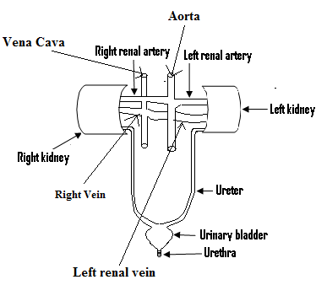

**STRUCTURE OF THE KIDNEY:**

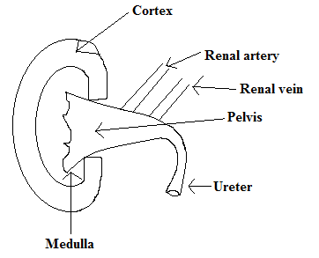

–The renal artery brings blood containing excretory products to the kidney, while the renal vein carries the filtered blood to the vena cava.

–The kidney removes excess mineral salts, water and urea from the body.

–This organ has a bean shape and we have two kidneys.

- Urine is produced in the kidney.

- Blood containing water, oxygen, glucose, urea and salts enter the kidney through the renal artery.

–The oxygen is used up by the cells of the kidney for respiration.

–Some of the glucose as well as some of the salt, and a large portion of the water are absorbed by the kidney for urine production.

–This urine produced which consists of urea, salts, large amount of water and sometimes glucose flows through the ureter into the bladder (urinary bladder).

–The urinary bladder stores the urine and when it is full, the urine is brought out of the body through the urethra.

**The Skin:**

Simplified diagram of the skin:

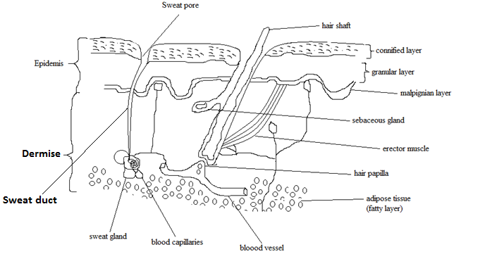

**The skin as an excretory organ:**

–The skin is considered as an excretory organ because of the sweat glands it contains.

- Had it not been the presence of these sweat glands within the skin, it would not have been an excretory organ.

–Sweat which is an excretory product is excreted by the skin, which is the largest organ within the body.

–The skin is also able to act as a sense organ.

The skin is made up of two main layers and these are;

1. The outer layer called the epidermis.
2. The inner layer called the dermis.

–The dermis has a lot of blood vessels or capillaries in it, as well as tubes which lead from its inside to the surface.

–These tubes are called sweat ducts, and at the bottom of these sweat ducts can be found the sweat glands.

- Blood which enters the skin contains a lot of waste substances, which has been collected from the cells of the body.

–These waste products are absorbed into the sweat glands as sweat, which passes through the sweat duct to the surface of the skin.

–Some of the waste products contained in the sweat are water, mineral salts (mostly common salt), and a small quantity of urea.

- Apart from its functions as excretory and sense organs, the skin also regulates or controls the body’s temperature.

**Functions of the skin:**

1. Protects the body against germs, dirt and damages.
2. Excretes sweat.
3. Contains sensitive cells e.g. those sensitive to touch.

The lungs as an excretory organ:

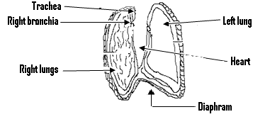

- Eventhough the lungs are a respiratory organ, it can also act as an excretory organ by excreting carbon dioxide and water vapour.

- Oxygen taken to the cells by the blood are used up by these cells for respiration.

–This results in the production of carbon dioxide by these cells, which is harmful to them.

–These cells therefore give the carbon dioxide to the blood to be taken to the lungs, which bring the carbon dioxide out of the body.

–This explains why the lungs are considered as excretory organs.

The liver as an excretory organ:

–Since the body cannot store excess amino acid, any excess amino acid is sent to the liver where it is broken into two portions i.e. the keto-acid and the amino group.

–The amino group is converted into ammonia which is harmful to the cells of the body.

- For this reason, the ammonia is converted into urea is then sent to the kidneys or skin for excretion.

–The keto-acid is converted into carbohydrate which can be used by the body.

The functions of the Liver:

–The functions of the liver are:

1. It stores vitamins especially vitamin A and vitamin D.
2. It removes excess glucose from the body and stores it as glycogen. (This glycogen can be converted back into glucose when the need arises by the liver).
3. It helps the body to maintain a constant temperature.
4. It produces fibrinogen which is needed for the clotting of blood.
5. It converts poisonous substances in the blood into non poisonous forms.
6. It breaks down the excess amino acid in the blood into urea.

Excretion in plants:

- Excretion also occurs in plants since they also produce waste substances.

–These waste substances or products include water and carbon dioxide, which are brought out of the plant through the stomata found on the leaf and the stem.

- Other waste products such as tannins, alkaloid and plant oil are stored in certain parts of the plant such as the leaf, the fruit and the sepal of the flower.

–These parts later on die or ripen and drop off.

**Questions**

1. Name the process in which waste is removed from the body.

**Ans:**Excretion.

1. Name three waste products found in man.

**Ans:** Urea, carbon dioxide and mineral salt.

1. Explain why excess amino acid must be removed from the body.

**Ans:** Because there is no organ or tissue to store it.

1. Explain what will happen if carbon dioxide is not removed from the body.

**Ans:** It will harm the body.

1. Why are waste produced in men.

**Ans:** As a result of the body’s metabolism.

**(Q2)**

1. Make a labeled diagram of the kidney.
2. Give the roles played by the following:
3. The renal artery.
4. The renal vein.

**Ans:**While the renal artery brings blood containing excretory products to the kidney, the renal vein carries filtered blood to the vena cava.

1. Name three components or constituents of urine.

**Ans:** Urea, salt and water.

1. In which part of the body is urine stored.

**Ans:** The bladder.

.

**(Q3)**

1. Make a labeled diagram of the skin.
2. Explain why the skin is considered as an excretory organ.

**Ans:** Because it contains sweat glands, into which waste products are absorbed, for their excretion.

1. Name the two layers of the skin.

**Ans:** These are the dermis and the epidermis.

1. Give the importance of the sweat ducts.

**Ans:** Sweat produced inside the skin passes through them to the surface of the skin.

1. List two functions of the skin.

**Ans:**

1. It excretes sweat.
2. It protects the body against germs, dirt and damage.

**(Q3)**

1. Name the excretory products excreted by the lungs.

**Ans:** These are carbon dioxide and water vapour.

1. Explain why any excess amino acid is sent to the liver, to be broken into an amino group and the keto-acid.

**Ans:** Because the body cannot store it.

1. List two functions of the liver.

**Ans:**

1. It helps the body to maintain a constant temperature.
2. It stores vitamins A and D.
3. Name two waste products produced in man.

**Ans:** Carbon dioxide and water vapour.

**Chapter Eighteen**

**Respirations**

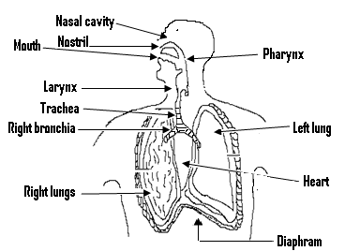

**Respiration:**

–This is defined as the process by which oxygen is used to release energy stored in food.

- Living organisms need energy for their activities and processes such as reproduction, excretion, movement and digestion.

- But this energy is stored in the food we eat, and before it can be used by the cells of the body, it must be released from the food by the process of respiration.

– For respiration to be continous, there must be a constant supply of oxygen.

–The breathing of human beings and many animals is one form of respiration, occurring within the tissue of the body is another form of respiration, called internal respiration.

– A third form of respiration called cellular respiration occurs within the cell itself.

- Carbon dioxide and water are produced at the end of respiration, and the energy produced appears in the form of heat.

–- Respiration can be represented by the equation given next:

C6H12 O6 + 6O2 →6CO2  + 6H20 + Energy.

i.e Glucose + Oxygen 🡪Carbon dioxide+ Water + Energy.

–Since in photosynthesis carbon dioxide and water combine to form carbohydrate (glucose) and oxygen, and in respiration oxygen and glucose combine to form carbon dioxide and water, then respiration can be said to be opposite to photosynthesis.

–The equation for photosynthesis is given by:

6H2O + 6CO2 -> C6H1206 + 6C02.

i.e Water + carbon dioxide -> Carbohydrate+ oxygen.

**Types of respiration:**

–There two types and these are:

1. Aerobic respiration.
2. Anaerobic respiration.

Aerobic Respiration:

–This is the type of respiration which occurs in the presence of oxygen.

- Most plants and animals respire aerobically.

Anaerobic Respiration:

–This is the type of respiration which occurs without oxygen.

–This type of respiration is practiced by very few living organisms, such as yeast.

– The conversion of carbohydrate by yeast to carbon dioxide and alcohol is referred to as fermentation.

External and Internal respiration:

- Respiration occurs in two stages and these are external and internal respiration.

External Respiration:

– The breathing of human beings and many animals is a form of respiration called external respiration.

- External respiration refers to the taking in of oxygen and the bringing out of carbon dioxide and water vapour.

–This process is normally referred to as breathing.

– External respiration or breathing occurs between the lungs and the outside environment.

Internal Respiration:

–The blood stream acts as a transportation system, carrying oxygen to all the cells and carbon dioxide away from them.

– Internal respiration occurs when the oxygen in the blood diffuses into the cells, for them to use to oxidize food substances so as to release energy, carbon dioxide and water.

– Since internal respiration occurs within the tissue, it is also referred to as tissue respiration.

- Internal respiration follows immediately after external respiration.

–The heart pumps blood containing oxygen to all parts of the body and as the blood flows through the body capillaries, the oxygen passes through the thin wall into the tissue cells.

– At the same time, the blood picks up carbon dioxide from these cells and carries it back to the lung for it to be excreted.

The Respiration System:

–The body of man is divided into the thoracic cavity(thorax) and the abdominal cavity.

–The respiratory system can be found in the thorax(i.e the chest).

–The main organs of the respiration are the lungs, and we have the right and the left lungs, both of which lie within the chest.

–The spongy lungs tissue is divided into many small air sacs called alveoli.

– Of equal importance are the ribs that form the chest cage and the muscles that move them.

The breathing process or mechanism:

- Breathing is made up of two separate acts and these are:

1. Inspiration or inhaling i.e. breathing in.
2. Expiration or exhaling i.e. breathing out.

– For breathing to occur, the chest muscles must act so as to expand and contract the chest cavity, causing the lungs to fill or empty.

- A pause occurs between inspiration and expiration.

Inspiration:

–For a person to breath in, his chest must expand for the lungs to fill the chest cavity completely.

– The lungs expansion lowers the pressure within them, creating a slight vacuum that pulls air into the lungs from the atmosphere.

- For this expansion to occur, the diaphragm contracts pulling its dome downwards.

–This provides more room or expansion within the chest cavity, which in turn causes the expansion of the lungs.

–At the same time the muscles associated with the ribs contract, causing the ribs to move upward and outward, making the chest cavity to expand frontward.

–These muscles associated with the ribs are called the intercostals muscles.

Expiration:

–This occurs when the process of inspiration is reversed.

- In this case the muscles act to force out air.

–First, the diaphragm relaxes and resumes its dome shape, reducing the space in the chest.

–The intercostals muscles relax, causing the ribs to move downwards and inwards which makes the chest cavity smaller.

– The lungs therefore decrease in size or become smaller, which causes the pressure within them to increase.

– And it is this increased pressure which forces air out of the lungs, causing them to decrease in size.

Breathing:

- During breathing, air enters the nasal cavity through the nostrils, and then moves into the larynx (the voice pipe) before moving into the trachea (wind pipe.)

–From the trachea, the air enters the left and the right bronchi and then into the bronchioles.

- At the tip of each bronchiole can be found an air sac called alveolus, and it is in this alveolus that oxygen diffuses into the blood. Also carbon dioxide within the blood diffuses into the alveolus.

–Therefore from the bronchioles, the air enters the alveoli where the oxygen found within the air diffuses into the blood. Also the carbon dioxide within the blood diffuses into the alveoli and then into the bronchioles.

–From the bronchioles, the carbon dioxide moves through the bronchus and then through the trachea as well as the larynx.

–The carbon dioxide comes out together with some water vapour through the nasal cavity, and finally through the nostrils.

The path followed by air, during inspiration and expiration:

1. Inspiration:

- Atmosphere → Nostril → Pharynx → Larynx → Trachea → Bronchioles → Alveoli → Capillaries → Blood.

1. Expiration:

- Blood → Capillaries → Alveoli → Bronchioles → Bronchi → Trachea → Larynx → Pharynx → Nostrils → Atmosphere.

Differences between inspiration (inhalation) and expiration (exhalation):

|  |  |
| --- | --- |
| **INSPIRATION** | **EXPIRATION** |
| The diaphragm contracts and flattens. | The diaphragm relaxes and becomes dome shaped . |
| The rib cage moves upwards and outwards. | The rib cage moves downwards and inwards. |
| The air pressure inside the chest cavity decreases. | The air pressure inside the chest cavity increases |
| The volume of the chest cavity increases. | The volume of the chest cavity decreases. |
| Atmospheric pressure drives air into the lungs. | Air is forced out of the lungs. |

Differences between respiration and photosynthesis:

|  |  |
| --- | --- |
| **Respiration** | **Photosynthesis** |
| It is carried out in all living things. | It is carried out in green plants only. |
| It releases water. | It uses water. |
| It releases carbon (IV) oxide. | It uses carbon (IV) oxide. |
| It releases energy. | It uses energy. |
| It uses oxygen. | It releases oxygen. |
| It occurs during the day and night. | It occurs only during the day. |

Differences between anaerobic and aerobic respiration:

|  |  |
| --- | --- |
| **Anaerolbic respiration** | **Aerobic respiration** |
| A little amount of energy is produced. | A lot of energy is produced. |
| No oxygen is required. | Oxygen is required. |
| Products include lactic acid and energy. | Products include carbon (IV) oxide, water and energy. |

Differences between inspired and expired air:

|  |  |
| --- | --- |
| **Inspired air** | **Expired air** |
| It contains less carbon dioxide. | It contains more carbon dioxide. |
| It contains more oxygen. | It contains less oxygen. |
| It contains less water vapour. | It contains more water vapour. |
| It contains more foreign materials. | It contains less foreign materials. |

Similarities between aerobic respiration and burning:

* Both processes need fuel and the supply of oxygen.
* Both processes produce waste.
* Both release energy whenever they occur.
* Both involve a chemical change.

The first experiment to demonstrate or show that expired air contains carbon dioxide (carbon (IV) oxide):

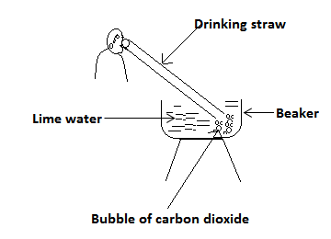

Procedure:

* Air is blown out of the mouth through a drinking straw into lime water in a beaker.

Observation: The colourless lime water turns milky white or chalky.

Conclusion:

* The lime water turning milky white shows that expired air contains carbon dioxide.

The second experiment to demonstrate that expired air contains carbon (IV) oxide (carbon dioxeide):

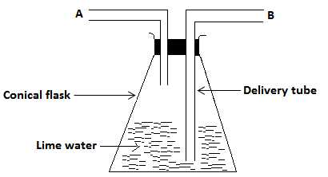

Aim: To show that expired air contains carbon dioxide.

Apparatus: Conical flask, limewater, cork and delivery tube.

Procedure:

* Gently breath out through tube A for a few minutes and then breath in through B for a few minutes.

Observation:

* The colour of the lime water becomes milky white, when we breathe out through tube B.
* But this is not so when we breathe in through tube A.

Conclusion: Since the lime water turned milky white during breathing out, then expired air contains carbon (IV) oxide.

Some living organisms and their respiratory organs:

|  |  |
| --- | --- |
| **Living organism** | **Respiratory organ** |
| Man | Lungs. |
| Fish | Gill. |
| Frog or toad. | Skin, lungs and mouth. |
| Earthworm. | Skin. |

The importance or usefulness of respiration:

* Respiration provides chemical energy to a living organism.
* This energy is used in many life activities such as:

1. In the production of heat which enables animals to maintain constant body temperatures.
2. In the division of cells.
3. In the production of chemicals substances in cells.
4. In the contraction of muscles, which causes movement.
5. In the breakdown of chemical substances in cells.

Artificial respiration:

* This is a means of forcing air into and out of the lungs of a person, by another person or by mechanical means.
* It is usually done to resuscitate a person during:

1. Cardiac failure or diseases.
2. An electric shock.
3. The taking in of an overdose of a depressive drug such as alcohol.
4. Suffocation in poisonous gases or the blockage of the respiratory tract.

* The brain will suffer permanent damage, if it is deprived of oxygen for five minutes.
* A slightly longer period without oxygen usually results in death.
* For these reasons, artificial respiration must be started immediately when the need arises.
* The mouth-to-mouth method is highly recommended.

Hazards to the respiratory system:

* These hazards include smoking, inhalation of poisonous gases as well as the inhalation of bacteria or fungi spores.

The effects of smoking to the respiratory system:

* It causes lung cancer.
* It damages the brain and the nervous system.
* The nicotine found in cigarette can cause severe heart diseases.
* The carbon dioxide found in the smoke combines with the haemogloblin of the blood, which reduces the amount of oxygen the blood can carry.

Diseases of the respiratory system:

1. Asthma- caused by allergens, chemical irritants and intense emotion.
2. Bronchitis- caused by viruses and bacteria.
3. Tuberculosis- caused by bacteria.
4. Pneumonia- mainly caused bybacteria.
5. Influenza (flu)- caused by virus.
6. Common cold- caused by a virus.
7. Hay fever- caused by airbone pollen grains.
8. Hay-fever and asthma may also be referred to as disorders of the respiratory systems of humans.

Hay fever:

* This is a reaction of the immune system to foreign substances such as pollen grains.
* The symptoms of hay fever are:

1. Intense sneezing.
2. Runny nose.
3. Watery eyes.

Control:

* Those suffering from hay fever should avoid coming into contact with pollen grains.

Asthma:

Its symptoms are:

1. Mild chest pressure.
2. Dry cough.
3. Difficulty in breathing.

Control:

* Those suffering from asthma (asthmatics) should wear nose marks when sweeping, or cleaning the environment to prevent the entry of particles into the respiratory tract.
* They must not use perfumes.
* They must avoid cigarette smoke or thick smoke.
* They must always take their medications.

**Questions:**

1. A. What is respiration?

**Soln**

–It is the process in which the energy stored in the food we eat, and which is needed by living organisms for certain important activities such as reproduction and excretion is released.

1. Explain what you understand by internal respiration.

**Ans:**

– It is the type of respiration, in which the exchange of gases between the blood and the body’s tissue takes place.

1. What is cellular respiration?

**Ans:**

–It is the type of respiration which occurs within the cell itself.

(Q2)

1. Explain why respiration considered to be opposite to photosynthesis.

**Ans:**

– Because during respiration, oxygen and glucose combine to form carbon dioxide and water, while during photosynthesis, carbon dioxide and water combine to form glucose and oxygen.

1. List two differences between photosynthesis and respiration

**Ans:**

- While photosynthesis occurs only during the day, respiration occurs both day and night.

-While during photosynthesis energy is used, energy is produced during respiration.

1. What is aerobic respiration?

**Ans:**

- It is the type of respiration which occurs in the presence of oxygen.

1. Explain what we mean when we say that plants and animals respire aerobically.

**Ans:**

- It means that they respire in the presence of oxygen.

1. What is anaerobic respiration?

**Ans:**

- It is the type of respiration which occurs in the absence of oxygen.

(Q3)

1. What is external respiration?

**Ans:**

- It refers to the taking in of oxygen and the bringing out of carbon dioxide and water vapour.

1. What is the main organ of respiration?

**Ans:**The lungs.

1. Differentiate between inspiration and expiration

**Ans:**

- Inspiration refers to breathing in while expiration refers to breathing out.

1. Briefly explain the process or mechanism of inspiration.

**Ans:**

–The chest expands, causing the lungs to also expand to fill the chest cavity.

–The pressure within the lungs falls or decreases as a result of its expansion, and the slight vacuum created pulls air from the atmosphere into the lungs.

(Q4)

1. Make a labeled diagram of the respiration system.

(Q5) Briefly explain how breathing occurs.

**Ans:**

- Air first enters the nasal cavity through the nostrils, move into the larynx and then into the trachea.

–The air enters the left and the right bronchi, before moving into the bronchioles.

–The air finally moves into the alveolus where oxygen diffuses into the blood, while the carbon dioxide within the blood diffuses into the alveolus and then into the bronchioles, the trachea and the larynx.

–The carbon dioxide then move into the nasal cavity, and is finally brought out through the nostrils.

(Q6)(a) List two differences between respiration and photosynthesis.

Ans:

* During respiration, energy is released but during photosynthesis, energy is used.
* Oxygen is used during respiration but released during photosynthesis.

(b)List two similarities between burning and aerobic respiration.

Ans:

* Both processes need fuel and oxygen supply.
* Both release energy.

(c)List two importance of respiration.

Ans:

* It provides the energy which is used in

(i) the division of cell.

(ii) the contraction of muscles which causes movement.

(Q7)Describe an experiment to show that we breathe out carbon (IV) oxide.

(Q8)(a)Give two situations when artificial respiration is used or needed.

Ans:

* During cardiac failure and electric shock.

(b)Name three diseases of the respiratory system.

Ans:

* These are tuberculosis, common cold and flu.

(c)Apart from the lungs, name two other organs which are used by the toad for respiration.

Ans:

* The skin and the mouth.

(d)Give two effects of smoking.

Ans:

* It causes lung cancer.
* It damages the nervous system and the brain.

(e)Give two symptoms of asthma.

Ans: These are dry cough and difficult breathing

.

**Chapter Nineteen**

**Osmosis, diffusion and transpiration**

* The absorption and transportation of materials in plant involves two processes, and these are osmosis and diffusion.

Osmosis:

* This is the movement of small solvent molecules such as water molecules, from a region of low concentration to that of a high concentration, through a semi-permeable membrane.
* A semi-permeable membrane is the type of membrane whose holes are sufficiently large enough to allow small molecules to pass through.
* This implies that such a membrane is selective and as such, can also be referred to as the selective membrane.
* If equal amount of water is placed into two similar cups, and let say two cubes of sugar are dissolved in the water within the second cup, then the water within the second cup will be at a higher concentration that within the first one.
* Also if two cubes of sugar are dissolved in the water within the first cap, while five cubes are dissolved in the water within the second cup, then the second solution within the second cup will be at a higher concentration than the one within the first cup.

**An experiment to show or demonstrate osmosis in a living tissue:**

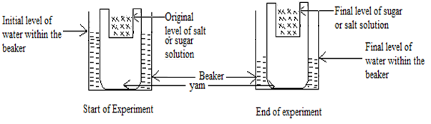

* To show osmosis in a living tissue, a piece of yam is used.
* The yam is flattened at the bottom and top so that it can stand upright.
* A large hole is made in the centre of the yam, and a strong sugar or salt solution is poured into this hole to a certain level.
* The piece of yam with the strong sugar or salt solution, is then placed into a beaker containing ordinary water.
* The level of this sugar or salt solution in the piece of yam as well as the level of water in the beaker is marked.
* The set up is allowed to stand till the next day, and when the levels of the liquids are checked, it will be observed that the level of salt solution has risen, while the level of water in the beaker has fallen.
* This is an indication that water has entered the yam from the beaker, by the process of osmosis.
* The salt solution is of high concentration while water is of low concentration, and the outer wall of the yam acted as a semi-permeable membrane.

However, when the same experiment is performed with water being placed into the hole instead of sugar or salt solution, the level of water in the hole and the beaker remains unchanged or the same.

This is due to the fact that osmosis cannot occur, since both liquids have the same concentration.

Experiment to demonstrate osmosis in a non-living cell or tissue:

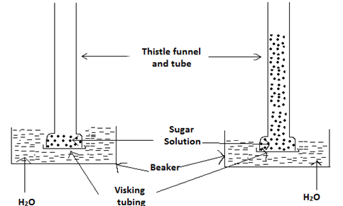

Start of experiment After an hour

1. A thistle funnel and a tube are connected together as shown in the diagram.
2. A visking tubing which acts as a semi-permeable membrane is stretched across the mouth of the tube.
3. A sugar or salt solution is placed inside the tube, and the tube is then placed into a beaker which contains water.
4. The level of water within the beaker is then marked or noted.
5. It will be observed that after an hour, the level of water within the beaker has fallen or decreased, while the level of sugar solution has risen into the thistle funnel.
6. We can therefore conclude that water molecules from the beaker have passed through the visking tubing into the salt or the sugar solution.
7. For this reason, osmosis has occurred in a non-living tissue.

Transpiration:

- This refers to the diffusion of water vapour from the cells of plant into the atmosphere.

- Transpiration may occur through the stomatas of the leaves or the lenticles of stem.

Conditions affecting the rate of transpiration:

- The rate at which water vapour leaves a plant depends on a number of factors.

- These factors are:

(1) The size of the stomatal pore:

- If the stomatal pores are large, more water will be lost from the plant but if these are small, the amount of water lost will be less.

(2) Humidity:

- This refers to the amount of water vapour within the atmosphere.

- When humidity is high, the rate of transpiration become low but this become high, when humidity is low.

(3) Temperature:

- At high temperatures, the humidity becomes low and as such transpiration rate becomes high.

- However, at low temperatures, humidity is high and as such the rate of transpiration becomes low.

(4) Light:

- When the leaves absorb light from the sun, the temperature of the leaves increases and this causes more water vapour to be lost from the plant.

- Transpiration therefore increases.

(5) Wind:

- Transpiration rate increases in moving air or wind, but decreases in still or non-moving air.

(6) Soil water:

- When the amount of soil water is very high, the amount of water absorbed by the plant becomes very high.

- The plant is now capable of losing more water and as such, the rate of transpiration becomes high.

- However, if the amount of soil water becomes low, then the plant can absorb less water or will contain only a small amount of water.

- The rate of transpiration will therefore be low.

Diffusion:

- This refers to the movement of molecules from a region of high concentration, to that of a low concentration.

- In plants, water vapour diffuses out of the cells of a plant, and gases such as oxygen and carbon dioxide diffuses in and out of the plant.

- Oxygen has a high concentration inside the plant and so diffuses into the atmosphere.

- Since carbon dioxide is of high concentration in the atmosphere, it diffuses into the plant.

- When a bottle of perfume is opened at one corner of a room, its molecules spread out throughout the whole room, and as such its scent can be detected at every part of the room.

- This is an example of diffusion in air.

- It is also by means of diffusion that when smoke is created at one part of a room, it spreads throughout the whole room.

- This is also another example of diffusion in air.

- Diffusion may also occur in liquids, and this can be demonstrated by putting water into a bucket.

- A crystal of potassium permanganate which is purple red in colour is dropped to the bottom of the water within the bucket.

-The crystal disappears and the colour of the water becomes purple red.

Differences between osmosis and diffusion:

|  |  |
| --- | --- |
| Osmosis | Diffusion |
| 1. A semi-permeable membrane is needed. 2. It occurs mainly in liquids. 3. Molecules move from a region of low concentration to that of a high concentration. | 1. A semi-permeable membrane is not needed. 2. It occurs in gases and liquids. 3. Molecules move from region of high concentration to that of low concentration. |

**Chapter Twenty**

**Flowering plants, photosynthesis and the dispersal of seeds:**

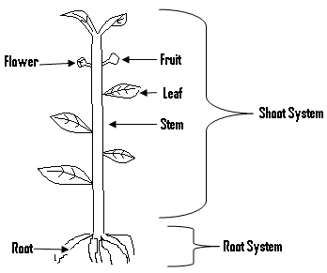

Flowing plant:

* A plant is normally made up of two parts and these are:

1. The root system.
2. The shoot system.

The roots:

* These are the parts of the plant which grow underground and away from sunlight but towards water. It may either develop from the seed or not.

**Functions of the root:**

* It absorbs water and mineral salts from the soil for the plant to use.
* It holds or fixes the plant firmly to the ground.
* It acts as storage organ in certain plant, i.e. it stores food for the plant e.g. cassava.

N/B: Found on the roots are root hairs which absorb water and mineral salts from the plants.

**Functions of the stem:**

* It holds the leaf in such a position in order to get sunlight.
* Some stems can be used for vegetative propagation, i.e. used to reproduce the plant.
* Water and mineral salts from the soil are carried through the stem to the leaf.
* It carries water and mineral salts to the leaf.
* It carries manufactured food from the leaves to the other parts of the plants.

**Functions of the leaf:**

* To carry out photosynthesis.
* To carry out transpiration.
* The exchange of gases occurs in the leaf.
* Some leaves store food, e.g. the onion.

Parts of the leaf:

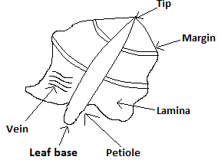

**The flower:**

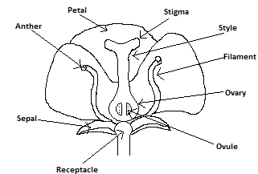

* The flower is the reproductive organ of most plants which bear seed.
* Apart from that, it is responsible for the development of seed and the production of fruit.

**Functions of the parts of the flower:**

**The sepals:**

* They are all referred to as the calyx.
* They enclose or cover the inner parts of the flower during its bud stage.
* Because they contain chlorophyll, they can also manufacture food.

**The petals:**

* The corolla is the name given to all the petals.
* Because they are brightly coloured and have sweet scent, they are able to attract insects to the flower.
* They also enclose and protect the stamen and the pistil.

**The stamen:**

* It consists of the anther and the filament.
* The anther produces the pollen grains, which contain the male reproductive cells.
* The filament bears and supports the anther in the most suitable position, for pollen transfer to take place.
* It us the male part of the flower and also referred to as the androcium.

**The pistil:**

* This is the female reproductive part of the flower.
* It is also referred to as the gynoecium.
* It consists of the ovary, the style and the stigma.
* The ovary produces the female cells or gametes called the ovules.
* The style holds the stigma in the most suitable way, so as to be able to receive the pollen grains.
* The stigma receives the pollen grains.

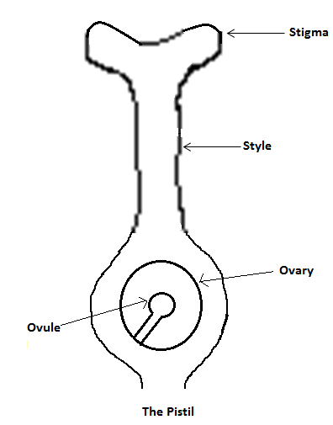

**The flower stalk:**

* It holds the entire flower.

**The receptacle:**

* This is the expanded end of the flower stalk, on which the other parts of the flower are attached.

**Fertilization:**

* In the flower, the two sex cells or gametes which are the pollen grains and the ovule take part in the sexual reproduction of the flower.
* Fertilization is the process in which the male gamete, fuses with the female gamete to form a zygote.
* After fertilization, the ovary develops into the fruit and the ovules into the seeds.
* The pollen grain which is transferred unto the stigma, germinates in the form of a tube called style towards the ovary.
* The nucleus of the pollen tube divides into two male gametes as it grows, and the pollen tube eventually enters the ovule at the two male gametes.
* One of these male gametes then focuses with the female gamete to form a zygote.
* The other male gamete then fuses with the secondary nucleus in the embryo sac to form the endosperm nucleus.

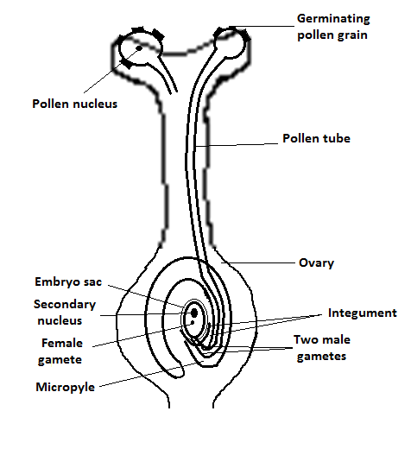

**The life cycle of a flowering plant:**

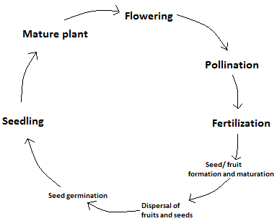

**Pollination:**

* This refers to the transfer of the pollen grains from the anther to the stigma of a flower.
* There are two types and these are self-pollination and cross pollination.

**Self-Pollination:**

* This occurs when the pollen grains are transferred from the anther to the stigma of the same flower, or to the stigma of another flower on the same plant.
* In this type of pollination, only one plant is involved.

**Characteristics of self-pollinated flowers:**

* The flower is bisexual i.e. the flower contains both the male and the female part.
* The stigma and the anther mature at the same time,
* The flower opens only after the occurrence of self-pollination.

**Advantages of self-pollination:**

* There is an assurance of seed production, since no agent of pollination is required.
* Since the pollen grains are transported over a short distance, they are more likely to get to the stigma for pollination to occur.

**Cross pollination:**

* This occurs when the pollen grains of one flower are transferred to the stigma of a flower of the same type, on another plant.
* Therefore for this type of pollination, two plants of the same type are involved.

**Characteristics of cross pollinated plant/ flowers:**

1. The plants bearing the flowers are dioecious, i.e. the male and the female flowers occur on separate plants.
2. The flowers are unisexual i.e. each flower has only the male parts or the female parts.
3. The anther matures before the stigma or the stigma matures before the anther.
4. It is difficult for the pollen grains to reach the stigma of the same flower, since the length of the style and the filament are different.

**Advantages of cross pollination:**

* The offsprings are of greater resistance to diseases.
* The seeds produced in this case are produced from two different parents, and are healthier than those produced from a single parent.
* This leads to the production of varied seed, which can grow in different places.

**The fertilization process:**

* When the pollen grains drops onto or falls on the stigma, it absorbs sugar solution from the stigma.
* This enables it to grow a tube towards the ovule.
* When the tube meets with the ovule, a zygote is formed which later on develops into the embryo or seed, while the ovary develops into the fruit.

**Differences between self and cross-pollination:**

|  |  |
| --- | --- |
| **Cross-Pollination** | **Self-Pollination** |
| It involves two flowers on different plants of the same species. | It involves one flower on one plant. |
| Produces healthier offsprings. | Produces less healthier offsprings. |
| The level of growth of seed is high. | The level of growth of seed is low. |
| Since the pollen grains are from different flowers, the seeds produced are well varied. | Since the pollen grains are from the same flower, the seeds produced are not well varied. |

**Agents of pollination:**

- These are either living things or non living things which carry the pollen grains from the anther to the stigma.- Some of these agents are insects and the wind.- Flowers which are pollinated by insects are called insect pollinated flowers, and those pollinated by the wind are called wind pollinated flowers.

**Insect pollinated flowers:**

- These flowers are able to attract insects because: (1) They have brightly coloured petals which have sweet scent.(2) They contain a sweet liquid called nectar, which is needed by insects in making items such as honey. (3) When these insects visit the flowering plant, they move from flower to flower. (4) By so doing, some of the pollen grains stick to their bodies, which are later on deposited on the stigma.

**Characteristics of insect pollinated flowers:**

- They are large.- They have brightly coloured petals

- They contain nectar and have sweet scent.- They produce only a few pollen grains which are sticky.

**Wind pollinated flowers:**

- These are flowers which are pollinated by the wind. -These flowers are not visited by insects because they contain no nectar, and do not have brightly coloured or sweet scented petals. - For these reasons it is the wind which carries the pollen grains of these flowers, from one flower and deposits them on another flower of the same type.

**Characteristics of wind pollinated flowers:**

- They are normally small. - They do not have brightly coloured petals. - They have no sweet scent and do not contain nectar. - Their pollen grains which are light are produced in large numbers or quantities.

**The transport system in plants:**

* The movement of materials from one part of the plant to another is termed or referred to as the transportation of materials.
* These materials are transported in the liquid form through a special group of cells called the vascular bundle.
* The vascular bundle is made up of the phloem and the xylem.
* The xylem carries water and mineral salt from the roots to the leaves for photosynthesis.
* The phloem sends the prepared food from the leaves to all the other parts of the plant.
* Food materials enter the root through the process of osmosis.

**Sensitivity in flowering plants:**

* Sensitivity or irritability is the ability of living organisms to respond to external forces or stimuli.
* These stimuli include light, water, the force of gravity, touch, chemical substances and sound.
* Plants respond to stimuli by either moving towards or away from the source of the stimuli.
* The type of movement in which the whole part of the organism moves is called tropism, and in plant tropism is always a growth movement.
* Tropism is named according to the type of stimuli involved.

**Types of tropism:**

There are various types of tropism and some examples are:

1. **Phototropism:**

* This is the type of movement in which a plant grows towards light.

1. **Geotropism:**

* Is the type of movement in which a plant grows towards gravity or the centre of the earth.

1. **Hydrotropism:**

* Is the type of movement in which a plant grows towards water.

1. **Haptotropism:**

* Is the movement in plants, as a result of something touching it.

**Dispersal of seeds (fruits):**

* This refers to the scattering of seeds and fruits from the parent plant to other places.
* Fruits and seeds are dispersed with the help of certain agents.

**Agents of dispersal:**

- The agents of dispersal of fruits and seeds are:

(1) Wind. (2) Animals.

(3) Water. (4) Man.

**The seed:**

* This is a fertilized ovule found within the fruit.

**The structure of the seed:**

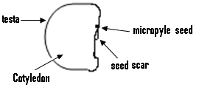

**The longitudinal section of a dicotyledonous seed such as a bean or a cowpea seed.**

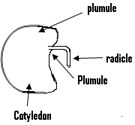

**The longitudinal section of a monocotyledonous seed such as a maize seed:**

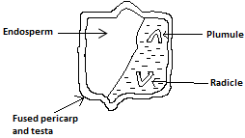

**Parts of the seed and their functions:**

1. **The Cotyledon:**

* This stores food for the embryo to use, during the early stage of germination.
* While a seed with only one cotyledon is said to be monocotyledonous, the one with two cotyledons are said to be dicotyledonous.

1. **The testa:**

* This is also referred to as the seed coat.
* It serves as a cover for the seed, and protects it against pests and diseases.

1. **The mycrophyl:**

* This is a small hole through whichair and water enters the seed.
* It is also through this opening that the pollen tube enters the ovule.

1. **The plumule:**

* This is the part of the seed that develops into the root.

1. **Hilium:**

* It marks the point where the seed is attached to the stalk.

**Differences between a fruit and a seed:**

|  |  |
| --- | --- |
| **Fruit** | **Seed** |
| Formed from an ovary. | Formed from an ovule. |
| Has two scars on its external. | Has only one scar on its external surface. |
| Has no pore (mycropyle) in the pericarp. | Has a pore (mycropyle) in its seed coat. |

**Wind dispersal of seeds/ Fruits:**

- There are three methods or ways by which this can occur, and these are:

1. The cancer method.
2. The winged fruit method.
3. The parachute mechanism.

**(a) The cancer method:**

- In this method, the ripe seed or fruit sways or moves in the wind, and it is carried to new places.

(b)**The winged fruit method:**

- In this method, the seeds or fruits have wings and are easily blown away by the wind.

**(c) The parachute mechanism:**

- In this method, the fruit or seed have hair and easily floats in the air.

* They are therefore carried to other places.

**(d) Animal dispersal:**

* Fruit and seeds dispersed by animals have hooks or are sticky.
* They therefore stick to the bodies of animals and are deposited some where else.

**(e) Man:**

* Man eats fruits and throws the seeds somewhere else.

**(f) Water dispersal:**

* Seeds and fruits dispersed by water contain a lot of air, and are covered by a coat or layer through which air and water cannot pass.
* The air is therefore trapped, and this trapped air enables them to float in water, so as to be carried to other places.

**(g) The explosive method:**- This is another way of dispersal of seeds or fruits without the help of any agent.

- The fruits simply burst open when ripe for the seeds to be scattered about.

**The importance of dispersal:**

* It prevents the overcrowding of the plants within an area.
* It helps the plant to be taken or introduced into new areas.
* It reduces the spread of diseases among plant species.
* It enhances the survival of plant species.
* It helps in the continuous existence of the plant.

**Types of fruits:**

* These are three types and these are:

1. Simple fruit. (b)Aggregate.

(c) Compound or multiple fruits.

* Simple fruit is formed from a single flower, and examples are lemon and beans.
* Compound fruit is formed from a branch of flowers, which are positioned close to each other, and an example is pineapple.
* Simple fruits can also be classified into two and these are:

1. Freshy fruits.
2. Dry fruits.

**Freshy fruits:**

* These are fruits which are juicy and succulent.
* There are various types and these are:

1. **Drupe:**

* This is a simple fruit which has a well-developed outer cover and examples are the coconut and the mango.
* A drupe has a thin epicarp, a fleshy or fibrous mesocarp and the seed is covered by a hard endocarp.

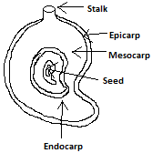

**The longitudinal section of a mango fruit (a drupe).**

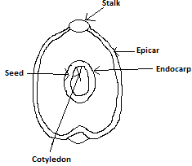

**Longitudinal section of a coconut (drupe)**

1. **Berry:**

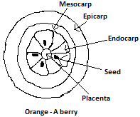

* A berry has a thin epicarp, a fleshy mesocarp and a fleshy endocarp.
* It produces many seeds.

1. **Pome:**

* This is also another simple fruit with examples being the apple and the pear.

**Dry fruits:**

* These are fruits which have hard outer cover called the pericarp.
* There are two types and these are

1. **Dry dehiscent fruits:**

* These are those dry fruits which can break open to release their seeds, with examples being okro and beans.

1. **Dry indehiscent fruits:**

* These fruits do not split open even though they have a dry outer cover.
* They are small and are produced in large numbers.

**An experiment to demonstrate the conditions necessary for the germination of seed:**

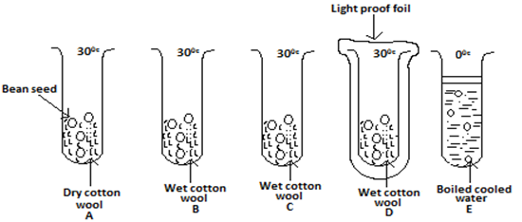

**Aim:** To show the conditions necessary for germination to occur.

**Apparatus:** Bean seeds, test tubes, cotton wool and boiled water.

**Procedure:**

* Five test tubes labeled A, B, C, D and E are set up as shown in the given figure.
* The test tube labeled A, B, D and E are placed in a warm place while C is placed in a refrigerator.
* The set-up is such that the bean seeds are exposed to the following conditions:

**Test tube A …………………….. Warmth and air.**

**Test tube B …………………….. Water, warmth and air.**

**Test tube C ……………………… Water and air.**

**Test tube D …………………….. Water, warmth, air and darkness.**

**Test tube E ……………………… Water and warmth (without air).**

* After a week, the set-up is observed for germination that has taken place.

**Observation:**

* No germination occurs in the test tubes labeled A, C and E.
* Germination failed to occur in the test tube labeled A, due to the absence of water.
* Germination failed to occur in the test tube labeled C, because its surrounding temperature of 00C, is not a suitable one.
* In the test tube labeled E, the boiled water contains no air since the boiling drove away the air found within the water.
* The oil also prevented any air from entering the water.
* Germination therefore failed to take place, due to the lack of air.

**Conclusion:**

* Germination of seeds only occurs in the presence of water, warmth (suitable temperature) and air.
* Light is not one of these conditions.

**Germination of Seeds:**

* Germination is the process whereby a viable seed starts to develop into a young seedling.
* A viable seed is a seed which develops when suitable conditions are available.
* The conditions which are necessary for germination to occur are:

1. The presence of water (moisture).
2. Suitable temperature.
3. The presence of air (oxygen).
4. The viability of the seed.

**The role played by water:**

* It softens the seed coat, so as to enable the seed coat to easily burst to release the plumule and the radicle.
* It facilitates the transport of food substances in seedlings.
* It is needed to activate the enzymes.
* It serves as a medium for metabolic activities.

**The role played by suitable temperature:**

* It increases the rate of metabolism in germinating seeds.
* It enables enzymes to be able to react.

**Role played by oxygen:**

* It is needed for aerobic cellular respiration.

**Role played by viable seed:**

* It has a healthy embryo which is disease free.
* It germinates under favorable environment conditions.
* They are free from disease causing organisms.

**How germination occurs:**

* Water enters the embryo through the mycropyle.
* This causes the swelling of the seed, which causes the rapture of the seed coat.
* Oxygen is absorbed by the seed which makes available the necessary energy needed for growth.
* The food stored in the cotyledon are broken down by enzymes into simpler substances, that are transported through the embryo to the various centers of growth.
* The radicle then breaks through the seed coat and develops root hairs, that absorbs water and attaches the embryo to the soil particles.
* The cotyledons later appear above the soil.

**Factors that affect the stages of the life cycle of flowering plants:**

* These factors are:

1. Temperature.
2. Oxygen.
3. Carbon dioxide.
4. Water.
5. Nutrition or availability of nutrients.
6. Light.

**Temperature:**

* It influences most plant processes such as photosynthesis, transpiration, respiration, germination and flowering.
* As temperature increases (up to a certain point), photosynthesis, transpiration and respiration also increases.

**Oxygen:**

* This is required by green plants for their normal growth.
* Energy is released during cellular respiration, and roots use this energy for the absorption of salts and root extension.
* Roots which do not get enough oxygen, may stop growing and are easily attacked by diseases.
* Seeds also need oxygen for germination, and their germination is affected when oxygen is not available for a long time.

**Carbon dioxide:**

* This is needed for photosynthesis.
* When the level of carbon dioxide production from respiration, becomes equal to the amount used for the photosynthesis, then no growth will occur in the plant.

**Water:**

* This is needed for photosynthesis and for the production of new compounds.
* Most growing plants contain about 90% water.
* Plants are cooled as they lose water from their leaves.

**Nutrition:**

* Two types of elements are needed for the growth and development of flowering plants.
* These are the macro elements and the micro elements.
* While the macro elements are needed in large quantities, micro elements are needed in small quantities.

**Light:**

* This is needed for photosynthesis.
* Plants will therefore not grow well in the absence of light.

**The reason why knowledge about the life cycle of flowering plant is important in crop production:**

* For a farmer to be successful in crop production, he or she must have sufficient knowledge about all the stages and factors that affect the life cycle of flowering plants.
* This is to ensure that all the conditions or factors necessary for a crop to grow through each of the life cycle exist.
* For example, if the crop is in the germination stage, then the farmer must ensure that it is exposed to a suitable temperature, adequate air and adequate water.

**Photosynthesis:**

- This is the process in which green plants prepare their food.- The food prepared by the plant is called carbohydrate or starch.- Unlike plants, animals cannot prepare their own food and they therefore eat plant or depends on plant for food.

**Conditions necessary for photosynthesis**

* These conditions are:

(1) Carbon dioxide (2) Water

(3) Chlorophyll (4) Sunlight.

**(1) Carbon Dioxide):**

- For photosynthesis to take place, carbon dioxide must be present. - The leaf of the plant absorbs carbon dioxide from the air through its stomatas. - These stomata are small holes found on the surface of the leaves.

**(2)Water:**

- The water needed for photosynthesis is absorbed or removed from the soil by the roots.- It is then conducted or passed through the stem into the leaf, where photosynthesis occurs.

**(3)Chlorophyll**:

- Chlorophyll is needed for photosynthesis. - It is a substance which when present in the plant, causes the leaves and other parts of the plant to be green in colour.- Photosynthesis normally occurs in green leaves, but it can occur in any part of the plant which is green in colour, since these parts also contain chlorophyll.

**(4) Sunlight:**

- Photosynthesis occurs only in sunlight but not in darkness.- The energy needed by plants for photosynthesis is sunlight.

* In the absence of sunlight, photosynthesis cannot occur.

**How photosynthesis occurs:**

* The chlorophyll is always present in the leaves.
* The carbon dioxide absorbed from the atmosphere gets into the leaves.
* The water absorbed from the soil passes through the stem into the leaves.
* When the sun appears, energyfrom it is absorbed by the leaves.
* The chlorophyll, CO2 and the water is then changed into carbohydrate or starch.
* Good or mediate temperature is also needed for photosynthesis to occur.
* Finally whenphotosynthesis occurs, oxygen is given off or released into the atmosphere.

**The importance of photosynthesis:**

* Oxygen is released into the atmosphere, which is used for breathing by man and animals
* **Experiment to show that oxygen is given out during photosynthesis:**

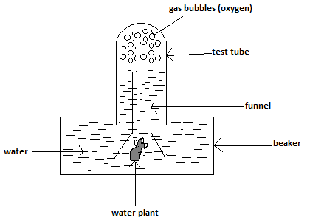

**Methods:**

* Take a beaker which contains water.
* Place the funnel over the water plant in the water, so as to enclose or cover the plant.
* Fill a test tube with water and invert it over the stem of the funnel.
* Place the whole set up in the sunlight for about five hours.

**Observation:**

* Bubbles of gas will collect in the test tube.
* This gas was able to rekindle a glowing wooden splint, which indicates that it was oxygen.

**Conclusion:**

Oxygen is therefore given out during photosynthesis.

**Experiment to show that chlorophyll is needed for photosynthesis:**

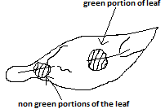

**Method:**

* A variegated leaf which has been in the sun for some time is detached or removed from the plant.
* A variegated leaf is one having green portions and non green portions.
* The leaf is then tested for the presence of starch.

**Observation:**

* It will be noted that it is only the green portions of the leaf which will turn blue black with iodine.
* Those parts of the leaf which are not green in colour will not turn blue black with iodine, which indicates the absence of starch.

**Conclusion:**

* Photosynthesis only occurs in the green parts of the leaf, which contain chlorophyll.

**N/B:** Oxygen which is one of the products of photosynthesis is given off from the surface of the leaf into the atmosphere through the stomata.

**Experiment to show that CO2 is necessary for photosynthesis:**

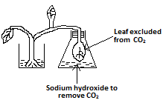

**Method:**

* Keep a potted plant in the dark for between 24 – 48 hours.
* This is to remove from the leave any starch they may contain.
* Sodium hydroxide is then placed into a bottle.
* A leaf which is still attached to the plant is placed inside the bottle, and tightly corked in order to make it air tight.
* The sodium hydroxide will remove the CO2 in the bottle.
* Place the plant in the sun (sunlight) for between 4 – 6 hours.
* Then remove the leaf from the bottle as well as another one outside the bottle.
* We then test for the presence of starch in each of the leaf.

**Observation:**

* The leaf from outside of the bottle will turn blue black within iodine but the one which was placed inside the bottle will not.

**Conclusion:**

* Because there was no CO2 in the bottle, the leaf which was kept inside the bottle could not undergo photosynthesis to produce starch.
* Therefore CO2 is needed so that photosynthesis occurs.

**An experiment to demonstrate that starch is a product of photosynthesis or an experiment to test for starch in a leaf:**

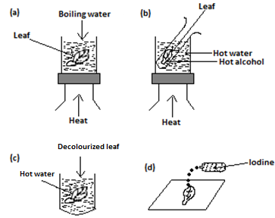

**Procedure:**

* A leaf which has received sunlight is plucked and boil in water for about five minutes to kill the leaf, (i.e. to kill the living cells in the leaf).
* The leaf is dipped in warm alcohol, in order to remove the chlorophyll that it contains.
* It is then dipped in cold water to wash away the alcohol.
* The leaf is dipped in boiling water about three seconds to make it soft.
* It is finally placed on a white plate and few drops of iodine solutions are poured on it.

**Observation:**

* The leaf turns blue black.

**Conclusion:**

* The blue black colour is an indication of the presence of starch in the leaf.

**Experiment to show that light is necessary for photosynthesis:**

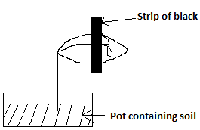

**Method:**

* Keep a potted plant in the dark for between 24 to 48 hours.
* This is to ensure that no starch is formed in it.
* Use a strip of black paper to cover part of the leaf, early in the morning.
* The whole plant is placed in the sun for about 5hours.
* The leaf is then removed from the plant and the strip of black removed from the leaf.
* The leaf is then tested for the presence of starch.

**Observations:**

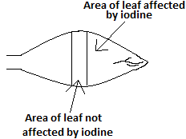

* It will be seen that the part of the leaf which was covered with the black paper will not turn blue black with iodine.
* This shows that starch was not formed in this portion.
* But the portion which was not covered will turn blue black which indicates it contains starch since it received sunlight.

**N/B:**

* There are certain types of leaves which are not entirely green in colour.
* These leaves may have red or yellow patches on them and they are called variegated leaves.
* These red or yellow patches normally do not undergo photosynthesis.
* It is only the green parts which undergo photosynthesis because these areas contain photosynthesis.

**Questions:**

(Q1)(a) Name the two main parts of a flowering plant.

Ans: The root system and the shoot system.

(b)List two importance or functions of the roots to the plant.

(c)Give two reasons why the stem is important to the plant.

Ans:

* Can be used for vegetative propagation.
* Carries manufactured food from the leaf to other part of the plant.

(d)List two functions of the leaf.

Ans:

* Some store food.
* To carry out photosynthesis.

(Q2)(a) Draw a flower and name its parts.

(b)Give the importance of the sepals to the flower.

Ans: - It protects the flower during the early stage of growth.

(c)Of what importance is the corolla or the petals to a plant.

Ans: They attract insects which cause pollination to the plant.

(d)Explain why the petals are able to attract insects to the plant.

Ans: Because of their bright colour and sweet scent.

(e)What is the name given to the female part of the flower?

Ans: Pistil or gynoceuim.

(Q3)(a) What is the name given to the food prepared by green plants?

Ans: Starch or carbohydrates.

(b)List three conditions necessary for photosynthesis.

Ans: Carbon dioxide, chlorophyll and water.

(c)Explain why photosynthesis can only occur in the green parts of the plant.

Ans: Because these areas contain chlorophyll, without which photosynthesis cannot occur.

(d)Name the gas which is released into the atmosphere during photosynthesis.

Ans: Oxygen.

(e)Give two importance of photosynthesis.

Ans: - Through it oxygen needed by animal to live is released into the air.

* Through it also, plants and animals get their food.

(Q4)With the aid of a diagram, describe an experiment to prove that oxygen is given off, during photosynthesis.

(Q5)Briefly explain how you will show that chlorophyll is needed for photosynthesis.

Ans: You must describe the experiment which shows that, chlorophyll is needed for photosynthesis.

(Q6)(a) Briefly explain how you will test for the presence of starch in a leaf.

(b)Why is it thatg such a leaf must be kept in sunlight for some time, before the test.

Ans: So that photosynthesis can occur for the starch produced to be in the lleaf.

(Q7)(a) What do you understand by the dispersal of seeds.

(b)List three agents of dispersal of fruits and seek.

Ans: - Wind, animal and water.

(Q8)Explain the following methods of seed dispersal.

(a) The cancer method.

(b) The parachute mechanism.

Ans:

* In the cancer method, the ripe seed or fruit sways in the wind, and carried to other places.
* In the parachute mechanism, the fruit or seed which have hair easily float in air, and carried to other places.

(Q9)Give two importance fruit and seed dispersal.

(Q10)Explain how man helps in the dispersal of seed.

* By throwing seeds away after eating fruits.

(Q11)List two differences between self-pollination and cross pollination.

Ans:

* Cross pollination produces healthier offsprings then self-pollination.
* For cross pollination, the level of growth of seed is high, but with self-pollination, this level is low.

(Q12)Give one advantage of self-pollination.

Ans:

* Because the pollen grains are transported over a short distance, they are more likely to get to the stigma for pollination to occur.

(Q13)Describe an experiment to demonstrate the conditions which are necessary for seed germination.

(Q14)List three factors that affect the stages of the life cycle of flowing plants.

Ans:

* These factors are temperature, oxygen, water and light.

**Chapter Twenty One**

**The Sense Organs:**

* Animals as well as man, is made aware of its external environment by means of the sense organs.
* These organs are the eye, the ear, the skin, the tongue and the nose.

**The eye:**

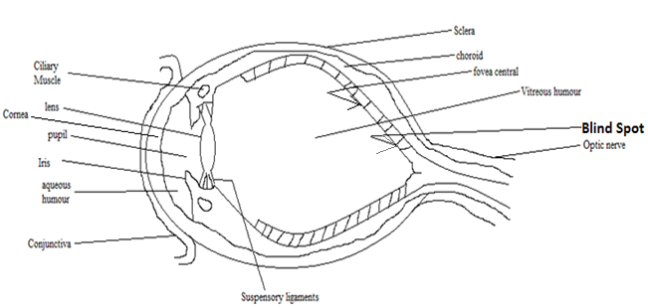

* This is the sense organ which is used for sight or seeing.
* The eye is spherical in shape and is found in a cavity or hole in the skull, called the eye socket or orbit.
* The lower and the upper eyelids protect the surface of the eye from the outside.
* The blinking of the eye distributes moisture evenly over the exposed surface of the eye.
* Each eye is provided with a tear gland which produces tears, which is slightly salty or saline.
* The tears clean the exposed part of the eye and keep it moist.
* The parts of the eye are:

**The Sclera**

* This refers to the outer covering of the eye, which protects the inner structure of the eye.
* The front part of the sclera is modified to form the cornea, which is the transparent part of the eye which allows light to enter the eye.

**The Choroid:**

* This forms a layer which provides nourishment to the eye.
* The choroid layer is supplied with many blood vessels, which carry ingredients to the various parts of the eye.

**The Retina:**

* This is the inner layer of the eye ball which is lined with cells, which are sensitive to light.
* The retina serves as a screen on which the images are formed on the eye.
* It contains two types of light – sensitive cells, which are the rods and cones.
* Whilst the rods are responsible for night vision, the cones are responsible for day light vision and colour.
* On the retina can be found two regions, which are the fovea contralis and the blind spot.
* The fovea contralis is the most sensitive region of the retina, and it is also referred to as the yellow spot.
* Images of objects fall on this part of the retina.
* Since the blind spot contains no sensory cells, images formed on them cannot be seen, since no impulses are sent to the brain from this spot

**The Lens:**

* This is a transparent object which focuses images onto the retina.
* Since the lens is flexible, it can change its shape and this is different from the camera lens, which cannot change its shape.
* The lenses of the eye are held in space by the suspensory ligament.

**The Iris:**

* This adjusts the size of the pupil.
* When the amount of light entering the eye is too bright, the iris decreases the size of the pupil inorder to reduce the amount of light entering.
* On the other hand if the amount light is too dim, the iris enlarges the pupil inorder to allow enough light to enter the eye.

**The Aqueous Humour and the Vitrous Humour:**

* The space between the lens and the cornea is filled with a liquid called aqueous humour.
* It helps in maintaining the shape of the eye and nourishes it.
* Another liquid called the vitreous humour can be found between the lens and the retina.
* It also nourishes the eye and helps it to maintain its shape.

**The Optic Nerve:**

* Massages from the eyes are sent to the brain through the optic nerve.
* Also responses from the brain pass through the optic nerve back to the eye.

**Formation of Image on the eye:**

1. Light from the object enters the eye through the cornea, and the lens focuses this onto the retina.
2. An image is therefore formed on the retina.
3. This image is real, inverted and diminished.

**Accomodation:**

* This refers to the ability of the eye lens to change its shape, so that objects at different distances can be focused on the retina.
* When viewing a distant object the lens becomes thinner, and the lens become fatter when the lens is viewing a near by object.

**The far point of the eye:**

* This is the furthest point the eye can see clearly.

**Eye defects:**

* These include long sightedness (hypermetropia), short sighted (myophia), presbyopia, astigmatism, colour blindness and glaucoma.

**Long Sightedness:**

* In this type of defect, the eye is able to see only distant objects clearly.
* This occurs when the eye ball is too short, causing the image to be formed not on the retina but behind it.
* This defect can be corrected by the use of a convex lens (converging lens).

**Short Sightedness:**

* This is the type of defect in which only nearby objects can be seen clearly.
* A short sighted person can therefore not see distant or far objects clearly.
* This defect is caused as a result of the eye ball being too long, causing the formation of the images of distant objects to occur not on the retina, but rather infront of it.
* Short sightedness is corrected by means of a concave or a diverging lens.

**Astigmatism:**

* This type of defect occurs when there are abnormalities in the shape of the cornea or the lens.
* Under such a condition, some of the light rays are focused on the retina, while others fall infront or behind the retina.
* This often results in eye straining and blurring for both distant and nearby objects.
* It can be corrected by the use of a cylindrical lens.

**Presbyopia:**

* This eye defect occurs at old age, for as one grows the lens of the eye becomes weak and for this reason, old people find it difficult to see nearby objects.
* Presbyopia is therefore a kind of long sightedness which occurs at old age.
* It can be corrected by the use of a biconvex lens.

**Glaucoma:**

* This occurs when the pressure inside the eye increases beyond the expected value.
* It can be treated by doctors when detected early.

**Colour blindness:**

* In this type of eye defect, a person is unable to distinguish between certain colours.
* It is inherited and cannot be corrected or cured.

The Ear

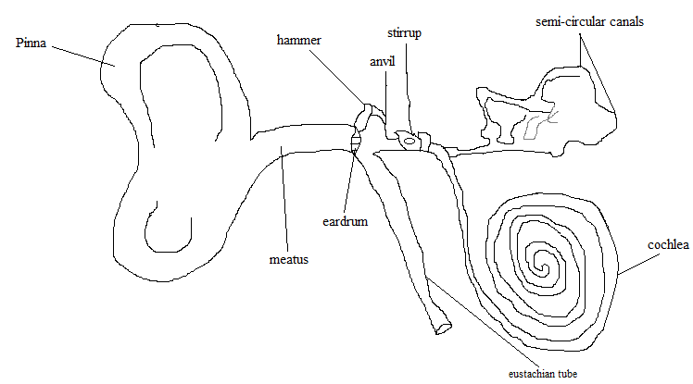

* The ear is the sense organ which is used for hearing, and enables us to balance.
* It consists of three parts and these are the outer ear, the middle ear and the inner ear.

**The outer ear:**

* The outer ear consists of the pinna and a canal called the auditory meatus or the meatus.
* The function of the pinna is to collect and direct sound waves through the canal to the ear drum, causing it to vibrate.
* The canal also contains fine hairs, oil and wax gland which protects the ear drum from bacteria and dirt.

**The middle ear:**

* It consists of the tympanic membrane (ear drum), the ossicles and the oval window (fenestrate ovalis).
* The ear drum receives sound waves and transfers them to the ossicles.
* The ossicles which is found within the middle ear consists of three pieces of bones, and these are the hammer (malleus), the anvil (incus) and the stirrup (stapes).
* The function of these ossicles is to amplify the sound waves, for onward transmission into the inner ear.
* The Eustachian tube runs from just behind the tympanic membrane to the pharynx.
* The middle ear also contains nerve cells which are sensitive to vibrations, and sound vibrations are sent to the brain from this point.

**Inner ear:**

* It consists of a coiled tube called the cochlea which is filled with a liquid, and the semi-circular canals.
* The cochlea enables an individual to hear, while the semi-circular canal helps an individual to maintain balance.

**Hearing:**

The process of hearing is as follows:

1. The sound wave enters the ear and strikes the ear drum, causing it to vibrate.
2. This causes the three bones in the middle ear to vibrate.
3. These vibrations are passed onto the cochlea as well as the liquid inside it.
4. The vibration of the liquid stimulates the nerve cell, which sends sound vibrations to the brain.

**The tongue:**

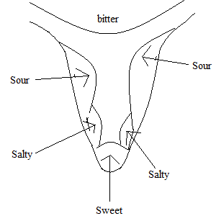

* The tongue is the sense organ for taste, and different parts of the tongue are sensitive to different tastes.
* Whilst same parts are sensitive to salty substances, others are sensitive to sweet and bitter substances as indicated in the given diagram.

**Co-ordination:**

* This refers to the relationship among the various parts of the body.
* There are two types and these are:

1. Nervous co-ordination by the nervous system.
2. Chemical co-ordination by the endocrine system.

**The brain:**

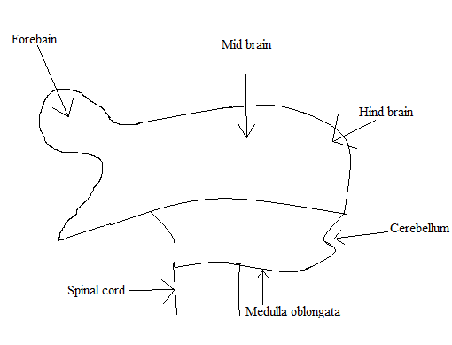

* The brain controls about 80% of the body’s activities
* The brain is divided into five parts and these are:

1. Forebrain. 2. Midbrain.

3. Hindbrain. 4. Medulla. 5. The cerebellum.

* The surface of the brain is grey in colour while the inside is white in colour
* All the parts of the brain perform different functions
* The brain functions by receiving information called impulse through the nerves, from sensory organs such as the skin.

**Forebrain:**

* This is the seat of the sense of smell and consists mainly of the cerebrum
* In other words, the cerebrum forms the largest part of the forebrain.
* For this reason, the forebrain is sometimes referred to as the cerebrum
* All voluntary actions are controlled by the cerebrum, and it is this part of the brain that the following occurs:

1. The ability to learn.
2. The ability to show intelligent behavior i.e. making correct responses in a given situation.
3. Serving as the centre of memory, reasoning and judgment.

* Attached to the cerebrum are two structures called the olfactory lobes, which receive the small impulses.
* There are also two other structures called the thalami and each is referred to as thalamus.
* Below the thalami is the hypothalamus which control centre for body temperature, appetite and sleepiness.
* Even though the cerebrum controls all the voluntary actions, certain parts of the brain control involuntary actions.

**Midbrain:**

* ­­­This is the sight which controls sight and hearing.

**Hindbrain:**

* This is made up of Pons varolli, medulla oblongata and cerebellum.
* The cerebellum controls the movement of muscles.
* The medulla oblongata controls many involuntary body actions, especially those concerned with respiration, heartbeat and digestion.
* While the surface of the medulla oblongata is white, its inside is grey.

**The spinal chord:**

* This is a cylindrical tube which is attached to the base of the brain, and located within the backbone or the vertebral column.
* Whilst its surface is white, it is grey inside.
* It functions by receiving information through the nerves, from the sense organs such as the skin.
* When it receives impulses or information, it reacts unconsciously and immediately to it and this is expressed in the person’s behavior.
* The spinal cord controls most of the involuntary actions or reflex actions, and examples of these reflex actions are the blinking of the eye and sneezing.

**Different between Voluntary and Involuntary actions:**

|  |  |
| --- | --- |
| Voluntary action | Involuntary action |
| 1. The responds effect is slow. | The responds effect is very fast. |
| 1. It is controlled by the brain. | It is controlled by the spinal cord. |
| 1. It occurs consciously i.e. they are under the control of the will of the individual. | It occurs unconsciously i.e. it is not under the control of the will of the individual. |

**Reflex action:**

* These are actions that occur automatically.
* They are considered to be involuntary actions.
* They are controlled by the spinal cord only, since there is no part of the brain which controls a reflex action.

**Reflex arc:**

* This is the part followed by a reflex action.
* It consists of three neurones (i.e. the sensory neurone, intermediate neurone and the motor neurone), a receptor and an affector.

**Receptors:**

* These are sense organs which receive massages from external stimuli
* They are found in the skin.

**Effectors:**

* They receive interpreted massages from the spinal cord or the brain.
* They are mostly muscles and glands.
* When a receptor receives a massage from an external stimulus, it is carried by the sensory neuron to the intermediate neuron in the spinal cord.
* The interpreted massage passes through the motor neuron to the effectors, for the necessary action to be taken.

**The nervous system:**

* This consists of the central nervous system and the peripheral nervous system.
* The central nervous system is made up of the brain and the spinal cord.
* While the brain is protected by the bony cage called the cranium, the spinal cord is protected by the backbone.
* The brain and the spinal cord are made up of cells called nerve cells or neurones.
* There are two types of nerve cells and these are the sensory neurone and the motor neurone.
* A group of neurones is referred to as a nerve.

**Sensory Neurones:**

* These are neurones that send impulses or massages from the sense organs to the brain, and a group of sensory neurones are called sensory nerve.

**Motor Neurones:**

* These are neurones that send response from the brain to the sense organs.
* A group of motor neurones are known as motor nerve.

**Voluntary and Involuntary action:**

* The activities of the body are grouped into two and these are Voluntary action and Involuntary action.

**Voluntary action:**

* These are actions which are under the control of the cerebrum, which implies that they are under the control of the will of an individual.
* They are therefore thought of before they occur.
* Examples of voluntary actions are reading, laughing, walking and speaking.

**Involuntary action:**

* These are actions which occur unconsciously, which implies that they are not thought of before they occur.
* Since they occur automatically, they are not under the control of an individual.
* An example is the rapid removal of the hand from a hot object, when one mistakenly touches one.

**Questions:**

1. (a) What is the shape of the eye?

**Ans:** Spherical.

(b) Give the importance of the eyelids to the eye.

* It protects the surface of the eye from the outside.

1. Explain why the blinking of the eye is important?

**Ans:**It distributes moisture evenly over the eye surface.

1. What is cornea?

**Ans:** It is the transparent part of the eye, through which light enters the eye.

(2)(a) What is meant by the retina and give its importance?

Ans:-It refers to the inner layer of the eye ball, which is lined with light sensitive cells.

* Its importance is due to the fact that:

1. It serves as a screen on which images are formed.
2. It contains sensitive cells called the rods and the cones, which are responsible for night and day time vision respectively.
3. What do you understand by the yellow spot?

Ans: It refers to the most sensitive portion of the retina, on which images are formed.

1. Explain why the images formed on the blind point of the eye, cannot be seen

Ans: Because impulses are not sent to the brain from this spot, since it contains no sensory cells.

1. Give the importance of the iris and the lens to the eye.

Ans: Whilst the lens focuses images onto the retina, the iris adjusts the size of the pupil and as such controls the amount of light which enters the eye.p

(Q3) (a) Explain what the aqueous humour is and give it importance.

Ans: It is the liquid found between the lens and the cornea.

* Its importance is that it nourishes the eye, and also helps to maintain its shape.

(b) Of what importance are the optic nerves?

Ans: Massages from the eye are sent to the brain through these nerves.

* Responses from the brain to the eye pass through these nerves.

1. Make a labeled diagram of the eye.
2. Differentiate between long sightedness and short sightedness, explaining how each can be corrected.

Ans: In long sightedness, only distant objects can be seen clearly by the eye, while in short sightedness, only nearby objects can be seen clearly. Long sightedness can be corrected using convex lens and short sightedness can be corrected using concave lens.

(Q4)(a) What is astigmatism and explain why it occurs.

Ans: Astigmatism is a kind of eye defect.

* It occurs as a result of abnormalities in the shape of the cornea or the lens, causing some of the light rays to be focused on the retina, whilst others fall infront or behind the retina.

(b) Explain that we mean when a person is said to be suffering from colour blindness.

* This implies that he cannot distinguish between certain colours.

(c) Make a labeled diagram of the ear.

1. Give the importance of the ear.

Ans: For hearing and balance.

(5)(a) Of what importance are the pinna and the canal to the ear?

Ans: The pinna directs sounds waves to the ear drum, causing it to vibrate.

* Within the canal are fine hairs, oil and wax glands which protect the ear drum from dirt and bacteria.

(b) Give the main function of the ear drum.

Ans: To receive sound waves and transfer them to the ossicles.

1. Give the importance of the cochlea and the semi-circular canal.

Ans: The cochlea enables us to hear and the semi-circular canal helps an individual to maintain his or her balance.

1. Briefly describe the process of hearing.

(Q6)(a) Name the main parts of the brain.

Ans: These are the forebrain, the midbrain, the hindbrain, the medulla and the cerebellum.

(b) Which part of the brain controls voluntary actions.

Ans: The cerebrum.

(c) Give the roles played by the hypothalamus.

Ans: It is responsible for an individual's appetite, sleepiness and the control of his body’s temperature.

1. Give the role played by the medulla oblongata.

Ans: It controls certain involuntary actions such as those concerned with respiration and digestion.

1. Name the structure which protects the spinal cord.

Ans: The backbone.

(Q7)(a) Give the main function of the midbrain.

Ans: It controls seeing and hearing.

(b) Name the structure which controls most of the reflex actions, and give an example of such an action.

Ans: The spinal cord controls most of the reflex actions, and an example is the blinking of the eye.

(c) Differentiate between voluntary action and involuntary action.

Ans: While voluntary actions are under the control of the will of an individual, involuntary actions are automatic and as such are not under the control of an individual.

1. Give one difference between voluntary action and involuntary action.

Ans: With voluntary action the response effect is slow, but with involuntary action it is fast.

1. Explain what the reflex arc is.

Ans: It is the path followed by a reflex action

CHAPTER TWENTY TWO

CELLS AND BLOOD

Cell:

- This is the smallest unit of a living organism, which is capable of basic life processes such as excretion and reproduction. All living things are composed of cells, and certain microscopic organisms such as the bacteria, protozoa, euglena as well as amoeba consist of a single cell.For this reason, they are said to be unicellular.On the other hand, plants, animals, humans and fungi are composed of many cells and are therefore said to be multicellular. The cell consists mainly of the cytoplasm and the nucleus, which are collectively referred to as the protoplasm.The cytoplasm is a jelly-like fluid within the cell, which consist of about 90% water with salt and sugar dissolved in it.Fats and proteins are suspended in the cytoplasm.The function of the cytoplasm is that it contains all the organelles, starch granules and oil globules.At the centre of the cytoplasm is a dense structure called the nucleus, which is surrounded by the nuclear membrane.The functions or importance of the nucleus are that, it controls all the chemical processes or reactions within the cell, and it is also responsible for the division of the cell.Apart from that the nucleus also contains the chromosomes, which carry the genetic information of the cell.

There are two types of cells and these are the plant and the animal cells.The outer cover of the animal cell is referred to as the cell membrane or the plasma membrane.It is very thin and semi-permeable, made up of layers of lipids and protein.Cell wall is the name given to the outer covering of a plant cell, and it is made up of carbohydrate called cellulose.Found also within the cell are the vacuoles and the mitochondrion.

**The animal cell**

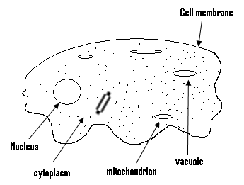

- Animals cells are of different shapes and sizes and may be spherical, irregular or spiral in shape.They are flexible and consist of the cell membrane, which is the outermost wall.Within the cell membrane can be found the cytoplasm and nucleus, which are referred together or collectively as the protoplasm, which is the living part of the cell.Found also within the animal cell are the mitochondrion, and open spaces called the vacuoles which accumulate food and waste materials from the cells.The nucleus directs all the living processes within the protoplasm, while all the chemical processes take place in the cytoplasm.

**The plant cell**

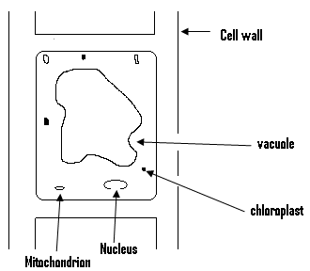

The plant cell has a rectangular outline and a fixed shape. It consists mainly of the cell wall, chloroplast, mitochondrion, cytoplasm, nucleus and the vacuole.The cell wall protects the inner part of the cell which is known as the protoplasm.The chloroplast found within the plant cell gives the green colour to most leaves and stems, and apart from that it also absorbs sunlight for photosynthesis.The vacuole accumulates the food and waste found within the cell.

**Differences between plant and animal cells;**

(1)Plant cell has cell wall, while animal cell has cell membrane.

(2) Plants cells have chloroplast but animals do not.

(3) Plant cell has a large vacuole and a small cytoplasm, but animal cell has a small vacuole and a large cytoplasm.

(4) Plant cells are bigger than animal cells.

**Tissue:**

- This is formed when a group of cells comes together to perform the same duty.- Examples of tissues found in animals are the bones, the nerves and the muscles.- Also examples of tissue found in plants are the phleom and the xylem.

**Organs:**

- This is formed when a group of tissues come together to perform the same function.- Examples of organs found in animals are the heart and the kidney, and that of those found in plants are the roots, the stem and the leaves.

**System:**

- This is formed by the coming together of a group of organs to perform the same function.- An example is the circulation system, which consists of the heart, the blood, the veins, the arteries and the capillaries.The excretory system consists of the kidney, the bladder, and the urethra.

**Organism:**

- This is formed from the efficient co-ordination of organs and systems, to produce an individual capable of separate existence.

**Blood:**

- This is a living tissue and is the life stream of the human body.

- This red fluid performs many tasks, and no part of the body can live without it.

- Blood supplies the cells of the body with the food and oxygen they need for work and growth.

- It carries waste products from the cells to special organs that remove them from the body, or break them down into harmless substances.

- It is the heart which pumps the blood through the body.

- Eventhough blood flows from the heart through the arteries, it is returned to the heart through the veins.

- The large arteries which leave the heart carry blood into smaller and smaller vessels, with the smallest of these being the capillaries.

- Oxygen, food and waste pass between the blood and the body cells through the walls of the capillaries.

- Blood flows from the capillaries into larger and larger veins, until it reaches the great veins that enter the heart.

- Many other organs work to keep the blood functioning.

- For example, the lungs supply it with oxygen and remove carbon dioxide from it.

- While the kidney keeps it free of poison, the liver and the intestines supply the blood with food.

The components or the composition of blood:

Blood has four main parts and these are:

(1) Plasma. (2) Red blood cells.

(3) White blood cells. (4) Platelets.

**Plasma:**

--This is the liquid part of the blood.

-- The red and white blood cells as well as the platelets are solid substances that are

suspended in it.

-- Eventhough it consists mostly of water, it also contains other substances such as protein, digested food, waste products and minerals.

-- Digested food enters the plasma from the intestines, and the blood carries it to the body cells, which use it to produce energy and new tissue.

-- Waste products are picked up from the cells by the blood, and the plasma carries many of these wastes.

-- The kidney and the liver remove waste from the plasma.

-- Plasma also carries various minerals and dissolved gases,and also carries homones from one part of the body to anther.

**The Red Blood Cells:**

-- They are also referred to as the erythrocytes or the red blood corpuscles.

-- Their main job is to carry oxygen from the lungs to the body tissues or cells, and to carry carbon dioxide from these tissues or cells to the lungs.

-- They contain a red pigment called haemoglobine which gives the blood its red colour.

**The White Blood Cells:**

-- They are also referred to as leucocytes, and they protect the body against disease and infection.

-- They are also called the white blood corpuscles.

**Platelets:**

-- They help in the clotting of blood, and as such prevent the loss of blood from damaged blood vessels.

-- If a vessel is cut or broken, platelets stick to the damaged surface and to one another.

-- As they pile up, they form a temporary seal over the injury and at the same time, they release substances that start the process of blood clotting.

-- For a person will bleed to death from even a small cut, if his blood does not clot.

**The Functions of Blood:**

(1) It carries oxygen from the lungs to the body’s tissues for respiration.

(2) It transports carbon dioxide from the tissues or cells to the lungs for excretion.

(3) It transports digested food from the intestines to the tissues (cells).

(4) It helps in the distribution of heat within the body, and as such regulates the body’s temperature.

(5) It helps the body defend itself against diseases.

(6) It transports hormones to the tissues and stops bacteria from entering the body.

(7) It clots, which prevents further bleeding to prevent the excssive blood lost.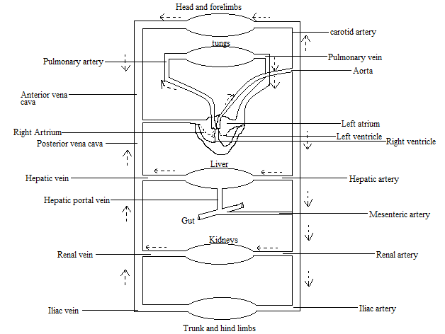

Blood Circulation:

-- In man, blood transports materials from one part of the body to another.

-- The blood flows through certain structures called blood vessels.

-- The heart which is the main organ of circulation pumps the blood into the blood vessels.

**Blood Vessels:**

These are the structures through which the blood flows.There are three types and these are the arteries, veins and the capillaries.

**Arteries:**

These are the blood vessels that carry blood away from the heart, with the largest artery being the aorta.They divide into smaller ones called arterioles.Arteries carry oxygenated blood i.e. blood which contains oxygen.

**Veins:**

These are blood vessels that carry deoxygenated blood i.e. blood which does not contain oxygen to the heart.The vena cava which is the largest vein within the human body, divides into smaller ones called venules.

Capillaries:

These are blood vessels which joins the arteries to the veins.Capillaries are very light, and the assimilation of digested food occurs within the capillaries by the process of diffusion.The next diagram illustrates the connection between the artery, capillary and the vein.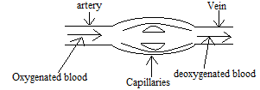

**The Heart:**

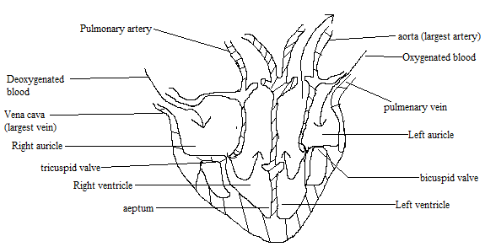

The heart is the centre of circulation and without it; there can be no blood circulation.As it pumps oxygenated bloods to all parts of the body, it also receives deoxygenated blood from all parts of the body.The heart works continuously and does not stop working.

**The Structure of the Heart:**

- The heart is divided into two main parts, and these are the auricle and the ventricle. - The auricle is again divided into two i.e. the left auricle and the right auricle. - Just as the auricle, the ventricle is also divided into two main parts i.e. the left and the right ventricles.

- For this reason, there are four chambers within the heart i.e. the left and the right auricles as well as the left and the right ventricles.While the left part of the heart is used for oxygenated blood, the right half is used for the deoxygenated blood.

-The left half of the heart which consists of the left ventricle and the left auricle receives oxygenated blood from the lungs, and pumps it to the rest of the body through the aorta. -The right half of the heart which consists of the right ventricle and the right auricle, receives deoxygenated blood from the rest of the body, and pump it to the lungs for oxygenation or the addition of oxygen.

-It can be seen that within the heart, the mixing of oxygenated and deoxygenated blood does not occur.

-- Oxygenated blood from the lungs enters the lungs through the pulmonary vein, while deoxygenated blood from the heart enters the lungs through the pulmonary artery.

**Types of Blood Circulation:**

In man there are two types of circulation, and these are pulmonary circulation and systemic or body circulation.

**Pulmonary Circulation:**

-This type of blood circulation occurs between the heart and the lungs.- Deoxygenated blood enters the heart through the vena cava into the right auricle.- When the right auricle is full, the tricuspid valve opens and allows the blood into the right ventricle.The right ventricle pumps the deoxygenated blood through the pulmonary artery, to the lungs where it receives oxygen and gives out carbon dioxide.- After receiving the oxygen the blood becomes oxygenated, and the oxygenated blood flows back to the heart through the pulmonary vein into the left auricle.- When the left auricle is full, the bicuspid valve opens to allow the blood into the left ventricle.- The left ventricle then pumps the oxygenated blood to the rest of the body through the aorta.

**Systemic or body Circulation:**

-This type of circulation occurs between the heart and the rest of the body. . -- Oxygenated blood leaves the heart through the aorta to the cells of the body.- This oxygenated blood contains digested food substances and water.- When this oxygenated blood gets to the cells of the body, it gives up its oxygen and the digested food substances to the cells.The cells in turn give up their carbon dioxide, urea and other waste materials they have produced to the blood.- The blood which is now deoxygenated returns to the heart, through the vena cava with the waste materials.The deoxygenated blood is pumped by the heart to the lungs, where it gives up the carbon dioxide it contains and takes in oxygen to become oxygenated.- The oxygenated blood then returns to the heart, and the whole cycle is repeated.- Pulmonary circulation and systemic circulation occurs at the same time, and are continuous with each other.

- Since man uses both pulmonary and systemic circulation, circulation in man is termed as double circulation.

**Differences between arteries and veins:**

|  |  |
| --- | --- |
| **Veins** | **Artery** |
| (1) They carry blood to the heart. | (1)They carry blood away from the heart. |
| (2)Injury to veins can be fatal. | (2)Injury to artery is not fatal. |
| (3)They are red in colour. | (3)They are pink in colour. |
| (4)They are smaller in size. | (4)They are bigger in size. |
| (5)They have valves. | (5)They have no valves. |
| (6)They have thin walls. | (6)They have thick walls. |
| (7)With the exception of the pulmonary veins, all veins carry deoxygenated blood. | (7)With the exception of the pulmonary artery, all arteries carry oxygenated blood. |

Causes of diseases of the circulatory system:

Some of these causes are:

1. Heavy smoking.
2. Aging.
3. Hereditary.
4. Emotional or psychological stress.

Some diseases of the circulatory system:

These include high blood pressure, piles, arteriosclerosis and stroke.

**High blood pressure(hypertension):**

- Blood pressure is the force with which the heart pumps blood through the arteries, so as to allow the blood to reach the various parts of the body.For without blood pressure, the blood cannot flow sufficiently to supply the body with oxygen and food.- High blood pressure refers to the condition in which a person`s blood pressure becomes above the normal level.

**Causes:**

(1) Excessive intake of alcohol. (2) obesity or overweight.

(3) Heavy smoking. (4) Lack of regular exercise.

**Symptoms:**

1) Dizziness. 2) Severe headache.

**Prevention or treatment:**

* By performing regular exercise.
* By a low intake of salt and fat.
* By reducing body weight.

**Management of high blood pressure:**

* High blood pressure can be managed in the following ways:
* By a regular check of blood pressure.
* By a low intake of salt and fat (oil).

- By a regular performance of exercise

**(b)Piles(haemorrhoids):**

**Cause:**

* Frequent constipation.

**Symptoms:**

* Severe pain in the rectum.
* Profuse bleeding in the affected area.

Prevention or treatment:

* By eating a lot of fruits and vegetables.
* By drinking a lot of water after meals.

**(c)Arteriosclerosis:**

Causes:

* Excessive intake of fat.
* Heavy smoking.
* Lack of exercise.

**Sympptoms:**

* Heart attack.
* Chest pain.

**Prevention or treatment:**

* By eating a lot of fruits and vegetables.
* By drinking a lot of water after meals.

**Prevention of heat diseases:**

* By a low intake of sat and fat.
* By reducing body weight.
* Avoid excessive alcohol intake.
* Avoid smoking.
* By performing regular exercise.
* Avoid too much stress.

QUESTIONS

(Q1)List the four main components of blood.

Ans:

(a) Plasma (b) Red blood cells.

(c) White blood cells (d) Platelets.

(Q2)

(a) Give the name of the liquid portion of the blood.

Ans: Plasma.

(b) Name three solid substances suspended within the plasma.

Ans: The red blood cells, the white blood cells and the platelets.

(c) List three non solid substances found within the plasma.

Ans: Protein, waste products and minerals.

(d) Name two organs which remove waste from the plasma.

Ans: Liver and kidney.

(Q3)

(a) Give the main role played by the haemoglobine.

Ans: It transports oxygen to the parts of the body where it is needed. .

(b) Explain why blood is red in colour.

Ans: As a result of the presence of the haemoglobin.

(c) Give the main role or importance of the white blood cells.

Ans: To protect the body against disease and infection.

(d) What is the main importance of the platelets?

Ans: They help in blood clotting, and as such the loss of blood after an injury or a cut.

(Q4)

(a) List three functions of blood.

Ans:

1. Regulating of the body’s temperature.
2. Helps the body defend itself against diseases.
3. It carries oxygen from the lungs to the body’s tissue for respiration.

(b) Name the main organ of blood circulation.

Ans: The heart.

(c) What is the main difference between an artery and a vein?

Ans: Artery carries blood away from the heart, while a vein carries blood to the heart.

(d) What joins together the veins and the arteries?

Ans: The capillaries.

(Q5)

(a) Make a labeled diagram of the heart.

(b) Give a brief description of the heart or the structure of the heart.

(c) Briefly describe the pulmonary types of circulation.

(Q6)

(a) Differentiate between oxygenated and deoxygenated blood.

Ans:

While oxygenated blood contains oxygen, deoxygenated blood does not.

(b) List two differences between arteries and veins.

Ans:

1. Arteries are pink in colour but veins are red in colour.
2. Arteries are found deep in the muscles, but veins are found at the surface.

(Q7)

(a) Explain what you understand by protoplasm.

Ans: It refers to the cytoplasm and the nucleus.

(b) Make a labeled diagram of the plant cell.

(c) Give the importance of the cell wall to the plant cell.

Ans: It protects the inner part of the cell or the cytoplasm.

(d) Give the roles played by the vacuoles and the chloroplast found in plant cells.

Ans:

The food and waste materials produced by the cell, gather or accumulate within the vacuoles.The chloroplast contains the chlorophyll, which makes some leaves and stems green in colour.

(Q8)

(a) Make a labeled diagram of the animal cell.

(b) List two differences between the plant cell and the animal cell.

Ans:

Plant cells are bigger than animal cells.

Plant cells contain chloroplast but animal cells do not.

(c) Explain what an organ is.

Ans: It is formed by the coming together of a group of tissues to perform the same function.**.**

**Chapter Twenty Three**

**Reproduction**

**Introduction:**

This is the process by which living things create more of their own kind.It also ensures the continuation of these species, and results in the production of new individuals to replace their parents who grow old and die.Unicellular organisms such as amoeba and paramecium reproduce by simply dividing into two, and each half then grows into an adult.In such a case, the nucleus and the cytoplasm divide into two equal halves and each half then grows into an adult.This process is called binary fission and involves only one organism.There are two types of reproduction and these are sexual production and asexual reproduction.Like plants, animals can produce asexually and sexually and in multi cellular organisms such as worms, insects and vertebrates, the usual method of reproduction is by sexual means.Human beings and most high plants and animals reproduce sexually, while most lower animals and plants reproduce asexually.

**Sexual reproduction:**

* This is the type of reproduction in which a new organism is formed, from the joining of two sex cells called gametes.
* This type of reproduction involves two separate individuals i.e. the male and the female, each of them producing reproductive cells or gametes.
* The male cell or gamete is called sperm or spermatozoa, while the female cell is called ovum (plural ova) or egg.
* While the sperms are produced by the testes, the eggs are produced by the ovaries.
* When a male and a female gametes unite, the sperm fertilizes the egg and for this to occur, the sperm must penetrate the egg i.e. fuse with it.
* The process in which a sperm fuses with an ovum is called fertilization and after the fertilization of the egg by the sperm, the fertilized egg changes into a new individual called the zygote.
* The zygote then grows into an embryo which develops into a fully formed human being.
* In man, an egg is usually fertilized at a time which results in the production of a single baby.
* But if two eggs are fertilized at the same time, then twins are produced.
* In order to bring about fertilization, a male and a female should come together to mate or copulate.
* This act ensures that sperms from the male are injected into the female.
* This allows the sperm to swim inside the female`s reproductive system, so as to get the chance to fertilize any egg which may be available.
* The zygote formed after fertilization grows into an embryo inside the body of the female.
* Each cell contains tiny structures called chromosomes, and the way and manner in which a new organism develops after fertilization, depends on the chemical information in the chromosomes.
* It is these chromosomes which causes a fertilized dog egg to grow into a dog.
* There are two kinds of fertilization and these are external and internal fertilization.
* In most fishes and amphibians, fertilization is external which means that the sperm fuses or combines with the egg outside the body of the female.
* Examples can be found in toad and frogs whereby the eggs which are laid outside the female’s body, are sprayed with sperms for fertilization to occur.
* In reptiles and birds, fertilization is internal which means that the sperm fuses with the egg outside the female`s body.

**Asexual Reproduction:**

* This is the type of reproduction in which a new organism develops from parts of, or from parts produced by only one parent.
* Asexual reproduction may take any of the following forms or processes listed next:

1. Some animals and plants simply split into two and each half then grows into an adult.
2. Certain organisms give off parts of their bodies which develop into new organisms.
3. Some simple animals and plants produce tiny structures called spores that grow into adult organisms.

**The Male Reproductive System:**

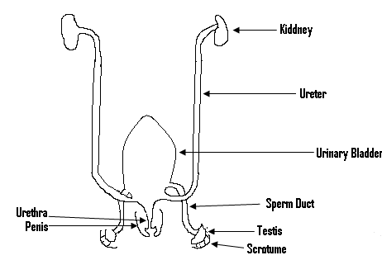

* The male reproductive system or the male sex organs or genitals are mostly outside his body.
* It consists of the penis, the testes, the scrotum, the urethra and the urinary bladder.
* The penis is a finger shaped organ found between the legs of the male.
* This structure ensures that sperms produced by the testes get into the vagina.
* It consists of tissues, muscles and blood vessels.
* During mating the penis becomes erect when blood rushes to occupy the spaces within the spongy tissue.
* Behind the penis hangs a small sack called the scrotum or the scrotal sacs, which contains the sex organ called the testicles or the testes.
* The urethra which serves as a passage for both urine and sperms, passes through the penis.
* Sperms are produced and stored by the testes.
* A whitish fluid called the semen (seminal fluid) is produced by the prostate gland and the seminal vesicles.
* The seminal fluid is important for the following reason:

1. Sperms are mixed with it and stored.
2. It serves as a medium in which the sperm can swim.
3. It contains nutrients which make the sperms active.
4. The fluid has an alkaline nature which neutralizes the acid medium of the female sexual organ.

* The semen which contains the sperm is released through the urethra.
* Urine from the bladder and sperm from the testicles are both discharged from the body through the penis, but at different times.
* A hormone called testosterone controls sperm production, and is also responsible for the development of secondary sex characters found in male.
* This hormone is produced by the testes when the male is considered matured for sex, and makes the male reproductive system increase in size from the time of puberty.
* At puberty a lot of changes called the male secondary sexual characteristics occur in the male.

Male sexual characteristics:

(1) Deep voice. (2)Enlargement of the penis.

3) Appearance of hair in the ampit and pubic area.

4) Appearance of facial hair such as moustache.

**Functions of the parts of the male reproductive organ:**

**Testes:** They produce the sperm.

**Epididymis:** It temporarily stores sperms and produces secretions that keep the sperm alive.

**Sperm duct (Vas deference)**: It is the passage, through which sperms from the epididymis pass.

**Urethra:** It serves as the passage way for both semen and urine.

**Penis:** It is used to release semen into the vigina.

**The female Reproductive organ**

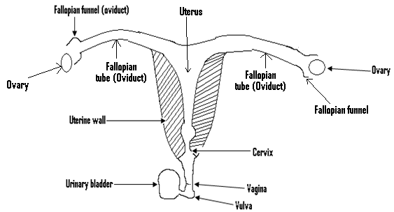

* All the female reproductive organs are inside her body.
* It consists of a pair of ovaries which produce and store the eggs.
* Lying very close to each ovary is a funnel shaped structure, called the fallopian funnel which leads into the fallopian tube or the oviduct.
* The ovaries normally release an egg about every 28 days, and this process in which the egg is released is called ovulation.
* The egg released is first received by the fallopian funnel, and then passed on into the fallopian tube or oviduct.
* There are two fallopian tubes or oviducts and these combine to form the uterus or the womb, which leads into the vagina.
* The cervix is the lower narrower end of the uterus which leads into the vagina.
* Each fallopian tube is associated with only one ovary.
* The urethra leads from the urinary bladder to the outside.
* In the female human being, the urethra and the vagina open to the outside by separate openings.
* The sensitive clitoris lies above the vagina.

**The functions of the various parts of the female reproductive organ:**

1. **The ovaries:** They produce the female sex cell or the ova.
2. **Oviduct (fallopian tubpe):** It is the place where fertilization occurs.
3. **Uterus (womb): It is the place where the embryo develops.**
4. **Cervix:** It serves as a link between the womb and the vagina.
5. **Vagina:** It receives the semen during sexual intercourse, and also serves as the organ through which a baby is born.
6. **Vulva:**They are sensitive organs at the mouth of the vagina.
7. **Clitoris:** It is a sensitive organ that arouses the sexual feeling of a woman.

**Ovulations and menstruation:**

* In the male, the testis produces and stores millions of sperms which can be released at almost any time.
* But the ovaries produce only a few thousand eggs, and only a few hundreds of them are released during the female’s life time.
* Usually, only one egg is released at a time as part of the monthly process called the menstrual cycle.
* During this cycle, changes take place in the uterus for its soft inner lining, develops many tiny blood vessel which thickens.
* It reaches its full thickness shortly after the release of the egg from an ovary.
* If the egg from an ovary is not fertilized within about 12 hours, it dies and the unfertilized egg together with the inner lining and the blood vessels of the uterus, is then slowly discharged through the vagina in a process called menstruation.
* This cycle which usually last for about five or six days, occurs every month unless an egg is fertilized.
* The onset of menstruation signals sexual maturity of the female concerned, and from this time onward she becomes capable of becoming pregnant.
* The menstrual cycle may stop around the age of 45, and this period when this cycle stops is known as menopause.
* The monthly menstrual cycle is controlled by certain hormones which are oestrogen and progesterone.
* It is oestrogen which stimulates the development of the female secondary characteristics.
* At puberty, several changes occur in the female and these changes are referred to as the female secondary sexual characteristics.

**Female secondary sexual characteristics:**

1. The appearance of hair in the ampit and the pubic region.
2. The enlargement of the breast and the hip (pelvic).
3. Roundness and softness of the body.
4. The onset or the beginning of menstruation.

**Fertilization:**

* During mating, semen containing millions of sperms is ejaculated or discharged from the penis into the vagina.
* Each sperm has a head and a long thread like tail.
* These sperms travel from the vagina into the uterus and some of them enter the fallopian tubes.
* If an egg or a matured ovum is passing through one of the fallopian tubes, then one of them is likely to fertilize it.
* It must be noted that it is only one of the millions of sperms released by the man, which is needed to fertilize an egg.
* Even though fertilization almost always takes place in a fallopian tube, it may also occur within the uterus.
* After fertilization, the fertilized egg or zygote attaches itself to the lining of the uterus, and then starts to develop according to the information in the chromosomes from both parents.
* The zygote then develops into an embryo which continues to grow and produce new cells which develop to form tissues and organs.
* After the formation of all the organs, the embryo is known as foetus and after about three months, the foetus looks like a human being.
* An organ called the placenta found within the uterus enables food, oxygen and waste products to be exchanged between the embryo and its mother.
* After the birth of the baby, the placenta is expelled from the body of the mother and it is often referred to as the after birth.
* The umblical cord connects the embryo and the placenta.
* This umblical cord and the placenta carry oxygen and food substances from the mother to the developing child.
* They also carry carbon dioxide and other waste back to the mother.

**Birth:**

* As the foetus becomes fully developed, the contraction of the muscles of the uterus begins.
* This finally pushes the baby into the cervix and then through the vagina.

**Parental Care:**

* This comes in two forms which are the pre-natal care and the post-natal care.

1. **Before birth (Pre-natal):**

* Since a well-developed embryo results in a healthy baby, the pregnant mother must;

1. take in balanced diet during the gestation or the pregnancy period.
2. Avoid tedious work.
3. Visit the clinic at regular interval.
4. Avoid drug abuse, smoking and alcoholism.
5. Do exercises in order to be fit.
6. Ensure a good personal hygiene.

**Importance of pre-natal care:**

* It helps in the development of the foetus into a mature embryo.
* It enables the pregnant woman to feel healthy.
* It helps in the detection of problems associated with pregnancy.
* It helps to avoid miscarriage.
* It enables the mother to have a safe and peaceful delivery.

1. **After birth (post – natal):**

* After birth, the attention needed by the child includes;

1. Regular bathing.
2. The regular feeding with breast milk for the first six months.
3. The weaning of the child out the right time.
4. The regular visits of the mother and the baby to the clinic.
5. The immunization of the baby against the six killer diseases.
6. Mother should feed on balanced diet whilst still breast feeding.
7. The weight of the baby must be checked regularly by visiting the weighing centre regularly.

**The importance of post-natal care:**

* It enables the mother to restore her normal life, after the pregnancy period.
* It prevents the child from getting any of the six killer diseases in future.
* It helps the wounds had by the mother during delivery to heal.
* It ensures a healthy baby.
* It helps the baby to grow fast.

**Stages of growth and development in humans:**

* The growth and development in humans occurs in the following order or stages:

1. Infancy.
2. Childhood.
3. Adolescence.
4. Adulthood.

**Infancy:**

* This is the first stage of growth and development.
* It begins from the day a baby is born till he or she achieves the age of one year.
* This stage is usually characterized by rapid growth in size, height and weight of the individual.
* Milk teeth are developed at this stage and these are later replaced by a set of permanent teeth.
* The child begins to familiarize him or herself with the environment, parents and other associates.
* During this stage also, the child cannot control his or her bladder and bowel.

**Childhood or Juvenile stage:**

* This period begins from the age of one up to puberty age (1 – 12 years).
* This stage can be divided into the pre-school stage and the middle childhood.
* At this stage, there is a rapid rate of growth initially which slows down towards the end of the period.
* Muscular development takes place, and the bladder and the bowel can be controlled.
* The set of teeth developed, are likely to be permanent.

**Adolescence:**

* This normally starts at about age 12 and extends to adulthood, or age 20.
* There is rapid growth and secondary sexual characteristics are developed.
* There is an increase in intelligence and most people eat a lot (especially male).

**Adulthood:**

* This begins from adolescence to old age (20 – 50 years).
* There is virtually no growth in the body.
* The apparent increase in size may be due to the deposition of fat under the skin.
* The stage is characterized by a permanent set of teeth and sexual maturity.
* The adult is usually strong from ages 18-35.
* After about 35 years, the body begins to decline in strength.
* For this reason, the skin begins to lose its elasticity and the skeletal muscles lose their strength.

**Causes of early parenthood:**

* Factors which lead to early parenthood include the following:

1. Giving out girls into marriage at an early age.
2. Poverty.
3. Illiteracy.
4. Lack of parental care.
5. Death of either one or both parents.
6. Broken marriages and separations;

**Effects or consequences of early parenthood:**

1. Dropping out of school.
2. Inability of the young parent to provide the needs of the child.
3. As a result of lack of education or trade of the young parent, he or she may become unemployed.
4. Leads to large family size.

**Effects of teenage pregnancy:**

* Teenage pregnancy occurs when a teenager becomes pregnant.
* Its effects include:

1. The occurrence of ectopic pregnancy.
2. The damage caused to the pelvic bones, when the foetus presses it during pregnancy.
3. The dropping out of school of the teenage girl.
4. The death of the teenage girl during labour.
5. The production of an underweight baby.
6. The occurrence of severe bleeding during birth.

**Dangers of indiscrimate sex:**

* Unwanted pregnancy.
* Early parenthood.
* The possibility of dropping out of school.
* Contracting sexually transmitted diseases.

**Causes of infertility:**

* A couple may fail to bear children due to a number of reasons such as:

1. Blocked fallopian tubes.
2. Irregular menstrual cycle.
3. Non production of ova by the female.
4. Non production of sperm by the male.
5. Impotence in the male.

**Genes:**

* These are the carriers of parental characteristics, from parents to children.
* For example if the nose of a child looks like that of the father or the mother, then it is the genes which bring about this resemblance.
* Physical characteristics such as skin colour, hair colour, height or skin may be transferred to the offspring.
* Apart from that, behavior characteristics such as intelligence, patience and temperament may also be transferred.
* The process whereby certain characteristics are transferred from parents to children is referred to as heredity.

**Questions:**

(Q1)(a) What is reproduction?

Ans:

* It is the process by which living things create more of their own kind.

(b)What is fertilization?

Ans: - It is the process in which a sperm fuses with an egg.

(c)Differentiate between sexual and asexual reproduction.

Ans:

* Sexual reproduction is the type, in which a new organism is formed by the union of the two different type of sex cells.
* But in asexual reproduction, a new organism is develops from parts of or from parts produced by only one parent.

(d)Which organs produce the sperm and the egg.

Ans:

* The sperm is produced by the testes, while the egg is produced by the ovary.

(e)What is a zygote?

Ans:

* It is what is formed when an egg is fertilized by a sperm.

(Q2)(a)What is the main difference between internal fertilization and external fertilization?

Ans:

* In internal fertilization, the fertilization of the egg by the sperm occurs within the female`s body but in external fertilization, this fertilization occurs outside the body of the female.

(b)Make a labeled diagram of the male reproductive organ or system.

(c)Briefly describe the male reproductive sex organ or system.

Ans:

* It consists of the penis, behind which hangs the scrotum which contains the testes, which produces the sperm.
* A passage called the urethra runs through the penis, and both urine and sperm pass through the penis.

(d)Name the hormone which is responsible for the development of male secondary characteristics in boys, and list three of such characteristics.

Ans:

* This hormone is called testosterone.
* Three of such characteristics are:

1. Deep voice
2. Appearance of ampit and pubic hair.
3. Enlargement of the penis.

(Q3)(a)Make a labeled diagram of the female reproductive system.

(b)Briefly describe the female reproductive system.

Ans:

* It consists of a pair of ovaries.
* Lying close to each of these ovaries is the fallopian tube or the oviduct. –The two fallopian tubes combine to form the uterus or the womb, which leads to the vagina.

(c)What do you understand by ovulation?

Ans:

* It is the process in which an egg is released by an ovary.

(d)What is menstruation?

Ans:

* It is the process in which an unfertilized egg, together with the inner lining and the blood vessels of the uterus is slowly discharged through the vagina.

(e)Explain why menstruation occurs.

Ans:

* During the menstrual cycle, the inner lining of the uterus develops many tiny blood vessels, which reaches its full thickness shortly after the egg is released.
* If this egg is not fertilized within a certain time period, then it is discharged through the vagina together with the inner lining and the blood vessels of the uterus.

(Q4)(a)Name the hormones which control the menstrual cycle.

Ans:

* These are oestrogen and progesterone.

(b)Which hormone is responsible for the female sexual characteristics, and list three of such characteristics.

Ans:

* The hormone is oestrogen and three of these characteristics are:

(1)the appearance of pubic and ampit hair.

(2)the enlargement of the breast.

(3)the onset of menstruation.

(c)List two pre-natal care.

Ans:

* Regular visit to the clinic by the mother.
* The eating of balanced diet.

(d)List two post-natal care.

Ans:

* Regular feeding of the child with breast milk, for the first six months.
* Regular bathing of the child.
* Give the importance of the placenta.

Ans:

* It carries oxygen and food substances from the mother to the embryo.
* It also carries carbon dioxide and waste products from the embryo to the mother, for them to be excreted.

(Q5)

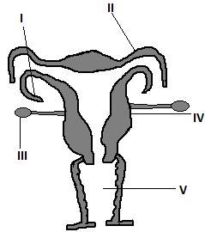

The given diagram shows the female reproductive organ. Identify and give the functions of the parts labeled I, II, III, IV and V.

Ans:

* For this, kindly refer to the notes already given.

(Q6)

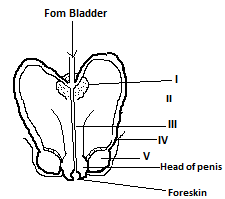

Ans:

* I is the protrate gland which produces the white fluid which mixes with the sperm.
* II is the sperm duct which serves as the passage way for the sperm from the epididymis.
* III is the urethra which serves as the passage for both urine and semen.
* IV is the epididymis which stores the sperm temporarily, and also produces secretions which keep the sperm alive.
* V is the testes which produce sperms.

(Q7)

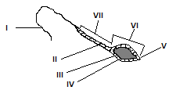

Ans:

* It is a sperm cell (spermatozoan)

(a)- The portion labeled I is the tail, which is used to propel the sperm in its movement.

- III is the nucleus of the sperm which fuses with the ovum to form the zygote.

- V is referred to as the cap.

- VI is the head of the sperm, and it is this part which penetrates the ovum.

- VII is referred to as the middle piece.

(Q8)Explain the meaning of the following terms:

(a) Ejaculation.

(b) Gestation period.

(c) After birth.

**Soln:**

1. Ejaculation refers to the release of the sperm into the vagina, during mating.
2. Gestation period is the period between fertilization and birth.
3. The after birth refers to the placenta, the umbilical cord and the other membranes that come out of the womb after childbirth.

(Q9)List three importance of the placenta to the embryo.

Ans:

* It serves as a passage way for food, water and oxygen from the mother to the embryo.
* It helps in the elimination or the removal of carbon dioxide and nitrogenous waste (urea) from the embryo to the mother.

It prevents the passage of some harmful products and pathogens from mother to the embryo.

**CHAPTR TWENTY FOUR**

MICROBES, DISEASES AND FOOD

MICROBES:

These are microscopic organisms that are found everywhere in nature, and examples are bacteria, virus and fungi.There are three main kinds of microbes and these are useful microbes, microbes of decay and harmful microbes.

USEFUL MICROBES:

These are microbes which are of benefit to man.An example is penicilium which is a microbe used in the production of the drug called penicillin.Another microbe called yeast is used in alcohol production and for banking.

MICROBES OF DECAY:

During decay, certain microbes called decomposers breakdown dead plants and animals remains into nutrients, which also serve as food for these microbes.Green plants also make use of these nutrients.

CONDITIONS NECESSARY FOR DECAY:

These conditions are:

(1) The presence of oxygen.

(2) A warm environment.

(3) The presence of moisture.

HARMFUL MICROBES:

These are those microbes which are dangerous to man, since they cause many diseases in man.

DISEASE:

This is any change in the body of an organism which causes sickness.

SYMPTOMS:

These are those signs which show up in the body of an organism, to indicate that it is sick.

VECTORS OR GERM CARRRIER:

These are insects which carry and transmit germs which cause certain diseases.Examples are housefly, the mosquito and the tsetse fly.

ANTIBODY:

This is a substance produced by the body to destroy any germ, or any harmful toxin or poison which enters the body.

PATHOGENS:

These are disease causing organisms which includes bacteria, virus and fungi.

ANTISEPTIC:

This is any substance that kills or stops the growth of pathogens, but is not poisonous to the body’s cells.

IMMUNITY:

This is the ability of the body to resist infection, by producing antibodies.

There are two types and these are:

(a) NATURAL IMMUNITY:

This occurs when an immune state is produced by natural means.

(b) ACQUIRED IMMUNITY:

This can be due to any of the following:

(i) By having the disease.

(ii) By the introduction of the weakened micro — organisms into the person, in order to produce antibodies.

(iii) By injecting antibodies from one person into another.

VACCINATION:

This is the process in which a mild or dead form of disease germs, are introduced into the body so as to stimulate the production of antibodies.

IMMUNIZATION:

This is the process in which an organism is made resistant to infection.

DISEASES, PREVENTED BY IMMUNIZATION:

Some of the diseases controlled by immunization are:

(1) Diphtheria. (2) Polio.

(3) Tuberculosis. (4) Cholera.

(5) Tetanus. (6) Measles.

CAUSES OF DISEASES IN MAN:

Some of the causes of diseases are:

(1) Improper disposal of waste.

(2) By coming into contact with an infected person.

(3) Poor feeding.

(4) Environmental pollution.

WAYS OF PREVENTING DISEASES:

Diseases can be prevented by the following means:

(1) By having a good drainage and sewage system.

(2) Through immunization and vaccination.

(3) The proper disposal of waste and sewage.

(4) Through the maintenance of good personal hygiene.

(5) By isolating people with infectious diseases.

(6) By preventing flies from coming into contact with food.

GROUPS OF DISEAESES:

Some of these groups are:

(1) INFECTIOUS DISEASES:

These are also referred to as communicable diseases.

Infectious diseases are those diseases, which are caused by pathogens and can be passed from one person to another.An example is tuberculosis.

(2) NON INFECTIOUS DISEASES:

These are those diseases which are not caused by pathogens, and cannot be passed from one person to another.They are also referred to as non communicable diseases, with examples being asthmas and kwashiorkor.

(3) AIR BORNE DISEASES:

These are those diseases which are spread through the air and examples are tuberculosis and chicken pox.

(4) WATER BORNE DISEASES:

These are those diseases which are spread through water and examples are cholera and dysentery.

SEXUALLY TRANSMITTED DISEASES:

These are diseases which are transmitted through sex.They are also referred to as venereal diseases and examples are gonorrhea, syphilis and aids.S.T.D referred to sexually transmitted diseases.

GONORRHOEA:

This is a sexually transmitted disease.

CAUSATIVE AGENT (ORGANISM):

It is caused by a bacterium called gonococcus.

This bacterium attacks the membrane or the skin of the sex organ and the eye.

MODE OF TRANSMISSION:

The bacteria enter the body through the sexual opening, when one is having sex with an infected person.

SYMPTOMS:

These show up early in men than in women.In the male, the early symptoms or signs include the discharge of a whitish or a yellowish substance from the sex organ.If the infected person happens to be a male, he will pass urine with pain.In the female, it will take a long time for signs to show up, and she may not even take notice of them.But the bacteria keep on damaging the sex organ.In the advanced stage, the disease can lead to the inflammation of the sex organ, sterility, crippling and blindness.

SYPHILIS:

This is a venereal disease.

CAUSATIVE AGENT:

It is caused by a bacterium called spirochete or treponema palladium.

MODE OF TRANSMISSION:

The bacteria enter the body through the sexual opening, during sexual intercourse with an infected person.And once inside the body, it can attack any kind of tissue.

SYMPTOMS:

The bacteria cause sores and swellings at the area or the point of infection, i.e. the penis and the vulva.

Later on it will cause the sores and swellings to spread to other areas, such as the month, the finger and the skin.

The patient may become nervous, feverish, aneamic and loss of weight occurs.

The patient may become mad and blind.

AIDS:

Aids is the short form of acquired immune deficiency syndrome.

CAUSATIVE AGENT:

It is caused by a virus called the human immune deficiency virus.The HIV virus attacks mostly the white cell, (whose duty it is to protect the body against diseases) and destroy them.After the destruction of these white cells, any germ which enters the body will cause the person to fall sick and die.In short the virus destroys the body’s immune system.

MODE OF TRANSMISSION:

(i) Through sex.

(ii) Through the exchange of the body fluid such as blood.

SYMPTOMS:

Persistent diarrhea, skin rashes, fever and loss of weight.

PREVENTTION/CONTROL OF S.T.D OR VENERAL DISEASES:

Avoid indiscriminate sex.

Adult must stick to one sexual partner.

By using condom.

By encouraging the good moral and religious upbringing of children.

AIR BORNE DISEASES:

These include tuberculosis, cholera and measles.

TUBERCULOSIS (T.B):

This is a disease which attacks the lungs.

CAUSATIVE ORGANISM:

It is caused by a bacterium called tubercle bacillus.

MODE OF TRANSMISSION:

This disease can be spread in a number of ways which includes:

(i) By breathing in the germs coughed out by an infected person.

(ii) By drinking milk from an infected cow.

(iii) By taking in contaminated food or drink.

(iv) By inhaling or breathing in infested dust particles.

SYMPTOMS/SIGNS:

Infected people become weak and lose a lot of weight.

They sweat a lot during the night, and have persistent cough.

They have fever and headache.

They finally cough out blood.

PREVENTION:

Isolate sufferers.

Avoid overcrowding in bed rooms.

Children must be immunized or vaccinated against the disease.

Careless spitting must be avoided.

Cover your mouth and nose when someone coughs or sneezes.

TREATMENT:

Isolate the patient and allow him or her to rest to rest.

By using drugs such as BCG to kill the germ.

CHOLERA:

CAUSATIVE ORGANISM:

It is caused by a bacterium called vibrio cholera.

MODE OF TRANSMISSION:

The cholera germ is found in contaminated food and drink.

A housefly may pick some of these germs from a contaminated food, and deposit them on the food we eat.When we take in the contaminated food we become infected, and once the germs enter our body they multiply or increase rapidly causing us to be sick.Some times the germ may be carried in the air and deposited on our food.The germ can also enter our bodies after eating raw food such as mango, which has not been washed properly.Another way of being infected with the germ is by using night soil as manure.

SYMPTOMS:

Severe diarrhea and vomiting and the patient becomes dehydrated. He later on collapses and dies.

TREAMENT:

By injecting a salt solution into the body, in order to maintain the body’s fluid. And By using drugs to kill the germs.

PREVENTION/CONTROL:

Cover all food and drinks in order to keep houseflies away from them.

Do not throw toilet into water bodies from which people drink.

Boil water from dangerous sources before drinking.

Isolate sufferers.

Fruits and food eaten raw must be well washed before eating them.

MEASLES: It usually attacks children.

CAUSATIVE ORGANISM: It is caused by a virus.

MODE OF TRANSMISSION:

By coming into contact with an infected person.

By breathing in infected air after the coughing or the sneezing of an infected person.

PREVENTION:

Isolate infected persons.By using drugs.

Avoid coughing or sneezing into the air.

WATER BORNE DISEASES:

These include bilharzia and guinea worm.

BILHARZIA (SCHISTOSOMIASIS):

CAUSATIVE AGENT: It is caused by a flat worm called schistoma or the blood fluke.

MODE OF TRANSMISSION:

By swimming or bathing in a contaminated water body.If an infected person urinates into a water body, the egg of the flatworm gets into the water body.They then develop in the water and penetrate the skin of a person who enters the water.Once inside the body, they pass through the tissue and enter the blood where they develop into adult worm and stay in the bladder.

SYMPTOMS:

(1) Itching of the skin. (2) Pain in the lower abdomen.

(3) Blood in the urine. (4) General weakness.

CONTROL/PREVENTION:

Do not urinate into drinking water bodies.

Boil and filter drinking water.

GUINEA WORM:

CAUSATIVE AGENT:

It is caused by a round worm called dracunculus medinensis.

MODE OF TRANSMISSION:

Through the drinking of contaminated water which contains the worms.

SYMPTOMS:

A painful blister appears on the leg or the arm.

The blister soon burst and forms a sore.

A long worm then comes out of the worm.

CONTROL/PREVENTION:

Boil and filter water from bad sources before drinking it.

Taking in only good drinking water.

DISEAESES CAUSED BY PARASITES: These include malaria and taeniasis.

MALARIA:

CAUSATIVE ORGANISM: It is caused by a parasite called plasmodium.The disease is transmitted by the anopheles mosquito. The vector of the disease is therefore the anopheles mosquito.

MODE OF TRANSMISSION: The malaria parasite is found within the blood of an infected person.If the mosquito bites an infected person, it sucks the blood which contains the parasites. It then goes and bites a healthy person and by so doing, it introduces the parasite into his body which later causes him to become sick.

SYMPTOMS/SIGNS:

(1) Chill. (2) Weakness.

(3) Fever.(4) Anaemia.

(5) Sweating.

PREVENTION/CONTROL:

By sleeping in mosquito net.

By destroying the breeding grounds of mosquito.

By using insecticides to kill the mosquito.

By introducing certain fishes into stagnant waters to eat the mosquito larvae.

TAENIASIS:

CAUSATIVE ORGANISM:

It is caused by the tape worm.

MODE OF TRANSMISSION:

By eating infected pork.The eggs of the tape worm normally dwell within the muscles of the pig.

SYMPTOMS:

The affected person grows lean despite the fact that he eats well.

CONTROL/PREVENTION:

By boiling pork very well before eating it.

ONCHOCERCIASIS(RIVER BLINDNESS):

It is caused by a small worm called onchocerca volvulus, and spread by a vector called the blackfly.

CONTROL/PREVENTION: By destroying the black fly.

SKIN DISEASES:

These are diseases which attack the skin and examples are ringworm and foot rot.

RINGWORM: It is caused by a fungus.

MODE OF TRANSMISSION: Through dirty hair.

SYMPTOMS:

The hair of parts of the head gets off, leaving patches.

It causes severe itching

PREVENTION/TREATMENT:

Keep good personal hygiene.

Use ointment to cure it.

FOOTROT:

It is caused by fungus and normally occurs between the toes.

It normally affects people whose feet are constantly wet.

PREVENTION/TREATMENT:

Wear light airy shoes especially during warm weather.

Bath the feet twice a week.

VIRUS CAUSING DISEASE:

POLIO(Infantile paralysis):

CAUSATIVE ORGANISM: It is caused by a virus.

MODE OF TRANSMISSION: By taking in contaminated food and drink.

SYMPTOMS:

(1) Headache. (2) Aching neck and muscles.

(3) Paralysis in children.

CHICKEN POX:

It is caused by a virus and transmitted through contact with infected people.

SYMPTOMS:

(1) High fever. (2) General body pains.

(3) Rashes or blisters on the skin.

CONTROL/PREVENTION: By vaccination and the use of antibiotic.

RABIES: This is also known as hydrophobia, which means the fear of water.

CAUSATIVE ORGANISM: It is caused by a virus.

MODE OF TRANSMISSION:

Through the bite of carnivores such as dogs, cats and wolves.

SYMPTOMS:

(1) High fever. (2) Headache.

(3) Sore throat.(4) The sight of water creates fear in the patient, who behaves as a mad person.

PERSONAL HYGIENE: This is the practice of keeping one’s body and environment clean.

MAINTENANCE OF PERSONAL HYGIENE:

(1) Drink good or treated water.(2) Wash your hands before eating.

(3) Wash your dirty clothes regularly.(4) Clean your teeth daily.

(5) Keep your surroundings clean.

THE IMPORTANCE OF MAINTAINING PERSONAL HYGIENE OR CLEANLINESS:

This is to prevent:

1. Diseases.(b) Bad body odour. (c) Tooth decay.(d) Lice in the hair.

FACTORS WHICH PROMOTE GOOD HEALTH OR WAYS OF KEEPING THE BODY FIT:

These factors are:

(1) Regular exercise. (2) Having enough sleep and rest

3) Sleeping or living in good ventilated and lighted rooms.

CONDITIONS NEEDED TO KILL GERMS:

These conditions are:

(1) Heat or high temperature.

(2) Very cold temperature since it stops the growth of germs.

(3) Sunlight, since most herms cannot stand sunlight.

(4) Cleanliness, for germs like dirt.

FOOD POISONING:

This is an acute illness caused by food that may be naturally poisonous, or contaminated by certain types of pathogenic organisms.It may be caused by:

(a) Natural food items such as poisonous mushroom.

(b) Food contaminated by bacteria which produce toxin, which is a poisonous substance.

(c) Food contaminated by chemicals such as mercury and insecticides.

FOOD CONTAMINATION:

This occurs when food becomes infected with chemicals, germs or any substance that can be injurious to the body.

SYMPTOMS OR EFFECTS OF FOOD POISONING:

These symptoms are:

(1)Stomach pains. (2) Vomiting. (3) Diarrhoea.(4) Headache.

CAUSES OF FOOD POISONING:

Some of the causes of food poisoning include the following:

(1) Eating and handling food with contaminated hands.

(2) Eating and buying food from dirty environment.

(3) Drinking contaminated water and drinks.

(4) Buying food from people suffering from infectious diseases.

WAYS OF PREVENTING FOOD POISONING:

- Wash your hands before eating.

- Do not take in contaminated food or drink.

- Food must be covered.

FOOD PROCESSING:

This refers to the treatment of food so as to preserve it.Some of the importance of food processing are:

(1) To prevent the food from going bad.

(2) To enable us to get the food when such food is not in its season.

(3) To enable us export or import the food.

WAYS OR METHODS OF FOOD PRESERVATION OR PROCESSING:

There are various methods of food preservation, and some of them are:

(1) Boiling: In this method, the germs within the food which can make it go bad are destroyed by heat. By so doing the food cannot go bad for a certain length of time.

(2) Smoking: This also destroys the germs or the bacteria within the food.Apart from that, it also removes from the food water, which can also cause the food to go bad or decay.

(3) Frying: By frying the food, water which can cause the food to decay is removed from it.

(4) Canning and bottling: In this method, the food is first heated to kill the bacteria which can cause it to decay. Preservatives are then added to the food, after which it is sealed.

(5) Freezing: At very low temperatures, bacteria become inactive. In freezing the food is kept at a very low temperature, which makes the bacteriawhich can cause it to go bad, become inactive.

(6) Salting:

In this water is absorbed from the food, so as to prevent it from decaying.

QUESTIONS

(Q1)

(a) By giving two examples, explain what microbes are.

Ans: They are microscopic organisms found everywhere in nature, with examples being bacteria and fungi.

(b) Name two microbes and explain how useful they are to man.

Ans: Penicilium and yeast are two microbes.

While penicilium is used in the production of the drug called penicillin, yeast is used in the production of alcohol.

(c) What do you understand by decay?

Ans: This is the process in which decomposers breakdown the remains of dead plants and animals, into nutrients which also serves as their food.

(d) A dead goat is thrown into a bush. Give two conditions which can enhance or encourage its decay.

Ans: A warm environment and the presence of moisture.

(Q2)

(a) Why are certain microbes considered to be dangerous?

Ans: Because they are the cause of many diseases in man.

(b) Give two reasons why a person may become sick.

Ans: When he comes into contact with an infected person, and as a result of poor feeding.

(c) Give two ways in which a person can be prevented from becoming sick.

Ans: Through immunization and vaccination, as well as the proper disposal of waste and sewage.

(d) Differentiate between air borne and water borne diseases.

Ans: Air borne diseases are spread through the air, but water borne diseases are spread through water.

(e) Explain what we mean when a disease is said to be infectious.

Ans: It means that it is caused by germs or pathogens, and as such can be passed from one person to the other.

(Q3)

(a) Differentiate between immunity and immunization.

Ans: Immunity is the ability of the body of a person to resist infection, but immunization is the process in which a person is made resistant to infections.

(b) Name three diseases which can be controlled through immunization.

Ans: Measles, cholera and polio.

(c) Give two effects of food poisoning.

Ans: Stomach pains, vomiting and diarrhea.

(d) Give two ways a person may obtain acquired immunity.

Ans: By injecting antibodies from one person into that person.

By putting weakened micro organism into that persons body to produce antibodies.

(Q4)

(a) By giving an example, explain what a vector or a germ carrier is

Ans: A vector is an insect which can carry and transmit disease causing germs, with an example being the mosquito.

(b) Explain how vaccination is done.

Ans: By taking the mild or the dead form of the disease causing germs, and introducing them into a person’s body, in order to stimulate the production of antibodies.

(c) What is a symptom?

Ans: It is the sign of a disease.

(Q5)

(a) Give a reason why it is good to preserve food.

Ans: To prevent it from going bad.

(b) List three methods used in food preservation.

Ans: Boiling, smoking and freezing.

(c) Give the main use of antiseptic.

Ans: To kill or stop the growth of germs.

**Chapter Twenty Five**

**Environmental Pollution, Weathering and Diseases:**

**ENVIRONMENTAL POLLUTION:**

Environmental pollution occurs when poisonous substances are released into the environment in harmful quantities. - Items which cause the pollution of the environment are called pollutants.- There are two types of pollutants and these are:(1) Biodegradable pollutants.(2) Non degradable pollutants.

- Bio gradable pollutants are those that can be broken down into harmless substances, due to the activity of micro-organisms.

- Examples of such pollutants are leaves, refuse and dead animals.

- Non-degradable pollutants are those pollutants which cannot decompose (breakdown), or which decompose very slowly.

- For this reason, they remain in the environment permanently or for a long time period.

- Examples of such pollutants are glass, plastic and rubber.

TYPES OF POLLUTION: These are air pollution, water pollution, land pollution and noise pollution.

**Air pollution:**

This occurs when items such as gases, smoke or dust are released or put into the air.It can also be caused when the exhaust of automobiles enters into the atmosphere, and gases which normally cause air pollution are mostly from industries.Air pollutants are those items, which when present in the air cause it to become polluted.

**Some air pollutants:** Some of them are:

(1) Sulphur dioxide (SO2). (2) Nitrogen dioxide (NO2). (3) Carbon Monoxide (CO). (4) Particulates. (5) Mercury.

**Effects of air pollution:**

- It gives rise to the health problems such as cough and respiratory track diseases.- It causes a reduction in crop yield as well as the retardation of plant growth. - It reduces visibility and damages property. - It affects the weather and the climate.

**Control of air pollution:**

By discharging waste gases high into the atmosphere. -By passing waste gases from factories and the exhaust from automobile, through filters to remove some of their pollutants before they are discharged into the atmosphere. - New machines which do not pollute the environment must be developed by scientists and engineers.–Government must pass and enforce laws, to stop or reduce pollution causing activities.

**Water pollution:**

- This is caused when waste materials are discharged or put into water bodies, in large quantities. - Water pollutants which are items whose presence in water bodies cause them to become polluted, include the following:

(a) Waste from industries.

(b) Hot water from industries.

(c) Agric waste such as fertilizers and pesticides.

(d) Untreated sewage.

(e) Oil from leaking or sinking oil tankers or ships.

(f) Hot water from factories when dumped into water bodies causes a type of pollution called thermal pollution.

**Effects of water pollution:**

- Polluted water can cause diseases.

- It can cause the death of the creatures which live in the water, such as fishes. - Some water pollutants enter into the bodies of aquatic creatures such as fishes, and finally end up in the bodies of man after eating them. - It prevents the water from being used for activities such as swimming and drinking.

**Control of water pollution:**

- Sewage must first be treated (i.e. to remove most of the harmful items it contains), before it is dumped into water bodies. - Excess amount of agro chemicals must not be used. - Wastes from industries must not be dumped into water bodies. - Hot water from industries must first be cooled, before they are dumped into water bodies.

**Land pollution:**

- This is caused when items which do not easily decompose or rot, are left on the land, or when chemicals which are harmful to soil organisms are introduced into the soil. - It can be caused by using chemicals such as pesticides and weedicides or by damping non-degradable pollutants on the land.

**Effects of land pollution:**

- Some land pollutants enter the plant and kill them or affect their growth, leading to poor yield. - Some land pollutants absorbed by plants finally end up in the bodies of man and animals, after eating them causing them to fall sick. - It leads to land degradation. - Refuse dumps can serve as the home of germs and dangerous animals such as snakes.

**Control of land pollution:**- - By recycling waste such as metals or plastic. - By controlling the use of agric or agro chemicals.

- By making laws to stop the dumping of waste on land.

**Sound/ Noise pollution:**

This is caused by loud noise from radio sets, vehicles, industries etc.

Noise makes people feel uncomfortable.

**Effects of sound/ noise pollution:**

- It causes people to feel uncomfortable. - It can damage the ear and cause deafness.

**Control of noise/ sound pollution:**

- Equipments or items such as sound system and radio sets, must not be opened loudly. - Industries which create a lot of noise must not be located in residential areas. - Excess hooting, noisy vehicles and machines must be avoided.

**Weathering:**

- This refers to the breaking down of rocks into smaller particles.

**Types:**There are three types of weathering and these are:

1. Physical weathering.
2. Chemical weathering.
3. Biological weathering.

**Physical weathering:**

- This is the type of weathering which occurs as a result of changes in temperature.- The rocks expand on hot days and contract on cold days.- This expansion and contraction causes cracks in the rocks, causing them to break down.

**Chemical weathering:**

- This is caused by rain water which is a weak form of acid, and referred to as carbonic acid. - When rain water or carbonic acid falls on the rocks, it dissolves or destroys the cementing material which binds the rocks together, leading to their breakdown.

**Biological weathering:**

- This is caused by the roots of plants, which grow deep into the rocks. - They create cracks in the rocks, which finally lead to their breakdown.

**Agents of weathering:**

- These are certain visible items or conditions, through whose activities can lead to the breakdown of rocks. - These agents are:

1. Temperature changes.
2. Ice.
3. Roots of plants.
4. Water.

**Temperature changes:**

- On hot days, the temperature is high and the rock expands. - On cold days, the temperature becomes low and the rock contracts. - This expansion and contraction leads to the creation of cracks within the rock, leading to its breakdown.

**Ice:**

- In cold countries, water enters the rock on hot days. - On very cold days, this water within the rock freezes and expands.- The force exerted on the rock as a result of this expansion leads to its breakdown.

**Roots of plant:**- Roots which grow deep into the rocks create cracks within them.-These cracks weaken the rocks causing their break down.

**Water:**- Flood waters and other moving water bodies, sometimes carry rocks which fall into them.- As these rocks are being dragged or moved along, they hit against each other which leads to their breakdown.

**QUESTIONs:**

(Q1)(a) What is environmental pollution?

(b)List three types of pollution.

(c)List three air pollutants.

(d)Give two effects of air pollution.

(e)Give two ways in which air pollution can be controlled.

(Q2) (a) Name three water pollutants.

(b)What is thermal pollution?

(c)Give three effects of water pollution.

(d)Give two ways of controlling water pollution.

(Q3)(a) Differentiate between land and noise pollution.

(b)Give two ways of controlling noise pollution.

(d)Explain why it is important that industries are not sited, or located in residential areas.

Ans:

- Because if they are located in residential areas, the noise from these industries will disturb the people living in these areas.

(e)Explain why plastic and rubber are considered to be non-degradable pollutants.

Ans: - Because when they are introduced into the environment, they either do not decompose or they take a long time to do so.

(Q4)(a) Name the instruments used to measure:

1. Pressure

Ans: - Barometer.

1. The wind`s direction.

Ans: - Wind vane.

1. The wind`s speed.

Ans: - Anemometer.

(b) What is weathering?

(c)Briefly explain how rain water can cause chemical weathering.

Ans:

- Rain water is acidic in nature and is called carbonic acid.

- When it falls on the rock, it destroys the cementing material within the rock, causing it to break down.

(d) List three agents of weathering.

(e)How does temperature change causes weathering?

Ans:

- The rock expands on hot days and contracts on cold day.

- This expansion and contract leads to cracks being developed in the rocks which lead to its break down.

**CHAPTER TWENTY SIX**

**Ecology:**

1. Ecology is the study of the relationship that living things have with their environment.
2. Living-things refer to plants and animals.

**Characteristics of living things (similarity between plants and animals):**

These characteristic or similarities are:

1. **Movement:**

Living things move from place to place or show signs of movement.

1. **Respiration:**

All living things breath.

1. **Nutrition (feeding):**

They take in food.

1. **Irritability (sensitivity):**

They respond to stimuli such as touch or heat.

1. **Growth:**

All living things grow.

1. **Excretion:**

They excrete or remove waste from their bodies.

1. **Reproduction:**

They are able to produce their young ones.

**Differences between plants and animals:**

These differences are:

1. Plants can prepare their own food, but animals cannot.
2. Chlorophyll can be found in plants but cannot be found in animals.
3. Even though animals move from place to place, plants do not do so but only certain parts of them show signs of movements.
4. Animals respond immediately to stimuli, but plants respond slowly to stimuli.
5. Animals stop growing at a certain age, but plants do not stop growing.
6. Animals have excretory organs but plants do not.

**Basic classification of animals:**

* Animals can be divided into two main groups, and these are vertebrates and invertebrates.
* While vertebrates are animals with backbones, those without backbones are called invertebrates.
* Vertebrates and invertebrates can again be divided into other groups, and some of these groups are:

1. **Reptiles:**

* Examples are lizard, snake and turtle.
* They live on land and have scales on their bodies.
* They lay eggs.

1. **Amphibians:**

* Examples are frog and crocodile.
* They live in water and on land.
* They lay eggs and have scales on their bodies.

1. **Mammals:**

* Examples are horse, man, bat, dog, monkey and sheep.
* They breathe using lungs and their bodies are covered with fur.
* Their young ones are born and they suck milk produced by the mammary gland.
* They are warm blooded i.e they have a constant body temperature.

1. **Worms:**

* Examples are earthworm and tape worm.

1. **Mullucs:**

* **Examples are snails.**

1. **Insecta:**

* Examples are insects.

**The mode of feeding of plants and animals:**

* The feeding habit of plants is said to be autotrophic, because plants are able to manufacture their own food, through the process of photosynthesis.
* The feeding habit of animals is said to be heterotrophic, because animals cannot prepare their own food, and depend on plants for their food.

**Association:**

There are three types of association and these are:

1. Symbiotic association:

* This is a close association between two organisms, in which each organism benefits from the other.
* An example can be shown using the protozoanswhich live the stomach of termites.
* They help in the digestion of the food of the termite, but at the same time, these protozoans in turn get protection from the termite.

1. Parasitic association:

* Is the type of association which exists between two organisms, in which one organism depends on the other for its needs.

1. Commensalism:

* Is a loose association between two organisms in which only one or both may benefit.

**Ecological terms:**

1. **Environment:**

* This refers to the surroundings of living organisms.

1. **Population:**

* This refers to a particular kind of plants or animals, living in a particular area.
* Example(1), all the dogs living within an area called Mataheko, form the dog population of Mataheko.
* Example(2): All the parrots found at Kaneshie constitutes the parrot population of Kaneshie.

1. **Community:**

* This refers to all the different kinds of plants and animals, living within an area.
* Air, water and temperature are some of the things which form the environment.

1. **Habitat:**

- This refers to a place where living organisms can live and reproduce. There are two main types of habitats and these are:

(1) Terrestrial habitat. (2) Aquatic habitat.

- Terrestrial habitat refers to land and aquatic habitat refers to water bodies such as lakes and rivers. - There are two main types of aquatic habitats and these are:

(a) Fresh water habitat such as lakes, ponds and rivers which do not contain much salt.

(b) Marine habitat, which refers to the sea, which contains much salt.

**(4) Salinity:**

- This refers to the amount of salt within a water body.

**Factors that influence a living organism choice of a habitat:**

- A living organism may choose a particular habitat, based on the following reasons or factors:

(1) The availability of food. (2) Weather conditions. (3) Breeding. (4) Shelter. (5) Natural disasters. (6) Mortality or death rate.

Interaction between living organisms and chosen habitat:

(1) Bacteria and fungi helping to decompose organic matter, which is the remains of dead plants and animals. (2) Insects and birds acting as agents of pollination. (3) Trees providing shade and shelter to animals and other plants. (4) Animals acting as agents of seed and fruit dispersal. (5) Birds acting as agents of fruit and seed dispersal. (6) Termites aiding decomposition and aeration of the soil.

**ECOSYSTEM:**

- Is a combination of a community and its environment. - In short, an ecosystem consists of different living things and their habitats.

Adaptation:Refers to the special features which living organisms have, which enable them to live in their habitats.

**Adaptation of an aquatic creature such as a fish to its environments:**

- It has gills used for breathing. - It has fins which enables it to move in water. - The body is covered with scales for protection. - It has lateral line which makes it sensitive to its environment. - It has a streamlined or boat shaped body, for easy movement in the water. - Its colour blends with its environment, so as to avoid easy detection by enemies.

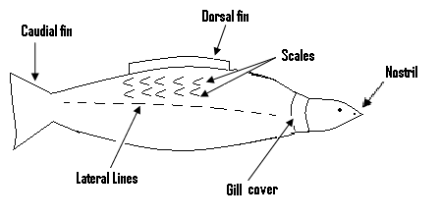

**N/B:** Aquatic creatures are those which live in water bodies.

Adaptation to its environment by an aeboral creature:

- Aeboral creatures are those which spent a great deal of their time in the air or a tree, e.g. bird. The bird adapts to its environments as follows: - It has wings for flight in the air. - The body is covered with feathers to keep it warm. - It has lungs for breathing. - It has a streamlined body for easy flight in the air.

* Its bones are hollow, which gives it a light weight.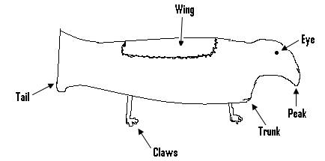

Adaptation to its environment by a terrestrial creature such as the rabbit or the lizard:

A terrestrial creature lives on land. The lizard adapts to its environment as follows:

* It has lungs used for breathing.
* Its colour blends with its environment, so as to avoid detection by its enemies.
* Its hind and fore limbs are such that they can easily be used for crawling and running.
* It has a sticky tongue used for the trapping of insects for food.

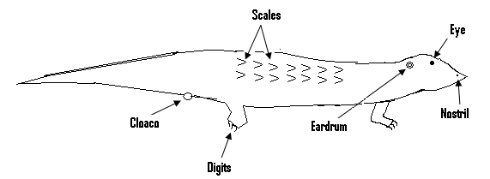

The adaptation of the rabbit to its environment:

The rabbit adapts to its environment in the following ways:

* It has hairy skin to keep its body warm.
* It has legs used for movement on land
* It has lungs used for breathing.

Adaptation of the toad/ frog to its environment:

* The toad belongs to a class of animals referred to as amphibians.
* These are animals which can live in both water and on land i.e. they spend part of their life on land and the other part in water.

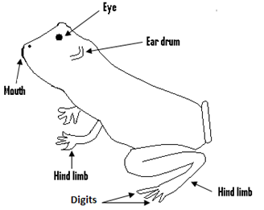

The toad adapts to its environment in the following manner: - It has gills which enables it to breathe in water. - It has lungs which enables it to breathe on land. - Its webbed feet are used for swimming in water. - It has a sticky tongue that helps in its feeding. - Its hind and fore limbs are strong and muscular which assist in hopping.

Adaptation of the bat (aeboral creature) to its environment:

- It has wings used for flight in air. - It has clawed thumbs used to cling to trees. - It has well-developed eyes which enables it to see at night. -It has a highly developed ear for hearing. - Its strong flight muscles enable it to fly long distances.

Adaptation of plants that float on water or live under water:

- They have light bodies which enables them to float. -Some have large flat floating leaves, which are water proof. - The stomatas are on the upper surfaces of their leaves. -They have special roots which can take in oxygen and help the plant to float in water.

The interdependency of living organisms:

Living organisms depend on each other for food, exchange of gases, mineral salts e.t.c.

Dependence of animals on plants:

- Animals depend directly or indirectly on the food produced by plants through photosynthesis. -The oxygen given off during photosynthesis, is used by animals for respiration. - Plants also act as the habitats for certain animals, i.e. those which live on trees.

Dependence of plants on animals:

- The CO2 produced by animals during respiration is used by plants during photosynthesis. - Some animals help in the dispersal of seeds. - Some insects, birds and bats are agents of pollination in plants.

How energy from the sun is used by organisms in an ecosystem:

- Green plants use chlorophyll in their leaves to trap energy from the sun, which is used to prepare their food during photosynthesis. - The energy from the sun is stored in this prepared food. - A herbivore, which is referred to as a primary consumer eats the plant and by so doing, the energy gets into the herbivore. - The herbivore transfers this energy to a carnivore (i.e. a secondary consumer) when the carnivore eats up the herbivore. - When a tertiary consumer eats the secondary consumer, which is the carnivore, this energy is transferred to the tertiary consumer.

Human and natural activities that disrupts the balance of the ecosystem:

1. Over exploitation or the depletion of natural resources.
2. Food shortages.
3. Competition for land space.
4. Increase in industrialization, which leads to an increase in the level of pollution.
5. Higher demand for shelter.

The effect of disrupting the balance of nature:

1. Cutting down trees indiscriminately without replacement, affects the food chain, since plants are producers within the system.
2. Sea pollution with industrial waste destroys the fishes which serve as food for man.
3. Bush burning destroys the nutrients which are needed for plant growth.
4. Indiscriminate hunting may cause the extinction of some animal species.

Ways of maintaining the balance of nature:

1. Replace cut down trees.
2. The amount of poisonous gases released into the atmosphere must be controlled using laws.
3. There must be a ban or check on indiscriminate hunting.
4. The activities of mining companies must be checked or monitored by the environmental protection agency.

Endangered species:

- These are species of plants or animals which are faced with extinction. - Examples are turtle, elephant, tiger, rhino, odum and mahogany.

Ways of protecting endangered species:

1. Manage national parks or game reserves very well.
2. Laws must restrict the illegal trafficking of these species.
3. Hunters must be banned from hunting these animals.
4. Marine pollution must be checked to prevent the death of some marine creatures.
5. Formation of wildlife clubs must be encouraged.
6. Through education.

**Protective mechanism in living things:**

**Predator:**

This is an animal which feeds on other animals.

**Prey:**

- This is the animal on which the predator feeds. - For example if a lion kills and feeds on a deer, then the lion is the predator and the deer is the prey. - In order to avoid being killed by predators, preys have special features which enables them to protect themselves from their enemies, when in danger. - These special features possessed by animals in order to protect or defend themselves, or escape from predators are referred to as protective mechanism.

**Ways animals protect themselves against predators or enemies (i.e. protective mechanism in animals):**

- Some animals ran faster than their enemies or predators. - Some have weapons such as horns used to fight predators. - The colours of certain animals blend with their surroundings, and this makes it difficult for enemies to detect them.- Some have bad body smell which drives enemies away. - Some such as snails and tortoise have hard shell, into which they hide in case of danger.- Also, others have poisonous bite.

**Protective mechanism in plants:** - Certain plants have thorns which drive their enemies away. - Some have poisonous leaves, which keep predators away from them.- Some have unpleasant smell or scent which drives predators away.- Others have leaves which trap their enemies such as insects.

**Population density:**This refers to the number of organisms which live within a unit area (i.e. an area of one square kilometer).If too many organisms occupy an area, then the population density is high and if a few occupy an area, then the population density is low.

**The effect of population density on plants and animals:**

If the population density of animals within an area is high, there will be competition for the basic necessities of life such as food and water.The weak ones may not get enough of these necessities and may die. Only the stronger ones will survive. If the population density of plants within an area is high, then there will be competition for necessities such as water and nutrients. The plants may not get enough and as such not grow well

.

**Food Chain:**

- Within every habitat, there is interaction between plants and animals.

- The interaction is in the form of feeding. - Animals depend upon green plants for food, and these green plants on which animals depend on for food are called the primary producers. -These green plants or primary producers are in turn eaten by plant or grass eaters called herbivores. - These herbivores are later on eaten by flesh eating animals called carnivores. - Food chain refers to the linear feeding relationship between living organisms, in which the organisms feeding are also being fed upon. - In food chain, energy and minerals are transferred from one organism to the other.

**Terms associated with food chain:**

1. **Consumers:** Are living organisms, usually animals that feed on other animals or plants in order to obtain energy.

* Consumers are further divided in three groups and these are:

1. Primary consumers (herbivores).
2. Secondary consumers (carnivore).
3. Tertiary consumers.

**Primary consumers:** Are the first consumers in the food chain, and they feed only on plants. They are called plant eaters e.g sheep, goat and cattle.

**Secondary consumers:** They are the flesh eaters and eat mostly the primary consumers e.g. tiger, dog and cat.

**Tertiary consumers:**They feed on secondary consumers.

**Omnivores:**

* Are living things which feed on both plants and animals.

**Scavengers:**

* Are animals that feed on dead animals, e.g. vulture.

**Decomposers:**

* Are organisms which cause the breakdown of organic matter, and absorb the simple food substances produced.
* Due to this breakdown, decaying occurs and nutrients are returned to the environment.

**Pattern of food chain:**



Examples of food chain:

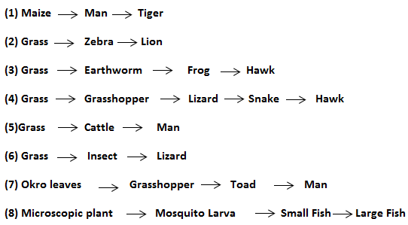

**N/B:** Food chain always begins with green plants and involves a herbivore and at least one carnivore.

**Example of food chain in aquatic habitat:**

1. Algae -> tilapia -> cat fish.
2. Microscopic plant -> mosquito larva -> small fish -> large fish -> crocodile.

**Herbivore food chain/ food chain in a terrestrial habitat:**

* In a herbivore food chain, green plants form the basis of the food supply, since they can manufacture their own food through photosynthesis, and are known as producers.

**Examples:**

1. Green grass -> cow -> man.
2. Grass -> antelope -> man.

**Food web:**

* In an ecosystem, there are different food chains and when those food chains are connected together to form a network of feeding relationship, we get a food web.
* A food web is therefore made up of a number of food chains linked together.

**Differences between food chain and food web:**

|  |  |
| --- | --- |
| **Food Chain** | **Food Web** |
| 1. Involves fewer organisms. 2. Involves one chain. 3. Organisms have lesser survival chance. 4. Linear feeding relationship. | 1. Involves many organisms. 2. Involves many chains. 3. Organisms have greater survival chance. 4. Complex feeding relationship. |

**Climatic factors or ecological factors which affect the environment:**

* These factors are:

1. **Temperature:**

* This is measured by using a thermometer.

**Effect:**

1. It affects or determines the rate of transpiration or photosynthesis.
2. It affects certain animals, since below a certain temperature, some animals become inactive.
3. The germination of seeds depends on temperature.
4. It determines the distribution of vegetation.
5. **Rainfall:**

* This is measured using a rain gauge.

**Effects:**

* It determines the type of vegetation.
* The cultivation of crops depends on rainfall.
* Amphibians need water for reproduction.
* It may cause flooding.

1. **Light:**

* This is measured using the photometer.

**Effects:**

* This is needed for photosynthesis.
* It produces vitamin D in the skin.
* It influences the growth of plants.

**.**

1. **Humidity:**

* This refers to the amount of moisture within the air, and it is measured using the hydrometer.

**Effects:**

* High humidity gives rise to poor visibility.
* Low humidity causes the level of transpiration to increase in plants, and also causes the fast evaporation of water bodies.

**N/B:** Transpiration is the process, in which the excess water in a plant is lost through its stomatas into the atmosphere.

1. **Wind:**

* This is moving air.
* The direction of the wind is measured using the wind vane, and the speed of the wind is measured using the anemometer.

**Effects:**

* It disperses seeds.
* It is used by flying creatures.
* Strong wind can increase the rate of evaporation.
* It brings about rainfall.

1. **Pressure:**

* This is measured by using the barometer and its unit is Nm-2 or pascal.
* It decreases as we move higher and for this reason, mountainous areas have low pressure.

**Effects:**

* It determines the boiling points of substances such as water.

**QUESTIONS:**

(Q1)(a) List three characteristics of living things.

(b) List three differences between plants and animals.

(c) Differentiate between the autotrophic type and the heterotrophic type of feeding.

Ans: - The autotrophic type of feeding is the type found in green plants, in which they manufacture their own food through the process of photosynthesis.

* The heterotrophic type is that found in animals in which they depend on plants for their food, since they cannot manufacture their own food.

(d)What is the main difference between the symbiotic and the parasitic type of association.

Ans: - In the symbiotic type, both of the organisms involved in the association benefit from it.

* But in the parasitic type, it is only one of the organisms called the parasite which benefits from the association,since it depends on the other organism for is needs.

(Q2)(a) Explain what the following mean.

1. Population.
2. Community.
3. Habitat.
4. Salinity.

(b)Differentiate between terrestrial and aquatic habitat.

Ans: - Terrestrial habitat refers to land on which living organisms can live and multiply.

* But aquatic habitat refers to water bodies in which living organisms can live and multiply.

(c)Give three reasons why a living organism, will choose to live in a particular habitat.

Ans:

* The weather conditions of the habitat.
* The availability of food within the habitat.
* The availability of shelter within that habitat.

(d)Of what importance is adaptation to living organisms.

Ans: It is through adaptation that living things living within a particular habitat, acquire special features which enable them to live in that habitat.

(Q3)(a) By naming an aquatic and a terrestrial creature, give three ways each of them adapts to its environment.

Ans: - The fish which is an aquatic creature adapts to its environment in the following manner:

* It has gills used for breathing.
* It has fins which enables it move in water.
* The scales covering its body protect it.
* The lizard which is a terrestrial creature adapts to its environment in the following manner:
* It has lungs it uses for breathing.
* Its hind and fore limbs are designed for crawling and running.
* It has a sticky tongue, which it uses for the trapping of insects for food.

(b)By giving two examples of aeboral creatures, explain what an aeboral creature is.

Ans: - An aeboral creature is one which spends a great deal of its time in the air and on trees.

* Examples are the bird and the bat.

(c)Give two ways in which a named aeboral creature, adapts to its environment.

Ans: -The bird adapts to its environment in these ways.

1. It has peak used for feeding.
2. It has lungs used for breathing.

(Q4)(a) List three human and natural activities, which are capable of disrupting the balance in the ecosystem.

Ans:

* Increase in industrialization which increases the level of pollution.
* Depletion of natural resources.
* Competition for land space.

(b)Give two ways of maintaining the balance of nature.

Ans:

* By replacing cut down trees.
* By limiting the amount of poisonous gases released into the air.

(Q5)(a) What are endangered species?

Ans: These are plants and animals, which are faced with extinction.

(b)Give three examples of endangered species.

Ans: - The tiger, the rhino and the mahogany tree.

(c)Give two ways of protecting endangered species.

Ans:

* Laws must be made to stop or restrict the illegal trafficking of these species.
* The hunting of these species must be stopped.

(Q6)(a)By using the lion and man as an example, differentiate between the predator and the prey.

Ans:

* The predator is the animal which feeds on the other animal, while the prey is the animal being fed upon.
* For example since a lion is capable of eating up man as food, then it is a predator and man becomes the prey.

(b)What do you understand by protective mechanism.

Ans: - These are special features possessed by preys, which enables them to protect themselves against predators, when they are in danger.

(c)Give two ways animals protect themselves against enemies.

- Some have weapons such as horns used to fight off enemies.

Some can ran faster than their predators or enemies, and as such can escape from them when in danger.

(d)List two protective mechanism in plants.

Ans:

* Some have thorns which drive enemies away.
* Others have poisonous leaves, to keep away from them their predators.

(Q7)(a) What is population density?

(b)Explain what we mean when an area is said to have a high population density.

Ans: When the number of organisms which occupy the area is too high, then such an area is said to have a high population density.

(c)What are the effects of such a high population density.

Ans: - If the organisms are plants, then they may not get enough necessities such as sunlight, air and mineral salts.

* Their growth will therefore be affected.
* But if the organisms are animals, then they will compete for basic necessities of life such as food and water.
* For this reason, only the stronger ones will survive.

(Q8)(a) What are primary producers.

Ans: -They refer to green plants upon which animals depend for their food.

(b)Differentiate between a herbivore and a carnivore.

Ans: - A herbivore is a grass eating animal, while a carnivore is flesh eating animal.

(c)What are decomposers and give their importance.

Ans: -They are organisms which cause the breakdown of organic matter into nutrients.

* They are of importance because as a result of the breakdown, nutrients are added to the soil for plant use.

(Q9)(a) Form food chains using the following:

1. Grasshopper, cat, lizard, grass, man.

Ans: Grass -> grasshopper -> lizard -> cat -> man.

1. Algae, man, tilapia and lion.

Ans: Algae -> tilapia -> man -> lion.

**Chapter Twenty Seven**

**General introduction to agriculture:**

**Agriculture:**

* This refers to the growing of crops and the raising of animals for sale or for consumption.
* The early men did not practice agriculture, and roamed in the forest looking for food.
* They also killed some of the animals they came across, and ate them as food.
* On certain days they had a lot of food, but on other days they had none.
* This made them to go hungry and some of them even died.
* Sometimes they were killed by some of the animals they tried to kill.
* As a result of these disadvantages, they started growing some
* of the food they came across near their homes.
* They also started keeping some of the animals they caught near their home.
* This was the beginning of agriculture or farming.

**The importance of agriculture:**

* Agriculture is very important for a number of reasons, and some of these are:

1. **Provision of employment:**

* The growing of crops and the raising of animals, serve as the work of many people.

1. **Provision of food:**

* Agriculture provides us with the food we need for living.
* This food also provides the energy we need to work and move about.

1. **Provision of raw materials:**

* Through agriculture, we get raw materials.
* Some of these raw materials are used to manufacture or make other products.
* For example, tomato is used in the manufacturing of tin tomato, while meat is used in the manufacturing of corned beef.

1. **Provision of Income and foreign exchange:**

* Farmers may sell some of their crops or animals to earn some income. Apart from that, agriculture also provides us with foreign exchange.
* We export some of the agriculture products to other countries.
* This makes us earn foreign exchange.

Selection of a site for making a farm:

There are certain factors which must considered in the selection of a site for your farm.Some of these factors are:

1. **The topography:**

* This refers to the nature of the land.
* Choose a level or a gentle sloping site for your farm.
* If the slope of your site is too steep, then erosion will occur on your land.
* The land will therefore become less fertile.

1. **The type of soil:**

* The site chosen must be rich in humus, which is a type of food for the plant.
* The soil must be able to hold or retain a moderate amount of water.

1. **Nearness of the site to the farmer:**

* The farm site must not be too far from the house of the farmer.
* This will enable him to get to the farm easily, and as often as possible.

1. **Nearness of the site to the market:**

* Your farm site must not be too far from the market.
* This will easily enable you to send your farm produce to the market.
* It will also cut down cost involved in transporting them to the market.

1. **Nearness to water source:**

* You site must be near a water source, so as to enable you get water and water your crops.

1. **Access to road:**

* There must be an access road to your farm.
* This will facilitate the transportation of your farm produce and input to and from the farm.

**Planting material:**

* There may be different varieties for a particular crop.
* Each variety has its own special features or characteristics.
* Select the variety which will give you a high crop yield, and can also cope with the climatic conditions of your area.
* The variety selected must be able to resist the diseases and pests found in the area.
* Lastly, ensure that seeds of the selected variety are variable in your area.

**Agricultural land:**

* An agricultural land is any land which is used for the growing of crops and the raising of animals.
* Land which is not used for these purposes is referred to as non-agricultural land.
* Agricultural land may be lost through the following:

1. Road construction.
2. Construction of new houses.
3. Bushfire.

**Land tenure system:**

* This refers to the conditions or terms, under which land may be held or acquired.
* There are various types and these are:

1. **Inheritance:**

* This is the type of land tenure system in which a land owned by an ancestor, is transferred within the family from generation to generation.

1. **Tenants at the will of government:**

* Under this system, the land is owned by the government and anybody living on it does so at the will of the government.

1. **Leasehold:**

* Under this system, land is given to individuals for a specific number of years under an agreement.

1. **Freehold title:**

* Under this system, the land is acquired through purchasing or as a gift.

1. **Communal land ownership:**

* Under this system, land is collectively owned by members of a community and their future generation.

**Factors influencing agriculture in Ghana:**

* These factors are:

1. **Climate:**

- Weather conditions such as rainfall, temperature and humidity can affect agriculture. - For example, at the time that the crops need water badly, the rain may not fall. - This may cause the death of the crops or affect their growth.

1. **Soil:** - Crops do well in certain types of soil. - This affects agriculture, because a farmer who wants to plant certain crops may not do so, since the soil will not permit him.
2. **Vegetation:** - The type of vegetation found within an area determines the types of crops which can be grown in that area.

* For example, while crops such as millet do well in Northern Ghana, crops such as the plantain and the cocoyam do well in the forest zone. - A farmer may wish to plant certain crops, but the vegetation may not permit him to do so.

**Effect of belief system:**- - Certain beliefs of people may affect agriculture. - For example, a farmer who does not eat pork for religious purposes or reasons may not produce or encourage pig production.

**Government policies for the promotion of agriculture:**

* These polices are:

1. Extension services.
2. Research.
3. Bank credit facilities.
4. Quarantine.

**Extension services:**

This is a department or forms part of the Ministry of Agriculture, which is responsible for teaching farmers modern farming methods, and also introducing the farmers to improved seeds and planting materials.

**Research**

- Research being carried out by institutions in the country in various aspects of agriculture, come out with findings to improve the quality of agriculture products and practices.

**Bank credit facilities:**

- This is a form of loan given to the farmers to help them carry out their farming activities successfully.

-The loan can be in either cash or in kind.

**Quarantine:**

- This is the principle in which serious plant and animal diseases are prevented from moving from place to place. - They make sure that plants and animals are free from diseases before they are imported or exported.

**Problems facing agriculture or farmers in Ghana:**

* These problems are:

1. **Poor storage facility:**

* A lot of agricultural produce or products are lost, since the farmers lack proper storage facilities.

1. **Agricultural land:**

* It is very difficult for the farmer to acquire land for large scale farming or to expand his farm.

1. **Low level income:**

* As a result the small nature of their farms as well as the activities of middlemen, the farmer`s income becomes low.

1. **Lack of amenities:**

* Most farmers live in rural areas which lack amenities such as electricity, good drinking water and good roads.

**Methods of planting:**

* Planting or propagation is the means in which the number of a plant is increased.
* A plant can be reproduced sexually or asexually.

**Sexual propagation (reproduction) in plants:**

* This is also known as seed propagation.
* Many crops are propagated or reproduced by using seeds, and examples are pawpaw, mango and maize.

**Advantages of seed propagation:**

* Seeds of plants with desirable characteristics can be stored for future use.
* Varieties of crops can be produced through cross pollination.
* Seed propagated plants are of greater vigour.

**Disadvantages of seed propagation:**

* Parent plants can pass on their undesirable characteristics to their young ones.
* The young plants do not look exactly like parent plants.

**Vegetative propagation:**

* This is the process of growing a new plant by using a part of an old one.
* It involves the use of parts of the plant other than the seed for reproduction.
* This type of reproduction is also referred to as asexual reproduction.
* There are two methods of producing agricultural crops in a vegetative manner, and these are natural vegetative propagation and artificial vegetative propagation.

**Natural vegetative propagation:**

* This involves the use of underground stems(i.e. rhizome, corn, bulb and stem tubers), stolon, suckers and so on to propagate the plant.

**Rhizome:**

* This is an underground shoot with a swollen stem, which stores food.
* In rhizome, the stem remains underground but continues to grow horizontally.
* Rhizomes have nodes, buds and tiny leaves and do not die when cut, but yields or produces new plants. Rhizomes include ginger.

**.**

**Corm:**

* This is an underground storage organ of certain plants, which is capable of producing new plants.
* A plant such as the cocoyam is propagated using the corm.

**Stem tubers:**

* These are swollen underground portions of plants which have buds or eyes.
* Plants such as the yam and sweet potato are propagated using tubers.
* The yam or the sweet potato is cut into pieces and put into the soil.
* If these pieces contain buds or eyes, they will grow into new plants.

**Bulb:**

* This is an underground modified stem that consists of flesh food storing scale-leaves.
* Crops that can produce young plants from bulbs include onion, garlic and shallot.

**Stolon/ runner:**

* This is a shoot produced at the base of the stem that grows horizontally outwards.
* When the shoot is buried below the surface of the soil, it is termed a stolon.
* But if it grows on top of the soil, it is called a runner.

**Offsets:**

* They are vegetative parts which resemble suckers, but grow above the ground.

**Crown:**

* This is a vegetative propagation structure found on top of certain fruits such as the pineapple.

**Sucker:**

* It is a growth on the existing plant , that develops under the ground from the root or the main stem.
* Plants such as the plantain and the banana produce suckers and are reproduced using suckers.

**Artificial vegetative propagation:**

* This involves the use of cuttings (stem, leaf and root), setts, grafting, layering and tissue culture to propagate plants.

**Stem cuttings:**

* This is what is used to propagate plants such as cassava, sugar cane and the hibiscus flower.
* Pieces or sections of the stem are cut and placed in the soil for them to grow into new plants.

**Setts:**

* These are parts or pieces of a tuber from which new plants can develop.
* Setts are used to propagate yam and cocoyam.

**Grafting:**

* This is a type of artificial propagation in which a cut surface of one plant is joined to a cut surface of another plant, so that they unite and grow as one plant.
* The supporting plant is called the stock and the plant that is grafted to it is called the scion.

**Layering:**

* This is a type of artificial vegetative propagation, in which root development is induced in a branch that is held onto the ground with the aid of pegs.
* The branch is later cut off from the parent plant and allowed to grow independently.
* Crops propagated by layering include coffee, cocoa and some citrus plants.

**Tissue culture:**

* This is the method of growing small amounts of tissues in nutrients, to produce identical new plants in large number.
* In this plant tissue such as the leaf is cut into small pieces.
* These tiny pieces of tissue are placed into a glass tube which contains water and nutrients.
* These pieces of tissue develop shoots and root to form new plants which are similar to the plant.
* One main advantage of tissue culture is that, one plant can be used to produce many new ones.

**Advantages of vegetative propagation:**

* The offsprings produced are exactly like their parents.
* It is a way of producing seedless plants.
* Agents of pollination and fertilization are not required.
* Plants produced using this method usually require less care.
* This method of reproduction is simple and fast.

**Disadvantages of vegetative propagation:**

* The offsprings are less resistance to diseases.
* Diseases or defects are carried from parent to offspring.
* No new varieties of plants are produced.
* It may lead to overcrowding of plants and as such, the spreading of diseases and competition for necessities such as water and nutrients.

**Harvesting of crops:**

* Crops are harvested when they reach a certain stage of growth or maturity.
* Signs of maturity include:

1. Withering of stem and leaves.
2. Ripening of fruits.
3. The drying of pods in legumes.

* Harvesting of crops must not be delayed because:

1. It increases the incidence of pest and disease infestation.
2. It affects the viability of seeds.
3. It reduces the quality of the crops due to insect infection.

* However, harvesting too early may result in yield reduction, poor quality fruits and reduced viability of seeds.

**Processing and Preservation of harvested crop produce:**

* Food processing refers to the transformation of crop or raw animal produce into tasty, nutritious and safe food products.
* Food processing methods create products that are convenient for customers, such as products that are ready to be eaten or require minimal preparation and cooking.

**Importance of food processing:**

* It generates income for many people.
* It creates employment for people.
* It enables food to be transported to distant places without getting spoilt.
* It ensures that food harvested in large quantities do not go waste.
* It makes seasonal crops available throughout the whole year.

**Processing pineapples to produce juice:**

* Fresh pineapple fruits are washed clean.
* They are peeled and sliced into appropriate sizes, and placed in a machine called extractor to extract the juice.
* The juice is flavored and then pasteurized, after which preservatives are added to it.
* Packaging in bottles or cans then takes place.

**Processing of cassava to produce gari:**

* Fresh cassava tubers are peeled and washed.
* The peeled cassava is grated and pressed in clean sacks for two or three days.
* The pressed cassava is then sifted to obtain cassava grains for roasting.
* The cassava grains are roasted in a pan over fire to get gari.
* Starch is obtained as a by-product in gari production.

**Processing oil palm fruits to produce palm oil:**

* Palm oil is made from the outer fleshy portion of the fruit of the oil palm tree.
* Palm nuts are removed from the fruit bunch and cooked.
* The cooked fruits are pounded in a motar with a pistle.
* Sometimes, a machine called power driven hydraulic press is used to crush the fruits.
* Kneading is done and in the process cold water is added. Finally the liquid on top of the nuts called crude oil is skimmed off into a container and boiled.

**Food crop preservation:**

* This refers to the processing techniques which are used to prevent food from spoiling.
* Spoiled food results from chemical changes that occur within the food, as well as the growth of micro-organisms within the food.
* These organisms produce substances that make the food to go bad.
* Some of the food preservation methods are:

**Freezing and refrigeration:**

* At very low temperatures, bacteria become inactive.
* This makes the bacteria which cause the food to go bad inactive.

**Advantages:**

* There is no loss in weight.
* The food lasts as long as it is frozen.
* Frozen food resembles the fresh product more closely than food preserved by other methods.

**Disadvantages:**

* The food gets spoilt when there is power failure.

**Drying:**

* In drying, the water in the food is removed.
* For this reason, micro-organisms cannot grow in it.
* Also, as a result of the drying, the chemical changes which cause the food to go bad slow down.
* Food normally dried include maize, pepper and cola nuts.

**Advantages:**

* It is cheap.
* Dried food has peculiar taste and flavor.
* Dried food can last from four to twelve months, depending on the storage conditions.

**Disadvantages:**

* Dried foods tend to shrink and lose weight.
* The texture of the food becomes tough and chewy.

**Canning:**

* In this method, the food is first heated to kill the bacteria which can cause it to decay.
* It is then put into a sterilized can, heated to drive out the air and then sealed.
* Food crops that are commonly canned include tomatoes.

**Advantage:**

* Canned food can last for a longer time if canning is properly done.

**Disadvantage:**

* The food goes bad within a short time if canning is not properly done.

**Bottling:**

* The food is heated to a very high temperature and then sealed in sterilized bottles.
* The heating kills the germs or bacteria and special preservations may then be added.
* Fruit juice and certain vegetables such as tomatoes can be bottled.

**Advantage:**

* Bottled products last for a longer time.

**Disadvantage:**

* When bottling is done improperly the product easily gets spoilt.

**Pickling:**

* This refers to the preservation of food in an acid such as vinegar.
* It is the acid environment that prevents the growth of bacteria.
* Most pickled foods are first soaked in salt solution to remove the water or moisture within the food.
* This is to prevent this water from diluting the acid which is used to pickle the food.

**Advantages:**

* It can be used to preserve perishable foods for months.
* The acidity or salinity of the solution prevents the easy growth of bacteria.

**Food irradiation:**

* In this method, appropriate radiation is used to destroy the bacteria within the food.
* The food is then stored.

**Advantages:**

* It can be used to delay the ripening of fruits.
* It disinfects grains, cereal products, fresh and dried fruits.

**Disadvantages:**

* The carcasses, faeces or toxins of micro-organisms or insects remain in the food when they are killed by irradiation.

**Marketing:**

* This is the process of directing the flow of goods from producers to customers.
* It involves these activities:

1. **Planning:**

* This involves deciding which of the farm produce will be sold, and how it will get to the consumer.

1. **Pricing:**

* This involves the setting of prices for agricultural produce.
* It must be done in such a way that no losses are made by the farmer.

1. **Assembling:**

* This refers to the gathering of farm produce from different sources, and is done by buying farm produce from several small farmers.

**Sorting:**

* This is the process of separating farm produce into different grades.

**Packing:**

* This involves the arrangement of the farm produce in containers.

**Processing:**

* This is a means of changing agricultural produce from one state into another.

**Storing:**

* Farm produce which are not sold during the market process must be stored properly.
* This is to avoid losses to the farmer.

**Distribution:**

* This is the means by which farm produce are sent to where they are needed.
* The right quantities of farm produce must get to the right place at the right time.
* Producers and middlemen are involved in the distribution of farm produce.

**Transporting:**

* This involves conveying agricultural produce from the farm gate to the market.
* Transportation maybe by means of carrying the produce by road or by rail.

**Importance of marketing:**

* It helps to determine the price of farm produce.
* It saves time and energy, since the buyers do not have to go to the producers to buy needed produce.
* It creates employment for people.
* It helps to make farm produce available throughout the whole year.

**Marketing channels:**

* These are the various routes taken by agricultural produce from the producer till it gets to the consumer.
* In a simple marketing channel, producers sell farm produce directly to consumers.

**Marketing agents:**

* They are individuals, groups or organizations which are involved in conveying farm produce from producers to consumers.
* Marketing agents include producers, middlemen, marketing board, wholesaler, marketing co-operative and retailer.

**Producer**:

* Is either a person or a company that produces and sells farm produce to middlemen and to other marketing agents.

**Middleman:**

* This is a person who buys agricultural produce from a producer or producers, and resells them in large quantities to a retailer, who in turn sells them to the public (consumers).
* The roles of middlemen in the marketing of agric produce include:

1. Storing farm produce.
2. Buying farm produce from farmers.
3. Giving loans to farmers for production.
4. Packaging farm produce.
5. Distribution and transportation of farm produce.

**Marketing board:**

* This is an organization that buys farm produce from producers and sells them to consumers, or export to international market.
* Marketing boards have the following roles.
* They fix and stabilize prices of agricultural commodities.
* They provide secure market for producers.
* They arrange for sale or export of agricultural produce.
* They provide incentive packages for farmers, e.g. scholarships.

**Wholesaler:**

* This is a company or a person that buys and sells agricultural produce in large quantities.

**Retailer:**

-This refers to a person or a business that sells agricultural produce to the public or to consumers.

**Marketing co- operatives:**

-Their main aim is to buy farm produce from individual farmers and sell them to consumers.

-They are also involved with the transportation, storage, fixing and stabilizing prices of farm produce.

**Problems of marketing:**

- Some of these problems are:

**Poor transportation:**

- Lorry owners and drivers are unwilling to go to farming areas with poor road network. - This causes a lot of farm produce to spoil.

**Unstable prices of farm produce:**

- During bumper harvest, the prices of agricultural produce fall.

**Problem of middlemen:**

- These middlemen buy the farm produce from the farmers at very low prices, and resell them later on at very high prices.

**Inadequate market information:**

- Very often, most farmers are unaware of the places where they will get a good market for their produce.

**Inadequate storage facilities:**

* ­As a result of this, many farm produce especially the perishable ones go bad.

**QUESTIONS:**

(Q1)(a) List two reasons why agriculture is important.

Ans:

* Provision of employment.
* Provision of raw materials.

(b)List two factors you will consider in the selection of a site for making a farm.

Ans:

* The type of soil.
* The topography.

(c)Explain why your farm site must be close to the market.

Ans:

* To enable easy transportation of farm produce to the market.

(d)Differentiate between agricultural land and non-agricultural land.

Ans:

* Agric land is used to grow crops and raise animals, but non agric land is not used for these purposes.

(e)Explain what the following means:

(a) Leasehold.

(b)Freehold title.

Ans:

* Under the leasehold system, land is given to individuals for a number of years under an agreement.
* Under the freehold title, the land is acquired through purchasing.

(Q2)(a)List two factors which influences agriculture in Ghana.

Ans:

* These are climate and soil.

(b)Briefly explain how vegetation influences agriculture in Ghana.

Ans:

* It determines the type of crop which can grow in an area.
* The farmer is therefore forced to grow these crops but not the ones he wishes.

(c)What do you understand by bank credit facilities and quarantine?

Ans:

* Credit facilities is a “form of loan” given to farmers, which assists them to do their work successfully.
* Quarantine is a principle which prevents the spreading of plant and animal diseases, from place to place.

(d)Give one advantage of seed propagation.

Ans:

* Seed propagated plants are of greater vigor.

(e)What is vegetative propagation?

Ans:

* Is the process of growing a new plant by using a part of an old one.

(Q3)(a)What is rhizome?

Ans:

* It is an underground shoot with a swollen stem, which stores food.

(b)Name a stem tuber and briefly explain how it is propagated.

Ans:

* The yam which is a stem tuber is cut into pieces and put into the soil.
* If these pieces contain bud or eyes, they will grow into a new plant.

(c)Name two plants which are produced by means of suckers.

Ans:

* Banana and plantain.

(d)What is grafting?

Ans: - It is a type of artificial propagation in which a cut surface of one plant is joined to the cut surface of another plant, so that they unite and grow as one plant.

(e)List one advantage of tissue culture.

Ans:

* One plant can be used to produce many young ones.

(Q4)(a)Give two disadvantages of vegetative propagation.

Ans:

* The offsprings are less resistance to diseases.
* Diseases or defects are carried from parent to offspring.

(b)What is food processing?

Ans: - In this raw food is converted into products that are convenient for customers.

(c)Give two reasons why food processing is important.

Ans:

* It creates employment for people.
* It generates income for many.

(d)Explain why food gets spoilt.

Ans:

* The spoiling of food is due to the work of micro-organisms within the food.
* These organisms produce substances which make the food go bad.

(e)Explain why freezing prevents food from going bad.

Ans:

* Freezing causes the temperature of the food to become very low.

At this low temperature, the bacteria which cause food to go bad become inactive.

(Q5)(a)Explain the effect middlemen have on farmers.

Ans: - They make farmers become poor by buying farm produce from them at very low prices, and reselling them at very high pries.

(b)What are marketing channels?

Ans:

* They are various routes taken by agricultural produce from the producer to the consumer.

(c)List two importance of marketing.

Ans:

* It helps to determine the price of farm produce.
* It creates employment for people.

(d)Give the main aim of marketing co-operatives.

Ans: - To buy farm produce from individual farmers and sell them to consumers.

(e)Give two problems of marketing.

Ans:

* Unstable prices of farm produce.
* Problem of middlemen.

**CHAPTER TWENTY EIGHT**

**Agricultural Tools:**

**DEFINATION:**They are devices or designs which help man to do work easily.

**Types:**

1. **Handy Tools:** They are devices which are simply operated by hands.

Examples are: Cutlass, hoe, rake, pick axe, Mattock, etc.

1. **Implements:** They are devices, designs or instruments drawn by animals or machines.

Examples are: Harvesters, planters, harrows, etc.

1. Other simple tools are associated with the maintenance of farm machines.

Examples are: spanner, screw driver, hammer, bolts and nuts.

**Parts of tools:**

1. **Blade : Is the** portion of a tool used directly to do the work.
2. **Cutting edge: Is** sharpened part of a blade which does the work directly.
3. **Tang:**Is the part of a tool which is pushed into the handle to hold them together.
4. **Socket or eye:**It is a hole especially made on the handle through which the tang can be fixed.
5. **Ferrule:**Is a metal ring at the joint of the blade and the handle. to protect the handle and the blade during use from spoiling.
6. **Grip:**Is part of the handle held directly during operation.
7. **Rivet:** it is a nail like structure used to hold tightly the metal and handle.
8. **Shoulder:** Part of the blade opposite the cutting edge.
9. **Prongs:** These are pointed parts on some metal tools used in turning or stirring the soil or for collecting rubbish.
10. **Handle:** it is the part of a tool held when using the tool. It is made of wood or metal.

**Common tools and their uses**

|  |  |
| --- | --- |
| **Tools** | **Uses** |
| 1. Cutlass | 1. For clearing bushes. 2. For felling trees. 3. For digging holes for planting. |
| 1. Hoe | 1. For general weeding. 2. For making mounds, beds and ridges. 3. Earthing up. |
| 1. Mattock | 1. Removing stumps and roots. 2. Digging trenches. 3. Removing stones. |
| 1. Axe | 1. For felling large trees. 2. For splitting firewood. |
| 1. Pickaxe | 1. Removing stumps, roots and stones. 2. For splitting firewood. |
| 1. Secateurs | 1. For light pruning of fruits and other parts of plants. 2. For preparing the cuttings of hard-wooded plants. |
| 1. Garden shears | 1. For trimming bush and shrub hedges. |
| 1. Go-to-hell | 1. Used in harvesting cocoa and fruits on trees. |
| 1. Dibber | 1. For making holes for sowing large seeds or transplanting seedlings. |
| 1. Hand fork | 1. Losing the top soil around seedlings. |
| 1. Hand trowel | 1. Used for transplanting seedlings. |
| 1. Spade | 1. For digging. 2. For weeding. |
| 1. Shovel | 1. Mixing feed, soil or cement. |
| 1. Rake | 1. Clearing trash or collecting farm refuse. 2. Leveling soil surface after weeding. 3. Breaking soil lumps into smaller pieces. |
| 1. Watering can | 1. Supply liquid fertilizer. 2. Watering seedlings. 3. Watering plant during the dry season. |

**Maintenance of farm tools:**

(1) Wash, dry and oil them after use. (2) Tools should be used for the work they are designed for. (3) Tools should be kept at a cool and a dry place. (4) Records on tools movement should be kept. (5) Tools should be sharpened before use. (6) Tools should be repaired immediately they are broken. (7) Tools should be marked for easy identification.

**Diagrams of some common tools:**

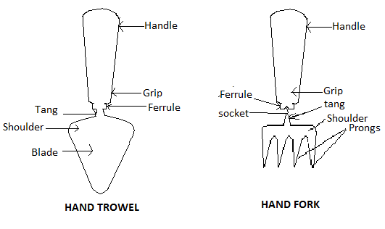

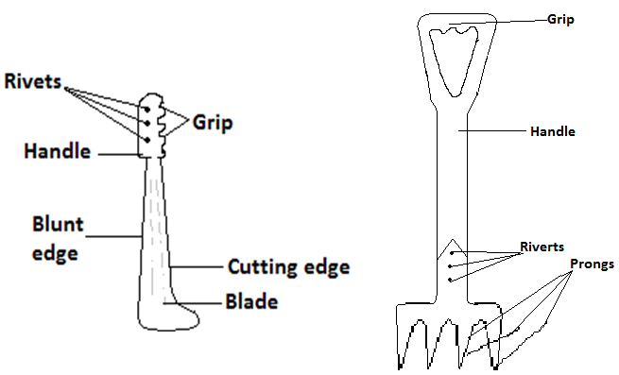

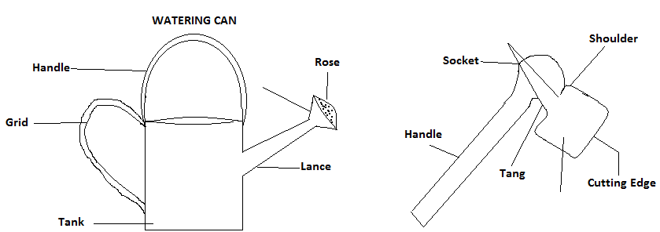

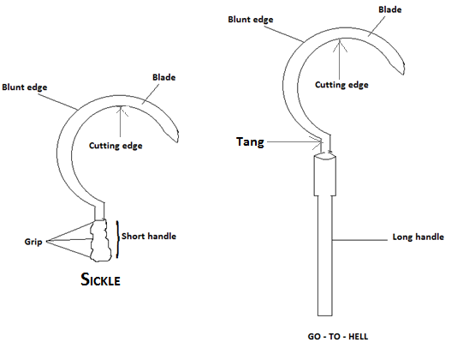

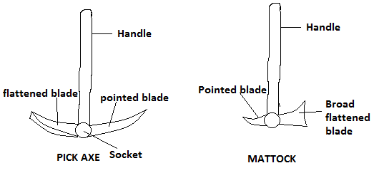

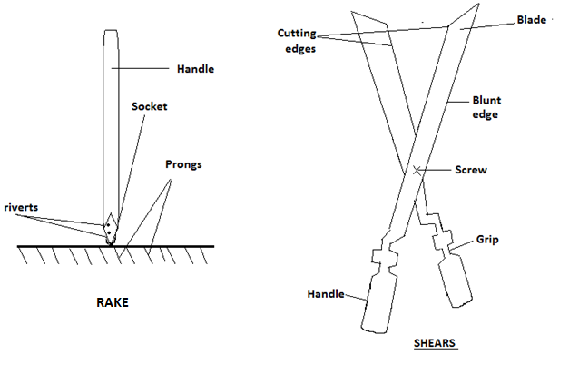

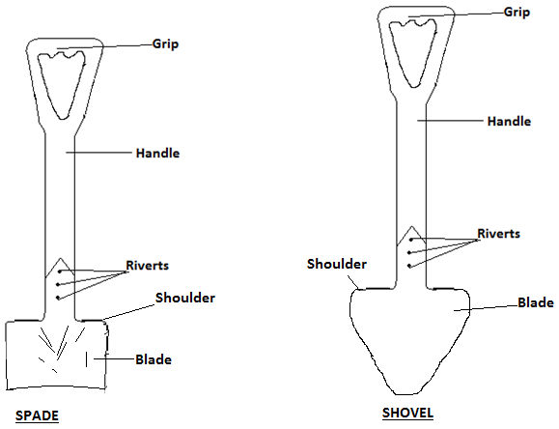

**Farm Implements:**

* These are farm tools or instruments which are drawn by machines,or animals used for farm operation.
* They can be grouped into two namely:

1. Animal Drawn Implements.
2. Machine Drawn Implements.

**Animal Drawn Implements:**

* These are implements drawn or operated by animals such as horses, donkeys, cattle, and oxen. They are used for land preparation and other functions. Such implements include ploughs, ridgers and weeders.

**Machine Drawn Implements:**

* These are implements drawn or pulled by machine power to perform certain farm operations like land preparation, planting of seeds and harvesting.
* Some of these implements include harvesters, planters, cultivators, ridgers and harrows.
* One most important machine used for this purpose is the tractor.

**Types of implements and their Uses:**

1. **Mould:** It is a large, gently curved metallic sheet with the share attended to the anterior part of the mould board plough.

**Uses:**

* To turn over the soil and to cut any plant material found in the soil.
* It is used on land with soft soil and stone-free soil.

1. **Disc Plough:** It consists of large revolving concave disc.

**Uses:**

* It can be used to make ridges by turning a furrow slice to one side with a scooping action.
* It can be used in drier soils and also where there are likely to be stones in the soil.

**Harrows:**

* It is made of tined implements.

**Uses:**

* Used in breaking up soil clods, weed combing, and dragging roots and stones out the soil.

**Ridgers:**

* They are made of discs of several sizes or forms which cut across the earth and turn the soil over to form ridges.

**Types:**

1. Mould Board Ridgers.
2. Disk Ridgers.

**Uses:**

* They are used in making ridges.
* They are drawn for use by tractors.

**Planters:**

* They are made up of spinning disk or a centrifugal distributor which consists of a rotating cone placed vertically and centrally below a hopper, (i.e. cylindrical metal container in which the seeds are put).

**Uses:**

1. To plant or sow seed.
2. To apply fertilizers and insecticides.
3. To apply weedicides to control weeds.

**Combine harvesters:**

* It is a made to cut, tresh and bag cereals normally on a large scale farm.

**Uses:**

1. For cutting crop plants ready for harvesting.
2. For treshing cereals like maize, rice and millet.
3. For bagging cereals.

**N/B:** All these functions of the combine harvester can be operated at the same time.

**Maintenance of farm implements:**

1. Broken and worn off parts of machines should be repaired immediately.
2. Engine oil and water in the radiator should be checked before using the machine.
3. Tyres must be well inflated before use.
4. Loose screws, bolts and nuts must always be tightened.
5. Implements should be used purposely for the work they are designed for.
6. Oiling and greasing of portions such as the bolts and nuts, as well as the metal joints must be regular.

**OTHER TOOLS:**

* Some other tools and materials used for the maintenance of farm machines are:

1. **Spanner:**

* It is used in turning nuts or turning tight things.

1. **Hammer:**

* Used for knocking nails or removing nails from things. It is also used for straightening metal plates.

1. **Screw-driver:**

* It is used for tightening or screwing screws to fit into their sockets or to remove them from their sockets.

1. **Pliers:**

* For cutting wire, bending wire and for holding objects still.

1. **Bolts and nuts:**

* Used to fasten metal or wooden materials together.

**CHAPTER TWENTY NINE**

**Plant Nutrients And Soil**

* These are sources of food needed for plant growth. - They are normally obtained from air and water.
* Nutrients obtained from the air include oxygen, nitrogen and carbon dioxide.

**Types**:

* There are two types and these are:

1. The major nutrients.
2. The minor nutrients.

**The major nutrients:**

* These are those nutrients which are needed in large quantities or amount for plant growth.
* They are also referred to as the macro nutrients.
* Examples are nitrogen, potassium, calcium, sulphur andphosphorus.

**Functions of certain major nutrients:**

**Nitrogen:**

* It helps in the development of fruits and tubers.
* It helps the development of the deep green colour in plants.

**Phosphorus:**

* It encourages the development of roots.
* During a plant`s maturity stage, it helps in the ripening of the fruits.
* It stimulates the activity of nitrogen fixing bacteria.

**Potassium:**

* It helps in the formation of fruits and seeds.
* It helps in the process of photosynthesis.
* It enables plants to become resistance to diseases, drought and high temperatures.

**Deficiency symptoms of certain important nutrients:**

- Deficiency symptoms are signs which appear in a plant, due to the lack of a particular nutrient. - The deficiency symptoms as a result of the lack nitrogen are: (a) The leaves of the plant become yellow in colour. (b) The growth of the plant becomes stunted or slowed down. - The deficiency symptoms as a result of the lack of potassium are: (a) There will be lodging in cereals. (b) The tips and the margins of the leaves become yellow. The deficiency symptoms as a result of the lack of phosphorus are: (a) There will be stunted growth in the plant. (b) The crops also will become stunted.

**The minor nutrients:**

- These refer to those nutrients which are needed in small amount for plant growth. - They are also referred to as the micro nutrients. - Examples are zinc, copper, iron and chlorine.

**Signs shown by plants when they get enough nutrients:**

* Their roots develop very well.
* Their leaves become broad.
* Their stem becomes thick.
* There is a high yield in crop production.

**Signs shown by plants when they do not get enough nutrients:**

* The growth of the plant becomes stunted.
* Parts of the leaves become yellow, with the other parts being green.
* The fruits fall prematurely.
* The crops mature at a slow rate.
* The leaves may fall prematurely.

**Manure:**

- There are two types of manure and these are: (i) Inorganic manure. (ii) Organic manure.

**Inorganic manure:**

- They are usually referred to as fertilizers. - Fertilizers are chemical plant food prepared by the agriculture scientist, which contain the major nutrients needed by plants. - It is normally used or applied when the soil becomes poor in plant nutrients. -There are two types of fertilizers and these are (a) Compound or mixed fertilizer. (b) Simple or straight fertilizer.

**Compound or mixed fertilizer:**

- This is the type of fertilizer which contains two or more major nutrients. - Examples are the N.P.K fertilizer and the N.P fertilizer. - An N.P.K is a mixture of nitrogen, phosphate and potash. - A compound fertilizer labeled 20:20:15 means that it consists of 20% nitrogen, 20% phosphate and 15% potash. - Compound fertilizers are usually round in shape and ash in colour.

**Simple or straight fertilizer:** -This is the type of fertilizer, which is made up of only one major nutrient. - Examples are the sulphate of ammonia, supper phosphate and ammonium nitrate. - It may be granular, powdery or crystalline in appearance.

**Organic manure:**

* This is the type of manure formed when dead plants and animal parts or remains are allowed to decay or decomposed.
* It includes compost, cow dung, poultry dropping and other farmyard manure.
* Organic manure in the form of compost can be made in many ways.
* In one method, a pit is dug and its bottom is lined with rocks to permit aeration and drainage.
* Plant materials such as leaves are placed into the pit as the first layer.
* The second layer is made up of animal manure such as cow dung, and a third layer of soil mixed with wood serves as the top layer.
* The whole heap is watered and turned every two weeks to improve aeration.
* The working temperature of the heap is tested by inserting a stick in it.
* If the stick is felt hot on removing, then decomposition is taking place.
* By the end of the sixth week, the heap would have bee decomposed into compost.

**Advantages of applying organic manure:**

1. It makes the soil rich with plant nutrients.
2. It loosens up the particles of compact soil particles.
3. It puts together very loose soil particles.
4. It maintains moisture within the soil.
5. It checks erosion.

**SOIL:**

-This is the upper part of the earth`s crust, which serves as the main dwelling place of plants.

**Formation of soil:**

- Soil is formed from rock, and is formed whenever a rock breaks down or disintegrates into pieces.

* Some of the factors or conditions which can lead to the break-down of these rocks to form soil are listed next:

1. – During a hot day, the sun heats the rocks causing them to expand.

* When the weather becomes cool especially during at night, the rocks cool and contract.
* This continuous heating and cooling results in the continuous expansion and contraction of the rocks, which results in the appearance of cracks and crevices within the rocks.
* These cracks and crevices leads to the gradual break-down or disintegration of the rocks to form soil.

1. - Strong wind carries dust particles which on striking the rock surface, chops out particles of the rock to form soil.
2. – When it rains, rocks are carried into running or moving water bodies such as rivers.

* Rocks being carried in running water knock against each other, which results in their break-down into soil.

1. – Roots of plants which grow deep into rocks create cracks and crevices within them.

* These cracks and crevices later lead to the disintegration of the rocks.

**Composition of soil:**

- Soil is made up of the following parts or constituents: (1) Rock particles. (2) Soil water. (3) Soil air. (4) Living organisms. (5) Organic matter.

**Rock particles:**

* These are also referred to as the mineral or inorganic matter.
* These are the components of the soil, which is made up of broken down rock particles.
* The broken down particles of rock consists of different sizes.
* Mineral matter is important due to these reasons;

1. Their different sizes and shapes of the broken down rock particles within the soil, create spaces for air and water to pass through.
2. It serves as a habitat for all soil living organisms.
3. It is the main source of plant nutrients such as calcium, magnesium and iron.
4. It holds air and water for both plant and animal activities.

**Soil water:**

* This is the name given to the water found within the soil.
* When there is too much water within the soil, the soil becomes waterlogged and such a soil has all its air spaces filled with water.
* Such a soil can be also improved for the planting of crops by creating gutters in it, so as to enable the excess water to flow away from the surface.
* Soil water is important because:

1. It is needed for photosynthesis.
2. It is needed for the germination of seeds.
3. It is needed for transpiration in plants.
4. It is needed for the transport of nutrients from the soil to the other parts of the plant.

**An experiment to demonstrate that soil contains water:**

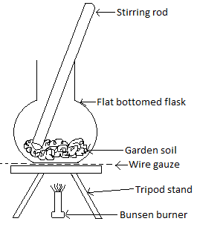

**Aim:** To show that soil contains water.

**Apparatu**

**:** Sample of garden soil, flat-bottom flask, Bunsen burner, tripod stand, wire gauze, metal plate, stirring rod and dry copper sulphate crystals.

**Procedure:**

* A sample of garden soil is placed in a flat-bottomed flask, and heated from below.
* The soil is stirred during the heating process.
* Moisture in the soil escapes into the atmosphere as steam, which can be condensed on a metal plate and tested with white copper sulphate crystals.
* The presence of water is confirmed since it turns the crystals into blue.

**Conclusion:** Soil contains water.

**Soil air:**

* This refers to the air found within the soil.
* It is important because of these reasons:

1. It is needed for the growth and the development of the plant.
2. Soil organisms as well as the roots of plants need it for respiration.
3. Without it, organic matter cannot be decomposed or broken down into humus.

**Experiment to show that soil contains air:**

**Aim:** To show that soil contains air.

**Apparatus:** Soil sample, container and water.

**Procedure/ method:**

* Put the soil into the container and add water to it.
* Shake the set up vigorously and allow it to stand.

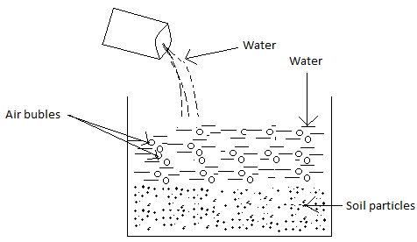

**Observation:** Bubbles of air was released to the surface.

**Conclusion:** Since the water displaced the air in the soil to form the air bubbles, then the soil contains air.

**Living organisms (soil organisms):**

* These refer to the plants and animals which live in the soil.
* While some can be seen by the eye, others cannot and are therefore known as micro-organisms.
* Examples of soil organisms are earthworms, termites, ants, bacteria and viruses.

Soil organisms are important due to the following reasons:

1. They improve the soil aeration by creating holes in the soil.
2. They help in the decomposition of organic matter.
3. They mix up the soil through their activities.
4. They improve soil drainage.
5. Some of them such as termites improve the soil structure by fixing soil particles together.

**An experiment to demonstrate that soil contains living organisms:**

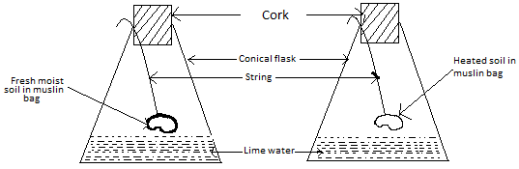

**Aim:** To investigate the presence of living organisms within the soil.

**Apparatus:** Conical flasks, corks, string, sample of fresh moist soil, heated soil, muslin bag and lime water.

**Procedure:**

* Fresh soil and heated soil are placed in separate muslin bags, and each suspended in a conical flasks by means of strings.
* The two conical flasks which contain lime water are corked to prevent the entry of air into them.
* The flask containing the heated soil sample serves as the control experiment.

**Observation:**

* Respiring living organisms in the fresh moist soil breathe or give out carbon dioxide which turns the lime water milky white.
* The lime water in the flask containing the heated soil sample remains clear or unchanged because, all the living organisms within the soil have been killed through the heating process.
* For this reason, no carbon dioxide was given out.

**Conclusion:**The soil contains living organisms.

**Some bad effects of soil organisms:**

* Some of them such as termites are pests of crops.
* Some produce toxins in the soil which slows down the growth and development of roots.
* Some cause plant and animal diseases.
* Some cause damage to farm wooden structures, e.g. termites.

**Functions and uses of soil:**

1. It supplies plants with nutrients.
2. It stores the water needed by plants.
3. It provides the necessary oxygen needed by roots for respiration.
4. It holds the plant firmly.
5. It contains living things such as micro-organisms.

**Fertile Soil:**

* This is soil which contains almost all the nutrients needed for plant growth.
* In order to improve and maintain the fertility of the soil, we have to:

1. Apply fertilizer or organic manure regularly.
2. Avoid the use of fire to clear farms or bushes.
3. Mulch the land.
4. Plant cover crops to protect the soil against erosion.
5. Allow fallow period.

**Loss of soil fertility:**

* Soil may loss its fertility due to a number of reasons, and some of these are:

1. **Leaching:**

* This refers to the downward movement of plant nutrients by water in the soil, beyond the reach of the root system.

1. **Crop removal:**

* The removal of vegetation after harvest exposes the soil to the agents of erosion, which results in the loss of the fertility of the soil.

1. **Continuous cropping:**

* The regular cultivation of a land, causes a depletion of its plant nutrients.
* This leads to the loss of the fertility of the soil or the land.

1. **Erosion:**

* Erosion results in the removal of the top soil which contains most of the plant`s nutrients.
* The loss of these nutrients makes the soil lose its fertility.

1. **Flooding or excessive irrigation:**

* These cause a continuous presence of water on the soil, which can lead to leaching.

**Kinds of soil:**

* There are three main types of soil and these are sandy soil, clayey soil and loamy soil.
* They differ from each other with reference to their physical characteristics or properties.

**Sandy Soil:**

* This is the type of soil with very large particles and therefore has a low water retaining capacity.
* Sandy soil becomes very hot when the sun shines on it, and possesses no or less plant nutrients.
* For this reason, plants do not grow well in it.
* Sandy soil can be improved or made good for farming by the addition of either natural or artificial manure.
* By so doing, the plant nutrients it contains will be increased.

**Characteristics of sandy soil:**

* Water easily drains or passes through it.
* Its particles are large.
* It has a low water holding capacity, i.e. it can hold only small amount of water.
* It is poor in plant nutrients and as such plants do not grow well in it.
* It contains large air spaces, i.e. it porosity is high.
* It has a low capillary action, i.e. water rises through the pores in sand very slowly.
* It particles are rough or gritty when felt between fingers.

**Reasons why sandy soil cannot support good plant growth:**

* It cannot hold enough water for plant or crop use.
* It does not contain enough plant nutrients.
* It has a poor ability to hold nutrients,, i.e. there is a great leaching losses.

**Clayey Soil:**

* This is the type of soil with very tiny particles.
* For this reason, it retains too much water and does not allow air to pass through so that cultivated plants can breathe.
* Despite the fact that it contains too much water, it contains quite enough plant nutrients.

**Characteristics of clayey soil:**

* Water does not easily drain or pass through it.
* Clay particles are fine, smooth or silky.
* Its particles are tiny.
* It holds a lot of water, i.e. it has a high water holding capacity.
* It contains a small amount of air spaces, I.e. its porosity is low.
* It has a high capillary action, i.e. water rises faster through its pores.
* It swells, when wet and shrinks when dry.
* It can support the growth of only a few plants.

**Reasons why clayey soil supports the growth of few crops:**

* It is waterlogged since it has a poor ability to drain water.
* It becomes very hard when it is dry.

**Ways of improving clayey soil:**

1. By making ditches for the standing water to flow from the surface.
2. – The tiny particles can be made larger by the addition of lime.

* The lime is sprinkled on the surface of the clay soil, so as to make the tiny particles a bit larger.

1. By adding organic matter to the soil.

**Loamy soil:**

* This type of soil is a combination of sand and clay.
* It is the best type of soil because, while the sandy particles allow air to enter the soil, the clay particles retain or keep water in the soil and also supply plant food or nutrients.

**Characteristics of loamy soil:**

* Water drains through loam better than clay but poorer than sand.
* Its particles are not too rough and not too smooth.
* Its particle sizes lie between that of sand and clay.
* It can support the growth of most crops.
* It contains a moderate amount of air spaces.
* It is very rich in plant nutrients.
* It has a moderate capillary action.

**Reason why loamy soil supports the growth of most crops or plants:**

* It contains a lot of nutrients for plant use.
* Water easily drains through it, and does not easily become waterlogged.

**Humus:**

* It is a type of plant food found in the soil.
* It is formed when the remains of dead plants remains of dead plants and animals are decomposed by micro-organisms.
* When it is present in a soil, the colour of the soil becomes dark brown or black.
* Humus is normally found on the top part of the soil.

|  |  |  |  |
| --- | --- | --- | --- |
| **Characteristics of soil** | **Clay** | **Sand** | **Loam** |
| Drainage of water through soil. | Water drains through slowly. | Water drains through easily. | Water drains through better than clay but poorer than sand. |
| Water holding capacity. | It retains or holds a lot of water which makes it wet and waterlogged. | It can hold very little water. | It holds a moderate amount of water. |
| Support of plant growth. | Only plants that do well in water, can be supported in the soil. | It does not support good plant growth. | It is the best soil for the growth of plants. |
| Nutrients content of soil. | Rich in plant nutrients. | Poor in plant nutrients. | Richer in plant nutrients. |
| Capillary action of soil. | High capillary. | Low capillary action. | Moderate capillary action. |
| Size of particles. | Small or tiny. | Large. | Medium or moderate. |
| Amount of air spaces between soil particles. | Contains a small amount of air spaces. | Contains a large amount of spaces. | Contains a medium amount of air spaces. |
| Feel of dry soil when rubbed between fingers. | Fine, smooth or silky. | Rough, coarse or gritty. | Moderate, i.e. between that of sand and clayey. |

**The chemical properties of soil:**

* This includes soil acidity and soil alkalinity.

**Soil acidity:**

* This refers to the concentration or the number of hydrogen ions (i.e. ) within the soil.
* Soil acidity is measured by means of the pH scale.
* If the pH of the soil is less than 7, then the soil is acidic.
* And if it is greater than 7, then the soil is alkaline.
* Lastly, if the pH is 7, then the soil is neutral.
* The pH of the soil is very important to the farmer for these reasons:

1. Many plants and soil organisms prefer either an acidic, or an alkaline condition.
2. Some diseases tend to thrive when the soil is alkaline or acidic.
3. The pH controls the ability of the plant to absorb nutrients from the soil.
4. Soil acidity or acidic soil can be caused by leaching and the application of acidic fertilizers.

**The effects of soil acidity:**

* It can cause a reduction in the number of soil organisms.
* It can cause the malfunctioning of the roots of crops.
* It can reduce the rate of the decomposition of organic matter.
* Acidic soil can be made good or conducive for farming, by a process called liming.
* During liming, calcium-containing compounds such as calcium hydroxide are added to the soil.

**The importance of liming:**

* It improves the structure of heavy soils.
* It enhances the movement of air and water within the soil.
* It reduces soil pH or acidity.
* It promotes the activity of soil organisms.

**Soil alkalinity:**

* This refers to the concentration or the number of hydroxyl ions (i.e. O) in the soil.
* It is also measured using the pH scale.
* If the pH of the soil is greater than 7, then the soil is alkaline.
* Alkaline soil can be made conducive for cultivation by:

1. Applying sulphur to the soil.
2. Applying acid fertilizers to the soil.

(3) Irrigating the soil in order to dissolve some of the salts.

**Experiment to determine the pH of a sample of soil:**

**Aim:** To determine the pH of a soil sample.

**Apparatus:** Soil sample, litmus paper, water and a container.

**Procedure:**

* Sample of soil is placed in a container.
* A small amount of water is added to the soil, in order to dissolve the minerals it contains.
* Blue and red litmus papers are then in turn, brought into contact with the soil suspension, i.e. the water containing the dissolved minerals.

**Observation and conclusion:**

* The soil sample is acidic if the blue litmus paper changes to red.
* It is alkaline when the red litmus paper changes to blue.
* If both litmus papers does not change colour, then the soil sample is neutral.

**Soil erosion:**

* This is the washing away of the top soil which contains plant nutrients by rain (water), wind and ice.

**The effects of soil erosion:**

* It causes the lost of soil.
* It causes the lost of the plant nutrients found in the soil.
* It causes the washing away of crop plants.

**Methods adopted to prevent soil erosion on a farm:**

* Erosion can be prevented or checked by:

1. Applying organic matter.
2. The construction of terraces.
3. The construction of water channels.
4. By mulching the land.
5. By avoiding overgrazing and bush burning.

**The effect of bush burning:**

* It destroys the soil structure.
* It destroys the organic matter and the nutrients found in the soil.

**Mulching:**

* Mulching is the covering of the soil with materials such as dead plants, cut weeds or rotten litter to keep the soil rich and cool.

**The importance of mulching to the soil:**

* It prevents the loss of water from the soil and as such keeps the soil moist and cool.
* It checks the growth of weeds.
* It helps to control or check soil erosion.
* It keeps the soil damp and loose.
* It enables the soil to become rich.

**How mulching helps to keep the soil moist, cool and enriches the soil:**

* Mulching helps keep the soil moist and cool.
* The mulch or the material used for the mulching, always prevents the sun`s energy from getting to the soil.
* In this way, it touches only the material used for the mulching and spares the soil.
* The mulch also rots to form organic matter when the rain falls on it.
* By so doing, the amount of organic matter within the soil is increased, which causes an increase in the soil`s fertility.

**Soil capillarity and its water holding capacity:**

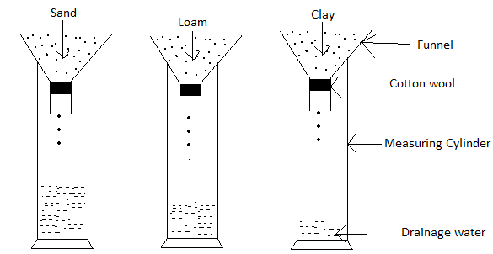

* The water holding capacity of soil refers to its ability to retain water.
* This depends on the texture, as well as its organic matter content.
* Soil which contains a lot of water is capable of holding or retaining a lot of water.

**An experiment to demonstrate the water holding capacity of the drainage ability of sand, loam and clay:**

**Aim:** To compare the water holding capacity or drainage ability of sand, loam and clay.

**Apparatus:** Three measuring cylinders, water, cotton wool, dry sand, dry clay, dry loam and three funnels.

**Procedure:**

* Grind the three soil samples into smaller particles.
* Block the neck of each of the funnels with cotton wool, to prevent the soil from entering the measuring cylinder.
* Put equal amount of sand, loam and clay into each of the measuring cylinders.
* Equal volume of water is poured into each of the funnels at the same time.
* In order to get the volume of water retained by each soil, we subtract the volume of water drained through each soil, from the initial volume of water poured into the funnels.
* It will be noticed that the greatest amount of water was able to drain through the sand.
* The least amount of water was able to drain through the clay, with a moderate amount draining through the loam.

**Conclusion: -**

* Clayey soil retains water most, followed by loamy soil with sand being the poorest.
* This also implies that sandy soil drains water most, followed by loamy soil and finally by clayey soil.

**Precautions to be taken:**

* With the exception of the sandy soil, grind the other types of soil.
* All the soil samples used must be dry.
* Sieve all the soil samples.
* The water must be poured into the funnel at the same time.
* The amount of water poured into the funnel, must be twice the volume of the soil.

**Soil Capillarity:** - Capillarity also refers to the rise of a liquid within a capillary tube.- A capillary tube is a small tube, with a hole in its middle.- Soil capillarity refers to the rise of water through the pores in the soil.- It depends largely on the pore spaces between the individual soil particles.- The smaller these pores, the greater will be the capillary rise or action within the soil, and the larger these pores, the lower will be the capillary action or rise.

**An experiment to demonstrate the capillary action of sand, loam and clay:**

**Aim:** To compare the capillarity of sand, loam and clay.

**Apparatus:** Three glass tubes, water, trough, cotton wool, stop clock, dry sand, dry clay, dry loam and a clamp.

**Procedure:**

* Take three glass tubes and block the one end of each with a cotton wool.
* This soil samples, except the sand are grounded into powder.
* The three glass tubes are then filled with dry sand, dry loam and dry clay respectively.
* Tap the tubes gently on the ends, so that the soil in each is tightly packed.
* With the aid of a clamp, the three glass tubes are suspended in water within a glass trough.

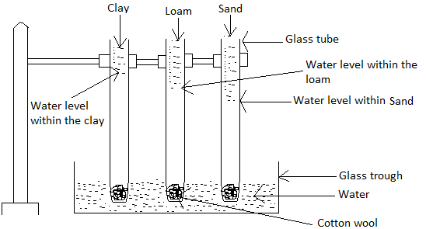

**Observation:**

* The level of the rise of water will be greatest for the clay, followed by that of the loam.
* Also, the level of water rise for the sand will be the lowest.

**Conclusion:**

* The capillarity of clayey soil is the greatest, followed by that of loam, with that of sand being the least.

**Precautions to be taken:**

* The soil samples must be dry.
* Sieve the soil samples.
* Ensure that cotton wool is fixed at the bottom or one end of the tube.
* All the soil types except the sandy soil must be grinded.

**Soil temperature:**

* The temperature of a body refers to its degree of hotness or how hot it is.
* The temperature of the soil is usually different from that of its surrounding.
* Soil temperature refers to the temperature within the soil.

**The importance of soil temperature with reference to crop production**

* It effects the formation and the decomposition of organic matter.
* It affects the population of the soil micro-organisms.
* It influences seed germination and root development in seedlings.
* The absorption of water and nutrients from the soil, is affected or determined by the temperature of the soil.

**Soil porosity:**

* This refers to the size, the number and the arrangement of the pores within the soil.
* Pores are created as a result of contact made between irregularly shaped soil particles.
* Porosity greatly affects water movement and the exchange of gases.
* Some soils have numerous pore spaces which are important to the soil organisms, which require air and water for survival.
* Soil porosity also affects the transport of plant nutrients.

**Soil colour:**

* This refers to the colour of the soil.
* Even though it does not affect the soil, it is an indication of certain properties of the soil.
* Soil which is rich in organic matter appears black or dark brown in colour.
* Soil which has its pores spaces filled completely with water appears grey, blue or green in colour, since the minerals that give it the red and yellow colours have been leached away.
* Soil colour is determined using the Munsell soil colour chart.

**An experiment to determine the colour of soil:**

**Aim:** To determine the colour of a sample of garden soil.

**Apparatus:** Water, soil colour chart and garden soil.

**Procedure:**

* A ped of garden soil is slightly moistured with water, if it is dry.
* The ped is broken into two and one part is examined with the colour chart.

**Observation/ conclusion:**

* The colour of the soil sample will be shown by the chart.

**Precaution:**

* One must stand with the sun over the shoulder, so that sunlight shines on the colour chat and the soil sample under examination.

**Soil profile:**

-This is the vertical cross- sectional view of the layers of soil in the earth crust.

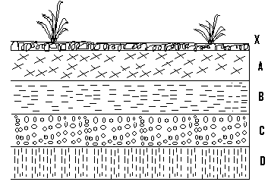

Key.

A= Top soil

B= Sub soil

C= Weathered rocks

D= Parent rock

X= Superficial layer.

**The importance of soil profile to the farmer:**

1. - The thickness of the superficial layer (organic layer) and the top soil layer tells the farmer the types of crops to cultivate.

* For example, shallow-rooted crops are grown in thin top layer while deep- rooted crops are grown in thick top layer, since the top layer contains most of the plant nutrients.

1. - The sub soil in the soil profile tells the farmers whether erosion can occur on the land or not.

* When the soil particles of this layer are closely arranged, then erosion cannot easily take place.
* Also when these particles are loosely arranged, then leaching can easily take place.

1. The weathered rocks show the content of the minerals, present in the top soil and the subsoil.

* The parent rock indicates the type of mineral salt present in the soil.
* It helps the farmer to determine the drainage status of the soil.
* It also enables the farmer to decide on the right fertilizer or manure to use.

**Soil texture:**

* This refers to the relative proportion of sand, silt and clay which is present in a given sample of soil.
* It also refers to the sizes of the particles that make up the soil.
* A fine-textured soil mainly consists of tiny clay particles.
* A coarse-textured soil comprises of medium to large size sand particles.

**Determination of soil texture by the feel method:**

**Aim:**To find out the texture of a soil using the feel method.

**Apparatus:** Soil sample.

**Procedure:** A small sample of soil is taken and rubbed between the forefinger and the thumb.

**Observation and conclusion:**

* A gritty feel represents the presence of sand, whereas a smooth or silky feel represents the presence of clay.

**An experiment to determine the texture of a given sample of soil, using the field method:**

**Aim:** To determine the texture of a sample of soil.

**Apparatus:** Flat wooden board, soil samples, water, sieve and tablespoon

**Procedure:**

* Samples of different types of soil are taken.
* Each of them is sieved and a tablespoonful of each sample is taken.
* A few drops of water are added to each sample, until a sticky point is reached and a ball formed from each or not.
* Those soil samples that form balls are rolled on a flat wooden board into a cylinder.
* Cylinders of some of the soil samples are bent (with or without cracks) into circles.

**Observations/ conclusion:**

* If the soil sample:

1. Cannot be shaped into a ball, then it is sand.
2. Makes a ball but not a cylinder, then it is loamy sand.
3. Makes a short fat cylinder, then it is light loam.
4. Makes a full-length cylinder, but breaksupon bending then it is loam.
5. Makes a cylinder that can be bent into a U-shape but not a circle, then it is heavy loam.
6. Makes a circle, but with cracks, then it is light clay.
7. Makes a circle without cracks, then it is clay.

**Importance of soil texture:**

* It helps the farmer to determine the drainage ability of the soil.
* It enables the farmer to know the type of soil on his farmland.
* It helps the farmer to determine the tillage practices to adopt in the cultivation of crops.
* It helps in the evaluation of the soil`s ability to supply mineral nutrients.

**An experiment to determine the particle size distribution of a sample of soil, i.e. the arrangement of the size of the solid particles of the soil:**

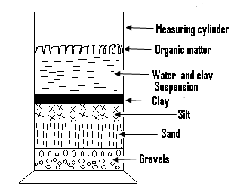

**Apparatus:** Measuring cylinder, water, sample of garden soil and table.

**Procedure:**

* A sample of dried garden soil is placed into a measuring cylinder.
* Water is added until the soil is covered with water.
* Stir or shake vigorously till the soil mixes thoroughly with the water.
* Place the mixture on a table for about three hours.

**Observation:** The soil sample separates into its mineral components.

**Conclusion:** Garden soil is therefore made up of different soil particle sizes.

**Soil structure:**

* Soil structure is the arrangement of the individual particles into aggregates, creating pore spaces of various sizes.
* Each individual unit of soil structure is called a ped.
* The particles of soil include that of sand, silt and clay, and these particles are bound together by organic matter.
* Soil structure has a direct effect on crop yield, for if the soil structure is good, then air circulation will be good and waterlogging, erosion and leaching will be reduced.

**Types of soil structure:**

1. **Single grain structure (structureless):**

* In this, the individual particles or grains of soil, are separated from each other.
* It is commonly found in sandy soil.

1. **Crumb structure;**

* In this, the units are not fitted together and are formed by porous little rounded aggregates.
* Loamy soil has this type of soil structure.

1. **Blocky structure:**

* In this, the soil particles form blocks with irregular edges.
* Even though it is common in subsoil, it also occurs in surface soils that have high clay content.

1. **Platy structure:**

* In this, the units look like stacks of dinner plates overlaying one another.
* Platy structure tends to impede the downward movement of water and plant root through the soil.

1. **Prismatic structure:**

* This is formed when primary particles join to form prism- like aggregates with the vertical axis of each aggregate.

1. **Granular structure:**

* In this, the primary particles coagulate or comes together to form rounded aggregates.

1. **Columnar structure:**

* In this, the units are similar to prisms but are bounded by flat or slightly round vertical forces.

The importance of soil structure to the farmer:

* It helps them to determine which soil can easily be eroded.
* It enables him to know which soil will easily allow water and air to enter.
* It enables the farmer to know which crop to grow.
* A good soil structure promotes the activities of soil micro-organisms.

**The physical properties of soil:**

* These include soil texture, structure, temperature, colour, porosity, capillary and its water holding capacity.

**CHAPTER THIRTY**

**Vegetables Production:**

**Vegetables:**- Vegetables are edible plants that are grown for their leaves, roots, seeds and fruits.

* Examples are pepper, cabbage, onion, lettuce and okro.

**The importance of vegetables:**

* We eat them as food so as to be healthy.
* They add taste to our food.
* Vegetable production provides some people with employment.
* When they are exported, a country earns foreign exchange.
* They provide enough fibre to help in easy digestion in our bodies.
* They supply cannery industries with agricultural raw materials, which they use to produce canned vegetables.

**Classification of vegetables:**

* Vegetables can be classified or grouped according to their source or origin, their growth cycle and their edible parts.

**Classification according to their origin:**

* With respect to their origin, vegetables are classified as exotic or local vegetables
* Exotic vegetables are those which come from foreign countries, and examples are carrot, lettuce, French beans, cauliflower and cabbage.
* Local or indigenous vegetables are those which come from our country and examples are pepper, garden eggs and cocoyam leaves.

**Classification according to their growth cycle:**

* Under this, vegetables are classified as annual, biennial or perennial vegetables.
* Annual vegetables are those that grow within a year.
* Examples of such vegetables are lettuce, garden eggs, tomatoes and okro.
* Biennial vegetables are those which take about two years to grow and examples are cabbage, carrot and beetroot.
* Since biennial vegetables last for just about two years, all these vegetables grow within two years.
* Perennial vegetables are those which last for many years or for a long time and examples are cocoyam and Indian spinach.

**Classification according to their edible parts:**

* Under this, vegetables are classified or grouped into roots, leaves, stems, flowers and bulbs.
* For root vegetables, the food is stored usually in the root, which usually serves as the edible part.
* It is therefore the root which is usually eaten, and an example it the carrot.
* With respect to food vegetables, the food is usually stored in the leaf, which usually serves as the edible part and examples are cabbage and lettuce.
* For those vegetables classified as fruits, the food is stored in the fruits which they bear.
* The edible part is usually the fruit and examples are tomatoes, garden eggs and pepper.
* In vegetables classified as bulbs, the food is stored in the bulb which is the edible part, and examples are the onion and shallot.

**Factors which affect the production of vegetables:**

* These factors are climate and soil factors.

**Climate factors:**

* Climatic factors which affect the production of vegetables are temperature, rainfall, humidity and wind.

**Temperature:**

* Depending on the type, vegetables grow well within a certain temperature range, and if this temperature range is absent, then that type of vegetable crop may die or may not grow well.

Rainfall:

* For vegetables to grow well, the right amount of rainfall must be available.

Humidity:

* The level of humidity determines the ability of diseases to attack vegetable crops.
* During high humidity, the crops are usually attacked by diseases but this is not so during low humidity.
* While high humidity usually occurs during the wet season, that of low humidity occurs during the dry season.

**Wind:**

* When the speed of the wind is low, the rate of photosynthesis increases within the plant.
* This means that the plant Is able to manufacture more food.
* But the rate of photosynthesis decreases when the wind speed is high.
* The plant therefore can produce less food and as such, its growth rate can be affected.

**Soil factors:**

* These include soil texture, soil structure, soil colour and soil p.H.

**Soil texture:**

* This determines the aeration of the soil, drainage and the ability of the soil to hold water.
* Since loamy soil has a good drainage, retains water well and contains a good amount of nutrients, then it is the best soil for vegetable production.

**Soil Structure:**

* This determines the entry of water and air into the soil, which affects the growth of crops.
* A soil has a good soil structure if its particles are neither too loose nor tightly packed.
* For such a soil, air can easily enter.

**Soil colour:**

* Vegetables grow well in soil whose colour is black or dark brown.
* This is due to the fact that, this type of soil contains a type of plant food called humus.

**Soil pH:**

* Most crops including most vegetables grow well in soil, whose pH value ranges from 6.5 to 7.
* At low pH values, the activities of soil micro-organisms are reduced.

**Nursery practices in vegetable cultivation:**

**The nursery:**

* It is a place where seedlings are raised from seeds and cared for until they are ready for transplanting.

**Types of nursery:**

* There are two types of nursery and these are

(a)the nursery bed.

(b)the nursery box.

**The nursery bed (seed bed):**

* This is prepared on a small patch of fertile soil (loamy soil), by losing the soil and adding organic manure so as to make the soil richer.
* It is usually 1m x 1m in size.

**Nursery box (seed box):**

* This is a small box made of wood or plastic in which seeds are sown.
* There are holes around or under it, so as to allow the extra water in the soil it contains to drain away.
* The seed box is filled with a special soil mixture to a depth of about 4cm.
* This special soil mixture consists of sand, loam and compost in the ratio of 1:2:1 respectively.

**Vegetable propagation:**

* The method used in the sowing or the propagation of vegetables seeds, depends on the type and the size of the seed.
* Some common methods used are:

1. Sowing the seeds on nursery beds, before transplanting them later on. - Small seeds are sown by this method and the drilling method is used. - In the drilling method, a dibber is used in making small trenches which are 7cm apart, and not more than 2cm deep.- Seeds are then carefully placed into these trenches, covered with fine soil and watered.
2. Sowing seeds in nursery boxes before they are transplanted.

* It is also small seeds which are sown by the means, and the drilling method is also used.

1. Planting at stake or sowing the seeds directly on the farmland.

* Seeds which are large in size are propagated by this method.
* In this case also, apart from the drilling method the broadcasting method can be used in sowing the vegetable seeds.
* In the broadcasting method, the seeds are spread evenly on top of the soil, covered with a within layer of soil and then watered.

1. Vegetative propagation.

* This involves the use of parts of the parent plant, to propagate or reproduce young ones.
* Vegetables or plants which barely produce seeds are propagated by this method.

**Importance of raising seedlings before transplanting them onto the fiels.**

* It enhances the quick germination of seeds.
* It gives seedlings a good start.
* It enables us to select only the healthy seedlings for transplanting.
* It reduces the incident of diseases.
* It allows easy handling of seeds.
* It reduces the incident of pest attack.

**Sources of vegetable seeds:**

* Ensure you plant only good vegetable seeds.
* Such seeds can be obtained from a registered seed dealer, a seed company, the open market or from a previous harvest.
* Good seeds will lead to the production of healthy and diseases free crops.

**Care of the nursery:**

1. **watering of seedlings:**

* Seedlings must be watered daily using watering can.
* The watering must be done during the early morning, as well as the evening.

1. **Shading:**

* Very young seedlings must be provided with shade, so that they do not get too much sunlight.
* This also reduces the rate of transpiration.

1. **Weeding:**

* Since weeds compete with seedlings for sunlight, nutrients, space and water, they must be removed as soon as they appear on the nursery bed.

(4)**Thinning out:**

- This refers to the removal of very weak seedlings, as well as some of those seedlings which are very close to each other.

- It is important because it prevents the overcrowding of seedlings, and also enables them to get enough nutrients, water, space and light for needed growth.

It also reduces diseases and pest investigation and ensures the proper growing of the remaining seedlings.

**Picking out:**

- This refers to the transfer of very young seedlings from the seed box to special trays or beds. - In this case, the seedling does not need a ball of earth around its uprooted root. -After pricking out, the seedling is well watered in order to enable it establish or grow in its new environment.- The importance of pricking out is to avoid the overcrowding of seedlings, as we as to help late germinators to grow well.- It reduces the incidence of diseases and pests in the nursery.- It also reduces competition for space, light, nutrients and water, and ensures a more uniform growth of seedlings.

**Preparation of a piece of land for construction of vegetable garden:**

- This site chosen for the vegetable garden must be cleared of all trees, bushes and grass. - The layout which is how the garden will look like is then planned.

**Vegetable bed preparation:**

-There are two main types of vegetable beds and these are the sunken bed and the raised bed.

**The sunken bed:**

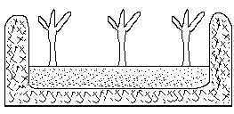

* This is made lower than the surrounding soil surface.
* Since it is capable of holding water for a long time, it is very useful during the dry season.

**The raised bed:**

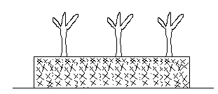

* This type of bed is made higher than the surrounding soil surface.

Since soil water is capable of draining through it, this type of bed is necessary during the rainy season, since it prevents water logging.

* The importance of raised bed is to encourage the development of root crops, as well as to check erosion.
* It also promotes soil aeration and prevents the washing away of seeds.

**Transplanting vegetables seedlings:**

* Before the transplanting of seedlings, their water supply must be reduced gradually.
* They must also be well exposed to sunlight.
* This reduction in water supply and the exposure to sunlight is referred to as hardening off.
* Hardening off ensures that the seedlings adapt to the harshconditions in the field, and to accumulate carbohydrate in their tissue so as to help them produce new roots quickly after transplanting.
* Transplanting takes place when the seedlings reach the four or five leaf stage, and should not be done immediately after applying fresh manure on the vegetable.
* This is due to the fact that when manure is fresh, the heat generated during its decomposition can kill the seedling.
* The best time for transplanting is the evening.
* Seedlings transplanted at day time are exposed to harsh weather conditions, which increase the rate of transpiration which is highly injurious to the seedlings.

**Steps followed in transplanting vegetable seeding:**

* Water the seedling to be transplanted.
* Remove the seedling with a hand trowel.
* Put the uprooted seedling (with a ball of earth around its roots) in a container.
* Make a hole which is larger than the ball of earth for planting.
* Lift the seedling from the container and place it in the hole.
* Plant the seedling in such a way that the ball of earth will appear higher than the surrounding soil surface.
* Put the soil that was removed from the hole around the ball and press firmly.
* Water and mulch the surface of the bed.
* Shade the seedling when the weather is warm.

**Spacing:**

* Good spacing of seedlings during transplanting is important because:

1. It prevents overcrowding.
2. It prevents competition for water, nutrients and sunlight.
3. It makes farm inspection easy.
4. It makes working on the land easy, e.g. weeding.

**Cultural practices in vegetable production:**

* Cultural practices are routine activities we undertake on the garden or the farm, after we transplant the seedlings till the time of harvesting.
* The cultural practices are:

1. **Watering:**

* This softens the soil and keeps it moist.

1. **Mulching:**

* This refers to the covering of the surface of the bed with grass or leaves.
* It is important because of the these reasons:

1. It keeps the soil cool.
2. It protects the moisture content of the soil.
3. It prevents the erosion of the top soil.
4. It resists the growth of weeds.
5. It enriches the soil with organic matter.
6. **Weed control:**

* A weed is a plant which grows at a place where it is not wanted or needed.
* The importance of weed control is to:

1. Avoid the competition of the weeds with the seedlings, with respect to the available soil nutrients, water and sunlight.
2. Allow the free circulation of air.
3. Avoid the creation of the hiding and breeding places of pests.
4. Avoid overcrowding.
5. **Staking:**

* This is the act of giving support to crops with weak stems.
* The advantages or the importance of staking are:

1. To ensure that fruits are clean at harvest, and not affected by soil borne diseases.
2. To enable certain plants with weak stem to support the weight of the fruits.
3. To support plants against strong wind or rain.
4. To position the leaves of weak and climbing plants towards sunlight.
5. **Thinning out:**

* The advantages or importance of thinning out are:

1. To allow air circulation.
2. To avoid overcrowding of the vegetable crops and avoid competition for nutrient and water. Thinning out is the act of removing some of the seedlings from an area, when there are too many of them within that area.
3. **Manuring:**

* The importance or the advantages of applying inorganic or organic manure are;

1. To enhance the growth of the vegetables.
2. To loosen the compact soil particles and as such, improve the soil structure.
3. To keep moisture in the soil.
4. **Prunning:**

* This refers to the removal of the side shoots from staked plants.
* It is also referred to as de-sucking.
* It is important because:
* (a) it prevents the spread of diseases.
* It enhances fruit development.
* It allows good aeration.

**Cultivation of some common types or selected vegetables:**

* The production of vegetable is done under certain basic planting requirements. These are;

1. Soil and climate requirement.
2. Method of propagation.
3. Cultural practices.
4. Pests and diseases.
5. Control of pests and diseases.

**.**

**Tomato (Lycopersicon esculentum):**

* This is an annual crop which is cultivated for its fruits.

**Varieties:**

* Some of the varieties are

(I) Wosowoso (II) Ronita

(III)Improved zuarungu (IV)M-90 (V) Roma VF.

**Soil and climate requirement:**

* Tomato grows well within a temperature range of 150C to 250C.
* A well drain soil which is rich in humus must be used.
* Waterlogged soils must not be used to cultivate the crop.

**Method of propagation:**

* Seeds are sown on nursery beds or in seeds boxes, and transplanted when they are four weeks old.
* Spacing of seedlings is usually 35cm x 60cm, and the harvesting period is between eleven to eighteen weeks.

**Cultural practices;**

* The cultural practices associated with the cultivation of tomato are weeding, staking, watering, mulching, stirring, de-sucking, disease and pest control.
* Staking keeps the fruits of tomato off the ground and ensures that they ripe early, are clean at harvest, and free from diseases.
* The plants are watered daily after transplanting, and this watering is gradually reduced to every three or four days.

**Pests:**

* The pests which attack the tomato plant are the cricket, grasshopper, beetle and the caterpillar.

**Control of pests:**

* Spraying with pesticides and insecticides.
* **Weeding and hand picking.**

**Diseases:**

* Diseases which attack the tomato plant include bacterial wilt, leaf spot, blight, blossom end root and root knot.

**Control of diseases:**

* By using fungicides.
* Practicing good sanitation in the garden

**Fertilizer requirement:**

* Apply NPK (15 – 15 – 15) at 340kg to 680kg per hectare.
* This must be applied four to six weeks after transplanting.

**Maturity and harvesting:**

* This occurs three to four months after transplanting.

**Storage:**

* Ways of storing tomatoes include:

(1) Keeping them in deep freezer.

(2) Canning them in the form of a paste.

**Uses of tomatoes:**

1. It is eaten raw, usually in salad.
2. It is used in preparing soup.

**Onion (allium cepa):**

* This is a vegetable which is mainly grown for its bulb.

**Varieties:**

* These include:

1. Tropical Bombay red.
2. Bawku onion.
3. Crystal white wax.

**Climatic and soil requirement:**

* Onions do well in rich loamy soil which is well aerated and drained.
* They do not like loose soils such as alluvial soil.
* They need a good supply of moisture during the growing period.
* However, it requires a dry period, as the plants mature and the leaves begin to die off.

**Method of propagation:**

* The seeds are sown on nursery beds or in seed boxes, before they are transplanted when they are about 10cm tall at a spacing of 12 – 15cm.
* Bulbs can also be used for propagation.

**Cultural practices:**

* These include watering, uprooting of weeds, stirring, mulching, fertilizer application as well as disease and pest control.
* The seedlings are watered daily after transplanting, and this watering is gradually reduced as the plants reach their maturity.
* Onions responds to NPK (15 – 15 – 15) at 340kg/ha.

**Pests:**

* The pests which attack the onion plant are the bulb maggot, cut worms and the millipedes.

**Pest control:**

* By spraying with insecticides and pesticides.
* By hand picking the pests.

**Diseases:**

* Diseases which attack the onion plant include the downry milder, leaf blight and the purple blotch.

**Disease control:**

* By the use of chemicals.
* By means of good sanitation practices.

**Maturity period and harvesting:**

* The bulbs mature 100 – 140 days after sowing.

**Storage:**

* By putting the bulbs in a mesh bag and placing them in a dry cool place.
* By bottling the bulbs.
* By pickling the bulbs.

**Uses of onion:**

* Used in salad preparation.
* Used for seasoning foods.
* Used in soup and stew preparation.

**Hot pepper (capsicum frutescens)**

* It is normally used as a spice.

**Varieties:**

* These include:

(i) Legon 18 (ii) Green long pods.

(iii)Indian purple (iv) Local chilli pepper.

**Climatic and soil requirements:**

* This crop requires a rainfall amount of about 65cm and lot of sunshine.
* Temperature must be between 18 – 320C.
* The crop does well in rich well drained loamy soil.

**Method of propagation:**

* Seeds are sown in seed boxes or nursery beds, and germinate in a week’s time.
* Transplanting is done a month after germination and spacing of the seedling is about 30cm – 40cm apart.

**Cultural practices:**

* These include watering, weeding, stirring, fertilizing, mulching as well as the control of pests and diseases.
* The seedlings are watered daily, and the watering is reduces as the plant reaches maturity.
* Pepper responds to the application of NPK(15-15-15) at 220kg/ha, 10 days after planting.
* This is followed by 220kg/ha of sulphate of ammonia two weeks after the first application.

**Pests:**

* Pests which attack this plant are the stem and the fruit borers.

**Control of pests:**

* By spraying with chemicals.
* By practicing good sanitation practices.

**Diseases:**

* Diseases which attack the hot pepper plant are the fruit rot, root know disease, leaf spot and leaf curl.

**Control of diseases:**

* By spraying with fungicides.
* By planting resistance varieties.

**Maturity:**

* The fruits mature 2 – 3 months after planting and harvested ripe or unripe.

**Storage:**

* The fruits are stored in cocoa bags after drying them in the sun.
* Occasional drying is necessary if they are to be stored for longer periods of time.

**Uses of onion:**

* Used for preparing medicine.
* Used for preparing soup and stew.

**QUESTIONS:**

(Q1)(a) List two importance of vegetables.

Ans:- They add taste to our food.

* Growing them provides some people with employments.

1. Differentiate between exotic and local vegetables.

Ans:

* The exotic vegetables are those that come from foreign countries, but the local ones are those which come from our own country.

(c)Explain what the following mean;

(i) Annual vegetables.

(ii) Biennial vegetables.

Ans:

* Annual vegetables are those that grow within one year.
* Biennial vegetables are those which grow within a two year period.

(d)List three factors which affects vegetable production.

Ans:

* These factors are temperature, rainfall and humidity.

(e)How does temperature affect vegetable production?

Ans: - Vegetable only grows within a certain temperature range and will not grow if this temperature range is not available.

(Q2)(a) What do not you understand by soil factor.

Ans:

* It refers to soil texture, soil structure, soil colour and soil p.H.

(b)Explain why it is the best to plant vegetables in loamy soil.

Ans:

* Because it has a good drainage, retains a good amount of water and contains enough plant nutrients.

(c)When is a soil said to have a good soil structure?

Ans: - When its particles are neither too loose nor tightly packed.

(d)Why do vegetables grow well in dark brown soil?

Ans: - Because this type of soil contains a lot of plant food or nutrients called humus.

(e)What effect does low p.H values have on micro-organisms.

Ans: At low p.H values, these organisms become less active.

(Q3)(a) What is a nursery and name two types of nursery we have?

Ans: - A nursery is place where seedlings are raised and cared for, till they are ready for transplanting. The types are the nursery bed and the nursery box.

(b)List two importance of raising seedlings before transplanting them onto the field.

Ans: - It gives seedlings a good start.

* So as to select the good ones for transplanting.

(c)Explain why it is good to buy seeds from registered seed dealers or companies.

Ans:

* Because seeds from these sources are good and give rise to healthy and disease-free crops.

(d)Give three ways in which you will care for a nursery.

Ans:- These ways are;

(I)To water the seedlings every morning and every evening.

(II)To provide the seedlings with shade.

(III)To remove weeds as soon as they appear on the nursery bed.

(e)Explain the effect on weeds on vegetable crops.

Ans: - Weeds compete with the crops for sunlight, space, nutrients and water.

* For this reason, the crops will not grow well.

(Q4)(a)List two importance of thinning out.

Ans:- It prevents the overcrowding of seedlings, which enables them to get enough nutrients, space, water and sunlight.

* It reduces diseases and pests infections.

(b)Differentiate between a raised bed and a sunken bed.

Ans: - A raised bed is made higher than the surrounding soil surface, but a sunken bed is made lower than the surrounding soil surface.

(c)Give two effects if transplanted seedlings are not well spaced.

Ans:

* These effects are

(a)there will be overcrowding of the seedlings.

(b)yield will be decreased.

(Q5)(a) Differentiate between the drilling method and the broadcasting method.

Ans:

* Both methods are ways of sowing seeds.
* In the drill method trenches are made in the soil, and the seeds placed in them and finally covered with fine soil.
* In the broadcasting method, the seeds are evenly spread on the surface of the land, and the covered with soil.

(b)What do you involves the use of parts of the parent plant, to reproduce the plant.

(c)Name two cultural practices and give two advantages of each.

Ans:

* Two cultural practices are mulching and staking.
* Mulching keeps the soil cool and resists the growth of weeds.
* Staking supportsplants against strong wind or rain, and ensures that fruits are clean at harvest as well as not affected by soil borne diseases.

(d)Briefly list the steps you will go through when transplanting vegetable seedlings.

(e) Give two importance of applying manure to soil.

Ans:

* To keep moisture in the soil.
* To enhance the growth of crops such as vegetables.

(Q6)(a) List two varieties of tomato.

Ans:

* Harvester and Ronita.

(b)What is the best temperature range for growing tomato.

Ans: - Temperature range of 150C– 250C.

(c)Name two pests which attack the tomato plant.

Ans:

* These are the grasshopper and the beetle.

(d)Name two diseases which attack the tomato plant.

Ans: - These are the leaf spot and the blossom end root.

(e)Name two pests which attack the onion plant.

Ans:

* These are cut worms and the maggots.

(f)Give two ways of controlling pests in hot pepper production.

Ans:

* By spraying with chemicals.
* By good sanitation practice.

(g)Briefly explain how hot pepper is stored after harvest.

Ans:

* Dry the fruits and store them in cocoa bags.
* If the storage period is long, then occasional drying is necessary.

**CHAPTER THIRTY ONE**

**Crop Protection:**

**INTRODUCTION:**

* This is the study of the living and non living things that cause damage to our crops, and how to control them.
* These therefore include pests and diseases.
* A pest is anything that cause economic damage to our crops.
* Disease is anything that causes deviation from the normal growth or in any of the structures or organs of the plant.

**Groups of pests:**- Crop pests can be put into four groups and these are:

1. Rodents. (3)Nematodes.
2. Birds. (4) Insects.

**Rodents:**

* These are small animals which move on four limbs and have strong teeth.
* They gnaw and chew stored cereals, nuts, tubers and so on.
* Rodents that cause damage to agricultural crops include rats, grasscutters, mice and squirrels.

**Control of rodents:**

* Rodents can be controlled on a farm by:  
  (a) setting traps to catch and destroy them.

(b) creating a barrier such as a fence to keep them off the farm.

(c)poisoning them

**Birds:**

* This group of pests feed mainly on grains or cereals and fruits.
* They also eat seeds which are germinating.

**Control of birds:**

* They can be controlled on the farm by:  
  (1) Creating noise to frighten them away.

1. Using scarecrow to drive them away.

**Nematodes:**

* They are also called eelworms and they live in the soil.
* They cause damage by feeding on the roots of plants and their feeding habits cause swellings.
* They also transmit soil-borne diseases to crops.
* They attack crops such as pineapple, cowpea and tomato.
* Nematodes can be controlled by:

1. Using chemicals.
2. Soil sterilization.
3. Crop rotation.
4. Allow fallow periods or fallowing the land.
5. Growing marigold plants, which are plants which release substances which are poisonous to the nematodes into the soil.

**Insects:**

* They form the largest group of pests.
* Despite the fact that many insects are pests, there are some which are of benefit to man.
* Some of these benefits are that some of them pollinate crops, and produce useful products such as honey and silk.
* Apart from that, some insects are used for sciencetific experiment.
* Insects are grouped into three and these are:

1. Chewing and biting insects.
2. Sucking and piercing insects.
3. Boring insects.

**Biting and chewing insects:**

* This group of insects has strong mouthparts called mandibles and maxillae.
* These strong mouthparts are used in biting and chewing leaves and so on.
* Examples are caterpillar, grasshopper and cockroach.

**Boring insects:**

* They have special mouthparts called proboscis, which is used to pierce into fruits, leaves and tender stems.
* Examples are capsids, whiteflies and aphids.

**Boring insects:**

* This group of insects creates holes (burrow) in stems or fruits of plants.
* They have strong mouthparts which they use in boring into growing plants, fruits and stored grains.
* Examples are weevils and beetles.

**Storage pests:**

* These are those pests that are found in the place, where harvested crop produce are stored.
* They include mice, maize weevil, cockroach, rat and rice weevil.

**Effects of pests on crop production:**

* This is also referred to as the economic importance of pests.
* Some of these effects or economic importance are as follows:

1. They reduce crop yield.
2. They render crops unwholesome which affects their market value.
3. They cause an increase in the cost of production of crops, since the farmer has to buy chemicals to control them.
4. Chemicals used to control pests, can have an adverse effect on both crops and the soil.
5. They can destroy the whole crop farm.

(6) They can transmit disease causing organisms such as bacteria and viruses.

**General control of crop pests:**

* This include:

1. **Quarantine control:**

* In this there is a law which bans the movement of plant parts from one area to another.

1. **Cultural method:**

* These are farming techniques which control pests and these includes:

1. Crop rotation which breaks the life cycle of pests.
2. Planting resistant varieties of crops.
3. Practicing good sanitation such as the draining of stagnant water in the farm, to avoid the breeding of insect pest.
4. Ploughing farmlands in order to destroy the eggs and certain earth burrowing creatures such as the millipede.
5. **Mechanical method:**

* **­**This does not involve the application of chemicals and includes:

1. Hand picking or collecting and crushing pests when they are a few on the farm.

|  |  |  |
| --- | --- | --- |
| **Insects** | **Crops attacked.** | **Damage caused.** |
| Weevils. | Cereals | Bore into seeds of cereals. |
| Mealy-bugs. | Mangoes/ oranges | Render fruits unwholesome. |
| Grasshopper, caterpillar and crickets. | Okro leaves, garden eggs leaves,, maize plant, e.t.c. | They mine leaves i.e. they eat the soft parts of leaves, leaving the skeleton or veins. They also cut down tomato seedlings and terminal buds. |
| Butterfly/ moth | Fruits and flowers of plants | They pierce into crops or fruits which makes them rot. |
| Beetles | Tubers and okro | They spoil tubers and chew leaves |
| Millipedes | Tubers /roots | They eat tubers and roots. |

**Control of pests:**

* Methods used include

1. **Crop rotation and mechanical control:**

* By planting different types of crops every season, the pest build up on the land reduces. Mechanical methods such as trapping the pests, hand picking them and fencing the farm can be used.

1. **The use of resistant crop varieties and quarantine control:**

* Crop varieties that are resistance to pest attack must be used for planting.In quarantine control, laws are made to regulate or ban the movement of plant parts from one area to another.

1. **The use of chemicals:**

* In this method, special chemicals are used to kill the pests.

1. **Planting and harvesting early:**

* Cultivation of crops should be planned such that planting and harvesting are done earlier in the growing season to avoid pest.

**(5) Biological method:**

* This includes:

1. Allowing animals to eat smaller animal pest.
2. By using chicken to pick insects on the farm.

**Field and storage pest:**

* Field pests are those that are found where crops are cultivated.
* For example, field pests of crops include maize weevils, squirrels, monkeys, grasscutters, caterpillars and the army-worms.
* Storage pests are those found at where the crops are stored.

**Chemical methods (types):**

* These include the use of:

1. **Rodenticides:**

* This is used to control rodents.

1. **Nematicides:**

* This is used to control nematoes.

1. **Insectiides:**

* This is used to control insects.

**Diseases of crops:**

* A disease is any change in the normal function of any part of the plant.
* Plants which are attacked by diseases show such symptoms such as reduced leaf size, appearance of swellings on the plant and reduced yield.

Effects of diseases on crops:

* These effects are:

1. Reduction in crop yield.
2. Reduction in the market value.
3. An increase in the cost of production of the crops, since chemicals have to be bought to control these diseases.
4. Rotting of fruits and vegetables.
5. Total crop failure.

**Types of crop diseases:**

* In plant, diseases can be grouped into two and these are:

1. **Pathogenic diseases:**

* These are those diseases caused by micro-organisms called pathogens.
* Examples of pathogens are fungi, virus, nematoes and bacteria.

1. **Non-pathogenic diseases:**

* This refers to those diseases which are not caused by pathogens.
* They may be due to certain factors such as lack of light, or the lack of certain nutrients.

|  |  |  |  |  |  |
| --- | --- | --- | --- | --- | --- |
| **Diseases** | **Causal agent** | **Symptoms** | **Transmission** | **Affected crops** | **Control** |
| Bacterial blight | Bacteria | - Affected crops get water-soaked angular leaf spot which later become black.  -Also, long black lesions develop on the stems, and the cotton ball rot. | Spread by growing infected seeds. | Cotton | * Grow disease free planting material.   Growing resistance varieties of cotton.   * Uproot and burn diseased plants. * Practicing crop rotation. |
| Galls | Bacteria | -Swellings called galls appear on stem and roots.  -Later the galls become hard and woody, and the affected plant wilts. | Spread through infected soil, rootstocks and seedlings. | Fruits trees, tomato. | * Remove and destroy affected plants. * Use clean planting materials. * Practicing crop rotation. |
| Bacterial wilt | Bacteria | -Affected plants become pale, bend downwards and wilt.  -The upper leaves and the shoot of the plant eventually die. | Spread through the rain, infected soil and planting materials. | Tomato, groundnut potato and tobacco. | * Practicing crop rotation. * Grown resistant varieties of crop.   Use clean and healthy planting materials.   * Remove and destroy affected crops. |
| Bacterial soft rot | bacteria | -Leaves of affected crops become yellow, and the stem rots.  -The fleshy underground parts of affected plants rot. | -The disease spreads through infected soil and planting materials. | Roots and tuber crops, carrot, rhizomes and fruits. | * Use disease free planting material. * Practicing crop rotation. * Remove and destroy affected plants and crops. |

**Disease caused by nematodes:**

|  |  |  |  |  |  |  |  |  |  |  |
| --- | --- | --- | --- | --- | --- | --- | --- | --- | --- | --- |
| **Disease** | **Causative agents** | | **Symptoms** | | **Transmission** | | **Affected crops** | | **Control** | |
| Rus | Fungus | | * Small yellowish spots appear on the leaves and sheaths. * These spots later on turn brown and break open to show yellowish red spores. | | Spread by the wind | | Sorgum, maize and coffee | | * By growing resistant varieties of maize. * Spraying crops with fungicides. | |
| Smut | Fungus | | Large blackish lumps appear on stems, leaves and cobs. | | Spread by the wind, through infected seeds and crop residue. | | Maize rice, millet and sorghum | | * Uproot and burn diseased plant. * Plant resistant varieties of crop. * Dress seeds with mercury before planting. | |
| Sooty mould | Fungus | | Blackish powder appears on the leaves and the fruits. | | Spread by aphids. | | Citrus coffee, mango, pepper and garden eggs. | | * Using chemicals to control the aphids. * Keeping good sanitation on the farm. | |
| Basal rot | Fungus | | The leaves of affected plants turn yellow and the bulb slowly decays. | | Spread through infected planting materials. | | Onion and shallot. | | * Practicing crop rotation. * Growing disease free materials. | |
| Leaf spot | Fungus | | Brown spots that are enclosed by yellow rings appear on the leaves. | | Spread by the wind. | | Banana, tomato, oil palm, rice, yam and cassava. | | * By dressing seeds with chemicals before planting. * By planting early ‘to avoid the disease. * Practicing crop rotation. | |
| Tikka | Fungus | | - Yellow spots appear on the leaves of affected plants.  -These leave later fall off the plant. | | Spread by the wind. | | Groundnut. | | * Practicing crop rotation. * Growing resistant varieties of crops. | |
| Fruit rot | Fungus | | The surfaces of affected fruits show sunken and rotten areas. | | Spread through the air and rain splash. | | Tomato | | * Keeping good sanitation. * Applying fungicides. * Removing and destroying affected fruits. | |
| Black pod | Fungus | | * A brown spot appears on the spot which spreads in all directions. * The pod later becomes black and dry. | | Spread through rain splash and by insects. | | Cocoa | | * Remove and destroy affected pods. * Apply fungicides. | |
| Downy mildew | Fungus | | Grey white threads appear on the leaves of affected plants. | | Spread by the wind. | | Maize, millet, onion and cabbage. | | * Growing resistant varieties of crops. * Keeping good sanitation on the farm. * Remove and burn affected plants. | |
| Blast | Fungus | | -Brownish or reddish spots with grey centres develop on he leaves of affected plants.  -Plants becomes weak and fall over. | | Spread by the wind. | | Maize and rice. | | * Remove and destroy affected plants. * By planting resistant varieties of rice. * By dressing seeds with fungicides before planting. * Spraying with chemicals. | |
| Gummosis | Fungus | | * Leaves turn yellow and fall prematurely. * The bark of citrus plants dies and cracks. * Gum flows from the cracked bark. | | Spread through soil and rain splash | |  | | * Removing the diseased bark and treating the area with the right chemicals. * Using resistant rootstock varieties. | |
| Tristeza | | Virus | | -The leaves become yellow and falls.  -The young shoots then die. | | Spread by aphides and by using infected planting materials. | | Citrus | | * Planting resistances varieties of citrus. * Using chemical to control the apids. |
| Leaf curl | | Virus | | -Affected okro plants have their leaves curled upward and rolled. | | Spread by an insect vector called whitefly. | | Cassava, pepper, okro and tomato. | | * Regular spraying with chemicals to kill the whitefly. * Remove and burn affected plant. * Using virus-free planting materials. |
| Streak | | Virus | | -Yellow and green strips appear on affected leaves.  -Affected plants become deformed and stunted. | | Spread by piercing and sucking insects. | | Maize and tomato. | | * Remove and burn affected plants.   Growing resistance varieties of crops. |
| Swollen shoot | | Virus | | -Appearance of swellings on branches and twigs.  -Pods and leaves become mosaic. | | Spread by the mealy-bugs. | | Cocoa. | | * Growing resistant varieties of cocoa. * Destroy and burn affected plants. * Using chemicals to destroy the vector. |

**Disease caused by nematodes:**

|  |  |  |  |  |  |
| --- | --- | --- | --- | --- | --- |
| **Diseases** | **Causal agent** | **Symptoms** | **Transmission** | **Affected crops** | **Control** |
| Root knot | Nematode | - Roots of affected plants get swellings on them, causing poor growth. | Spread through the soil and by planting infected planting material. | Tomato carrot, shallot, pawpaw and lettuce. | * Growing resistant crop varieties. * By disinfecting the soil with nematicides. * Practicing crop rotation. |

**General measures taken to prevent disease outbreak on crop farm:**

* Keeping good sanitation on crop farms.
* Removing and destroying diseased plants.
* Using diseases-free planting materials.
* Growing resistant varieties.
* Using appropriate chemicals for spraying.

**General control of crop diseases:**

1. **Cultural control:**

* In this method, normal farming practices such as the planting of resistance varieties are used to control diseases.

1. **Chemical control:**

* In this, appropriate chemicals are used to control diseases.

1. **Biological control:**

* In this, enemies of disease causing organisms are used to destroy them.

**QUESTIONS:**

(Q1)(a) What is a pest and list three groups of pest.

Ans:

* Anything which causes damage to crops is a pest.
* Three groups of pests are birds, insects and rodents.

(b) Give two ways of controlling rodents.

Ans: - By setting traps to catch and destroy them.

* By poisoning them.

1. In what way do birds affect agriculture;

Ans: - They eat germinating seeds and reduce harvest yield.

(d)List the three groups of insects.

Ans:- These are:

1. Chewing and biting insects.
2. Boring insects.
3. Sucking and piercing insects.
4. Differentiate between storage and field pests.

Ans:

* Storage pest attack harvested crops at places where they are stored, but field pests attack the crops while they are growing on the farm.

(e)Give two economic importance of pests.

Ans:

* They reduce crops yiekd.
* They cost an increase in crop production.

(Q2)(a) Give two mechanical way of controlling pests.

Ans: - By hand picking and killing the pest.

* By trapping them using traps.

(b) Differentiate between rodenticides and insecticides.

Ans:- While rodenticides are used in controlling rodents,, insecticides are used in the control of insects.

(c)Give two effects of diseases on crops.

Ans:

* Reduction in crop yield.
* Reduction in the market value.

(d)What is the main difference between pathogenic and non-pathogenic disease.

Ans: - Pathogenic diseases are caused by micro-organisms, but non-pathogenic diseases are not caused by micro-organisms.

(e)List three general measures taken to prevent diseases outbreak on crop farms.

Ans:

* Keeping good sanitation on crop farms.
* Using disease free planting materials.
* Growing resistance varieties.

**CHAPTER THIRTY TWO**

**Farming Systems and Fish Farming:**

**Introduction:**

* This refers to the various methods of farming.
* Farming systems can also be referred to as agriculture systems, and there are various types.

**(1) Subsistence farming:**

* This is the type of farming in which the farmer grows food to feed himself and his family.
* The farm is usually small and simple tools such as the hoe and the cutlass are used.
* Under subsistence farming, the farming may also keep a few animals.
* The main of the farmer is not to make money, even though he may sell any excess produce.
* One disadvantage of this system of farming is that production is low.
* This is due to the fact that the size of the farm is small, and simple tools are used.
* Another disadvantage is that the animals kept under this system are not well cared for.

**(2) Cash crop farming:**

* This is the type of farming in which the farmer grows crops for sale.
* The main aim of the farmer is to make money and crops such as cocoa and yam may be grown.
* Apart from the farming, cash crop farmers do other jobs.
* Another name of cash crop farming is plantation farming.

**(3) Commercial farming:**

* This is the type of farming in which crops and animals are grown and reared on large scale for sale.
* Machines and farm inputs such as fertilizers are usually used.
* One main advantage of this system of farming is that, it provides factories with raw materials.
* Another advantage is that, it assists in solving the unemployment problem.
* One main difference between cash crop farming and commercial farming is that, under cash crop farming, the farmer does not devote all his time to the farm, but commercial farmers devote all their time to their farms.
* Another difference is that, cash crop farms are not as big as commercial farms.

**(4) Shifting cultivation:**

* This is the farming system in which a farmer after cultivating a piece of land till it becomes infertile leaves it for another land, with no intention of returning to the old one when it regains its fertility.
* In this case also, the farmer moves his family and his settlement to the new land.

**Advantages:**

* The old land becomes fertile again after the fallow period, i.e. the time when it was left bare.
* The farmer is able to avoid pests and diseases by moving from one land to another.
* Inputs such as fertilizerand insecticides are not very much necessary.
* Simple tools and inexpensive equipments are used.
* Since new lands are always cleared, the farmer always has a fertile land to farm on.

**Disadvantages:**

* Since new farmlands are always cleared, the forest is destroyed.
* It cannot be practiced in areas where land is scarce.
* Since land is always being cleared, this system of farming becomes expensive.
* Because the farmer uses only a small amount of input, the level of production is low.

**(5) Land rotation:**

* This is the method of farming in which a farmer cultivates a piece of land for sometime, and leaves it to cultivate on a new piece of land, with the intention of returning to the old land when it regains its fertility.
* In this case, the farmer does not move his family and settlement to the new land.

**Advantages:**

* Money is saved since the farmer does not build a new settlement any time he moves.
* It is cheap since simple tools are used.
* The old land becomes fertile again, when it is allowed to remain fallow for sometime.
* The farmer does not have problems with pests and diseases.

**Disadvantages:**

* Because new areas are cleared, the virgin forest is destroyed.
* It cannot be practiced in areas where land is scarce.
* It becomes expensive and difficult, since land is constantly cleared.
* Because simple tools are used, the commercial production of crop cannot occur.

**(6) Crop rotation:**

* This is the type of farming in which a farmer grows different types of crops on different plots in a definite order, on the same piece of lands.
* In each growing season, the farmer changes the crop grown on each plot.
* The rules to be followed when practicing crop rotation are:

1. Crops with long roots should follow those with short roots.
2. Crops which use the same type of plant food must not be allowed to follow each other, for example, maize must not be allowed to be followed by millet.
3. A fallow period must be included in the crop rotation program, so as to allow the land to regain its fertility.
4. Legumes must also be included in the program.

**Reasons why legumes are included in a crop rotation cycle:**

* They house nitrogen-fixing bacteria.
* They check erosion when used as cover crops.
* Because they provide a lot of leaves which serves as organic matter, the structure of the soil is improved.
* They increase the nitrogen level in the soil, since they fix nitrogen in the soil.

**Differences between land and crop rotation:**

|  |  |
| --- | --- |
| **Land rotation** | **Crop rotation** |
| 1. The farmer works on different pieces of land. | The farmer works on one particular land. |
| 1. The crops are grown in any order. | Different crops are grown in a definite order. |
| 1. In land rotation, legumes are not necessary. | In crop rotation, legumes are included in the cycle. |

**Advantages of crop rotation:**

* Since different types of crops are grown each season, diseases and pests are controlled.
* The farmer harvests a variety of crops.
* The soil nutrients are effectively used.
* Land is conserved.
* When one type of crop fails, the other may not fail.

**Disadvantages of crop rotation:**

* It involves a lot of work since the farmer grows different types of crops.

**A three-year crop rotation**

|  |  |  |  |
| --- | --- | --- | --- |
| **A piece of land is divided into three plots** | **Plot 1** | **Plot 2** | **Plot 3** |
| **Year 1** | Cassava | maize | Soyabean |
| **Year 2** | Maize | Soyabean | Cassava |
| **Year 3** | Soyabean | Cassava | Fallow |

**A four-year crop rotation**

|  |  |  |  |  |
| --- | --- | --- | --- | --- |
| **A piece of land is divided into four plots** | **Year 1** | **Year 2** | **Year 3** | **Year 4** |
| **Year 1** | Yam | Maize | Cassava | Soyabean |
| **Year 2** | Maize | Cassava | Soyabean | Yam |
| **Year 3** | Cassava | Soyabean | Yam | Maize |
| **Year 4** | Soyabean | Yam | Maize | Fallow |

**(7) Mixed farming:**

* This is the method of farming in which a farmer rears animals and grows crops on the same piece of land.
* The area where crops are grown must be fenced, so as to prevent the animals from destroying the crops.

**Advantages:**

* The droppings of the animals can be used to fertilize the soil.
* The farmer gets a regular income throughout the year.
* The farmer is more likely to get a higher income from the farm.
* Because the risk of losing the crops and the animals is very low, it is a form of insurance for the farmer.
* The farmer gets a balanced diet.

**Disadvantages:**

* More skills are required by the farmer in order to manage the crops and the animals.
* The farmer has no time to rest since it involves a lot of work.
* If care is not taken, the animals may destroy the crops.

**(8) Mixed cropping:**

* This is the type of farming system in which a farmer grows different types of crops on the same piece of land at the same time.

**Advantages:**

* The farmer obtains most of his crops from his farm.
* Since the crops are harvested at different times, the farmer obtains food for a longer time period.
* It guards against crop failure, since if one crop fails, others may do well.
* The spread of diseases is checked.
* The different crops will take up nutrients at different depths.

**Disadvantages:**

* It involves a lot of work.
* Soil nutrients and water may be used faster.
* Mechanization of the farm is impossible.
* Improper spacing may lead to the shading of crops.

**Differences between mixed farming and mixed cropping:**

|  |  |
| --- | --- |
| **Mixed farming** | **Mixed cropping** |
| Crops are grown and animals are raised. | Only crops are grown. |
| The farmer gets both plants and animal produce. | The farmer gets only plant produce. |
| The farm animals can provide farm power. | There are no animals to provide farm power. |
| Plant and animal waste are available to serve as manure. | Only plant waste is available to serve as manure. |

**(9)Monocropping:**

* This is the farming system in which a farmer grows one type of annual crop on a piece of land, and changes it during the next cropping season.
* The main difference between monocropping and mixedcropping is that, in mixed cropping, different crops are grown on a piece of land at the same time, but in mono-cropping, it is only one type of crop which is grown on a piece of land, at a particular time.

**Advantages:**

* The farmer gets to know more about the crops that he grows.
* Commercial production of crops is encouraged.
* The use of machines and implement is also encouraged.

**Disadvantages:**

* Pests spread easily.
* Diseases spread faster.
* There is a high risk of crop failure.
* The fertility of the soil drops at a fast rate.

**(10) Monoculture:**

* This is the system of farming in which the same crop is grown on the same piece of land every year.
* It is practiced when a particular crop is in high demand or has a good price.
* The differences between monoculture and monocropping is that, in mono-culture, the farmer continues to grow the same type of crop every year, but in monocropping, the farmer changes the crop he grows after harvest.
* Also, in monoculture, annual or perennial crops are grown but in mono-cropping only annual crops are grown.

**Advantages:**

* The farmer specializes in the cultivation of that crop.
* Farm mechanization is encouraged.
* Commercial production is encouraged.
* The farmer develops many skills on how to handle the farm produce.

**Disavantages:**

* The risk of crop failure is high.
* Diseases can easily spread among the crops.
* Pests can easily spread.
* Since the same type of soil nutrients are used yearly, the fertility of the soil drops drastically.

**(11) Pastoral farming:**

* This is the farming system in which the farmer only keeps farm animals.
* In a form of pastoral farming called pastoralism or nomadism, the farmer move his animals from place to place.

**Advantages:**

* The farmer gets both meat and milk.
* As the animals move about, their droppings fertilize the land.
* The animals perform a lot of exercises as they move about.

**Disadvantages:**

* The animals may get sick when they move into tsetse-fly infested areas.
* The animals get little food during the dry season.
* The movement of the animals may destroy farms, and pollute the sources of water.
* Overgrazing may occur which may lead to erosion.

**(12) Irrigation farming:**

* This is the type of farming in which water is brought to the farm, in order to water the crops.

**Advantages:**

* The farmer does not depend on rainfall.
* It enables the farmer to work throughout the year.
* The farmer can grow different types of crops.
* It enables water to be sent to the dry areas of the farm.

**Disadvantages:**

* The amount of money need to start this system of farming is very high.
* In an area where there is no permanent source of water, it cannot be practiced.
* The maintenance cost involved is high.

**(13) Ecological farming:**-This is the type of farming, in which the vegetation of the environment is protected as the farming takes place.

* Agro-chemicals and machines are not usually used, and the fertility of the soil is improved by the use of organic manure.
* Apart from that, trees are grown to protect the soil and the crops from harsh weather conditions.

**Advantages:**

* The trees planted improve the climate and the environment.
* Because of the planting of these trees, desertification is checked.
* The incidence of the pest is reduced.
* The importation of chemicals and machinery is reduced.
* Erosion is checked because of the vegetation cover.

**Disadvantage:**

* It usually takes a long time for full benefit of the investment made to be realized.

**(14) Intensive farming(agriculture):**

* In this, agro-chemicals and machines are used to produce a lot of crops on a small piece of land.
* It may involve the use of scientific means to raise a lot of animals on a small piece of land.

**Advantages:**

* With respected to space, more yield is had than extensive farming.
* It gives rise to cheaper farm produce.
* Because the available space is not enough, the animals do not move a lot and so save energy.They therefore require less food.

**Disadvantages:**

* The chemicals used can affect the environment.
* The pesticides used can kill useful insects as well as those which destroy crops.

**Extensive farming:**

* In this, a large farm is made using a few machines and a little amount of chemicals.

**Advantages:**

* This system is less expensive and as such requires less capital.
* The animals involved perform a lot of exercise, since they move on a large area.
* The amount of inorganic fertilizer used is less.

**Disadvantages:**

* The products have high prices.
* The yield per available space is small.

**Equipments needed for laying out a farm:**

* These equipments are:

1. **The ranging pole:**

* This is used for the sighting of areas.

1. **Measuring tape/ tape measure:**

* This is used for measuring distances and ares.

1. **Garden line/ rope:**

* This is used for marking out the plot.

1. **Pegs/ pins:**

* They are used for making straight lines and also needed for identification of specific measured points.

1. **Cross staff:**

* This is used for the construction of right angles at the corners of the plot to get straight lines.

1. **Cutlass/ matchet:**

* Used for weeding and the cutting of paths.

1. **Prismatic compass/ compass:**

* Used for the determination of angles and bearings.

1. **Hammer/ mallet:**

* Used for driving pegs into the soil.

**Sources of farm power:**

* There are different sources of farm power and some of these are:
* **Animal power:**
* This is used to operate implements such as the bullock plough, carts, cultivators, the harrow, carts and trail ridgers.

1. **Man Power:**

* This can be used to operate tools and equipments such as the hoe, the cutlass and the knapsack sprayer.

1. **Combustion engine:**

* This is used to operate machines such as cultivators, pumps, planters and harvesters.

1. **Electrical power/ generator:**

* This is used to operate pumps, sprayers, mills and shearer.

1. **Solar power:**

* This can be used to operate dryers and pumps.

1. **Wind power:**

* This is used to operate mills, wind vanes and pumps.

1. **Water power:**

* This is used to operate turbines, boats and canoes.

**(7) Mechanical** power:

-This is used to operate ridgers, planters and cultivators.

**Classification of the produce of certain systems of farming:**

Crops:­Class:

Ginger……….……………………………………………………………. Spice.

Banana ……….………………………………………………….…………..Fruit.

Tomato ………….………………………………………………………….Vegetable.

Rice ………………………………………………………………………..Cereal/ grain.

Cowpea ……………………………………………………………………..Legume.

Yam ……………………………………………………………………...Stem tuber.

Cocoa ……………………………………………………………………….Beverage crop.

Pineapple …………………………………………………………………… Fruit.

Millet ……………………………………………………………………... Cereal/ grain.

Onion ……………………………………………………………………… Vegetable/ spice.

Cassava ……………………………………………………………………... Root tuber.

Pepper ………………………………………………………………………. Spice/vegetable.

Soya beans……………………………………………………………….. Legume

**Record keeping in farming systems:**

- It is important for a farmer to keep farm records. - The farmer must keep farm record in order to: (a) Know which of the farm business is doing well and which is not doing well. (b) Compare his current business with those of the past.

(a) Use it to secure loans.

(b) Enables him to know the amount to pay as tax.

(c) Help in the preparatory of farm budget.

(d) Know the kinds of farm work carried out.

**Fish Farming:**

-This is the type of farming in which fishes are raised or reared in water bodies such as ponds, cared for and harvested when they grow.

- It is also referred to as fish culture.

- Fish farming is different from fishing because in fishing, we go and catch fishes which have grown on their own in water bodies such as lakes and rivers.

- Since fish culture refers to the rearing of aquatic organism in water, then fish farming is a form of agriculture.

**Reasons why fish farming is important:**

* Fish farming is important because:

(1) We eat fish as food.

(2) Fish is used to prepare poultry and animal feed.

(3) It can be used in the preparation of drugs such as God-liver oil.

(4) Certain fishes are used to destroy mosquito larvae.

(5) Fishes are used in aquariums.

(6) They provide is with income.

**Fish farming problems:**

* Fish farmers face certain problems and some of these are:

1. The pollution of the water in which the fishes are kept.
2. Poor storage facilities.
3. The hunting, killing or eating of the fishes by predators such as frogs.
4. The stealing of fish from the pond by thieves.
5. The constant loss of water from the pond as a result of evaporation and so on.

**Reasons why tilapia is widely reared in fish farming:**

* Tilapia is widely reared in this country because:

1. It reproduces within a short time.
2. It can even grow well in shallow waters.
3. Compared with other fishes, it grows at a faster rate.
4. It can be reared together with other fishes.
5. It feeds on mosquito larvae, aquatic weeds and certain parasites.
6. People are ready to buy them since it has a high market demand.

**Conditions necessary for the rearing of tilapia:**

* These conditions are that

1. The temperature of the water within the pond must be around 300C.
2. The ponds salinity must be between 15ppt and 20ppt.
3. The p.H. of the water within the pond must be between 6.5 and 9.
4. The water within the pond must not be muddy.

**The selection of site for the construction of a fish pond:**

* The site chosen must be of gentle slope, so as to allow water to easily drain into and fill the pond.
* The site must be near a permanent source of water.
* In order to avoid the loss of water through seepage, the soil found at the site must be clay.
* The site must be close to the farmer`s house.
* The water at the site must contain enough dissolved oxygen and must be free from pollution.

.

**The making of a fish pond:**

* The steps to be taken are:

1. Clear all trees, bushes and grass from the chosen site.
2. The size of the fish pond is marked on the ground.
3. The top soil is removed from the cleared site and put aside.
4. The pond is dug in such a way that it slopes towards the deep end.
5. Make the banks of the pond 2m wide and let the sides of the pond slope gently.
6. The soil on the bank must be made compact to prevent rain from pushing it back into the pond.
7. Make an inlet into the pond at the shallow end above the water level.
8. Make an outlet at the deep end of the pond to prevent it from overflow.

**Filling the pond with water:**

* The water used must not be muddy or polluted.
* This water must be slowly placed into the constructed pond.
* This will prevent the water from becoming muddy.

**The fertilization of the pond:**

* This refers to the addition of compost to the water in the pond.
* Too much compost must not be added, since it will reduce the amount of oxygen within the water.
* A well fertilized pond will look green in colour, and this colour is an indication of sufficient fish food within the pond.

**The stocking of the pond:**

* The pond must be stocked with fingerlings.
* These fingerlings which are baby fishes must be from a reliable source such as the fisheries Department of the Ministry of Food and Agriculture.
* During the stocking process, the temperature of the water in which the fingerlings are, must be the same as that of pond water.
* The fingerlings must not be poured into the pond but they must be allowed to swim into the pond by themselves.

.

**Factors to be considered in the selection of fish for the stocking of a pond:**

* The species of fish chosen must be in high demand and have a good market value.
* The fish must be able to grow within a short time.
* The fish must be hardy or able to withstand severe pond conditions.
* The fingering must easily be able to be handled and cared for.

**Feeding the fishes:**

* Even though the fishes can get their natural food called plankton from the pond, they must still be fed.
* Fish food includes wheat bran, rice bran, poultry feed, earthworms and cassava leaves.

**Loss of water from the pond:**

* This may occur as a result of;

1. **Leakage:**
2. Leakage which occurs when the banks of the pond are weak.
3. Evaporation.
4. Seepage into the soil.
5. Drinking of pond water by animals.

**The maintenance of fish pond**

* This can occur in a number of ways such as by:  
  (a) Ensuring that the pH of the pond water is between 6.5 and 9.

(b) The removal of dead and unhealthy fishes.

(c) The removal of piled silt.

(d) Cutting the weeds or grass along the banks of the pond.

**Harvesting the fish:**

* The fishes must be harvested when they reach maturity.
* The fingerlings can be collected and used to restock the pond.
* The harvesting can be done with fish traps, nets, spear, hook and line.

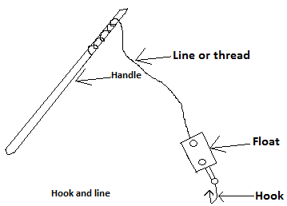

**Processing and preservation:**

* Fish processing and preservation methods include the following:

1. Drying. (b) Smoking.

(c) Frying. (d) Freezing.

(e) Canning.

**Questions:**

(Q1)What is subsistence farming and give one of its disadvantages.

Ans:

* It is the type of farming in which the farmer grows food to feed himself and his family.
* One disadvantages of this type of farming is that production is low.

(Q2) Differentiate between cash crop and commercial farming.

Ans:

* In cash crop farming, the farmer grows food for sale but in commercial farming, crops and animals are grown and reared on a large scale for sale.

(Q3)List two advantages of shifting cultivation.

Ans:

* Simple and inexpensive equipments are used.
* The farmer always has fertile land to farm on, since new areas are always cleared.

(Q4) Explain what land rotation is.

Ans:

* In this, after farming on a piece of land for some time, the farmer leaves it to cultivate a new land, with no intention to return to the old one when it regains its fertility.

(Q5)Give two reasons why it is good for land rotation to be practiced.

Ans:

* Since no new settlement is built, money is saved by the farmer.
* It is cheap since simple tools are used.

(Q6)List two rules which must be followed in crop rotation.

Ans:

* Crops which need the same type of nutrients must not be allowed to follow one another.
* Short rooted crops must follow long rooted ones.

(Q7)Give one reason of including legumes in a crop rotation program.

Ans:

* They check erosion when used as cover crops.

(Q8)Give one difference between land rotation and crop rotation.

Ans:

* In land rotation, legumes are not included, but they are included in crop rotation.

Ans:

* In land rotation, legumes are not included but they are included in crop rotation.

(9)What is the main difference between mixed farming and mixed cropping?

Ans:

* In mixed farming, the farmer rears animals and grows crops on the same piece of land, but in mixed cropping, different types of crops are grown at the same time on the same piece of land.

(Q10)Explain what we mean by mono-culture.

Ans:

* In this, a farmer grows the same crop on the same piece of land every year.

(Q11)Give two reasons why it is good for ecological farming to be practiced.

Ans:

* The trees planted improve the climate and the environment.
* Erosion is checked because of the vegetation cover.

(Q12)What name is given to the type of farming, in which water is brought from other places to water the crops.

Ans:

* Irrigation farming.

(Q13) Give two reasons why farmers must keep farm records.

Ans:

* To enable him know the amount to be paid as tax.
* To know the farm work carried out.

(Q14)List three sources of farm power.

Ans:

* These are solar power, electrical power and man power.

(Q15)List two problems faced by fish farmers.

Ans:

* These are the pollution of the pond water and poor storage facilities.

(Q16)Give two reasons why tilapia is widely reared in Ghana.

Ans:

* Because it can reproduce within a short time and it can be reared together with other fishes.

(Q17)Explain what we mean by the fertilization of the pond.

Ans:

* It refers to the addition of compost to the water in the fish pond.

(Q18)Give two ways in which fish pond is maintained.

Ans:

* By ensuring that the p.H of the pond is between 6.5 and 7, as well as the removal of dead and unhealthy fishes.

**CHAPTER THIRTY THREE**

**Poultry Husbandry:**

**Introduction:**

* This is a farm in which only birds are bred or raised for sale or for domestic perposes.
* Birds such as the fowl, turkey, duck and guinea fowl are raised on this farm.

**Starting the farm:**

* Beginners always start with a few birds, since it is easy to handle birds when they are few.
* Birds and animals are suited to certain living conditions and if they get the conditions which they like, then their number may be increased.

**Management or housing systems:**

* Having obtained his birds, the next thing a farmer must consider is where to house or keep them.
* Bad housing means a great loss, for the birds must be kept in clean and well ventilated houses.

**Kinds of housing systems:**

* The housing systems for poultry-keeping are:

1. The extensive system.
2. The semi-intensive system.
3. The intensive system.

**The extensive system:**

* In this system, the birds are allowed to move freely about in search of food and water.
* They are allowed to spend most part of the day outside.
* There are two types of the extensive system and these are:  
  (a) The free running system.

1. The free- range system.

**The free running system:**

* This is the cheapest or the economical type of housing system in poultry keeping.
* The birds are allowed to move freely about in search of food, over a large area around and beyond the farmer`s house.
* Some tiny coops are built for them, so that they can return to lay eggs or rest during the night.

**Advantages:**

* The large extent of land used avoids the overcrowding of the birds.
* The fowls are healthy since they perform a lot of exercise.
* Less money is spent in maintaining the fowls.
* The birds get enough green forage from which minerals are obtained.
* The birds get a lot of sunshine which is a source of vitamin D.

**Disadvantages:**

* Predators and moving vehicles may kill the birds.
* The fowls may go and destroy people`s farms and property.
* The fowls are exposed to weather hazards such as heavy rainfall.
* Their eggs may be lost, broken or become unclean.
* They can easily be attacked by pests and diseases.
* The birds population may not be known.

**The free-range system:**

* This is also referred to as the open range system.
* Under this system, the fowls are housed but allowed to move freely on a large grass run which is fenced during the day.
* Unlike the free running system, this system is somehow organized since balance rations are placed in feed trough in the range.
* Also, the control of diseases and pests is normally carried out by the owner.

**Advantages:**

* Since the birds are fenced, they are protected from intruders.
* The bird`s population can be accounted for.
* Since the birds are fenced, they do not destroy people`s farms and property.
* They exercise their body and get vitamin D from the sun`s energy.
* The fowls are not exposed to pests and infectious diseases.

**The semi-intensive system:**

* This is the type of housing system in which the birds spend part of their time in buildings and part in the open, (i.e. runs or paddock) which are mostly fenced.
* In fact, it combines some aspects of the extensive systems, since the birds have a restricted freedom of movement.
* There are two types and these are;

1. The run system.
2. The movable fold unit system.

**The run system:**

* In this system, the fowls are kept in a permanent house surrounded by a grass-field or a run which is fenced.
* The run or paddock in their system is normally divided, for the control of parasitic diseases and vegetation lost on the run.

**Advantages:**

* The system gives commercial quantities of eggs.
* It can easily be practiced as backyard poultry keeping.
* It permits a good supervision of the birds.
* Diseases and pests can easily be controlled.
* The birds enjoy sunlight and exercise their body.
* Since they are housed, they are protected against weather hazards.

**Disadvantages:**

* The run may become muddy and foul during the rainy season, when proper care is not taken.
* Pests and diseases may spread when the vegetation in the run is not well kept and controlled.

**The movable fold unit system:**

* It consists of a portable house to which a run is attached.
* While they are in the run, the birds get enough sunlight and fresh air.
* They also sleep in the portable house during the night.
* It is not commonly used in Ghana.

**Advantages:**

* Its portability makes it movable to dry and clean places at any time.

**Disadvantages:**

* Egg eating and cannibalism may occur among the birds, if they are not properly supervised.

**The intensive system:**

* This is the system in which many birds are kept within a small area, and never allowed to go out.
* It is capital intensive, i.e. a lot of money is needed.
* There are two types and these are:

1. The deep litter system.
2. The battery cage system.

**The deep litter system**:

* In this system, the birds are kept in a pen day and night.
* The pen must be provided with fittings or equipments such as water troughs, feed troughs and perches.
* The floor of the building must be covered with litter materials such as sawdust or dry grass, in order to collect the droppings of the birds.
* These litter materials used must be capable of decomposing easily, in order not to choke the respiratory tract of the fowls.

**Advantages:**

* It requires less labour.
* Just a little land is needed for a large number of birds.
* It is efficient and reliable if it is well supervised.
* Pests and diseases are reduced since hygienic conditions are provided.
* The birds are protected against weather hazards.
* A high production of eggs is assured.

**Disadvantages:**

* The system involves or needs a lot of money.
* The birds do not perform enough exercises, and do not get enough sunlight.
* Cannibalism, egg eating and so on may occur due to overcrowding.
* Pests and diseases can spread very fast, if good sanitation practices such as disinfecting and the washing of the floor is not done.

**The battery cage system:**

* It consists of a block of cages within which each cage is designed to contain one or more birds depending on the space, the design and the construction of the units.
* It is usually housed in well-ventilated and lighted pens.

**Advantages:**

* Less labour and little land is used.
* It permits strict supervision of the performances of the birds.
* Birds receive individual attention.
* The eggs obtained are clean and bigger.
* The eggs are not eaten or damaged by the birds, since they do not have access to these eggs.

**Disadvantages:**

* A high amount of money or capital is needed to establish or operate the system.
* The fowls lack exercise and sunlight.
* The fowls do not have access to natural vegetation.
* It is not suitable for brooding chicks.

**Feeding the birds together:**

* When many birds are fed together, they get in each other`s way and so it is important that there are enough troughs for them all to feed.
* About 15cm of trough space must be given to each bird.
* Birds walk into the food they eat, and may leave droppings there.
* Certain diseases are spread by the droppings from infected birds and for this reason, feeders are to be designed to prevent birds from eating the feed troughs.

**Poultry production:**

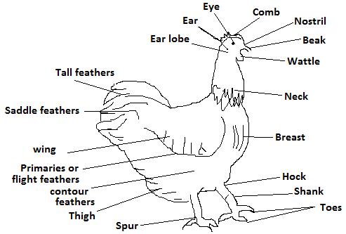

* The types of poultry reared in Ghana include fowls, turkey and ducks.

**The importance of poultry- keeping:**

* Poultry-keeping on the commercial scale provides employment for people.
* It provides income for people.
* Manure from poultry houses are used to fertilize the soil.
* Eggs are used in bakeries, cooking, production of vaccine and soap.
* The colourful feathers of poultry can be used for decoration on clothes and hats.

**Types of poultry:**

* There are two types of poultry and these are:

1. The exotic breed.
2. The local breed.

* While the exortic breed is from foreign countries, the local breed is from this country.

**Differences:**

|  |  |
| --- | --- |
| Exotic Breed | Local Breed |
| 1. Large in size. 2. They lay more eggs. 3. Their eggs are large in size. 4. Their meat is tender and soft. 5. They are often kept on the intensive system. | 1. They are small in size. 2. They lay few eggs. 3. Their eggs are small in size. 4. Their meat is tough. 5. They are often kept on the extensive system. |

* The type of breed of poultry kept or raised by a person, depends on what he wants to produce.
* He may keep these birds for:

(i) Egg production.

(ii) Meat production.

(iii) Production of both eggs and meat.

**Incubation:**

-This is the time taken by a hen or an incubator to hatch out chicks.

- There are two types and these are:

(i) Natural incubation. (ii) Artificial incubation.

**Natural incubation:**

* In natural incubation, a broody hen sits on the eggs for 21 days.
* During this period, it provides heat to the eggs.

**Artificial incubation:**

* In this method, a machine called an incubator is used.
* The eggs which are placed in the incubator are evenly heated for 21 days by the incubator.
* In order for this evenly heating to occur, the egg must be rotated from time to time during these 21 days, after which the eggs get hatched.
* The eggs are heated at a particular temperature.

**Obtaining day- old chicks for production:**

* The main sources of obtaining day- old chicks for poultry production are:

1. **Hatching the eggs with a broody hen:**

* A broody hen is the female hen which can sit on and hatch its own eggs.
* This method is used when only a few chicks are to be produced.
* Fertilized eggs are put under a broody hen too warm and hatch them after 21 days.
* The broody hen normally takes care of the chicks till the weaning period, when she prepares for another reproduction session.

1. **The hatchery:**

* When one wants to go into commercial poultry production, then one has to obtain the day old chicks from the hatchery.
* This is a place where day old chicks are produced in large quantities with incubator.

**Caring for the day- old chicks:**

* When the chicks are hatched, they are very small and have beenincubated at a higher temperature.
* They must therefore be protected against chilling.
* These chicks may be reared or raised using the natural method, in which a hen is used.
* They can also be raised using the artificial method in which the chicks are kept in brooder houses.

**The natural method:**

* In this method, the broody hen continues to care for the chicks after they have been hatched.
* They follow her, run to her for protection and creep under her for warmth.
* The hen and the chicks may be moved into a coop.
* The hen and the chicks must not be crowded together otherwise the chicks may be trodden on.
* The baby chicks should be allowed a limited run or short grass.
* The hen should remain with the chicks till they have grown feathers.

**Artificial brooding:**

* Since many chicks are hatched from incubators, they have to be brooded artificially.
* For this reason, these day old chicks are raised in a special structure called brooder.
* The brooder functions in the same way like the broody hen in providing warmth, protection and so on to the day old chicks.

**Equipments and materials in the brooder:**

* The equipments found within the brooder are:

**Litter:**

* This may be in the form of dry grass or dry sawdust, spread over the floor of the brooder to absorb the droppings of the birds.
* It must be changed when it becomes soiled.

**Feed troughs:**

* These are used to serve the chicks with feed or food.
* The chicks should be fed with the chick starter feed.

**Water troughs:**

* These are containers in which water is served.

**Source of heat:**

* This is what keeps the chicks warm, and also provides them with light to enable them feed in the night.
* It may be in the form of an electric bulb or a lantern, which has been suspended from the roof of the brooder.
* The chicks will move away from the heat source when they feel hot.
* They will crowd themselves together when they feel cold.

**Taking care of the brooder:**

* Before using the place for the first time, wash the floors, walls and equipments with warm water and disinfectants like Dettol.
* Give the birds sufficient clean food and water every day, and make sure the feed and water troughs are very clean.
* The culling of sick birds must be done.
* The litter must be changed regularly when it gets soiled.
* Lower the strength of the heat source when the chicks move away from it, and increases it when they move closer to it.

**Steps taken before collecting the day-old chicks:**

* Do a general cleaning of the brooder house, i.e. washing and disinfecting.
* Ensure that the brooder house can take the number of birds expected.
* Get the source of heat ready.
* Put fresh litter on the floor of the brooder house, after cleaning the house.
* The appropriate number of feeding and drinking troughs must be made ready.
* The chick starter for at least two weeks must be ready.
* The routine drugs for the first month must be made ready.

**Feeding the day old chicks:**

* Day old chicks need no food up to the second day after hatching.
* However, it is better to offer water or food within a few hours.
* The yolk supplies the chicks with food during the first and the second day after hatching.

**Signs to look out for when separating layers and non-layers:**

|  |  |  |
| --- | --- | --- |
| **Character** | **Layers** | **Non-Layers** |
| Comb | Large, bright red, smooth and glassy. | Dull, shriveled, scaly. |
| Face | Bright | Yellowish tint. |
| Vent | Enlarged, smooth and moist. | Shrunken, dry. |
| Pubic bones | Thin, pliable, spread out. | Blunt, rigid, close together. |
| Abdomen | Expanded, soft, pliable. | Contracted, hard, fleshy. |
| Skin | Soft, loose. | Thick, underlined with fat. |

**Caring for the birds after the brooder stage:**

* The heat source must be removed when the chicks develop feathers.
* Chicks between 8 or 20 weeks old are termed growers, and are fed on starter mashed feed.
* The growing stage of the growers is termed the rearing stage, and during this stage they are kept under the deep litter system.
* Growers grow to maturity as pullets and cockrels when they are about 6 months old.
* For table egg production, fowls are best kept in the battery cage system.

**Kinds of mashes:**

* The types of mashes we have are:

1. The baby chick meal or the chick starter.
2. Grower`s mash.
3. Layer`s mash.
4. Broiler’s mash.

**The chick starter:**

* This is the type of food given to day old chicks until they attain their grower’s stage.
* The mash consists of enough protein and less carbohydrate, for the baby chicks grow quickly and do not need much food for maintenance.

**The grower’s mash:**

* Chicks are much bigger when they attain the grower’s stage.
* They become active and so food containing more carbohydrate must be given to them.

**Layer’s mash:**

* Layers require more protein for egg production.
* Therefore the mashes given to them must contain more protein and less carbohydrate.

**Boilers mash:**

* Broilers are fowls which are mainly bred for sale.
* They must therefore be big, heavy and nice.
* For this reason, their mashes must contain very high amount of carbohydrate, in order to give them weight.

**Other food stuffs:**

* The following food stuffs must be added to the food of the birds:

1. **Green stuffs:**

* These are wet and juicy green leaves which are succulent.
* They are to be given to the fowls in minute form, and they supply vitamin A to the birds.
* Fowls fed on greens will have their yolks becoming completely yellow in colour.
* But those not fed on greens, will have white yolks.

1. **Fibre:**

* Dry grass or hay is sometimes added to the poultry food, and this contains cellulose.
* Fowls find it difficult to digest fibre.

**Minerals and vitamins:**

* Birds need minerals such as manganese, Calcium and phosphorus for their bodies to function well.
* Vitamins are also needed in small quantities, and birds fed on greens do not lack sufficient minerals.

**Signs shown by sick birds:**

* Poultry birds may be attacked by diseases caused by germs.
* These germs may be found in the food they eat.
* Signs shown by a sick bird are that:

1. It refuses to eat.
2. It becomes dull, weak, and slow and sleeps while standing.
3. Its wings become drooping.
4. Its features become rough.

**Common diseases of poultry:**

* These diseases include coccidiosis, newcastle and fowl pox.

1. **Coccidiosis:**

* This is a disease caused bya protozoa which lives in the caeca.
* It can cause heavy losses among chicks, especially when they reach the grower`s stage.

**Symptoms:**

* The affected birds become weak and restless.
* They may stand with a moping hunch-backed posture.
* Blood streaks appear in the loose droppings of the birds.

**Mode of transmission:**

* The protozoa which lives in the upper part of the small intestine, burrows into the caeca wall.
* These germs pass out with the droppings as hard coated materials.
* These lie dormant on the ground until they are picked up by other birds.
* The disease then develops in these birds.

**Prevention:**

* By vaccinating the chicks.
* By disinfecting the chicken coops or buildings regularly.

**Treatment:**

* By using sulphur drugs.

**New Castle:**

* This disease derives its name from a British city called New Castle.
* It is a highly infectious disease, which is obtained from improper sanitation.
* Birds may be attacked suddenly by this disease and may show no signs or symptoms at all.
* Sometimes some of the birds go crazy before they die.
* This disease is caused by a virus.

**Symptoms:**

* Breathing, coughing and sneezing become a problem to the affected birds.

**Treatment:**

* Consult a veterinary officer.

1. **Fowl pox:**

* This is also caused by a virus.

**Symptoms:**

Swellings appear on the comb and around the peak of affected birds.

**Treatment:**

* Consult a veterinary officer.

**The digestive system (organs) of the chicken:**

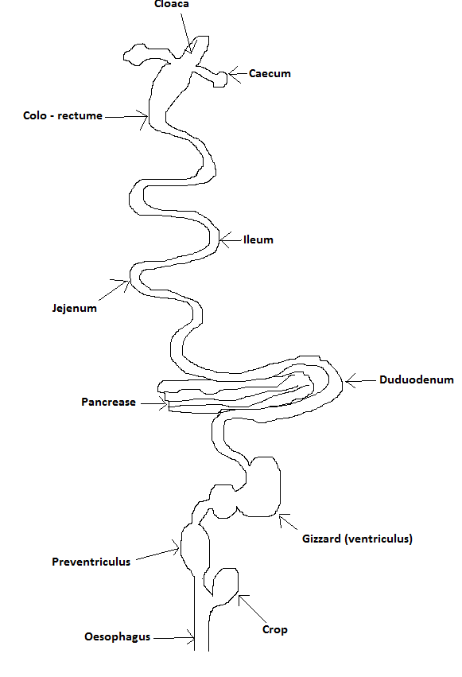

* Digestion is the process in which large food molecules which enter the digestive system, are broken down into smaller molecules with the help of enzymes and absorbed into the blood.

**The digestive system:**

* This is the part of the body which turns food eaten by the chicken, into materials and used in making eggs, meat and for repairs.
* The digestive system of the fowl has two main parts and these are:

1. The alimentary canal.
2. The assesory organs.

* The alimentary canal consists of the mouth (peak), the gullet (oesophagus), the crop, the proventriculus, the gizzard, intestine, the caeca, the large intestine and the cloaca.

**The mouth:**

* The fowl has no lip, no teeth and chin.
* It instead has a beak which is used for tearing apart and picking up food.
* The beak has no sense of taste.
* Within the beak can be found a pointed tongue, which is used to force the food into the gullet (oesophagus).
* Found also within the mouth or the beak are the mucus glands, which provide the saliva needed to moisture the food.

**The Oesophagus:**

* From the mouth the food enters the oesophagus or the gullet.
* The gullet is a tube leading from the mouth into the crop.
* The gullet is expansible.

**The crop:**

* This is an enlargement of the gullet into a sac like cavity.
* It is used for the temporal storing of food, and enables the bird to eat faster and swallow quickly.
* It also acts as a hunger sensation centre, by stimulating the chicken to feed when it is empty.

**The proventriculus (Stomach):**

* It is a thin wall sack and has glands which secrete chemical substances, that help to break down some of the food into soluble forms.

**The gizzard:**

* It helps in the further grinding or the breaking down of the food, before it enters the duodenum.

**Duodenum:**

* The chemical substance supplied to thhe duodenum by the pancrease, helps in digestion.
* It also serves as a passage for digested food from the gizzard to the small intestine.

**The small intestine:**

* It comprises the jejenum and the ilium which secrets the chemical substances needed for final digestion.
* Digestion is completed in the small intestine.
* Digested food substances are absorbed into the blood stream in the small intestine.

**Caeca (Caecum):**

* It is located the point where the small intestine meets the large one.
* Its function is to extract moisture from the faeces so as to prevent the excess loss of water.

**The large intestine (colo-rectume):**

* This extends from the small intestine to the cloaca.
* Its function is to hold faecal matter till it is excreted to the cloaca.

**Cloaca:**

* Faeces which are the waste products of digestion are eliminated or removed through it.

**Assessory organs:**

* They include the liver and the pancreas.
* The liver is used for purification purposes and also stores glycogen.
* It also transforms protein waste products into uric acid and other products, for the kidney to eliminate.
* The pancreas secrets the enzymes amylase, trypsin and lipsase as well as the hormone called insulin.

**Questions:**

(Q1)(a) Explain why we must always start a poultry farm with only a few birds, and when must we increase the number of birds?

Ans:

* Because it is easy to handle the birds when they are few.
* The number may be increased if the birds meet the right conditions and do not die.

(b)Why must your birds be well housed?

Ans:

* Because housing them poorly may lead to their death.

(c)Explain what the following meanand give two advantages of each:

i)The running system. ii)The free - range system.

Ans:

* In the free running system, the birds are allowed to move freely about around and beyond the farmer’s house, in search of food.
* In the free-range system, the birds are housed but allowed to move freely on a fenced run.
* Two advantages of the free running system are that

(i) the fowls are healthy since they perform a lot of exercises.

(ii) less amount of money is spent in maintaining them.

* Two advantages of the free-range system are that

(i) the birds are not exposed to pests and diseases.

(ii) they get sunlight and as such vitamin D.

(d)What is the difference between the movable fold unit system, and the deep litter system.

Ans:

* The main difference is that in the movable fold unit system, the birds are housed in a portable house to which a run is attached.
* But in the deep litter system, the birds are kept in pens day and night.

(d) Explain why in the deep litter system, the floor must be covered with litter materials.

Ans:

* To absorb the droppings of the birds.

(Q2)(a) Give two reasons why people keep poultry.

Ans:

* Because it provides them with income.
* It also provides them with employment.

(b)Differentiate between the exortic breed and the local breed of poultry.

Ans:

* The exotic breeds are those from foreign countries while the local breeds are those from this country.

(c)List two differences between the exotic breed and the foreign breed.

Ans:

* These differences are that

(i) the exotic breeds are large in size but the local breeds are small in size.

(ii)While the exotic type produces large eggs, the eggs of the local ones are small.

(d)Explain what you understand by

(i) natural incubation.

(ii) artificial incubation.

Ans:

* Natural incubation is the type in which a broody hen sits on and warm the eggs for 21 days, in order to hatch them.
* In artificial incubation, the eggs are heated in an incubator for 21 days in order to hatch them.

1. Explain what a brooder is.

Ans:

* It is a special structure, in which day old chicks are raised.

(b)List three equipments found in the brooder, and give the importance of each.

Ans:

* The equipments are litter, water troughs and heat source.
* Their importance are that

(i) the litter absorbs the droppings of the birds.

(ii)water is served to the birds in the water troughs.

(iii)the heat source provides the chicks with warmth or heat.

(c)Differentiate between the chick starter and the layers mash.

Ans:

* While the chick starter is given to the chicks till they get to the growers stage, the layers mash is given to layers.

(d)Explain what greens are and give their importance.

Ans:

* Greens are wet and juicy vegetable leaves, which are given in small amount to the birds.
* They are important since they supply the fowls with vitamin A.

(Q3)(a)List two signs or symptoms shown by sick birds.

Ans:

* They refuse to eat.
* Their wings become drooping.

(b)Name two poultry diseases and give two symptoms of each.

Ans:

* These two diseases are coccidiosis and new castle.
* For the cossidosis disease

(i) affected birds become weak and restless.

(ii)blood streaks appear in their loose droppings.

* For the new castle disease, these symptoms are

(I) breathing becomes difficult for affected birds.

(ii) coughing and sneezing also become a problem for them.

(c)Make a labellled diagram of the digestive system of the chicken.

(d)Give the importance of these organs, found in the digestive system of the fowl:

1. Peak.
2. Gullet.
3. Gizzard.
4. Small intestine.

Ans:

* The peak is used for the tearing apart and the picking of food.
* Food from the mouth passes into the crop through the gullet.
* The gizzard helps in the further grinding of food, before it enters the duodenum.
* Digestion is completed in the small intestine, and the absorption of the digested food substances into the blood occurs in the small intestine.

(d) Explain the terms Growers and Pullets.

Ans:

* Growers are chicks which are about 8 weeks old but less than 20 weeks old.
* Pullets are growers which have reached the laying stage, i.e. birds which are about 20 weeks old to their laying stage.

(e)Explain the following terms;

1. The rearing stage.
2. Brooding.
3. Cullng.

Ans:

* The rearing stage refers to the growing stages of the chicks.
* Brooding is the period when the hen cares for its chicks.
* Culling is the process of moving all unproductive birds from the productive ones.

**Chapter Thirty Four**

**Farm animals:**

**Introduction:**

* These are animals which are kept by farmers or raised on the farm.

**The importance of farm animals:**

* They provide us with meat or protein.
* They provide us with milk which makes our diet nutritious.
* They provide us with hide and skin, which are used for the manufacture of leather products.
* Their droppings can be used as farm manure.
* Some of them provide wool which is used for making cloths.
* They can be sold for money.
* Some are reared as hobby and for sports.
* Some are used for scientific research.
* Some are used in feeding industries.

**Products derived from some animals:**

1. **PIG:**

* The product had from pig is pork, which is used as food.

1. **Sheep:**

* The product had from sheep is wool, which is used to manufacture cloths.

1. **Goat:**

* The product had from goat is goat meat, which is referred to as chevon.

1. **Cow:**

* The product had from cow is milk, which is used to manufacture margarine.
* Cow also provides us with meat.

1. **Poultry:**

* The products had from poultry are eggs, which are used to make cakes.
* We also get meat from poultry.

1. **Rabbit:**

* The product had is wool, which is used to make clothing.
* Rabbit also provides us with meat.

**The importance of giving water to farm animals:**

* Water given to farm animals is important because;

1. It helps in the digestion of the food they eat.
2. It helps them to get rid of waste materials from their bodies in the form of urine and sweat.

* It forms part of the body fluid and blood.

**Animal feed:**

* There are three types and these are:

1. The basic animal feed.
2. Concentrate and supplement.
3. Roughages.

**The basic animal feed:**

* This feed is mainly used to feed non-ruminants and has a high food value.
* It is highly digestible.
* Even though it is very rich in carbohydrate, it lacks some nutrients.
* The feed includes the following:

1. Cereals such as maize, guinea corn, millet and rice.
2. Root and tuber crops such as yam, cassava and sweet potato.

**Concentrates and supplements:**

* These feeds are prepared from cereals, minerals and drugs.
* This type of feed is highly rich in protein, carbohydrate and minerals.
* It can easily be mixed by the farmer himself and can be produced commercially.
* It can be used to feed ruminants as supplement by adding vegetables such as lettuce, cabbage, kontomire and bokoboko.
* In short, concentrates are feed which are highly rich in protein, carbohydrates and minerals which are produced commercially for animal feeding.

**Roughage:**

* This refers to the fibrous feed materials which form the main diet of ruminants.
* They include grasses and legumes.
* These roughages can be stored in the form of hay and silage.
* The hay and silage can be used to feed the livestock during the dry season, when fresh green pasture is scarce.

**Food ration for farm animals:**

* Food ration is the daily prepared feed for farm animals.
* There are three types and these are:

1. The maintenance ration.
2. The production ration.
3. The balanced ration.

**The maintenance ration:**

* This is the amount of food needed by farm animals in order to prevent increase or decrease in its weights.

**Its importance:**

* The maintenance ration is important because:

1. It is used to maintain the weight of the animals during the dry season, when fresh green pasture is not available.(2) It provides the animals with just the amount of energy and protein which it needs for metabolic activities such as respiration, blood circulation and movement.
2. It is used in feeding animals kept under the intensive system of housing.

**Production ration:** This is a mixture of different food items, which is enough in order to enable production to occur in an animal.

**Importance:**

1. It can be used for flushing.

* This implies that it can be given as a special feed to the animal, two weeks before mating.

1. It can be used for “steaming up” in pregnancy.

* This implies that it can be given as special diet to the animals, two weeks before parturition.

1. **Balanced diet or ration:**

* This is the ration which contains all the food nutrients required by an animal, in the right proportion for maintenance and production.

**Importance:**

* It enhances the production or growth in a farm animal.
* It improves the quality of meat had from the animal.
* It keeps the animal healthy.

**Importance of food nutrients to farm animals:**

|  |  |  |
| --- | --- | --- |
| **Food nutrients** | **Functions** | **Deficiency symptoms** |
| 1. **Carbohydrate:**   **Sources-** Maize, millet and wheat bran. | 1. It provides energy. 2. It provides fat when in excess. | 1. Lack of energy. 2. Loss of weight. |
| 1. **Protein:**   **Sources: -** Fish meal, groundnut, cotton seed, palm kernel seed. | 1. It repairs worn out or damaged tissues. 2. Needed for body growth. 3. Provides energy. | 1. Slow growth. 2. Low resistance to diseases. 3. Lack of energy. |
| 1. **Fats:**   **Sources:** Cotton seed cake, groundnut cakes, palm kernel cake. | 1. It maintains the body`s temperature. 2. It provides energy. | 1. Loss of weight. 2. Dry or rough skin. 3. Lack of energy. |
| 1. **Vitamins:**   **Sources:** Greens and vegetables. | 1. Protects the body against diseases. 2. Helps in blood clotting. | 1. Low resistance to diseases. 2. Loss of blood through excessive bleeding when there is a cut. |
| 1. **Minerals:**   **Sources:** Oyster shell and common salt. | 1. Controls the processes and functions of the body`s organs (i.e. respiration, ,circulation, reproduction e.t.c.) 2. Calcium and phosphorus helps in the formation of bmones, teeth and shells. 3. Iodine is for growth, reproduction and formation of the thyroid. 4. Iron is for the formation of blood cells. | 1. Causes rickets and retarded growth. 2. Poor teeth and bone formation. 3. Goiter and anaemia. |

**Some farm animals and their breeds:**

|  |  |
| --- | --- |
| **Types of farm animals.** | **Breeds.** |
| 1. Sheep: | 1. Long – legged sheep. 2. Nungua black head. 3. Forest type. |
| 1. Goat: | 1. West Africa dwarf goat. 2. The Sokoto red. 3. The Anglo-Nubian. 4. Sapel type. |
| 1. Pig: | 1. Ashanti black. 2. Comborough. 3. Landrance. |
| 1. Cattle: | 1. N`dama cattle. 2. Sokoto Gudali. 3. White Fulani. 4. Zabu. |
| 1. Rabbit: | 1. Thurinda. 2. California white. 3. Chinchilla. 4. New Zealand white. |
| 1. Fowls: | 1. White leghorn. 2. Plymouth Rock. 3. Rhode Island Red. |
| 1. Fish: | 1. Tilapia. 2. Catfish (mudfish). |

**Pests in farm animal production:**

* Pests are living organisms that depends on other living organisms called the hosts, to cause damage or harm.
* With reference to farm animal production, pest can be grouped into two and these are:

(i) Endoparasites.(ii) Ectoparasites.

**Endoparasite:**

* These are parasites which live inside the body of their hosts.
* They include tape worm, round worm and liver fluke.
* They usually suck the nutrients in the gut or the alimentary canal of their host.

**Some endoparasites and their hosts:**

|  |  |
| --- | --- |
| Endoparasites | Hosts |
| Tape worm. | Pig, cattle and man. |
| Liver fluke. | Pig and cattle. |
| Hook worm. | Cattle, sheep, goat and pig. |
| Round worm. | Poultry, sheep, goat, cattle and pig. |

**Methods of controlling endoparasites:**

* Some of the methods used in the control of endoparasites are:

1. By a regular deworming of the animals using prescribed drugs.
2. By grazing the animals after sunrise, to avoid the swallowing of any worm which might be on grass.
3. By supplying the animals with clean food and water in clean troughs.
4. By the practice of good sanitation and washing the pen with disinfectants.
5. By removing the excreta of the animals so that worms do not breed in them.

**Ectoparasites:**

* These are parasites or pests which live outside the body of their hosts.
* They usually live on the skin of their hosts, and examples are tick, mange, mite, lice and tsetsefly.

**Some ectoparasites and their hosts:**

|  |  |  |
| --- | --- | --- |
| **Ectoparasites .** | | **Hosts.** |
| Tick. | | Sheep, goat, cattle and dog. |
| Tsetsefly. | | Cattle, sheep, goat and man. |
| Lice. | | Poultry, cattle, sheep and goat. |
| Bug. | Cattle, sheep, goat and man. | |

**Methods of controlling ectoparasites:**

* Some of the methods used in the control of ectoparasites are:

1. By spraying pesticides and insecticides in the pen and the surroundings of the animals.
2. By a regular wash of the animals.
3. By the draining pf stagnant water, which may serve as breeding places of certain insects.
4. By hand picking the pests when they are few.
5. By dustinig the animals with appropriate powdered chemicals.

**The economic importance of endoparasites and ectoparasites:**

* This refers to the effects of these parasites on animals, and some of these effects are that:

1. They reduce the economic value of the animals by retarding their growth.
2. Ectoparasites cause anaemia by sucking the blood of their hosts.
3. They easily transmit diseases to both man and animals.
4. The bites of some ectoparasites cause irritation to their hosts, and can even cause sores on these hosts.
5. They cause restlessness in farm animals which can bring about low production.

**Signs shown by female farm animals which are on heat:**

* When a female animals is on heat, it shows certain signs and some of these are:

1. Its vulva becomes red and swollen.
2. It will not eat much.
3. It will not allow other animals to jump on her.
4. It becomes restless and makes unnecessary noise.

**Signs shown by pregnant farm animals:**

* The signs shown by such an animal are that:

1. It refuses mating.
2. It does not come on heat again.
3. It becomes quite.
4. Its udder becomes bigger.

**Signs shown by healthy farm animals:**

* Some of these signs are that:

1. They will have appetite for food and water.
2. They are always active.
3. Their eyes become bright.
4. They look fat and fresh.
5. Their coat cover becomes fine and bright.
6. Their droppings will be in pellets and not watery.
7. They move together with the flock.
8. The animal does not sleep while standing.

**Signs shown by sick animals:**

* Some of these signs are that

1. Such an animal sleeps while it is standing.
2. There will be discharges from their eyes, or the vent of their cloacas.
3. The animals may look lean and bony.
4. They are not active and stay behind other animals in a group.
5. The droppings of these animals become watery.
6. They so not have appetite for food water.
7. Their coat becomes rough but not shiny or smooth.

**Digestive system of farm animals:**

* Farm animals can be grouped into two according to their digestive system (stomach), and the food eaten by these animals.
* These two groups are:

1. Ruminants.
2. Non-ruminants or monogastric.

* The main difference between these two groups is that, the ruminant has a complex stomach which is divided into four parts and chews grass.
* But the non-ruminant has a single stomach and cannot also digest grass.

**Ruminants:**

* They are animals with complex stomach, which are mostly grass eaters.
* Their stomach is divided into four parts or chambers namely;

1. The first chamber or the rumen.
2. The second chamber or the recticulum.
3. The third chamber or the omasum.
4. The fourth chamber or the abomasum.

* The first three chambers are referred to as the fore stomach, while the fourth one is referred to as the true stomach.
* Examples of ruminants are cattle, sheep and goat.

**The digestive tract of ruminants:**

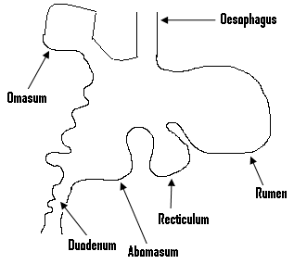

**Digestion in ruminants:**

1. – They feed by gathering a small quantity of grass with their,tongue, grip it by the help of its jaws and teeth, and jerk their heads to pull off the grass for swallowing.
2. –The grass then passes through the oesophagus into the rumen.

* The micro-organisms which live in the rumen cause the digestion of the cellulose within the grass.
* The digested portion of the grass which is referred to as cud, is stored in the rumen.

1. The undigested grass or the cud later on moves from the rumen to the recticulum.

* From the rectriculum, it is moved back into the mouth through the oesophagus for the animals, to rechew the cud with their molars.

1. The cud which is now in a semi-liquid state is now moved into the omasum, from where it is moved into the true stomach or the abomasum.

* The semi-liquid or the semi-digested food is now referred to as the chyme.

1. –While in the abomasum, gastric juice is secreted into the chime for further digestion to occur.

* The chyme then passes through the duodenum into the small intestine.
* In the small intestine, the digestion of the food is completed and the absorption of the digested substances into the blood stream occurs.

1. When the food moves from the small intestine into the large intestine, water is absorbed from it and the undigested materials are passed out through the anus as dung or faeces.

**The movement of food in the digested track of ruminants:**

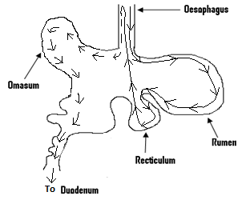

**Keys:**

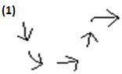**= The movement of the re-digested grass or the cud.**

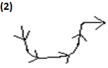**= The movement of grass or roughage.**

**Some common farm animal diseases:**

* These diseases include anthrax, rinderpest, foot and mouth diseases and trypanosomiasis.

**Anthrax:**

* It attacks herbivores such as cattle, sheep and goat.
* Its causative organisms or its causal agents are bacteria.
* In other words it is caused by bacteria.

**Symptoms:**

* There is a rise in the body temperature of the animal, which causes convulsion to occur, leading to the instant death of the animal.
* The animal lags behind the flock with its head hanging.
* It loses appetite.
* Its breathing becomes rapid.
* The affected lactating cows will stop producing milk.
* There may be blood discharge from the mouth and anus of affected animals.

**Control/ preventive measures:**

* The surroundings of the animals must be cleaned with soapy water and disinfectants.
* Animals which die from these diseases must be buried deep down the soil.
* Wash feeding equipments thoroughly, since the disease is transmitted through water and contaminated feed.

**Rinderpest:**

* It attacks cattle, sheep, goat and other ruminants.
* It is caused by a virus.

**Symptoms:**

* There is a rise in the body temperature of an affected animal.
* Swollens which contain fluid or liquid, appear in the mouth and on the feet of affected animals.

**Control/ preventive measures:**

* By the frequent vaccination of the animals.
* By good sanitation practices.

**Trypanosomiasis:**

* It is also referred to as sleeping sickness and attacks animals such as cattle, goat, sheep, pig and the horse.
* Its causative organism is a protozoa called trypanosome.

**Symptoms:**

* There is a rise in the body temperature of an affected animal.
* The animal becomes dull.
* It suffers from anaemia or the loss of blood and becomes blind.

**Control/ preventive measures:**

* By destroying the tsetseflies with insecticides.
* Stagnant and marshy areas should be drained and cleared, to avoid the breeding of the tsetsefly.
* If there is the need for treatment, you must consult a vertinary officer.

**The general control and prevention of farm animal disease:**

* By preventing the overcrowding of the animals.
* By routine medication.
* By supplying the animals with good feed and water always.

**QUESTIONS:**

(Q1)(a) Give three reasons why people keep farm animals.

Ans:

* They keep farm animals because:

1. They provide them with meat.
2. They can use their droppings as manure.
3. They can sell these animals for money.

(b)Give two reasons why farm animals must be given water.

Ans:

* Because it helps waste to be removed from the bodies of these animals.

(c)Briefly explain what the following mean:

(a) The basic animal feed.

(b) Concentrates and supplements.

Ans:

* The basic feed has a high food value and is used to feed non-ruminants.
* It is made up of cereals such as millet and rice, as well as roots such as cassava and sweet potato.
* Concentrates and supplements are highly rich in protein, carbohydrate and minerals produced commercially to feed animals.
* It consists of cereals, minerals and drugs.

(Q2)(a) Explain what you understand by maintenance ration and give one of its importance.

Ans:

* The maintenance ration refers to the amount of food which is needed by a farm animal, which prevents its weight from increasing or decreasing.
* It is important since it is used to maintain the weight of the animal, during the dry season when fresh green pasture is not available.

(b)What is the difference between production ration and balanced diet.

Ans:

* The production ration is a mixture of different food items, which is enough in order to enable production to occur in an animal.
* But a balanced diet contains all the food nutrients which are needed by an animal in the right proportion, far maintenance and production.

(c)List two sources of protein and state three functions of protein.

Ans:

* Two sources of protein are beans and meat.
* Protein is used to repair damaged tissue.
* It is needed for the growth of the body.
* It also provides energy.

(d)Give two reasons why the food of farm animals must include vitamins.

Ans:

* Because these vitamins prevent them from being attacked by diseases.
* Vitamins also help in the clotting of the animal`s blood, in case it gets a cut.

(e)List two deficiency symptoms shown by farm animals if they lack (a)protein, (b)fat.

Ans:

* In the case of protein, the animal loses weight and lacks energy.
* In the case of fat, the animal loses weight and its skin becomes dry and rough.

(Q3)(a) List two breeds each, of these animals.

i) Pig. (ii) Goat. (iii)Sheep.

Ans:

* For pig, we have the Combrough and the Ashanti Black.
* For thegoat, we have the West African dwarf goat, and the Sokoto Red.
* For the sheep, we have the Forest type and the Nungua black head.

(b)What is the main difference between an endoparasite and an ectoparasite.

Ans:

* The main difference is that while the endoparasite lives within the body of its host, the ectoparasite live outside the body of its host.

(c)Give three ways of controlling ectoparasites.

Ans:

* By hand picking them.
* By washing the animal regularly.
* By spraying pesticides and insecticides in the pens and the surroundings of the animals.

(d)Give two economic importances of endoparasites and ectoparasites.

Ans:

* They transmit diseases to man and animals.
* Ectoparasites cause anaemia in their hosts.

(e)List three hosts of tsetsefly.

Ans:

* These hosts are cattle, sheep and goat.

(f)List two signs shown by a female animal when it is

(i)on heat.

(ii)is pregnant.

Ans:

1. When an animal is on heat, then it will not
2. eat much.
3. allow other animals to jump on her.
4. When such an animal ispregnant, then
5. it will refuse mating.
6. its udder becomes bigger.

(g)List three symptoms shown by a farm animal when it is (a)healthy (b)sick.

Ans:

* When a farm animal is healthy, then

(a) it will be active.

(b)its eyes become bright.

(c) It looks fat and fresh.

* But when such an animal is sick, then

(a) it will look lean and bony.

(b)it will not be active.

(c)its droppings become watery.

(Q4)(a)Differentiate between a ruminant and a non-ruminant.

Ans:

* A ruminant has a complex stomach which is divided into four parts, but a non-ruminant has only a single stomach.

(b)Make a labeled diagram of the digestive track of a ruminant.

(c)Explain briefly what occurs when the grass eaten by a ruminant, passes from the mouth through the oesophagus into the rumen.

Ans:

* Micro-organisms found within the rumen cause the digestion of the cellulose found in the grass.
* The cud which is the undigested portion of the grass is then stored in the rumen.

(d)Name the causative organism of anthrax and list two symptoms of this disease.

Ans:

* It is caused by bacteria.
* The breathing of affected animals becomes fast.
* They also lose weight.

(e)List three animals attacked by rinderpest and give one way of controlling it.

Ans:

* These animals are cattle, sheep and goat.
* It can be controlled by the vaccination of all the animals.

(f) Make a labeled diagram of the digestive tract of a ruminant.